Hands-on No: 11
Topic: ER Diagram – Human Resource Management System
Date: 24-03-26

Problem Statement
The goal is to design an Entity-Relationship (ER) Diagram for a Human Resource (HR) Management System that accurately models the organizational structure and workforce management. The system should represent the key entities involved in HR operations, such as employees, job roles, departments, locations, and employment history, along with their attributes.
The ER diagram should capture how these entities are related to one another, including:
• Employee reporting hierarchy (self-referencing relationship where employees report to managers)
• Department assignments for employees and their roles
• Job history tracking, including previous positions held by employees across different departments and locations
• Location details for departments and employees, showing organizational geography
The diagram must clearly define Primary Keys (PK) for each entity to uniquely identify records, Foreign Keys (FK) to maintain relationships between entities, Cardinalities (1:1, 1:N, N:M) to specify how entities are associated, and Self-referencing relationships, such as an employee reporting to another employee (manager).

Entities and Attributes
EMPLOYEE:
• Employee_ID (PK)
• Name
• Email
• Phone
• Hire_Date
• Salary
• Job_ID (FK)
• Department_ID (FK)
• Manager_ID (FK)
DEPARTMENT:
• Department_ID (PK)
• Department_Name
• Location_ID (FK)
JOB:
• Job_ID (PK)
• Job_Title
• Min_Salary
• Max_Salary
LOCATION:
• Location_ID (PK)
• City
• State
• Country
JOB_HISTORY:
• History_ID (PK)
• Employee_ID (FK)
• Job_ID (FK)
• Department_ID (FK)
• Location_ID (FK)
• Start_Date
• End_Date

Relationships
• Employee reports to Employee (Self-referencing, 1:N)
• Department has many Employees (1:N)
• Job assigned to many Employees (1:N)
• Location has many Departments (1:N)
• Employee has many Job History records (1:N)

ER Diagram
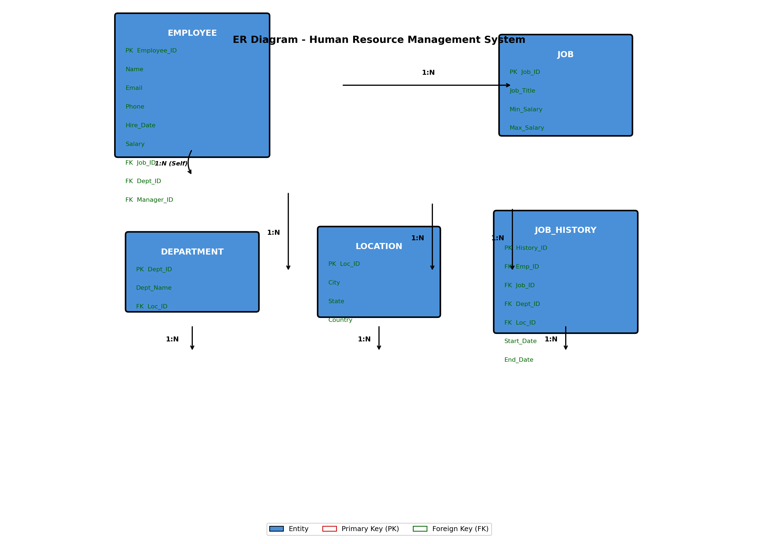

Conclusion
The ER diagram for the Human Resource Management System effectively structures the HR data by defining clear entities, attributes, and relationships. The self-referencing relationship in the Employee entity allows for modeling the organizational hierarchy where employees report to managers. The JOB_HISTORY entity tracks employees' career progression across different departments, job roles, and locations. This well-designed ER diagram ensures data integrity through primary and foreign keys, enables efficient querying of employee information, and provides a solid foundation for building the HR database. The cardinality relationships (1:N) ensure proper data organization and help maintain the integrity of the workforce management system.

