Training Feedback System
Agile Project Documentation
Team Members: Sriram (TL), Tamil, Samiha, Myl
Duration: 2 Weeks
Methodology: Agile Scrum

1. Project Overview
The Training Feedback System is a console-based application designed to collect and analyze feedback from participants who attend training sessions. The system allows administrators to manage training programs, trainers to conduct sessions, and participants to submit feedback. The collected feedback helps evaluate training effectiveness and improve future programs.

Training Feedback System – Requirements
- User Login
The system should allow users to login with their account.
There are three types of users: Admin, Trainer, and Participant.
- Training Registration
Participants should be able to register for training sessions.
The system should store the training details and participant information.
11. Training Feedback System
- Feedback Submission
After attending the training, participants should submit feedback through the system.
Feedback can include ratings and comments.
11. Training Feedback System
- Trainer Evaluation
Participants should evaluate the trainer based on the training session.
11. Training Feedback System
- Anonymous Feedback
Participants should have the option to submit feedback anonymously.
11. Training Feedback System
- Feedback Reports
The administrator should be able to view feedback reports and analyze the results.
11. Training Feedback System
- Notifications
The system should send reminders to participants to submit their feedback.
11. Training Feedback System
- Data Security
The system should securely store all feedback and user data

2. System Architecture (Classes)
MainSystem – Program start and main menu
User – Base class for system users
Admin – Handles admin operations
Trainer – Handles trainer operations
Participant – Handles participant operations
TrainingSession – Manages training session details
Feedback – Stores participant feedback
Survey – Manages survey questions
Report – Generates analysis reports
Database – Stores system data

3. Class Responsibilities
MainSystem: displayMenu(), login(), roleSelection(), logout()
Admin: login(), logout(), createTraining(), assignTrainer(), manageParticipants(), createSurvey(), viewReports()
Trainer: login(), logout(), viewSessions(), conductTraining(), viewFeedback(), respondFeedback()
Participant: registerTraining(), viewTrainingSessions(), submitFeedback(), viewFeedbackHistory()
TrainingSession: createSession(), viewSession(), registerParticipant()
Feedback: submitFeedback(), storeFeedback(), viewFeedback()
Survey: createSurvey(), addQuestions(), displaySurvey()
Report: generateReport(), calculateAverageRating(), displayReport()

4. Agile Sprint Plan

Sprint 1 – Authentication System
Users login using console and system identifies role.
Tasks: Login menu, validate credentials, detect role, redirect menu, logout logic.
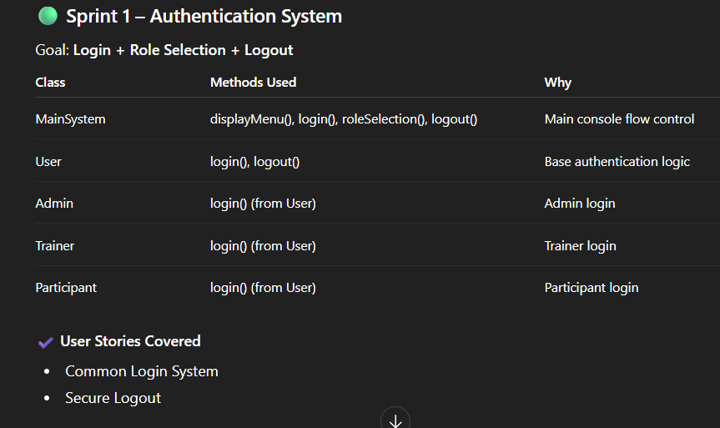
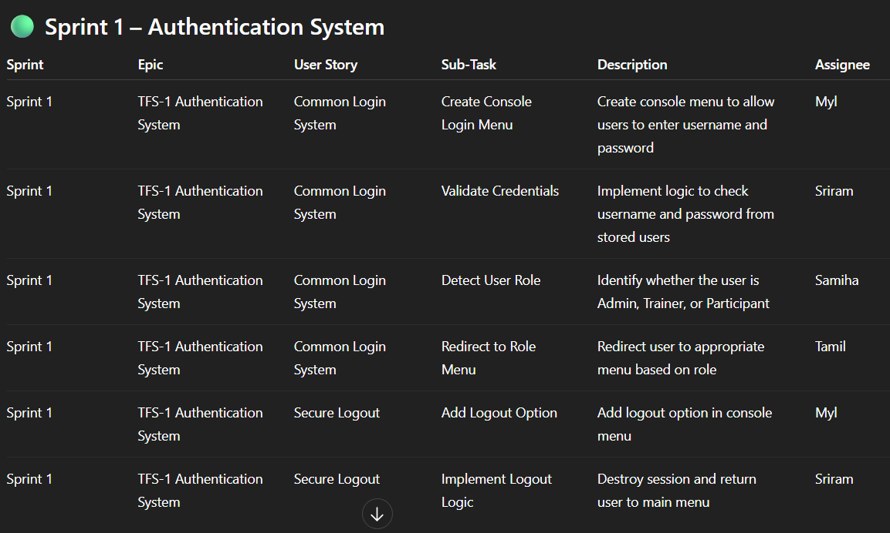

Sprint 2 – Training Session Management
Admin creates training sessions and assigns trainers.
Tasks: Create training session, store data, assign trainer, trainer views sessions.
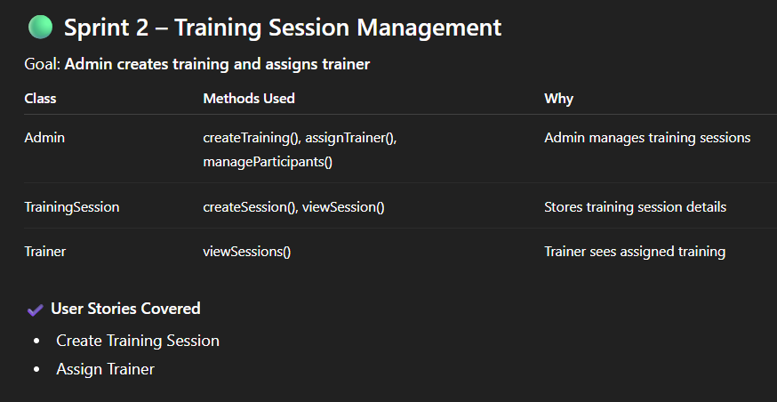
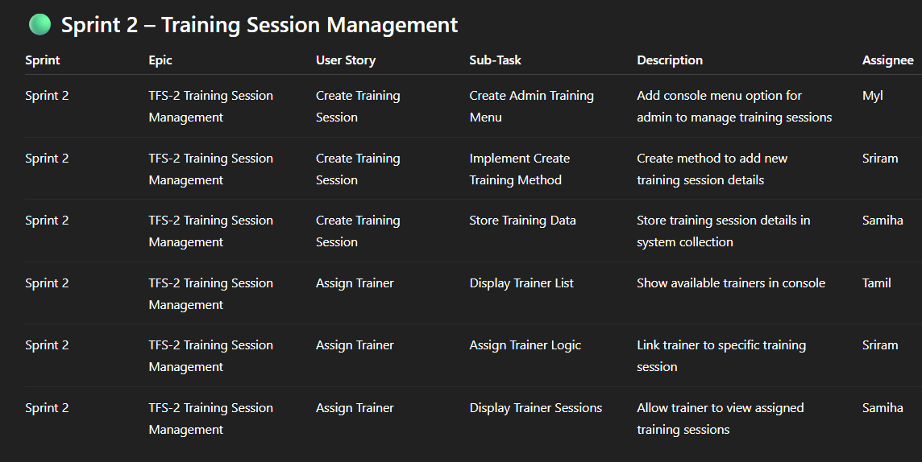

Sprint 3 – Feedback Survey System
Participants register for training and submit feedback.
Tasks: Display training sessions, register participants, submit feedback, store feedback data.
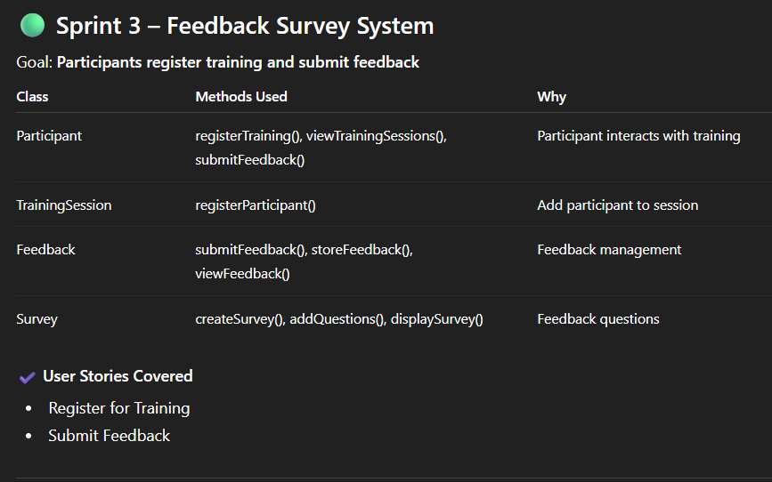
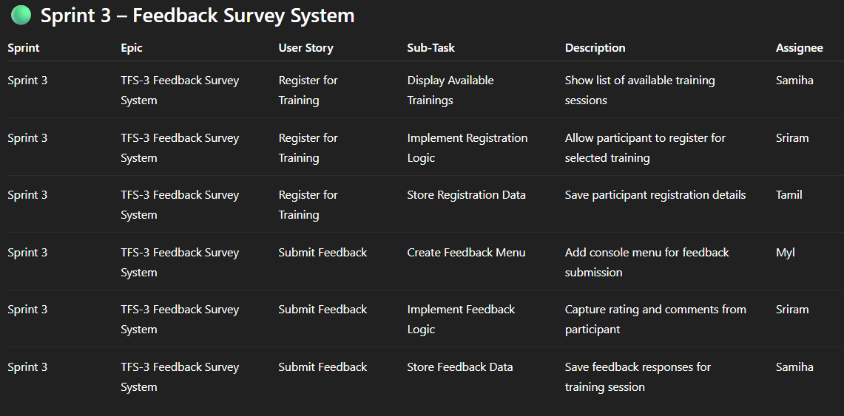

Sprint 4 – Instructor Evaluation & Reports
Participants evaluate trainers and admin generates reports.
Tasks: Trainer rating, evaluation storage, calculate ratings, generate reports.
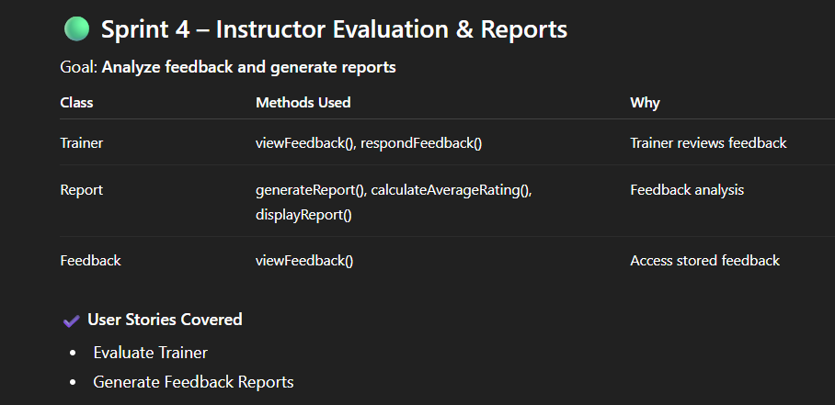
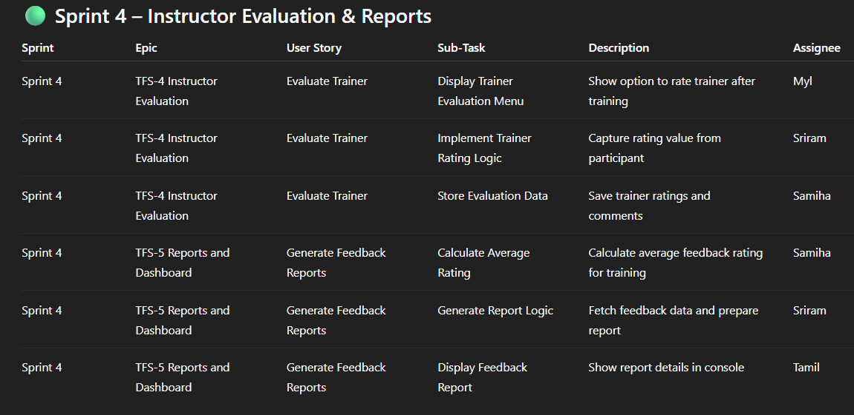

5. System Workflow
User Login
Role Identification
Admin Creates Training
Participants Register for Training
Trainer Conducts Training
Participants Submit Feedback
Instructor Evaluation
Feedback Analysis
Admin Generates Reports
Logout

6. State Diagram and class diagram

State –
https://mermaid.ai/app/projects/73c993e4-290f-46c8-b83b-862646f7267e/diagrams/efc0ffdc-7998-4c90-9e98-4b1d7fed2e11/version/v0.1/edit
class diagram –
https://mermaid.ai/d/efc0ffdc-7998-4c90-9e98-4b1d7fed2e11

