GT Username: sanne31@gatech.edu
Dataset Name: Social Circles - Facebook
Dataset Source: http://snap.stanford.edu/data/ego-Facebook.html
Description of data-source: Dataset contains information about a node having an internally generated nodeId of “0”. Has multiple files but the ones which have been used are 0.edges – naming the edges of the graph, 0.features – listing the features pertaining to the particular node and 0.featnames – having the names of the features for this particular node.
Observations:
- Edges – 5038, Nodes – 347
- Chose gender as the node attribute as it was the simplest to plot and every node would have it as an attribute => attribute value of 0 denotes female (green below) whereas a value of 1 denotes male (red below)
- Used small size nodes to show the edges clearly
- We can see that there is more red in the graph plot indicating that this node has more number of male connections/friends as compared to females.
- It is also observed that there are a few outliers which aren’t connected to other nodes.
- The connection between various nodes is also shown here.
- Code provided in ac4.R

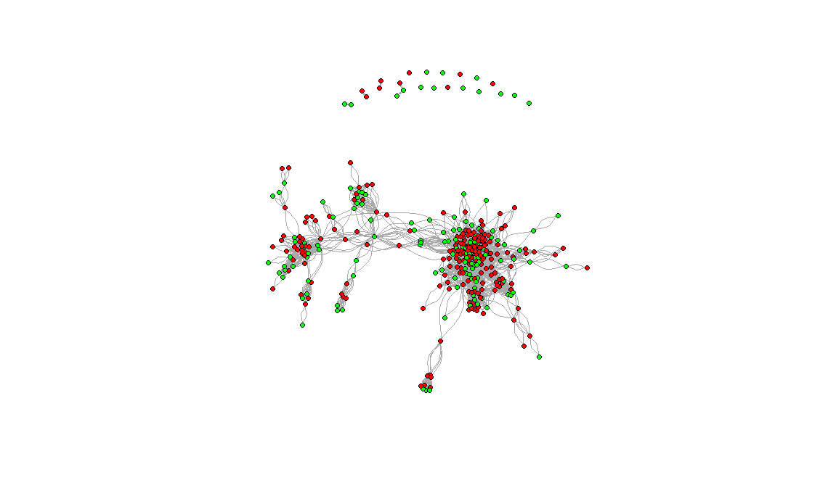
References: http://igraph.org/r/doc/degree.html , http://www.shizukalab.com/toolkits/sna/plotting-networks-pt-2,

