Login

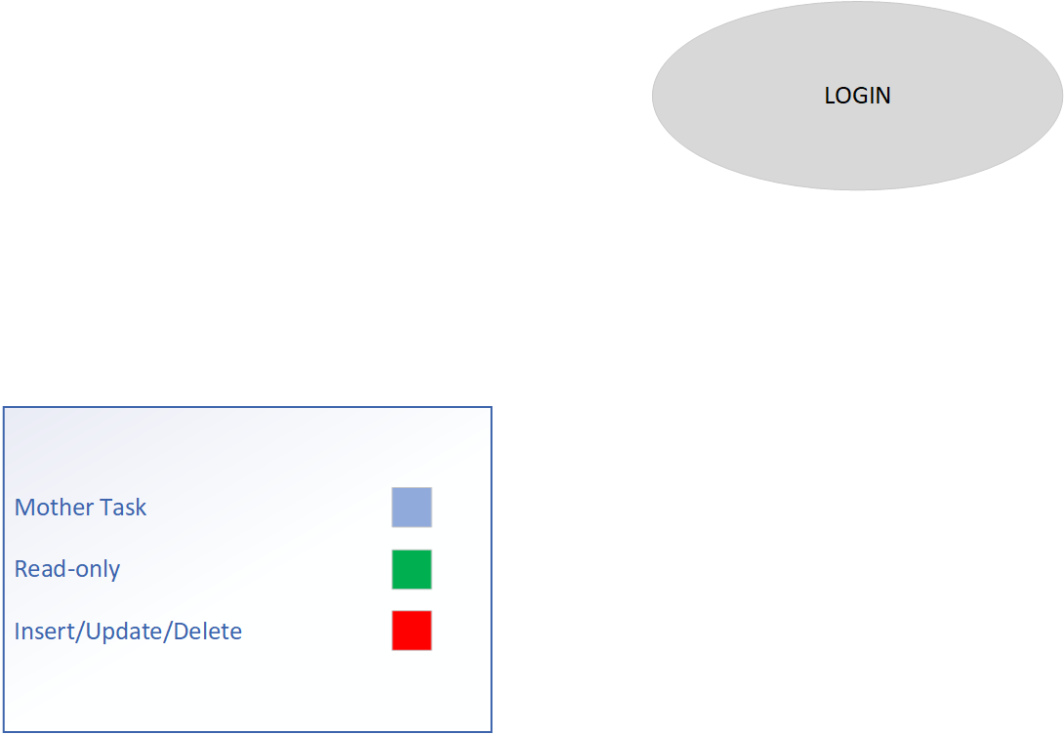

Lock-types: Read-only on Users table

Number of Locks: Single

Enabling Conditions: None

Frequency: 100 logins / day

Consistency: Not critical

Subtasks: Mother task not needed

New User Registration

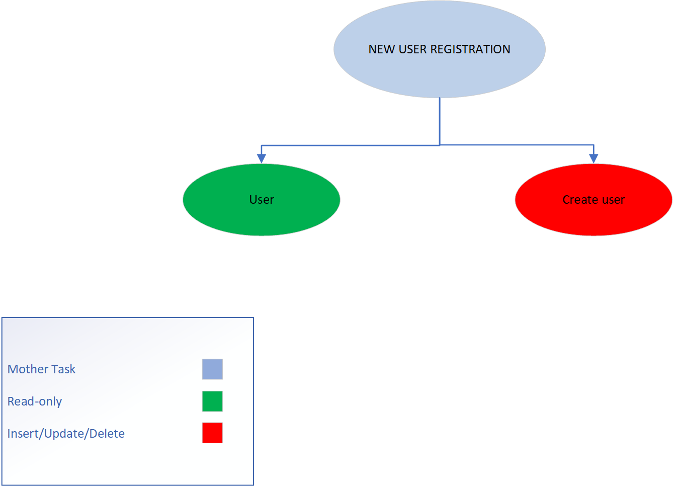

Lock-types: Lookup Users, Insert Users

Number of Locks: Single

Enabling Conditions: None

Frequency: 100 registrations / day

Consistency: Not critical

Subtasks: All tasks must be done. Mother task required to coordinate subtasks. User completes (validating user exists/doesn’t exist), then create user. In order to create user, must validate fields and passwords.

List Items

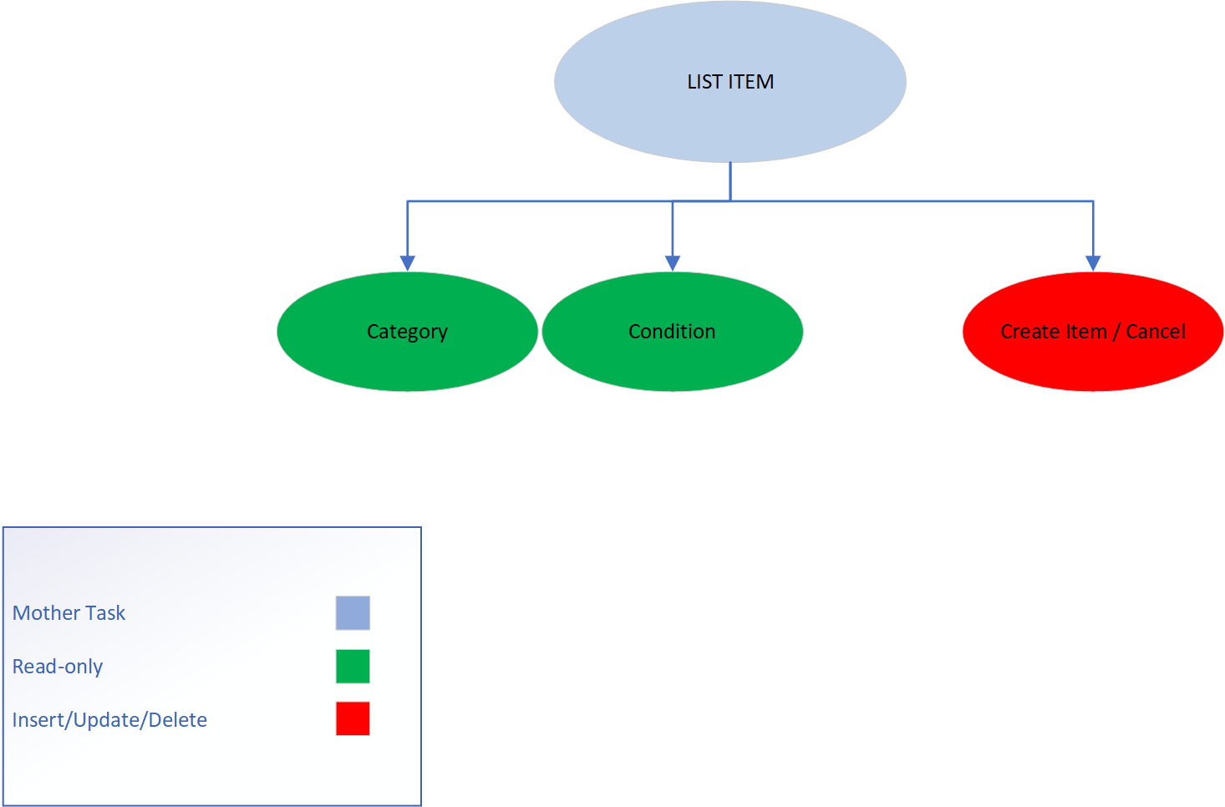

Lock-types: Read-only on Category, Condition and Insert on Item table

Number of Locks: Several different schema constructs are needed.

Enabling Conditions: Enabled by user’s login

Frequency: High Frequency

Consistency: Not critical

Subtasks: All tasks must be completed

Searching for Items

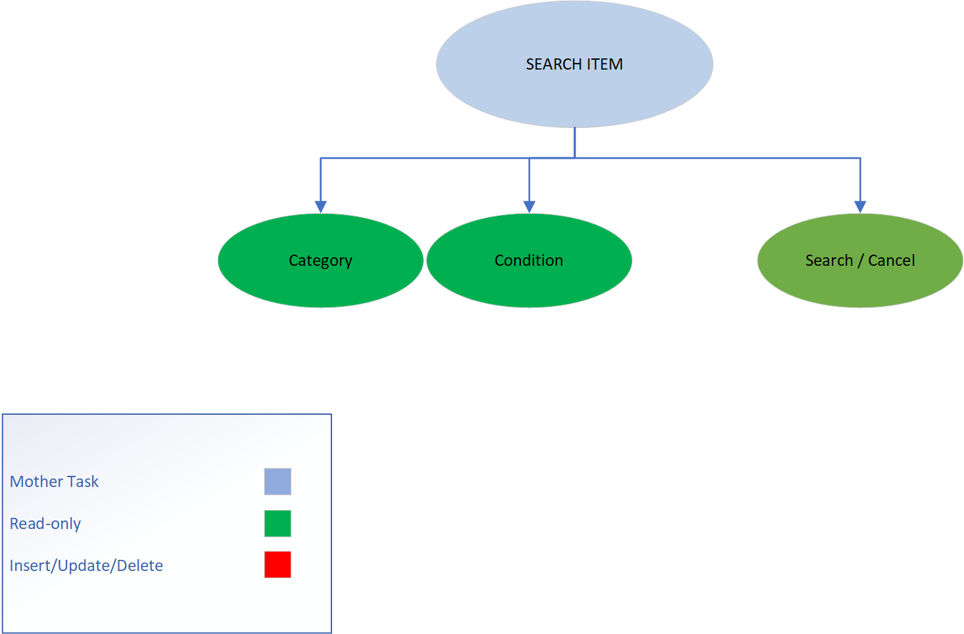

Lock-types: 3 read-only of Category, Condition, Item

Number of Locks: Several constructs needed

Enabling Conditions: User’s login

Frequency: All have same high frequency

Consistency: Not critical

Subtasks: Mother task needed for coordination of subtasks. Category/Condition can be completed in parallel prior to search/cancel

Bid

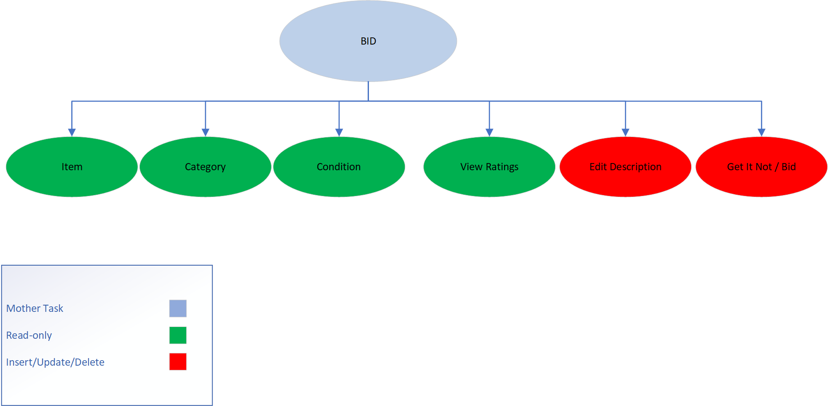

Lock-types: Multiple read-only and insert/update for Item and Bid.

Number of locks: multiple schema constructs needed

Enabling conditions: User’s login. For the edit description task, the user must be the item owner to enable the edit description prompt to be available.

Frequency: High

Consistency: Not critical

Subtasks: Mother task needed to coordinate all subtasks. Item/Category/Condition to be completed in parallel prior to any other options to be available. Edit description task does not need to be completed and is only available to the item owner.

View Ratings

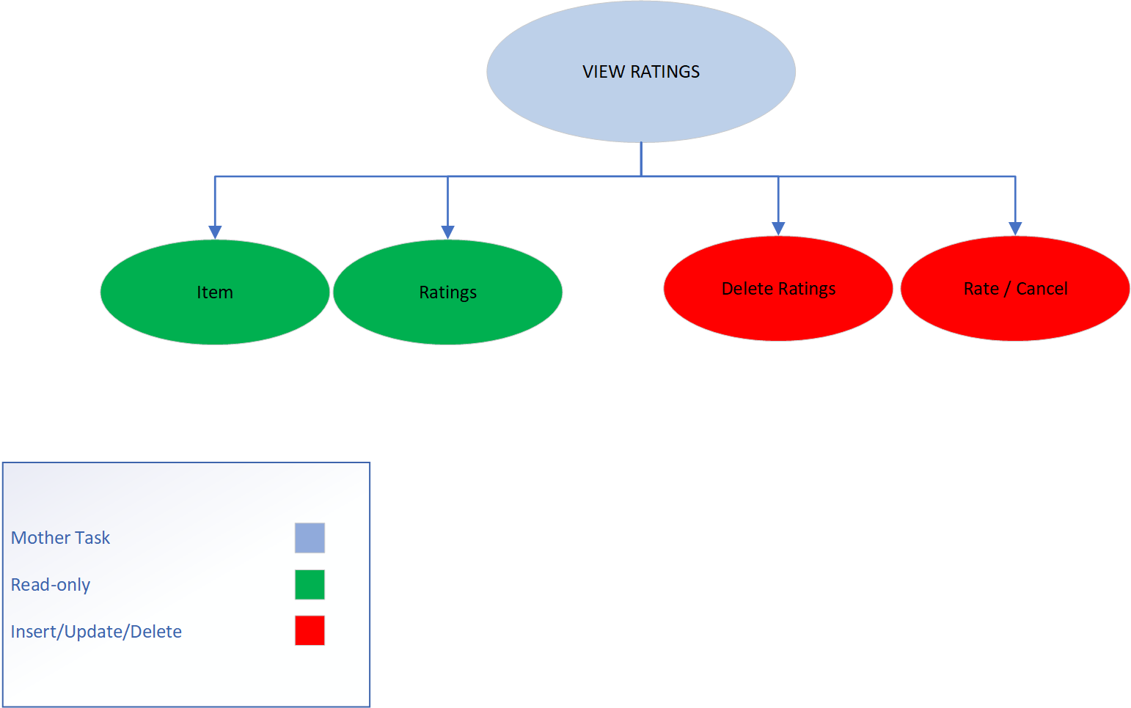

Lock-types: Read-only for Item and Ratings. Insert/Update/Delete for Ratings.

Number of locks: Multiple schema constructs needed.

Enabling Conditions: Enabled by user’s login. The delete ratings button is available only if the rating belongs to the logged in user.

Frequency: Moderate

Consistency: Not Critical

Subtasks: Mother task to coordinate subtasks. Delete ratings doesn’t need to be completed and is only available to logged in user, if user has created a rating for a specific item.

Auction Results

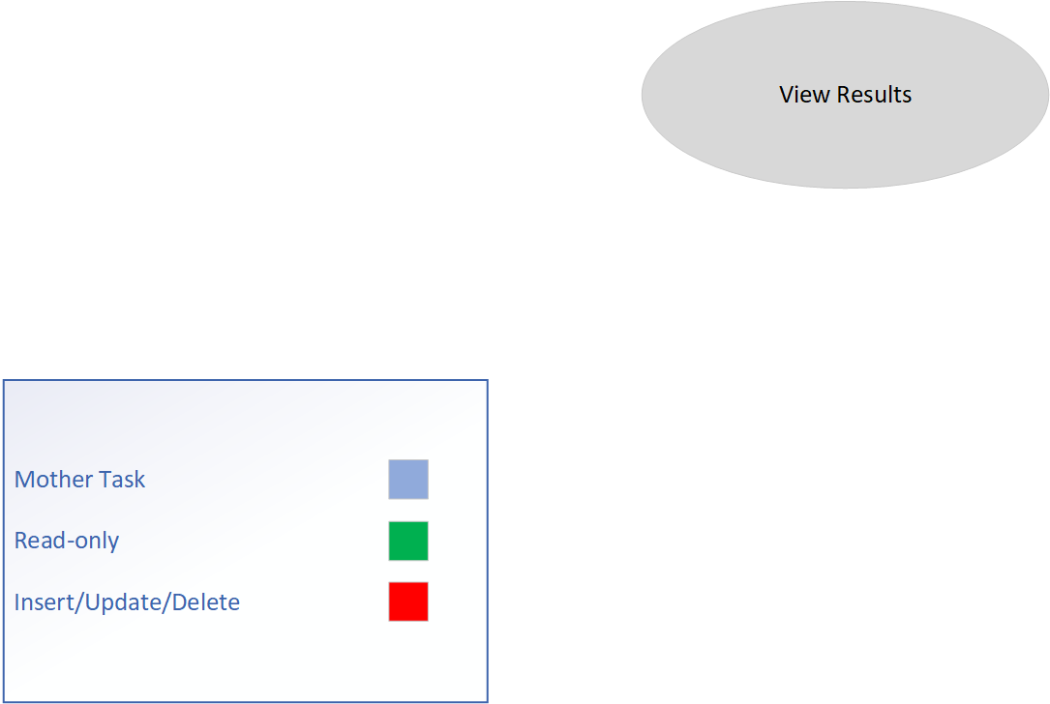

Lock-types: read-only on item/bids

Number of locks: 2

Enabling conditions: user’s login

Frequency: High

Consistency: Not critical

Subtasks: mother task not needed

Admin Reports

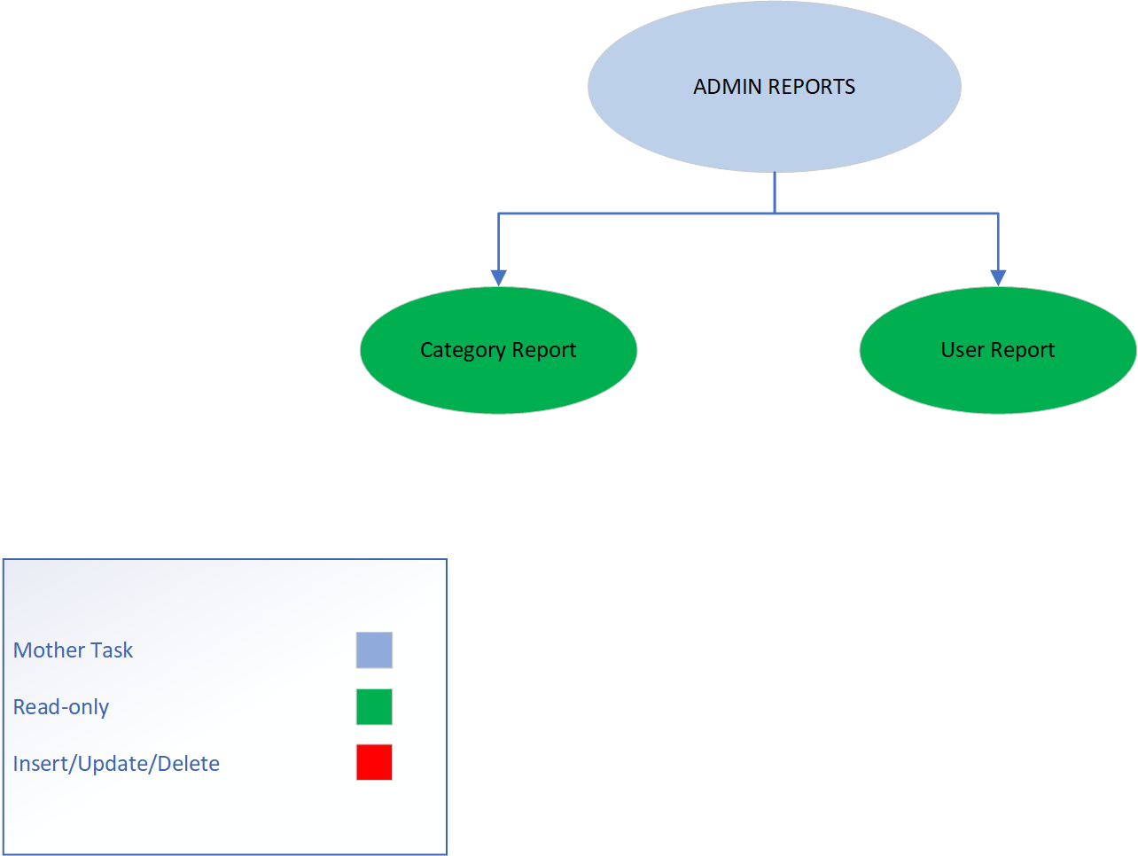

Lock-types: read-only on Item, Users, Bids, Category

Number of locks: multiple schema constructs needed

Enabling Conditions: User’s login and user must be an admin.

Frequency: Moderate

Consistency: Not critical

Subtasks: mother task not needed to complete coordinate. Both tasks do not need to be completed. Admin user logged in can view either report or both.