Conll Tree Tool

Tree Operation Tools:

Function 1:

return_index(lst, val):

Return index of all the occurrence of a node in a list.

Input: List, index_number
Output: List containing index of all the occurrence of the number.

Example:

lst = p_lst = [0,1,0,0,2,3,6,4,5,8,9,4,17,18,19,11,14,11,16,0,0,1,11,12,13]
val = 4

output = return_index(p_lst,4)
print(output)
[7,11]

Function 2:

get_ancestor((A_id,H_id,index):

Given word id and head id list of a conll tree and a particular node(index), returns the list containing all the nodes in the path to the root.

Input: A_id (List of word id), H_id (List of head id), index (node number)
Output: List containing the path to the root

Example:

Function 3:

remove_list(list1,list2):

Tree Transformation:

Example 1:

‘And Construction’

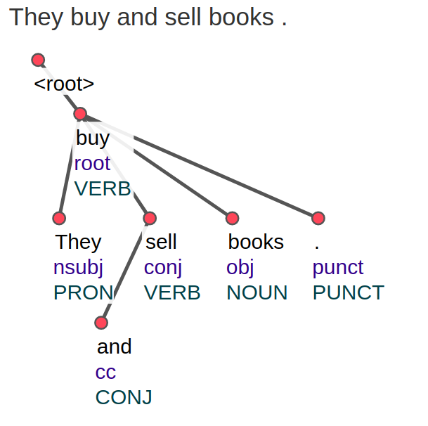

python tree-and.py and-ex1

Transformed tree is written to a file 'out'

'obl' construction:
-------------------

python tree-obl.py eng-obl-ex
python tree-obl.py hnd-obl-ex

output is given in the form of a list [[Index],[Head_id],[Relations],[Words]]

Top value and Bottom Value calculation:
-------------------

python top_bottom_value.py tb-val-ex

output is written to stdout

To convert constituency to conll format
-------------------

python constituency-to-conll.py const-conll-ex > jnk
../conllu-viewer-master/bin/conllu2svg jnk > jnk.html

To convert constituency original to indexed oneline format
-------------------

sh constituency-index.sh const-conll-ex

