MVJ COLLEGE OF ENGINEERING-BANGALORE
Fourth Semester B.E. Degree (Autonomous) Examinations, Jul/Aug 2024
MVJ22AI/CD/CG/
CS/IS41
USN

Analysis and Design of Algorithm
Computer Science and Engineering
Common to AI/CD/CG/IS
2022 Scheme
Duration: 3 Hrs. Maximum Marks: 100
Note:
- Answer all Questions in Part-A.
- Answer any five full questions in Part B choosing one full question from each module.
PART-A
Q.No. |  |  |  | Marks
1 |  | Define Algorithm. Mention their characteristics. |  | 2
2 |  | What is Order of Growth? Define Time and Space complexity. |  | 2
3 |  | What do you mean by Exhaustive search? |  | 2
4 |  | Why Divide and conquer method is needed? |  | 2
5 |  | Define Huffman Tree |  | 2
6 |  | What are the different types of Shortest Path Algorithms? |  | 2
7 |  | What is Transitive closure? |  | 2
8 |  | What are the applications of Floyd’s algorithm? |  | 2
9 |  | Define backtracking. |  | 2
10 |  | Mention the NP Hard and NP Complete Problems |  | 2
Part B
(Each Questions carries 16 Marks)
Q,No. |  |  |  | Marks
Module-1
1. | a) |  | Define asymptotic notations and explain the notations with an example. | 8
1. | b) |  | With a help of flow chart, Explain the various stages of algorithm design and analysis process. | 8
OR
2. | a) |  | Explain Mathematical analysis of non-recursive algorithm with an algorithm. | 8
2. | b) |  | Explain Worst case, Average case, and best case with an example. | 8
Module-2
3 | a) |  | Explain Quick sort algorithm with analysis and apply the same to solve the given problem  60 50 20 10 35 25 14 10 2. | 8
3 | b) |  | Explain the Maximum and Minimum problem with example and Algorithm | 8
OR
4 | a) |  | Apply insertion sort for the following inputs 35,3,12,56,62,8,44. show proper steps pictorially. | 8
 | b) |  | Explain the Strassen’s matrix multiplication explain with an example and give the analysis to show how Strassen’s matrix multiplication is better than traditional matrix multiplication | 8
Module-3
5 | a) |  | Explain the Prims and Krushkal Algorithm and apply the same to the following Graph  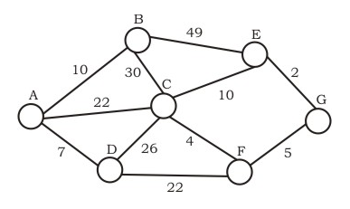 | 8
5 | b) |  | Construct a Huffman code for the following data: | 8
  Character | A | B | C | D | E | -
  Frequency | 0.5 | 0.35 | 0.5 | 0.1 | 0.4 | 0.2
OR
6 | a) |  | Apply Dijikstra’s algorithm to find single source shortest path for the graph given below. Consider Node 6 as source.  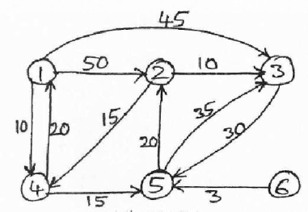 | 8
6 | b) |  | Obtain the optimal sequence of execution of job solution using greedy algorithm with n=5, profits (10, 3, 33, 11, 40) and deadlines (3, 1, 1, 2, 2). | 8
Module-4
7 | a) |  | Solve the given problem using Floyd’s algorithm, write the algorithm  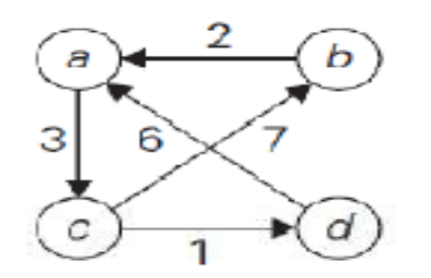 | 8
7 | b) |  | Explain Multistage graphs with example. Write multistage graph algorithm using forward approach. | 8
OR
8 | a) |  | Define transitive closure of a graph. Apply Warshalls algorithm to compute transitive closure of a directed graph  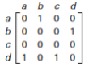 | 8
8 | b) |  | Construct an optimal binary search tree for the following four–key set | 8
  Key | A | B | C | D
  Probability | 0.1 | 0.2 | 0.3 | 0.4
Module-5
9 | a) |  | Solve assignment problem for the following job assignment and obtain optimal solution  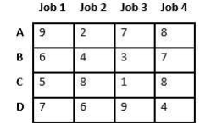 | 8
9 | b) |  | Write an algorithm using recursion for N queen problem solve for 8 Queens using backtracking method. | 8
OR
10 | a) |  | What is sum of subset problem? Consider the set S= {1,2,3,4} find the sum M=4 using backtracking technique. | 8
10 | b) |  | Find the maximum profit for the given object using Branch and Bound knapsack problem with backtracking approach  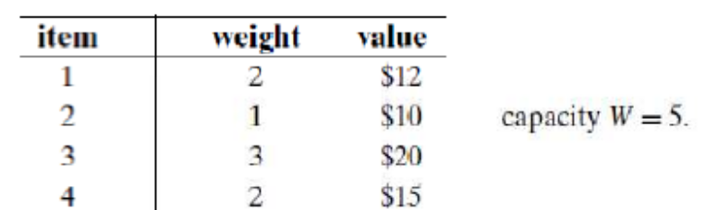 | 10

