MVJ COLLEGE OF ENGINEERING-BANGALORE
Fourth Semester B.E. Degree (Autonomous) Examinations, Jul/Aug 2024
MVJ22CG/CS452
USN

Graph Theory
Computer Science Engineering
Common to Computer Science and Design
2022 Scheme
Duration: 3 Hrs. Maximum Marks: 100
Note:
- Answer all Questions in Part-A.
- Answer any five full questions in Part B choosing one full question from each module.
PART-A
Q.No. |  |  | Marks
1 | A cycle of $n$ vertices is isomorphic to its complement. The value of $n$ is _________. |  | 1
2 | A graph is ____________ if it has at least one pair of vertices without a path between them. |  | 1
3 | The maximum number of leaves in a full 3-ary tree of height 4 can be ______. |  | 1
4 | If a simple graph $G,$ contains $n$ vertices and $m$ edges, then the number of edges in the graph complement of $G$ is __________. |  | 1
5 | If a connected planar simple graph has 17 edges and its planar representation divides the planar into 10 regions, then the number of vertices is _________. |  | 2
6 | Arrange the following simple graphs based on number of spanning tree they have:  - $K_{3}$ (Complete graph with 3 nodes)  - $K_{4}$ (Complete graph with 4 nodes)  - $K_{2, 2}$ (Complete bipartite graph of the 2 nodes in each partition)  - $C_{5}$ (Cycle graph of 5 nodes) |  | 2
7 | In how many ways can 12 different books be distributed among four children so that the two of the oldest children get four books each and the two youngest get two books each? |  | 2
8 | Suppose that a cookie shop has four different kinds of cookies. How many different ways can six cookies be chosen? |  | 2
9 | Let $a_{n}=2a_{n-1}, a_{0}=3$. Then the value of $a_{29}$ is ____. |  | 2
10 | There are 5 groups in a picnic who has brought their own lunch box, and then the 5 lunch boxes are exchanged within those groups. Determine the number of ways that they can exchange the lunch box such that none of them can get their own. |  | 2
11 | The generation function of the sequence $(1, λ, λ^{2}, λ^{3},…)$ is __________. |  | 2
12 | The generating function of the Fibonacci sequence is _______. |  | 2
Part B
Each Questions carries 16 Marks
Q,No. |  |  | Marks
Module-1
1. | a) | Define the graph isomorphism and hence verify whether the following graphs are isomorphic to each other.  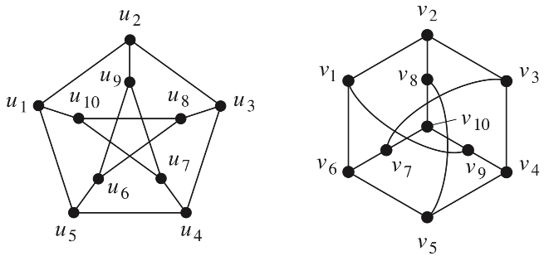  Fig 1 Fig 2 | 8
1. | b) | - Define Euler trail and Euler circuit with an example.  - Prove that if G is a connected graph and every vertex has even degree, then there is a Euler circuit in G. | 8
OR
2 | a) | Prove that in any graph G, there is a $u-v$ trail if and only if there is a $u-v$ path. | 4
2 | b) | Prove that a simple graph with $n$ vertices can have maximum $\frac{1}{2}n(n-1)$ edges. | 4
 | c) | Define (i) Connected graph (ii) Euler’s and Hamiltonian graphs with examples and hence show that the connected graph with a cycle remains connected if we remove an edge from the cycle. | 8
Module-2
3 | a) | Apply Dijkstra’s algorithm to the weighted digraph shown below in Fig 4, to find the shortest distance and shortest path from the vertex $a$ to $z$.  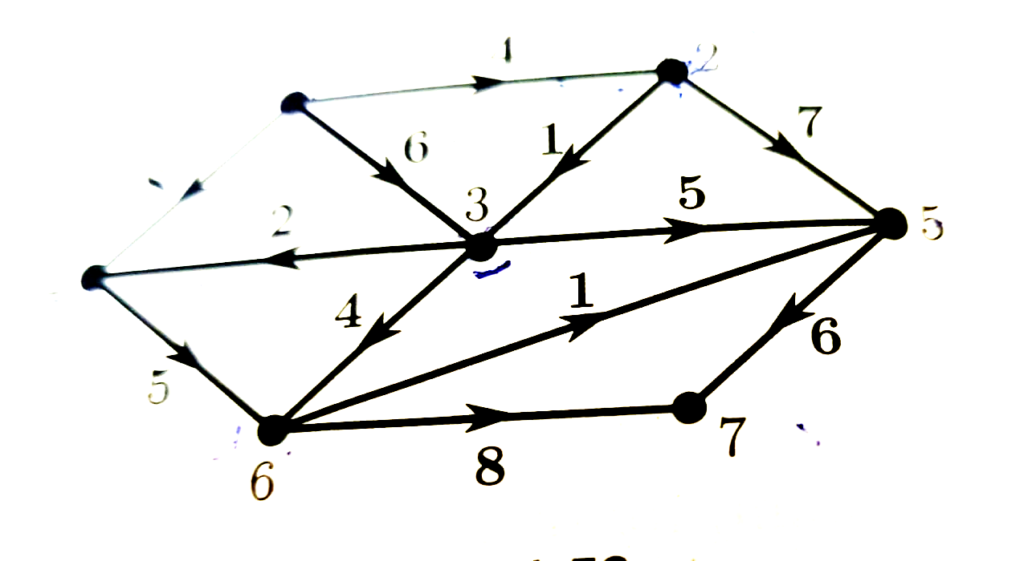  Fig 4 | 8
3 | b) | Construct an optimal prefix code for the symbols $a, o, q, u, y, z$that occur with the frequencies $20, 28, 4, 17, 12, 7,$ respectively. | 4
 | c) | Prove that a tree with ‘n’ vertices has n-1 edges | 4
OR
4 | a) | Apply the merge sort for the following sequence: $-1, 7, 4, 11, 5, -8, 15, -3, -2, 6, 10, 3.$ | 5
 | b) | Define m-ary tree, Binary tree, balanced tree, full binary tree with an example. | 5
 | c) | Write a note on konigsberg bridge problem and its solution. | 6
Module-3
5 | a) | A woman has 11 close relatives and she wishes to invite 5 of them for dinner. In how many ways she can invite them in following situations?  - There is no restriction on choice.  - Two particular people will not attend together  - Two Particular person will attend separately. | 8
5 | b) | How many arrangements are there of the letters in SOCIOLOGICAL?  - In how many of these arrangements A and G are adjacent?  - In how many of these arrangements all vowels are adjacent? | 8
OR
6 | a) | How many positive integers ‘n’ can we form using the digits 3,4,4,5,5,6,7 if we want ‘n’ to exceed 5,000,000? | 5
6 | b) | Obtain the coefficient of $a^{2}b^{3}c^{2}d^{5}$ in the expansion of ${\left(a+2b-3c+2d+5\right)}^{16}$. | 5
6 | c) | Find the number of arrangements of all the letters ‘TALLAHASSEE’. How many of these arrangements have no adjacent ‘A’s. | 6
Module-4
7 | a) | A total of 1232 students have taken a course in Spanish, 879 have taken a course in French, and 114 have taken a course in Russian. Further, 103 have taken courses in both Spanish and French, 23 have taken courses in both Spanish and Russian, and 14 have taken courses in both French and Russian. If 2092 students have taken at least one of Spanish, French, and Russian, then determine the number of students who have taken a course in:  - All three languages.  - Spanish and French, but not Russian  - Exactly one of the languages. | 8
7 | b) | - List all the derangements of $1, 2, 3, 4, 5$ where the first three numbers are $1, 2$ and 3, in some order.  - List all derangements of $1, 2, 3, 4, 5, 6$ where last three numbers are $4, 5$ and $6$ in some order. | 8
OR
8 | a) | Among 50 patients admitted to a hospital, 25 are diagnosed with pneumonia, 30 with bronchitis, and 10 with both pneumonia and bronchitis. Determine:  - The number of patients diagnosed with pneumonia or bronchitis (or both).  - The number of patients not diagnosed with pneumonia or bronchitis  - The number of patients not diagnosed with bronchitis.  - The number of patients diagnosed with only pneumonia. | 8
8 | b) | Find the rook polynomial for the board:  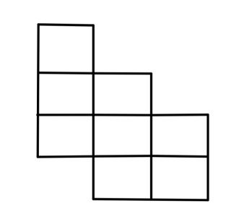 | 8
Module-5
9 | a) | Solve that recurrence relation $a_{n}=4a_{n-1}-4a_{n-2}$ subject to initial conditions $a_{0}=0, a_{1}=1.$ | 10
9 | b) | Use generating function to solve the recurrence relation:  $a_{k}=2 a_{k-1}, k≥1$ and initial condition $a_{0}=2.$ | 6
OR
10 | a) | The number of virus affected files in a system is 1000(to start with) and this increases every two hours. Use a recurrence relation to determine the no of virus affected files in a system after one day, | 8
10 | b) | Use generating function to solve the recurrence relation:  $a_{n}=8a_{n-1}+{10}^{n-1}, a_{0}=1.$ | 8

