**23BAI1117 – BCSE103E – Java**

**10/09/2024 – Day10**

<https://github.com/sriram-s-23BAI1117/javap>

1)

package pack;

public class A {

    void msg(){

        System.out.println("Hello");

    }

}

package mypack;

import pack.*;

public class B {

    public static void main(String[] args) {

        A obj = new A();

        obj.msg();//error

    }

}

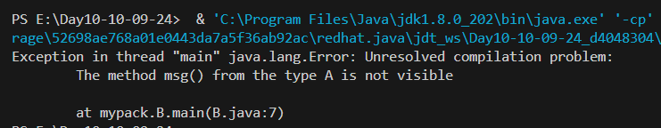

2)

package pack;

public class A2 {

    protected void msg(){

        System.out.println("Hello");

    }

}

package mypack;

import pack.*;

public class B2 extends A2 {

    public static void main(String[] args) {

        B2 obj = new B2();

        obj.msg();

    }

}

