**23BAI1117 – BCSE103E – Java**

**08/10/2024 – Day14**

<https://github.com/sriram-s-23BAI1117/javap>

1)

package mypack01;

class Package_Ex1{

    public static void main(String[] args) {

        System.out.println("This is my package!");

    }

}

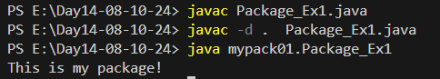

2)

package pack;

public class A {

    public void msg(){

        System.out.println("Hello");

    }

}

package mypack;

import pack.*;

public class B {

    public static void main(String[] args) {

        A obj = new A();

        obj.msg();

    }

}

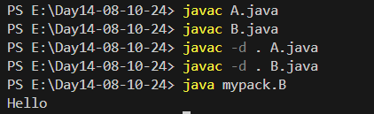

3)

package com.javatpoint.core;

public class Simple {

    public static void main(String[] args) {

        System.out.println("Hello subpackage");

    }

}

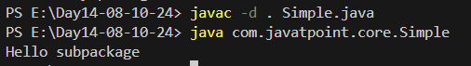

4)

package mypack02;

public class Simple2 {

    public static void main(String[] args) {

        System.out.println("Welcome to package");

    }

}

