**23BAI1117 – BCSE103E – Java**

**03/09/2024 – Day9**

<https://github.com/sriram-s-23BAI1117/javap>

1)

import java.time.LocalDateTime;

import java.time.format.DateTimeFormatter;

public class DateTimeEx1 {

    public static void main(String[] args) {

        LocalDateTime myDateObj = LocalDateTime.now();

        System.out.println("Before formatting: " + myDateObj);

        DateTimeFormatter myFormatObj = DateTimeFormatter.ofPattern("dd-MM-yyyy HH:mm:ss");

        String formattedDate = myDateObj.format(myFormatObj);

        System.out.println("After formatting: " + formattedDate);

    }

}

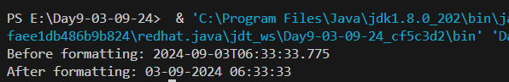

2)

class Employee {

    float salary = 40000;

}

class Programmer extends Employee {

    int bonus = 10000;

}

public class InheritanceEx1 {

    public static void main(String[] args) {

        Programmer p = new Programmer();

        System.out.println("Programmer salary is: " + p.salary);

        System.out.println("Bonus of Programmer is: " + p.bonus);

    }

}

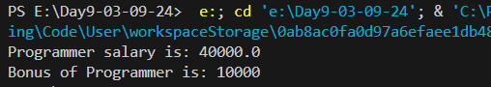

3)

class Animal {

    void eat() {

        System.out.println("eating...");

    }

}

class Dog extends Animal {

    void bark() {

        System.out.println("barking...");

    }

}

class BabyDog extends Dog {

    void weep() {

        System.out.println("weeping...");

    }

}

public class InheritanceEx2 {

    public static void main(String[] args) {

        BabyDog d = new BabyDog();

        d.weep();

        d.bark();

        d.eat();

    }

}

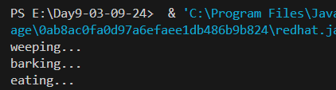

4)

class Animal {

    void eat() {

        System.out.println("eating...");

    }

}

class Dog extends Animal {

    void bark() {

        System.out.println("barking...");

    }

}

class Cat extends Animal {

    void meow() {

        System.out.println("meowing...");

    }

}

public class InheritanceEx3 {

    public static void main(String[] args) {

        Cat c = new Cat();

        c.meow();

        c.eat();

        System.out.println();

        Dog d = new Dog();

        d.bark();

        d.eat();

    }

}

