**23BAI1117 – BCSE103E – Java**

**30/09/2024 – Day10 – Theory**

**Exercises**

<https://github.com/sriram-s-23BAI1117/javap>

1. You are given the heights of consecutive buildings. You can move from the roof of a

building to the roof of the next adjacent building. You need to find the maximum number

of consecutive steps you can put forward such that you gain an increase in altitude with

each step.

**Code:**

import java.util.Scanner;

//consecutive increase

public class Ex1_30_9{

    public static void main(String[] args) {

        Scanner input = new Scanner(System.in);

        int n = input.nextInt();

        int[] arr = new int[n];

        for (int i=0;i<n;i++){

            arr[i] = input.nextInt();

        }

        int curc=0;

        int maxc=0;

        int i=0;

        while (i<n-1){

            curc=0;

            while (i<n-1 && arr[i]<arr[i+1]){

                curc++;

                i++;

            }

            if (curc > maxc){

                maxc=curc;

            }

            i++;

        }

        System.out.println(maxc);

        input.close();

    }

}

**Output:**

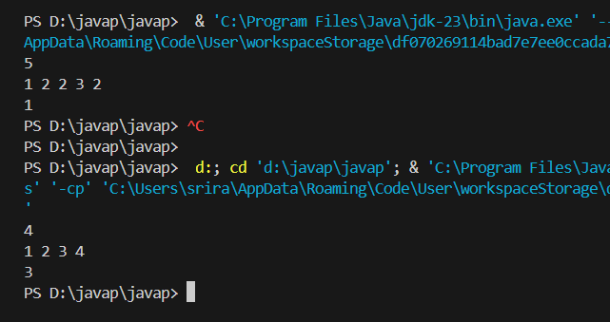

2. Given a singly linked list of integers. The task is to check if the given linked list is

palindrome or not.

Note: You should not use the recursive stack space as well

**Code:**

import java.util.Scanner;

//palindrome

class Node{

    int data;

    Node next;

    Node(){

        data=0;

        next=null;

    }

    Node(int x){

        data=x;

        next=null;

    }

}

public class Ex2_30_9 {

    public static void main(String[] args) {

        Scanner input = new Scanner(System.in);

        int n = input.nextInt();

        Node head = new Node();

        Node d = head;

        for (int i=0;i<n;i++){

            Node temp = new Node(input.nextInt());

            d.next = temp;

            d = temp;

        }

        input.close();

        Node copy = new Node();

        for (Node i=head.next; i!=null; i=i.next){

            Node t = new Node();

            t.data=i.data;

            t.next = copy;

            copy = t;

        }

        Node j=head.next;

        Node k=copy;

        while (j!=null && k!=null){

            if (j.data != k.data){

                System.out.println(false);

                return;

            }

            j=j.next;

            k=k.next;

        }

        System.out.println(true);

    }

}

**Output:**

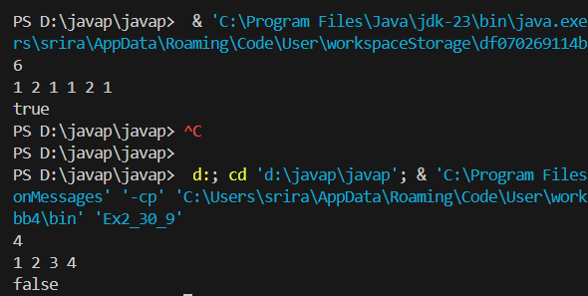

3. Given two strings **s** and **p**. Find the smallest window in the string **s** consisting of all the

characters(**including duplicates**) of the string **p**. Return "**-1**" in case there is no such

window present. In case there are multiple such windows of same length, return the one

with the **least starting index**.

**Note** : All characters are in Lowercase alphabets.

**Code:**

import java.util.Scanner;

public class Ex3_30_9 {

    public static String smallestWindow(String s, String p) {

        if (s.length() < p.length()) {

            return "-1";

        }

        int[] pCnt = new int[26];

        for (char c : p.toCharArray()) {

            pCnt[c - 'a']++;

        }

        int[] windowCnts = new int[26];

        int required = 0;

        for (int count : pCnt) {

            if (count > 0) required++;

        }

        int l = 0, r = 0, formed = 0;

        int minLen = 100001;

        int minLeft = 0;

        while (r < s.length()) {

            char c = s.charAt(r);

            windowCnts[c - 'a']++;

            if (pCnt[c - 'a'] > 0 && windowCnts[c - 'a'] == pCnt[c - 'a']) {

                formed++;

            }

            while (l <= r && formed == required) {

                c = s.charAt(l);

                if (r - l + 1 < minLen) {

                    minLen = r - l + 1;

                    minLeft = l;

                }

                windowCnts[c - 'a']--;

                if (pCnt[c - 'a'] > 0 && windowCnts[c - 'a'] < pCnt[c - 'a']) {

                    formed--;

                }

                l++;

            }

            r++;

        }

        return minLen == Integer.MAX_VALUE ? "-1" : s.substring(minLeft, minLeft + minLen);

    }

    public static void main(String[] args) {

        Scanner input = new Scanner(System.in);

        String s1 = input.next();

        String p1 = input.next();

        input.close();

        System.out.println(smallestWindow(s1, p1));

    }

}

**Output:**

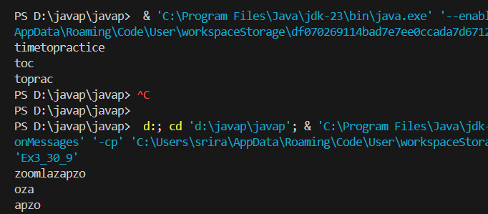

4. Given an unsorted array ***arr*** of positive integers. One number '**A**' from set {1, 2,....,n}

is missing and one number '**B**' occurs twice in array. Find numbers **A** and **B**.

**Note:** The test cases are generated such that there always exists one missing and one repeating

number within the range **[1,n]**.

**Code:**

import java.util.Scanner;

public class Ex4_30_9 {

    public static void findMissingAndRepeating(int[] arr) {

        int n = arr.length;

        int repeating = -1;

        int missing = -1;

        for (int i = 0; i < n; i++) {

            int index = Math.abs(arr[i]) - 1;

            if (arr[index] < 0) {

                repeating = Math.abs(arr[i]);

            } else {

                arr[index] = -arr[index];

            }

        }

        for (int i = 0; i < n; i++) {

            if (arr[i] > 0) {

                missing = i + 1;

                break;

            }

        }

        System.out.println(repeating+" "+missing);

    }

    public static void main(String[] args) {

        Scanner scanner = new Scanner(System.in);

        int n = scanner.nextInt();

        int[] arr = new int[n];

        for (int i = 0; i < n; i++) {

            arr[i] = scanner.nextInt();

        }

        findMissingAndRepeating(arr);

        scanner.close();

    }

}

**Output:**

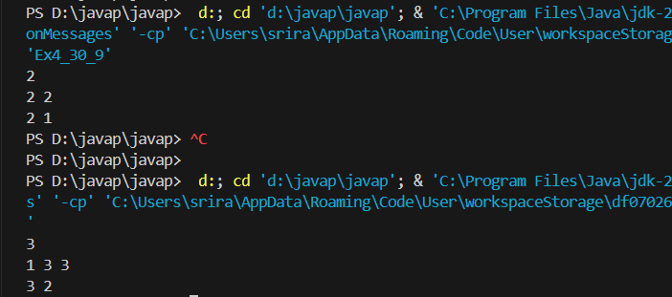

5. Given a string of characters, find the length of the longest proper prefix which is also a

proper suffix.

**NOTE:** Prefix and suffix can be overlapping but they should not be equal to the entire string.

**Code:**

import java.util.Scanner;

public class Ex5_30_9 {

    public static int longestPrefixSuffix(String str) {

        int n = str.length();

        int[] lps = new int[n];

        int length = 0;

        int i = 1;

        while (i < n) {

            if (str.charAt(i) == str.charAt(length)) {

                length++;

                lps[i] = length;

                i++;

            } else {

                if (length != 0) {

                    length = lps[length - 1];

                } else {

                    lps[i] = 0;

                    i++;

                }

            }

        }

        return lps[n - 1];

    }

    public static void main(String[] args) {

        Scanner scanner = new Scanner(System.in);

        String str = scanner.nextLine();

        int result = longestPrefixSuffix(str);

        System.out.println(result);

        scanner.close();

    }

}

**Output:**

