**23BAI1117 – BCSE103E – Java**

**12/08/2024 – Day4 – Theory**

<https://github.com/sriram-s-23BAI1117/javap>

1)

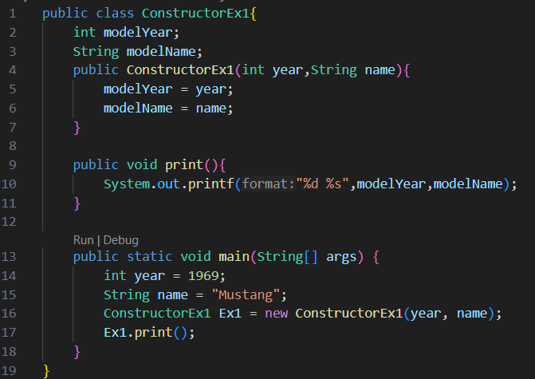

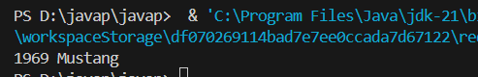

2)

