**23BAI1117 – BCSE103E – Java**

**19/08/2024 – Exercise**

<https://github.com/sriram-s-23BAI1117/javap>

1) Print Odd Numbers at Even Index using Java.

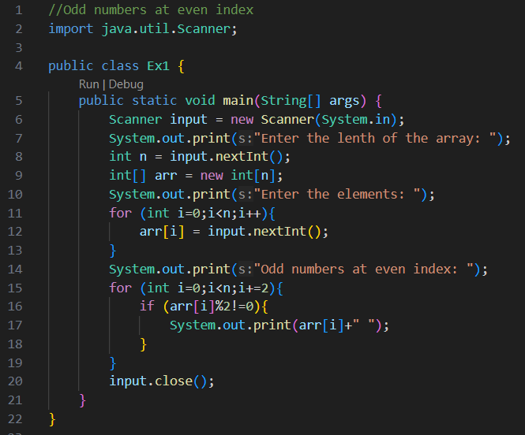

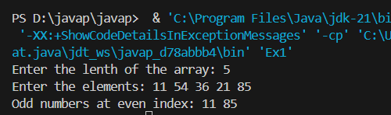

2) Write a Java program to find all pairs of elements in an array whose sum is equal to a specified number.

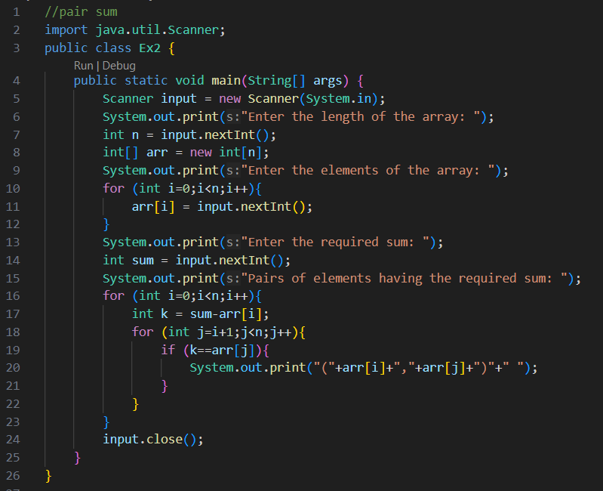

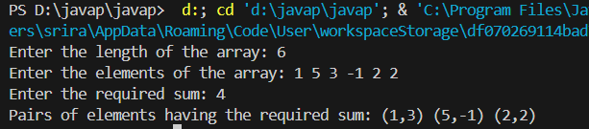

3) Write a Java program to move all 0's to the end of an array. Maintain the relative order of the other (non-zero) array elements.

