**23BAI1117 – BCSE103E – Java**

**02/09/2024 – Day6 – Theory**

<https://github.com/sriram-s-23BAI1117/javap>

1)

interface FirstInterface {

    public void myMethod();

}

interface SecondInterface {

    public void my2ndMethod();

}

interface ThirdInterface{

    public void my3rdMehtod();

}

class DemoClass implements FirstInterface,SecondInterface,ThirdInterface{

    public void myMethod(){

        System.out.println("Some text..");

    }

    public void my2ndMethod(){

        System.out.println("Some other text from interface 2..");

    }

    public void my3rdMehtod(){

        System.out.println("Some text from 3rd interface");

    }

}

public class MultipleInterfaceEx1{

    public static void main(String[] args) {

        DemoClass myObj = new DemoClass();

        myObj.myMethod();

        myObj.my2ndMethod();

        myObj.my3rdMehtod();

    }

}

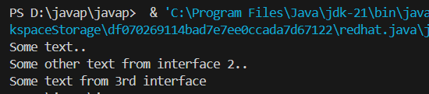

2)

enum Level{

    LOW,

    MEDIUM,

    HIGH

}

public class EnumEx1 {

    public static void main(String[] args) {

        Level myVar = Level.MEDIUM;

        System.out.println(myVar);

    }

}

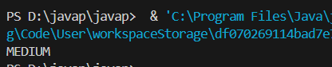

3)

public class EnumEx2 {

    enum Level{

        LOW,

        MEDIUM,

        HIGH

    }

    public static void main(String[] args) {

        Level myVar = Level.MEDIUM;

        switch (myVar) {

            case LOW:

                System.out.println("Low level");

                break;

            case MEDIUM:

                System.out.println("Medium level");

                break;

            case HIGH:

                System.out.println("High level");

                break;

            default:

                break;

        }

    }

}

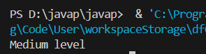

4)

public class EnumEx3 {

    enum Level{

        LOW,

        MEDIUM,

        HIGH

    }

    public static void main(String[] args) {

        for (Level myVar : Level.values()){

            System.out.println(myVar);

        }

    }

}

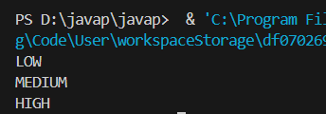

5)

import java.time.LocalDate;

public class DateEx1 {

    public static void main(String[] args) {

        LocalDate myObj = LocalDate.now();

        System.out.println(myObj);

    }

}

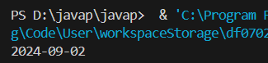

6)

import java.time.LocalTime;

public class DateEx2 {

    public static void main(String[] args) {

        LocalTime myObj = LocalTime.now();

        System.out.println(myObj);

    }

}

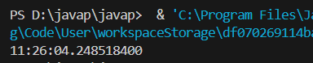

7)

import java.time.LocalDateTime;

public class DateEx3 {

    public static void main(String[] args) {

        LocalDateTime myObj = LocalDateTime.now();

        System.out.println(myObj);

    }

}

