Case study: Natural language queries in EBS
Proof-of-concept projects that demonstrate GenAI capabilities in EBS.

Technology: The solution leverages an Oracle Application Express (APEX) application embedded within EBS, which calls Oracle Cloud Infrastructure (OCI) Generative AI services to interpret user requests.

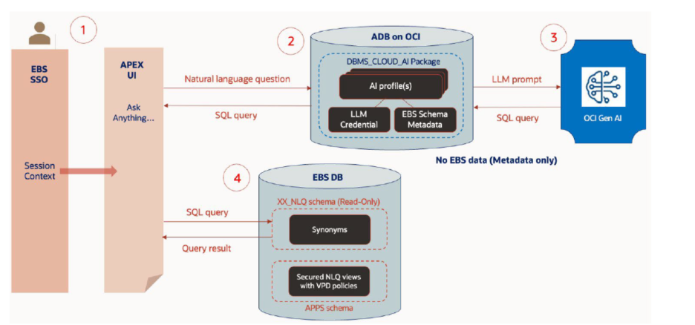
Oracle’s new prototype solution integrates OCI Generative AI with Oracle E-Business Suite (EBS) 12.2 to allow users to run natural language queries (NLQ) on EBS data. It uses an Oracle APEX application embedded in EBS, which sends user questions (e.g., “show delayed work orders”) to an Autonomous Database (ADB), which in turn uses Oracle’s Select AI to call an LLM that generates the correct SQL. The SQL runs on the EBS DB and returns results instantly—no SQL knowledge needed.

The use case: This integration allows EBS 12.2 users to pose questions about their data using natural language, like "What are our sales figures for the last quarter?" The OCI Generative AI then translates this request into a secure SQL query to retrieve information from the EBS system.

The benefit: This provides users with conversational access to their EBS data without requiring specialized SQL knowledge.
Key use cases for GenAI in Oracle EBS
Beyond natural language querying, the integration with Oracle's cloud AI services can enable several other generative AI use cases for EBS:
- Automated invoice processing: AI can efficiently extract and verify information from invoices, reducing manual data entry and errors.
- Intelligent chatbots: These AI-powered assistants can offer 24/7 support for common user questions across different EBS modules.
- Document generation: AI can automatically produce standard documents—such as policy manuals, contracts, or compliance reports—using data directly from EBS.
- Enhanced reporting: For financial and other reports, GenAI can automatically provide detailed narratives that explain variances or summarize key insights.
How generative AI is integrated with EBS
Since EBS does not have native generative AI capabilities, organizations bridge the gap using Oracle Cloud Infrastructure (OCI) and other technologies.
Using OCI services: Integrators use OCI's Generative AI and Autonomous Database services, which communicate with the on-premises EBS system via APIs or middleware.
The RAG approach: This is often done using a Retrieval-Augmented Generation (RAG) approach, where the large language model (LLM) pulls data from EBS to provide up-to-date, relevant, and accurate responses.

