# Introduction

The document details the steps to be followed to generate API Key to be used by Wei product. The product supports Google and Bing translator. The translator to be used is configurable and the user can specify in the configuration file the translator to be used.

If the choice of translator is Bing then follow the steps documented below.

# Details

The section below gives steps to be followed to generate the Bing API key.

1. Go to the url <http://www.bing.com/developers>, following screen will be displayed.

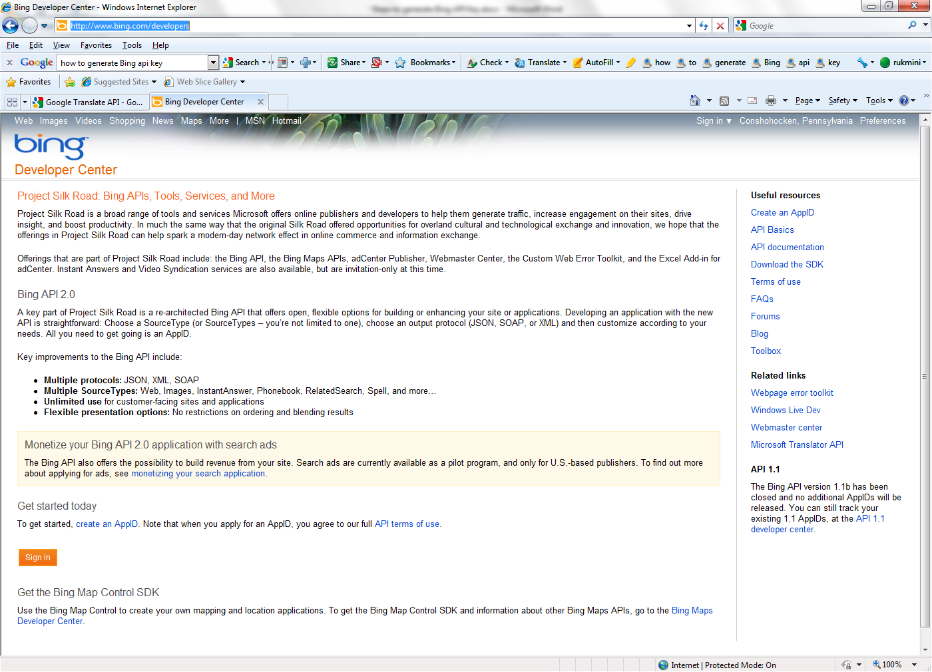

1. Click on the link “Create an AppId” link on the right hand side. The following screen will be displayed. If you have a windows live id, enter the username and password and click on the “Sign In” button.

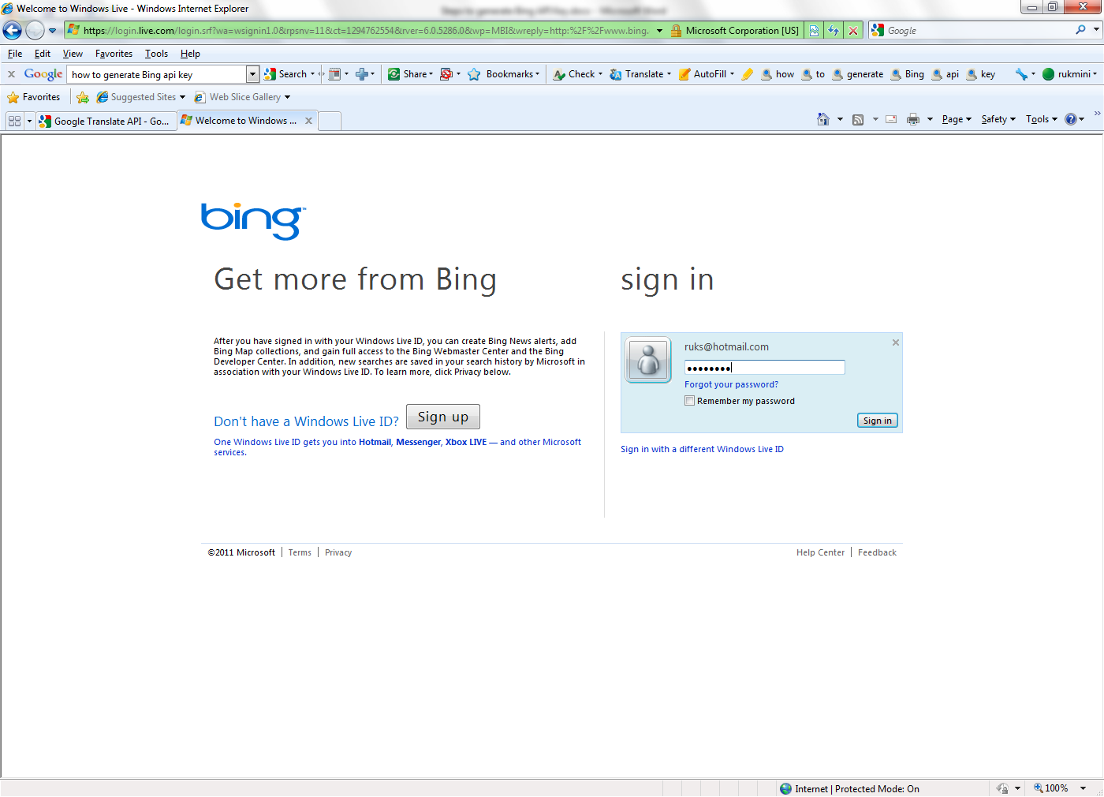

1. If you do not have the “Windows Live ID” then click on the “sign up” button. The following screen will be displayed. Enter all the information and click on “I accept” button.

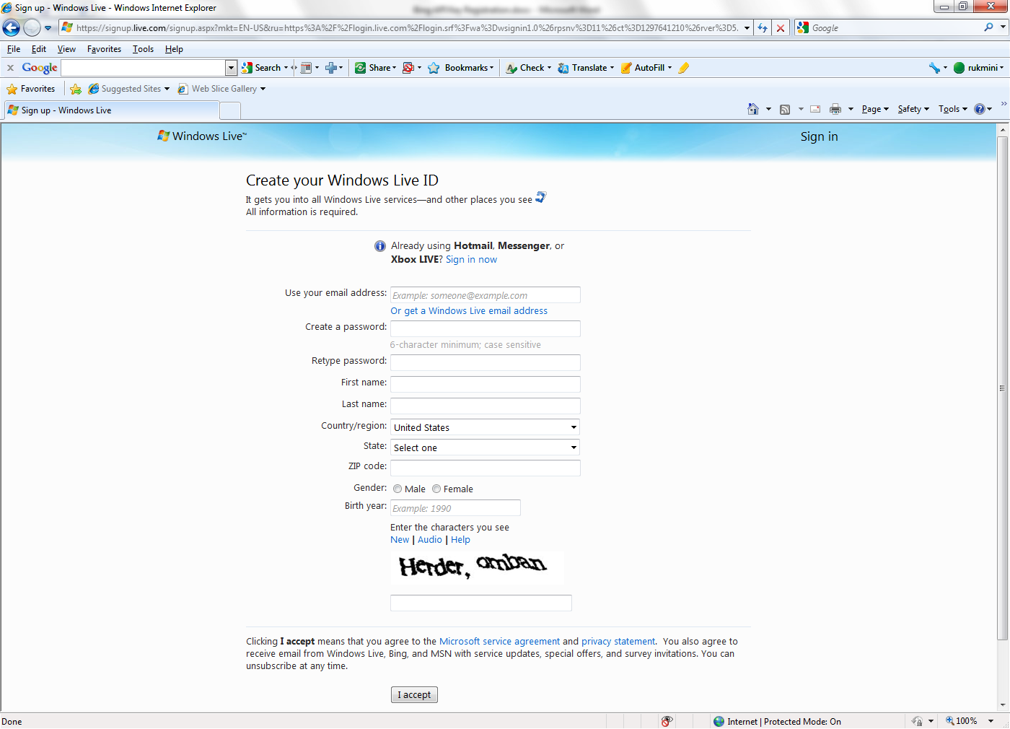

1. On a successful login, the following screen will be displayed. Enter all the required information and agree to the terms of usage and click on the agree button below.

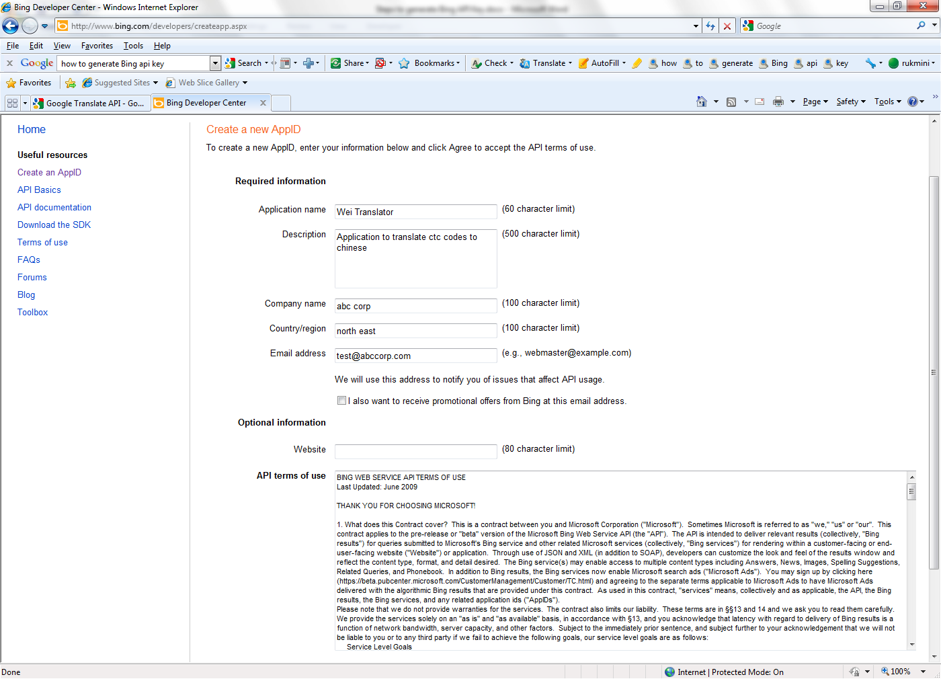

1. A new API ID will be generated and the following screen will be displayed with the ID. Make a copy of the ID for future use

