# Introduction

The document details the steps to be followed to generate API Key to be used by Wei product. The product supports google and Bing translator. The translator to be used is configurable and the user can specify in the configuration file the translator to be used.

If the choice of translator is Google then follow the steps documented below.

# Details

The section below gives steps to be followed to generate the Google API key.

1. Go to the url <http://code.google.com/intl/pl/apis/loader/signup.html>, following screen will be displayed.

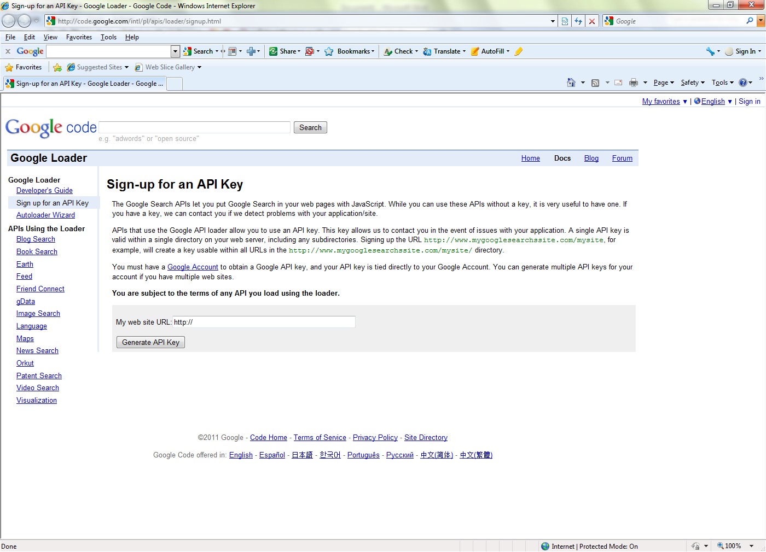

1. Enter the web site URL <http://www.test.com> and click on “Generate API Key”. The following screen will be displayed

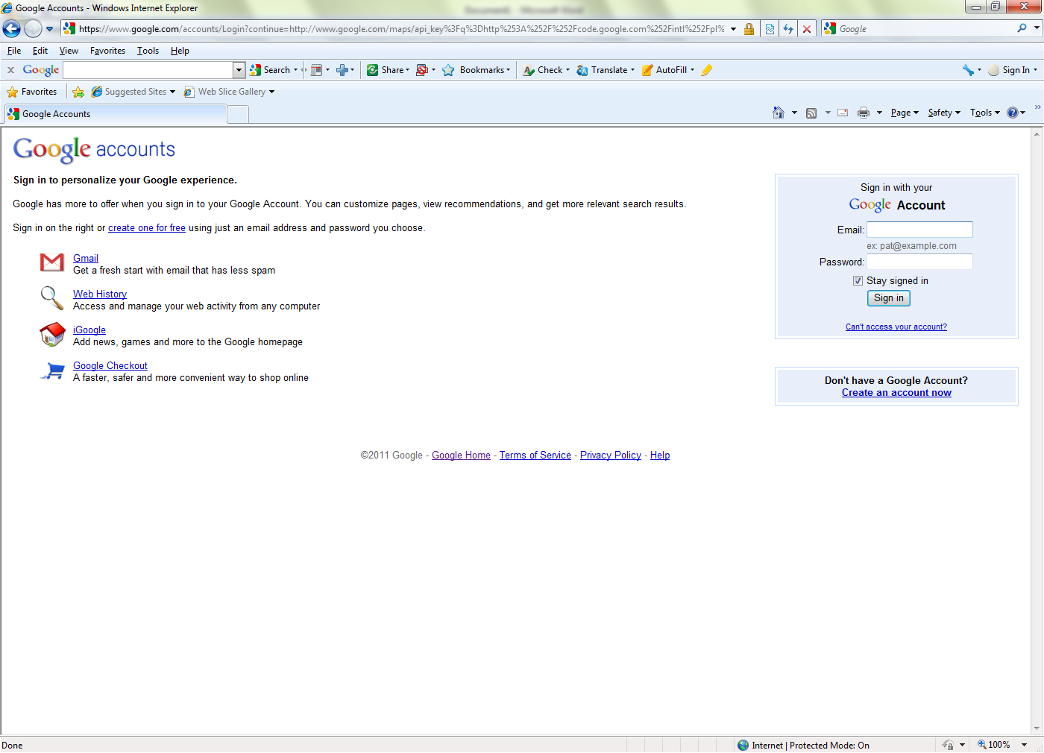

If you have a google account enter the username and password and signin. If you do not have a google account, click on the link “Create an Account Now” link.

1. If you are trying to create an account then the following screen will be displayed.

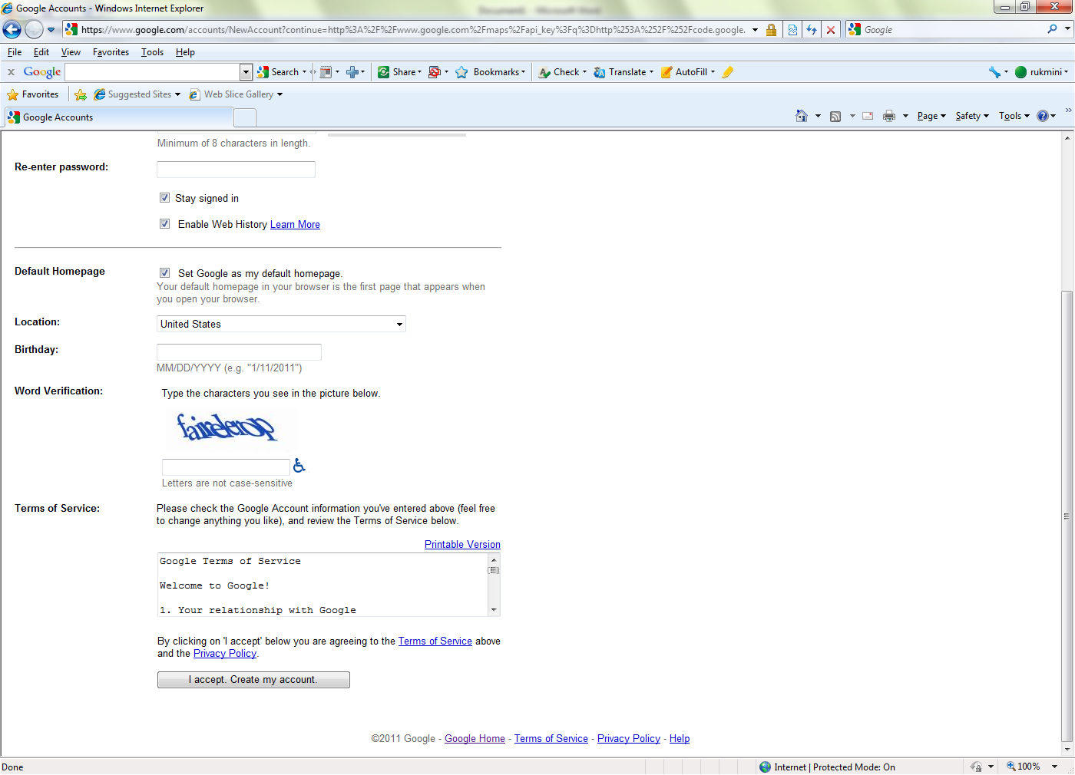

Enter all the details and click on “I accept. Create my account”. Then the API key will generated and the screen displayed in the previous step will be displayed.

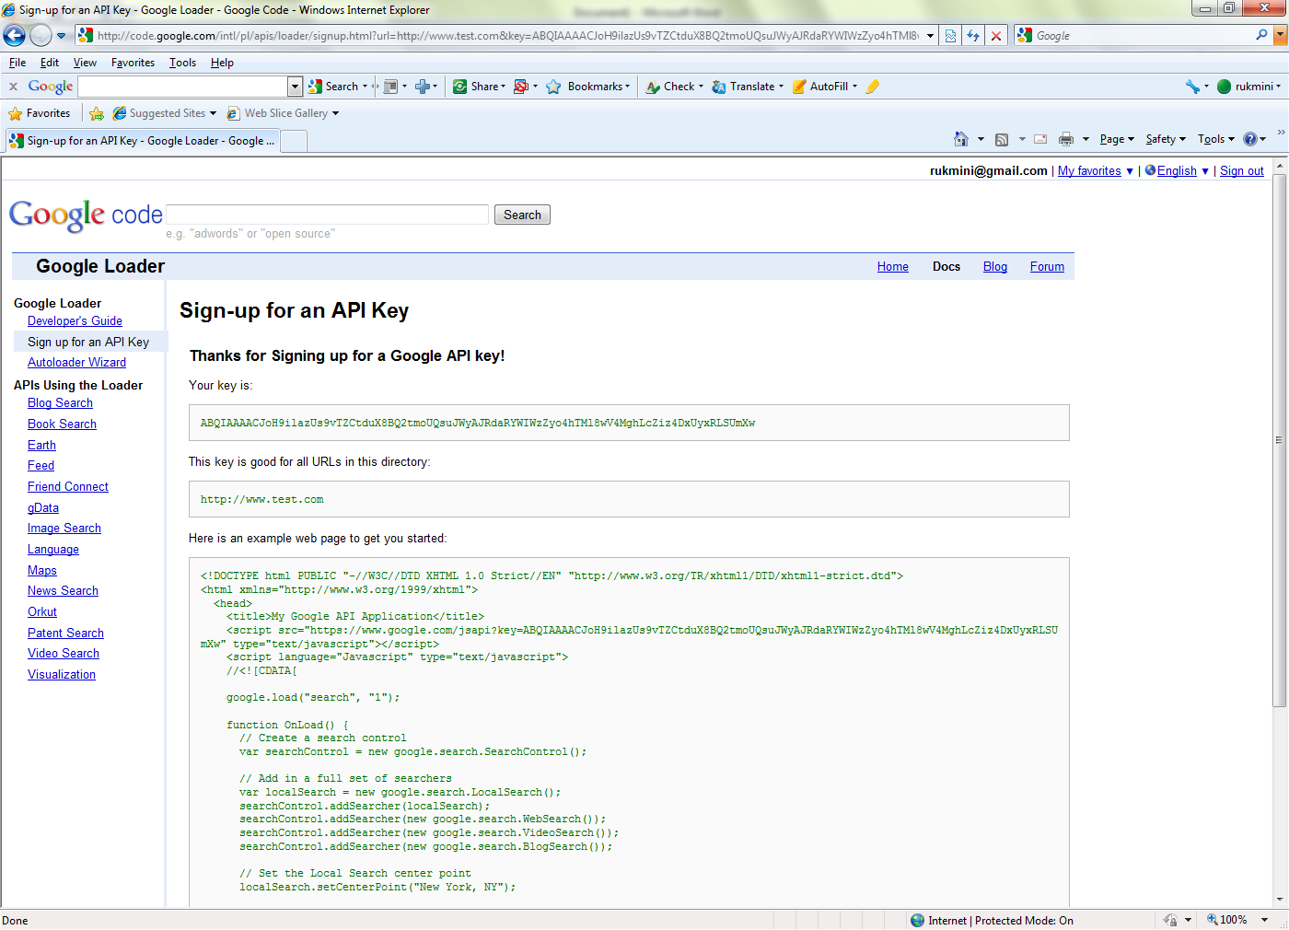

1. On a successful signin the following screen will be displayed with the API key generated.
2. Please make a note of the API key and save it for future use