**Exercise 1: Configuring a Basic Spring Application**

**Scenario:**

Your company is developing a web application for managing a library. You need to use the Spring Framework to handle the backend operations.

Solution:

//LibraryManagement—pom.xml

<project xmlns="http://maven.apache.org/POM/4.0.0" xmlns:xsi="http://www.w3.org/2001/XMLSchema-instance" xsi:schemaLocation="http://maven.apache.org/POM/4.0.0 https://maven.apache.org/xsd/maven-4.0.0.xsd">

<modelVersion>4.0.0</modelVersion>

<groupId>com.library</groupId>

<artifactId>LibraryManagement</artifactId>

<version>0.0.1-SNAPSHOT</version>

<name>LibraryManagement</name>

<dependencies>

<!-- Spring Core Dependency -->

<dependency>

<groupId>org.springframework</groupId>

<artifactId>spring-context</artifactId>

<version>5.3.34</version>

</dependency>

</dependencies>

</project>

// BookRepository

**package** com.library.repository;

**public** **class** BookRepository {

**public** **void** saveBook(String bookName) {

System.***out***.println("Book saved: " + bookName);

}

}

//BookService.java

**package** com.library.service;

**import** com.library.repository.BookRepository;

**public** **class** BookService {

**private** BookRepository bookRepository;

// Setter-based Dependency Injection

**public** **void** setBookRepository(BookRepository bookRepository) {

**this**.bookRepository = bookRepository;

}

**public** **void** addBook(String bookName) {

System.***out***.println("Adding book: " + bookName);

bookRepository.saveBook(bookName);

}

}

// MainApp.java

package com.library;

import com.library.service.BookService;

import org.springframework.context.ApplicationContext;

import org.springframework.context.support.ClassPathXmlApplicationContext;

public class MainApp {

public static void main(String[] args) {

// Load Spring container from XML

ApplicationContext context = new ClassPathXmlApplicationContext("applicationContext.xml");

// Get BookService bean

BookService bookService = (BookService) context.getBean("bookService");

// Use the service

bookService.addBook("Can we be Strangers Again...!?");

}

}

Output:

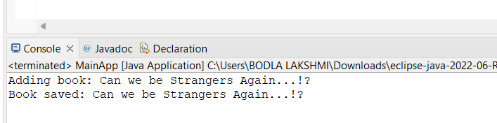

**Exercise 2: Implementing Dependency Injection**

**Scenario:**

In the library management application, you need to manage the dependencies between the BookService and BookRepository classes using Spring's IoC and DI.

Solution:

//applicationcontext.xml

<?xml version="1.0" encoding="UTF-8"?>

<beans xmlns="http://www.springframework.org/schema/beans"

xmlns:xsi="http://www.w3.org/2001/XMLSchema-instance"

xsi:schemaLocation="

http://www.springframework.org/schema/beans

http://www.springframework.org/schema/beans/spring-beans.xsd">

<!-- Bean for BookRepository -->

<bean id="bookRepository" class="com.library.repository.BookRepository" />

<!-- Bean for BookService with Setter Injection -->

<bean id="bookService" class="com.library.service.BookService">

<property name="bookRepository" ref="bookRepository" />

</bean>

</beans>

//BookRepository.java

**package** com.library.repository;

**public** **class** BookRepository {

**public** **void** display() {

System.***out***.println("BookRepository: Displaying book data from the database...");

}

}

//BookService.java

**package** com.library.service;

**import** com.library.repository.BookRepository;

**public** **class** BookService {

**private** BookRepository bookRepository;

// Setter for Dependency Injection

**public** **void** setBookRepository(BookRepository bookRepository) {

**this**.bookRepository = bookRepository;

}

**public** **void** displayBooks() {

System.***out***.println("BookService: Delegating to BookRepository...");

bookRepository.display();

}

}

//LibraryManagementApplication.java

**package** com.library.main;

**import** org.springframework.context.ApplicationContext;

**import** org.springframework.context.support.ClassPathXmlApplicationContext;

**import** com.library.service.BookService;

**public** **class** LibraryManagementApplication {

**public** **static** **void** main(String[] args) {

ApplicationContext context = **new** ClassPathXmlApplicationContext("applicationContext.xml");

BookService bookService = (BookService) context.getBean("bookService");

bookService.displayBooks();

}

}

Output:

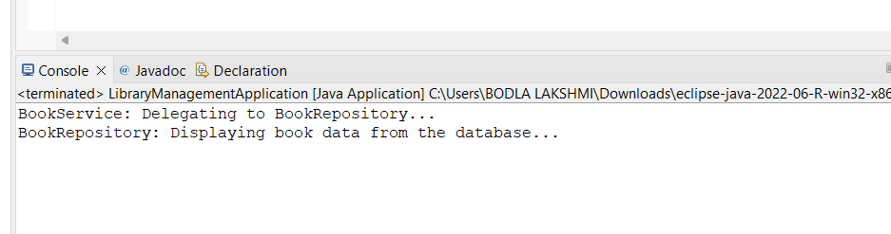

**Exercise 4: Creating and Configuring a Maven Project**

**Scenario:**

You need to set up a new Maven project for the library management application and add Spring dependencies.

Solution:

//pom.xml

<project xmlns="http://maven.apache.org/POM/4.0.0"

xmlns:xsi="http://www.w3.org/2001/XMLSchema-instance"

xsi:schemaLocation="http://maven.apache.org/POM/4.0.0

http://maven.apache.org/xsd/maven-4.0.0.xsd">

<modelVersion>4.0.0</modelVersion>

<groupId>com.library</groupId>

<artifactId>LibraryManagement</artifactId>

<version>1.0-SNAPSHOT</version>

<dependencies>

<!-- Spring Context -->

<dependency>

<groupId>org.springframework</groupId>

<artifactId>spring-context</artifactId>

<version>5.3.36</version>

</dependency>

<!-- Spring AOP -->

<dependency>

<groupId>org.springframework</groupId>

<artifactId>spring-aop</artifactId>

<version>5.3.36</version>

</dependency>

<!-- Spring WebMVC -->

<dependency>

<groupId>org.springframework</groupId>

<artifactId>spring-webmvc</artifactId>

<version>5.3.36</version>

</dependency>

<!-- Optional: Servlet API for Spring MVC if needed -->

<dependency>

<groupId>javax.servlet</groupId>

<artifactId>javax.servlet-api</artifactId>

<version>4.0.1</version>

<scope>provided</scope>

</dependency>

</dependencies>

<build>

<plugins>

<!-- Maven Compiler Plugin to set Java version -->

<plugin>

<groupId>org.apache.maven.plugins</groupId>

<artifactId>maven-compiler-plugin</artifactId>

<version>3.11.0</version>

<configuration>

<source>1.8</source>

<target>1.8</target>

</configuration>

</plugin>

</plugins>

</build>

</project>