[](http://www.comsol.com/)

Heat Flux around a Room

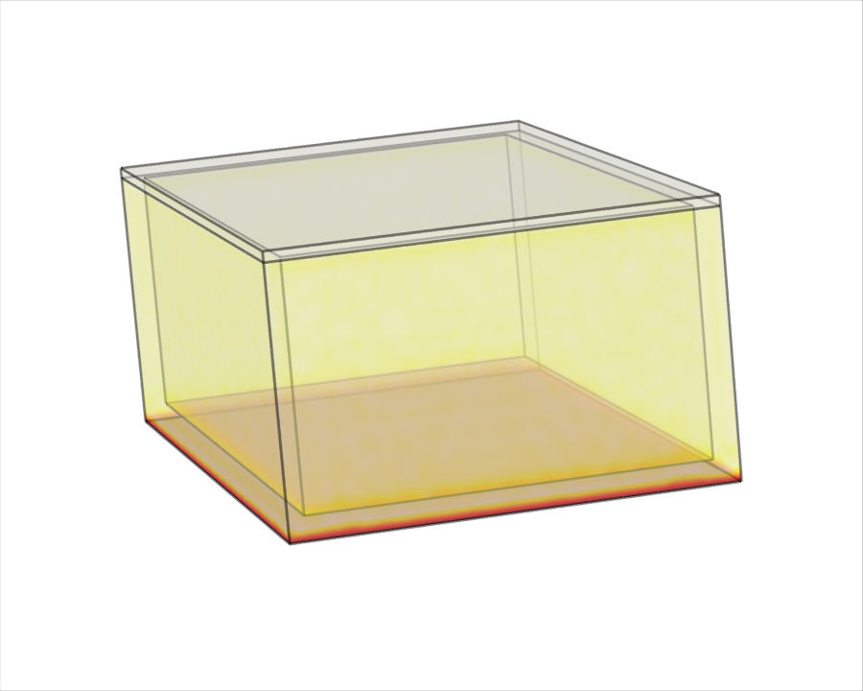

|  |  |
| --- | --- |
| Author | Sriram |
| Report date | Apr 29, 2025 10:44:03 AM |

Contents

1. Global Definitions

1.1. Functions

1.2. Mesh Parts

1.3. Materials

2. Component 1

2.1. Definitions

2.2. Geometry 1

2.3. Materials

2.4. Heat Transfer in Solids

2.5. Mesh 1

3. Study 1

3.1. Time Dependent

3.2. Solver Configurations

4. Results

4.1. Data Sets

4.2. Tables

4.3. Plot Groups

1. Global Definitions

|  |  |
| --- | --- |
| Date | Apr 29, 2025 10:33:57 AM |

Global settings

|  |  |
| --- | --- |
| Name | Simulation1.mph |
| Path | C:\Users\SRIRAM\OneDrive\Documents\Desktop\Chemical\CLL251\simulation1.mph |
| Version | COMSOL Multiphysics 5.4 (Build: 388) |
| Unit system | SI |

Used products

|  |
| --- |
| COMSOL Multiphysics |
| CAD Import Module |

* 1. Functions
     1. Toutdoor

|  |  |
| --- | --- |
| Function name | Toutdoor |
| Function type | Analytic |

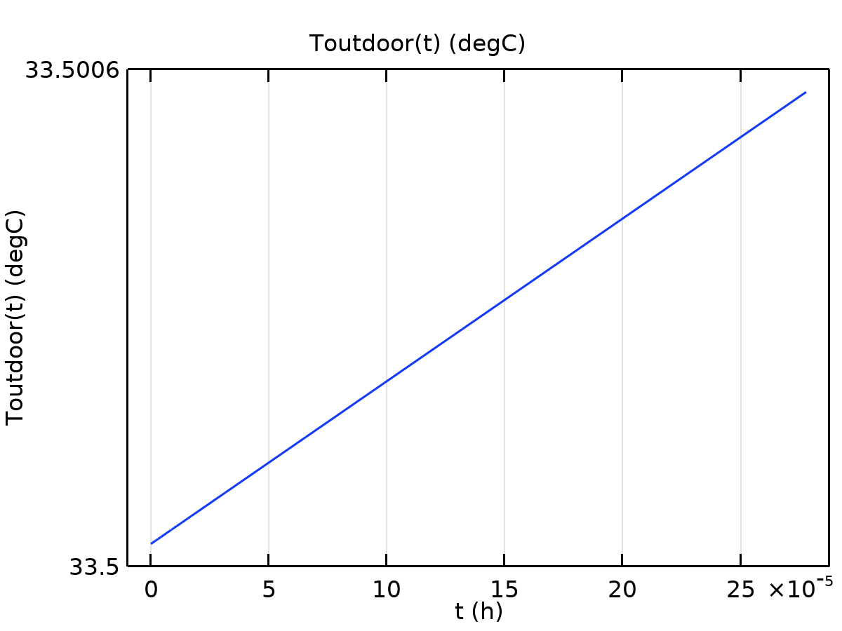

Toutdoor

Definition

| **Description** | **Value** |
| --- | --- |
| Expression | 33.5 + 8.5*sin(2*pi*t/24) |
| Arguments | t |

Units

| **Description** | **Value** |
| --- | --- |
| Arguments | h |
| Function | degC |

* 1. Mesh Parts
     1. Mesh Part 1

Mesh statistics

| **Description** | **Value** |
| --- | --- |
| Minimum element quality | 0.4984 |
| Average element quality | 0.628 |
| Triangle | 24 |
| Edge element | 24 |
| Vertex element | 16 |

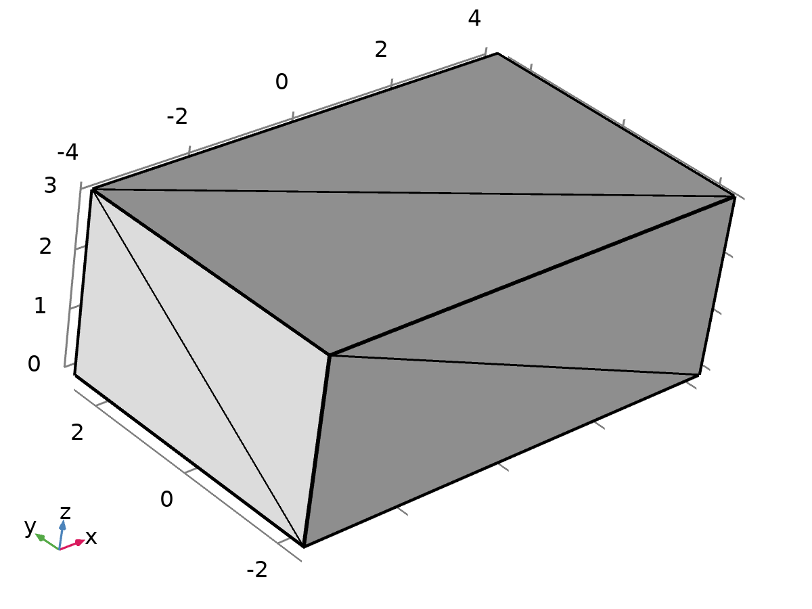

Mesh Part 1

#### Import 1 (imp1)

Settings

| **Description** | **Value** |
| --- | --- |
| Source | STL/VRML file |
| Filename | C:\Users\SRIRAM\Downloads\roof1.stl |

* + 1. Mesh Part 2

Mesh statistics

| **Description** | **Value** |
| --- | --- |
| Minimum element quality | 0.02209 |
| Average element quality | 0.4449 |
| Triangle | 28 |
| Edge element | 24 |
| Vertex element | 16 |

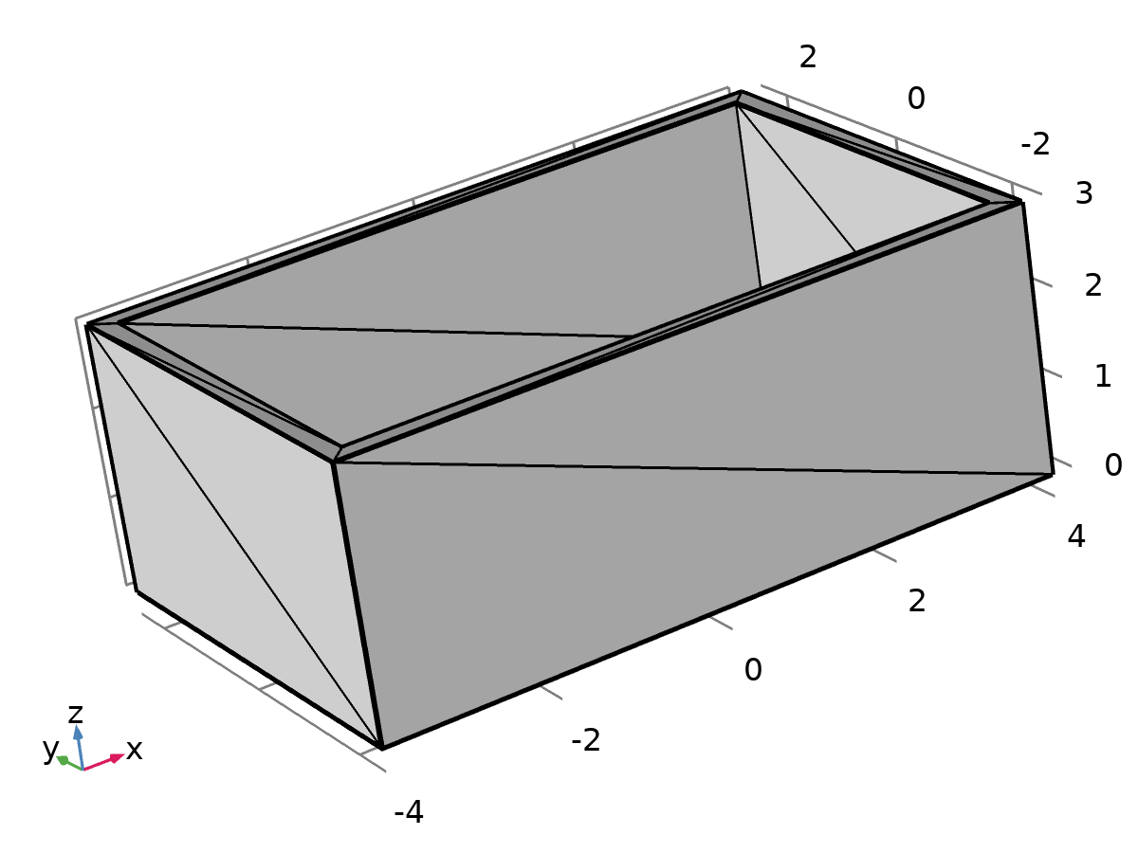

Mesh Part 2

#### Import 1 (imp1)

Settings

| **Description** | **Value** |
| --- | --- |
| Source | STL/VRML file |
| Filename | C:\Users\SRIRAM\Downloads\roof1shell.stl |

* 1. Materials
     1. Fired_Clay_Brick_Wall

Basic Settings

| **Description** | **Value** |
| --- | --- |
| Density | 1657 |
| Heat capacity at constant pressure | 940.4 |
| Thermal conductivity | {{0.3335, 0, 0}, {0, 0.3335, 0}, {0, 0, 0.3335}} |

* + 1. Concrete_Block

Basic Settings

| **Description** | **Value** |
| --- | --- |
| Density | 1961 |
| Heat capacity at constant pressure | 928.9 |
| Thermal conductivity | {{0.4462, 0, 0}, {0, 0.4462, 0}, {0, 0, 0.4462}} |

* + 1. Concrete_Brick

Basic Settings

| **Description** | **Value** |
| --- | --- |
| Density | 2122 |
| Thermal conductivity | {{0.6739, 0, 0}, {0, 0.6739, 0}, {0, 0, 0.6739}} |
| Heat capacity at constant pressure | 920 |

* + 1. AAC_block

Basic Settings

| **Description** | **Value** |
| --- | --- |
| Density | 623 |
| Heat capacity at constant pressure | 831 |
| Thermal conductivity | {{0.161, 0, 0}, {0, 0.161, 0}, {0, 0, 0.161}} |

* + 1. Copper_insulater_panel

Basic Settings

| **Description** | **Value** |
| --- | --- |
| Density | 2000 |
| Heat capacity at constant pressure | 900 |
| Thermal conductivity | {{0.1196, 0, 0}, {0, 0.1196, 0}, {0, 0, 0.1196}} |

* + 1. Standard rcc slab (no insulation) 1

Basic Settings

| **Description** | **Value** |
| --- | --- |
| Density | 2400 |
| Thermal conductivity | {{880, 0, 0}, {0, 880, 0}, {0, 0, 880}} |
| Heat capacity at constant pressure | 0.144 |

1. Component 1

|  |  |
| --- | --- |
| Date | Apr 28, 2025 4:50:45 AM |

Settings

| **Description** | **Value** |
| --- | --- |
| Unit system | Same as global system |
| Geometry shape order | Automatic |

Spatial frame coordinates

| **First** | **Second** | **Third** |
| --- | --- | --- |
| x | y | z |

Material frame coordinates

| **First** | **Second** | **Third** |
| --- | --- | --- |
| X | Y | Z |

Geometry frame coordinates

| **First** | **Second** | **Third** |
| --- | --- | --- |
| Xg | Yg | Zg |

Mesh frame coordinates

| **First** | **Second** | **Third** |
| --- | --- | --- |
| Xm | Ym | Zm |

* 1. Definitions
     1. Selections

#### roof

| **Selection type** |
| --- |
| Explicit |

| **Selection** |
| --- |
| No boundaries |

Color

| **Description** | **Value** |
| --- | --- |
| Color | Color 4 |

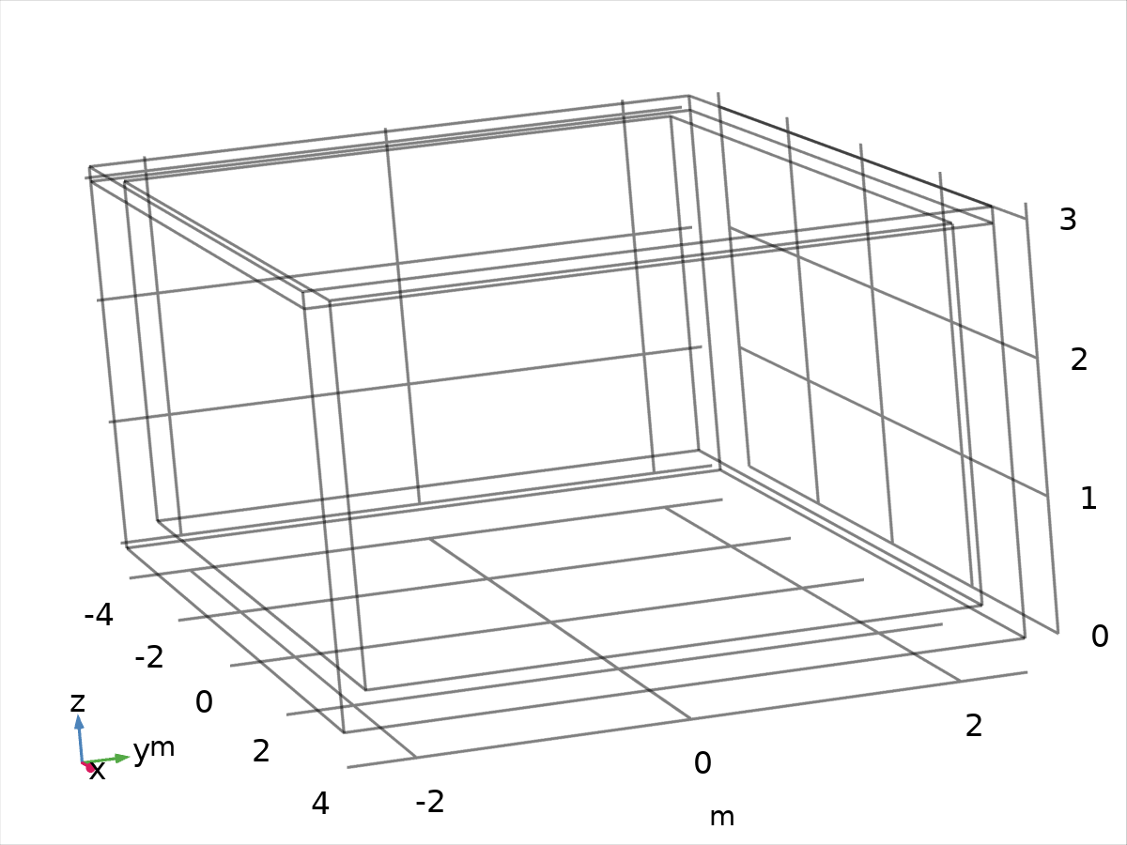

roof

#### wall

| **Selection type** |
| --- |
| Explicit |

| **Selection** |
| --- |
| No boundaries |

Color

| **Description** | **Value** |
| --- | --- |
| Color | Color 5 |



wall

#### floor

| **Selection type** |
| --- |
| Explicit |

| **Selection** |
| --- |
| No boundaries |



floor

* + 1. Coordinate Systems

#### Boundary System 1

|  |  |
| --- | --- |
| Coordinate system type | Boundary system |
| Tag | sys1 |

Coordinate names

| **First** | **Second** | **Third** |
| --- | --- | --- |
| t1 | t2 | n |

* 1. Geometry 1

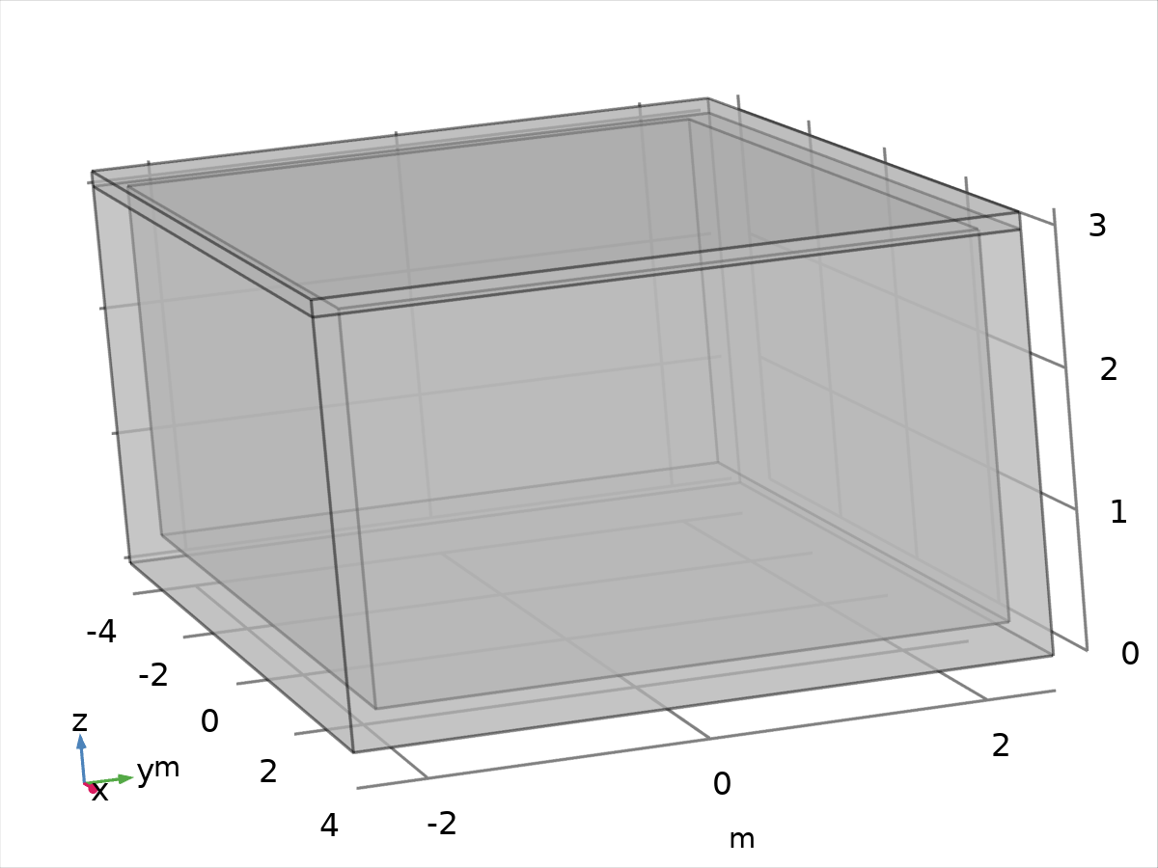

Geometry 1

Units

|  |  |
| --- | --- |
| Length unit | m |
| Angular unit | deg |

Geometry statistics

| **Description** | **Value** |
| --- | --- |
| Space dimension | 3 |
| Number of domains | 2 |
| Number of boundaries | 17 |
| Number of edges | 32 |
| Number of vertices | 20 |

* + 1. Import 1 (imp1)

Settings

| **Description** | **Value** |
| --- | --- |
| Source | Mesh or STL file |
| Mesh | Mesh Part 2 |

* + 1. Block 1 (blk1)

Position

| **Description** | **Value** |
| --- | --- |
| Position | {-0, 0, 3 + 0.12/2} |
| Base | Center |

Axis

| **Description** | **Value** |
| --- | --- |
| Axis type | z - axis |

Size and shape

| **Description** | **Value** |
| --- | --- |
| Width | 8 |
| Depth | 5 |
| Height | 0.12 |

* 1. Materials
     1. Fired_Clay_Brick_Wall 1



Fired_Clay_Brick_Wall 1

Selection

|  |  |
| --- | --- |
| Geometric entity level | Domain |
| Selection | No domains |

Basic Settings

| **Description** | **Value** |
| --- | --- |
| Density | 1657 |
| Heat capacity at constant pressure | 940.4 |
| Thermal conductivity | {{0.3335, 0, 0}, {0, 0.3335, 0}, {0, 0, 0.3335}} |

* + 1. Concrete_Block 1



Concrete_Block 1

Selection

|  |  |
| --- | --- |
| Geometric entity level | Boundary |
| Selection | No boundaries |

Basic Settings

| **Description** | **Value** |
| --- | --- |
| Density | 1961 |
| Heat capacity at constant pressure | 928.9 |
| Thermal conductivity | {{0.4462, 0, 0}, {0, 0.4462, 0}, {0, 0, 0.4462}} |

* + 1. Concrete_Brick 1



Concrete_Brick 1

Selection

|  |  |
| --- | --- |
| Geometric entity level | Domain |
| Selection | No domains |

Basic Settings

| **Description** | **Value** |
| --- | --- |
| Density | 2122 |
| Thermal conductivity | {{0.6739, 0, 0}, {0, 0.6739, 0}, {0, 0, 0.6739}} |
| Heat capacity at constant pressure | 920 |

* + 1. AAC_block 1

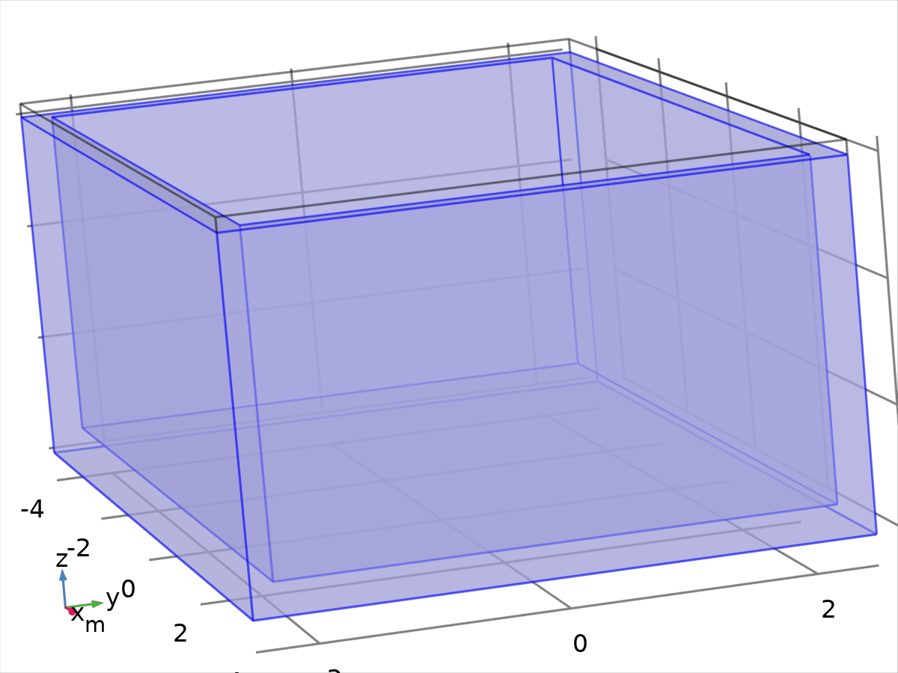

AAC_block 1

Selection

|  |  |
| --- | --- |
| Geometric entity level | Domain |
| Selection | Domain 1 |

Material parameters

| **Name** | **Value** | **Unit** |
| --- | --- | --- |
| Density | 623 | kg/m³ |
| Heat capacity at constant pressure | 831 | J/(kg·K) |
| Thermal conductivity | 0.161 | W/(m·K) |

Basic Settings

| **Description** | **Value** |
| --- | --- |
| Density | 623 |
| Heat capacity at constant pressure | 831 |
| Thermal conductivity | {{0.161, 0, 0}, {0, 0.161, 0}, {0, 0, 0.161}} |

* + 1. Copper_insulater_panel 1



Copper_insulater_panel 1

Selection

|  |  |
| --- | --- |
| Geometric entity level | Domain |
| Selection | No domains |

Basic Settings

| **Description** | **Value** |
| --- | --- |
| Density | 2000 |
| Heat capacity at constant pressure | 900 |
| Thermal conductivity | {{0.1196, 0, 0}, {0, 0.1196, 0}, {0, 0, 0.1196}} |

* + 1. Standard rcc slab (no insulation)

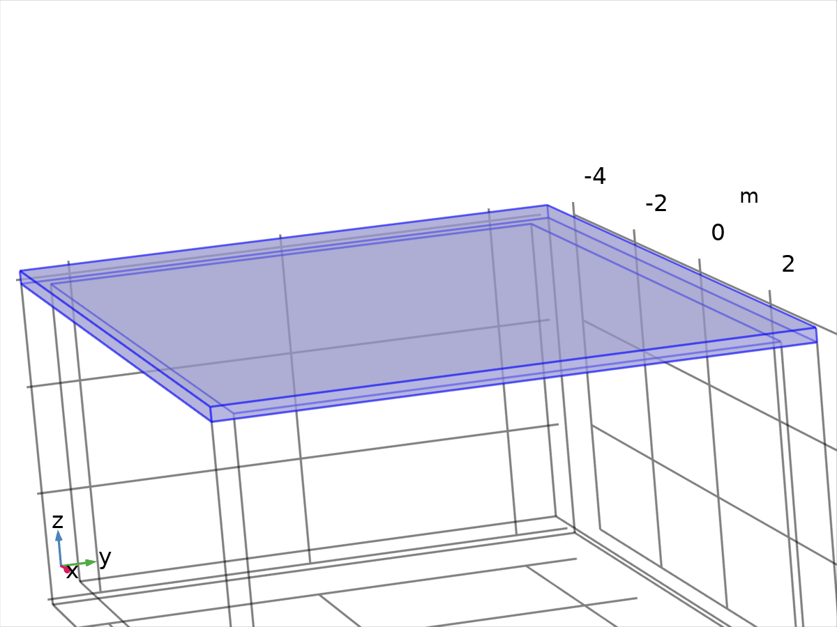

Standard rcc slab (no insulation)

Selection

|  |  |
| --- | --- |
| Geometric entity level | Domain |
| Selection | Domain 2 |

Material parameters

| **Name** | **Value** | **Unit** |
| --- | --- | --- |
| Density | 2400 | kg/m³ |
| Thermal conductivity | 880 | W/(m·K) |
| Heat capacity at constant pressure | 0.144 | J/(kg·K) |

Basic Settings

| **Description** | **Value** |
| --- | --- |
| Density | 2400 |
| Thermal conductivity | {{880, 0, 0}, {0, 880, 0}, {0, 0, 880}} |
| Heat capacity at constant pressure | 0.144 |

* 1. Heat Transfer in Solids

Used products

|  |
| --- |
| COMSOL Multiphysics |

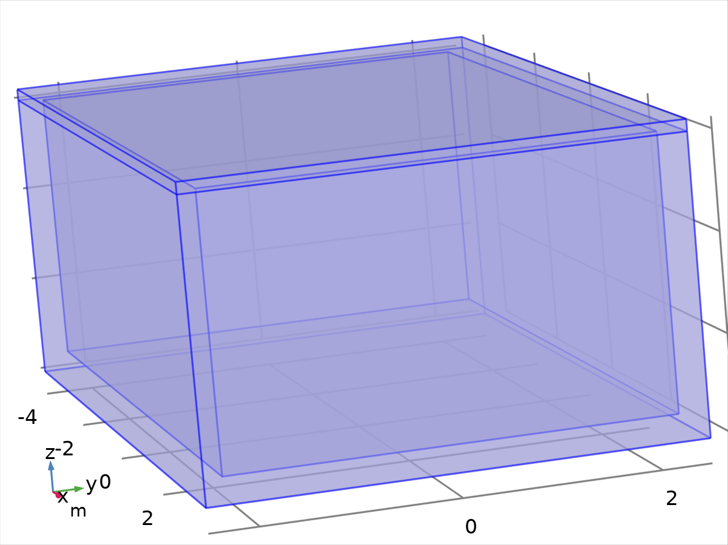

Heat Transfer in Solids

Selection

|  |  |
| --- | --- |
| Geometric entity level | Domain |
| Selection | Domains 1–2 |

Equations

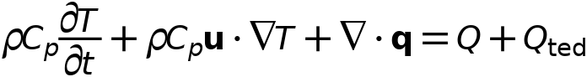



* + 1. Interface settings

#### Discretization

Settings

| **Description** | **Value** |
| --- | --- |
| Temperature | Quadratic Lagrange |

#### Physical model

Settings

| **Description** | **Value** |
| --- | --- |
| Heat transfer in biological tissue | Off |
| Isothermal domain | Off |
| Heat transfer in porous media | Off |
| Heat transfer in alloys | Off |
| Reference temperature | User defined |
| Reference temperature | 293.15[K] |

* + 1. Variables

| **Name** | **Expression** | **Unit** | **Description** | **Selection** | **Details** |
| --- | --- | --- | --- | --- | --- |
| ht.q0 | 0 | W/m² | Inward heat flux | Boundaries 1–17 | + operation |
| ht.Tu | up(T) | K | Temperature | Boundary 6 |  |
| ht.Tu | T | K | Temperature | Boundaries 1–5, 7–17 |  |
| ht.Td | down(T) | K | Temperature | Boundary 6 |  |
| ht.Td | T | K | Temperature | Boundaries 1–5, 7–17 |  |
| ht.Tref | model.input.Tref | K | Reference temperature | Global | Meta |
| ht.d | 1 | 1 | Thickness | Domains 1–2 |  |
| ht.HRef | 0 | J/kg | Reference enthalpy | Domains 1–2 |  |
| ht.DeltaH | 0 | J/kg | Sensible enthalpy | Domains 1–2 | + operation |
| ht.H | 0 | J/kg | Enthalpy | Domains 1–2 | + operation |
| ht.H0 | ht.H+ht.Ek | J/kg | Total enthalpy | Domains 1–2 |  |
| ht.Ei | 0 | J/kg | Internal energy | Domains 1–2 | + operation |
| ht.Ei0 | ht.Ei+ht.Ek | J/kg | Total internal energy | Domains 1–2 |  |
| ht.Ek | 0 | J/kg | Kinetic energy | Domains 1–2 | + operation |
| ht.dfluxx | 0 | W/m² | Conductive heat flux, x component | Domains 1–2 | + operation |
| ht.dfluxy | 0 | W/m² | Conductive heat flux, y component | Domains 1–2 | + operation |
| ht.dfluxz | 0 | W/m² | Conductive heat flux, z component | Domains 1–2 | + operation |
| ht.dfluxx | mean(ht.dfluxx) | W/m² | Conductive heat flux, x component | Boundaries 1–17 | + operation |
| ht.dfluxy | mean(ht.dfluxy) | W/m² | Conductive heat flux, y component | Boundaries 1–17 | + operation |
| ht.dfluxz | mean(ht.dfluxz) | W/m² | Conductive heat flux, z component | Boundaries 1–17 | + operation |
| ht.dfluxtestx | 0 | W/m² | Conductive heat flux, x component | Domains 1–2 | + operation |
| ht.dfluxtesty | 0 | W/m² | Conductive heat flux, y component | Domains 1–2 | + operation |
| ht.dfluxtestz | 0 | W/m² | Conductive heat flux, z component | Domains 1–2 | + operation |
| ht.dfluxtestx | mean(ht.dfluxtestx) | W/m² | Conductive heat flux, x component | Boundaries 1–17 | + operation |
| ht.dfluxtesty | mean(ht.dfluxtesty) | W/m² | Conductive heat flux, y component | Boundaries 1–17 | + operation |
| ht.dfluxtestz | mean(ht.dfluxtestz) | W/m² | Conductive heat flux, z component | Boundaries 1–17 | + operation |
| ht.dfluxMag | sqrt(ht.dfluxx^2+ht.dfluxy^2+ht.dfluxz^2) | W/m² | Conductive heat flux magnitude | Domains 1–2 |  |
| ht.cfluxx | 0 | W/m² | Convective heat flux, x component | Domains 1–2 | + operation |
| ht.cfluxy | 0 | W/m² | Convective heat flux, y component | Domains 1–2 | + operation |
| ht.cfluxz | 0 | W/m² | Convective heat flux, z component | Domains 1–2 | + operation |
| ht.cfluxMag | sqrt(ht.cfluxx^2+ht.cfluxy^2+ht.cfluxz^2) | W/m² | Convective heat flux magnitude | Domains 1–2 |  |
| ht.tfluxx | ht.dfluxx+ht.cfluxx | W/m² | Total heat flux, x component | Domains 1–2 |  |
| ht.tfluxy | ht.dfluxy+ht.cfluxy | W/m² | Total heat flux, y component | Domains 1–2 |  |
| ht.tfluxz | ht.dfluxz+ht.cfluxz | W/m² | Total heat flux, z component | Domains 1–2 |  |
| ht.tfluxMag | sqrt(ht.tfluxx^2+ht.tfluxy^2+ht.tfluxz^2) | W/m² | Total heat flux magnitude | Domains 1–2 |  |
| ht.tefluxx | 0 | W/m² | Total energy flux, x component | Domains 1–2 | + operation |
| ht.tefluxy | 0 | W/m² | Total energy flux, y component | Domains 1–2 | + operation |
| ht.tefluxz | 0 | W/m² | Total energy flux, z component | Domains 1–2 | + operation |
| ht.tefluxMag | sqrt(ht.tefluxx^2+ht.tefluxy^2+ht.tefluxz^2) | W/m² | Total energy flux magnitude | Domains 1–2 |  |
| ht.dflux_ux | up(ht.dfluxx) | W/m² | Conductive heat flux, x component | Boundaries 1–17 |  |
| ht.dflux_uy | up(ht.dfluxy) | W/m² | Conductive heat flux, y component | Boundaries 1–17 |  |
| ht.dflux_uz | up(ht.dfluxz) | W/m² | Conductive heat flux, z component | Boundaries 1–17 |  |
| ht.dflux_dx | down(ht.dfluxx) | W/m² | Conductive heat flux, x component | Boundaries 1–17 |  |
| ht.dflux_dy | down(ht.dfluxy) | W/m² | Conductive heat flux, y component | Boundaries 1–17 |  |
| ht.dflux_dz | down(ht.dfluxz) | W/m² | Conductive heat flux, z component | Boundaries 1–17 |  |
| ht.dfluxtest_ux | up(ht.dfluxtestx) | W/m² | Conductive heat flux, x component | Boundaries 1–17 |  |
| ht.dfluxtest_uy | up(ht.dfluxtesty) | W/m² | Conductive heat flux, y component | Boundaries 1–17 |  |
| ht.dfluxtest_uz | up(ht.dfluxtestz) | W/m² | Conductive heat flux, z component | Boundaries 1–17 |  |
| ht.dfluxtest_dx | down(ht.dfluxtestx) | W/m² | Conductive heat flux, x component | Boundaries 1–17 |  |
| ht.dfluxtest_dy | down(ht.dfluxtesty) | W/m² | Conductive heat flux, y component | Boundaries 1–17 |  |
| ht.dfluxtest_dz | down(ht.dfluxtestz) | W/m² | Conductive heat flux, z component | Boundaries 1–17 |  |
| ht.rflux | 0 | W/m² | Radiative heat flux | Boundaries 1–17 | + operation |
| ht.ncflux | mean(ht.cfluxx)*ht.nx+mean(ht.cfluxy)*ht.ny+mean(ht.cfluxz)*ht.nz | W/m² | Normal convective heat flux | Boundaries 1–17 |  |
| ht.ncflux_u | up(ht.cfluxx)*ht.unx+up(ht.cfluxy)*ht.uny+up(ht.cfluxz)*ht.unz | W/m² | Internal normal convective heat flux, upside | Boundaries 1–17 |  |
| ht.ncflux_d | down(ht.cfluxx)*ht.dnx+down(ht.cfluxy)*ht.dny+down(ht.cfluxz)*ht.dnz | W/m² | Internal normal convective heat flux, downside | Boundaries 1–17 |  |
| ht.ndflux | 0.5*(ht.ndflux_d-ht.ndflux_u) | W/m² | Normal conductive heat flux | Boundaries 1–17 | + operation |
| ht.ndflux_u | -ht.ndflux_d | W/m² | Internal normal conductive heat flux, upside | Boundaries 1–5, 7–17 | + operation |
| ht.ndflux_u | 0 | W/m² | Internal normal conductive heat flux, upside | Boundary 6 | + operation |
| ht.ndflux_d | 0 | W/m² | Internal normal conductive heat flux, downside | Boundaries 1–17 | + operation |
| ht.ntflux | ht.ndflux+ht.ncflux | W/m² | Normal total heat flux | Boundaries 1–17 |  |
| ht.ntflux_u | ht.ndflux_u+ht.ncflux_u | W/m² | Internal normal total flux, upside | Boundaries 1–17 |  |
| ht.ntflux_d | ht.ndflux_d+ht.ncflux_d | W/m² | Internal normal total flux, downside | Boundaries 1–17 |  |
| ht.nteflux | mean(ht.tefluxx)*ht.nx+mean(ht.tefluxy)*ht.ny+mean(ht.tefluxz)*ht.nz-mean(ht.dfluxx)*ht.nx-mean(ht.dfluxy)*ht.ny-mean(ht.dfluxz)*ht.nz+ht.ndflux | W/m² | Normal total energy flux | Boundaries 1–17 |  |
| ht.nteflux_u | up(ht.tefluxx)*ht.unx+up(ht.tefluxy)*ht.uny+up(ht.tefluxz)*ht.unz-up(ht.dfluxx)*ht.unx-up(ht.dfluxy)*ht.uny-up(ht.dfluxz)*ht.unz+ht.ndflux_u | W/m² | Internal normal total energy flux, upside | Boundaries 1–17 |  |
| ht.nteflux_d | down(ht.tefluxx)*ht.dnx+down(ht.tefluxy)*ht.dny+down(ht.tefluxz)*ht.dnz-down(ht.dfluxx)*ht.dnx-down(ht.dfluxy)*ht.dny-down(ht.dfluxz)*ht.dnz+ht.ndflux_d | W/m² | Internal normal total energy flux, downside | Boundaries 1–17 |  |
| ht.Qm | 0 | kg/(m³·s) | Mass source | Domains 1–2 |  |
| ht.Q | 0 | W/m³ | Heat source | Domains 1–2 | + operation |
| ht.Qoop | 0 | W/m³ | Out-of-plane heat source | Domains 1–2 | + operation |
| ht.Qtot | 0 | W/m³ | Total heat source | Domains 1–2 | + operation |
| ht.Qbtot | 0 | W/m² | Total boundary heat source | Boundaries 1–17 | + operation |
| ht.qs | 0 | W/(m³·K) | Production/absorption coefficient | Domains 1–2 | + operation |
| ht.qs_oop | 0 | W/(m³·K) | Out-of-plane production/absorption coefficient | Domains 1–2 | + operation |
| ht.Tvar | T | K | Temperature | Domains 1–2 |  |
| ht.Tvar | T | K | Temperature | Boundaries 1–17 |  |
| ht.Tvar | T | K | Temperature | Edges 1–32 |  |
| ht.Tvar | T | K | Temperature | Points 1–20 |  |
| ht.nx | nx | 1 | Normal vector, x component | Boundary 6 |  |
| ht.ny | ny | 1 | Normal vector, y component | Boundary 6 |  |
| ht.nz | nz | 1 | Normal vector, z component | Boundary 6 |  |
| ht.nx | dnx | 1 | Normal vector, x component | Boundaries 1–5, 7–17 |  |
| ht.ny | dny | 1 | Normal vector, y component | Boundaries 1–5, 7–17 |  |
| ht.nz | dnz | 1 | Normal vector, z component | Boundaries 1–5, 7–17 |  |
| ht.nxmesh | root.nxmesh | 1 | Normal vector (mesh), x component | Boundary 6 |  |
| ht.nymesh | root.nymesh | 1 | Normal vector (mesh), y component | Boundary 6 |  |
| ht.nzmesh | root.nzmesh | 1 | Normal vector (mesh), z component | Boundary 6 |  |
| ht.nxmesh | dnxmesh | 1 | Normal vector (mesh), x component | Boundaries 1–5, 7–17 |  |
| ht.nymesh | dnymesh | 1 | Normal vector (mesh), y component | Boundaries 1–5, 7–17 |  |
| ht.nzmesh | dnzmesh | 1 | Normal vector (mesh), z component | Boundaries 1–5, 7–17 |  |
| ht.dnx | dnx | 1 | Normal vector down direction, x component | Boundaries 1–17 |  |
| ht.dny | dny | 1 | Normal vector down direction, y component | Boundaries 1–17 |  |
| ht.dnz | dnz | 1 | Normal vector down direction, z component | Boundaries 1–17 |  |
| ht.unx | unx | 1 | Normal vector up direction, x component | Boundaries 1–17 |  |
| ht.uny | uny | 1 | Normal vector up direction, y component | Boundaries 1–17 |  |
| ht.unz | unz | 1 | Normal vector up direction, z component | Boundaries 1–17 |  |
| ht.dEiInt | 0 | W | Total accumulated heat rate | Global | + operation |
| ht.dEi0Int | 0 | W | Total accumulated energy rate | Global | + operation |
| ht.ntfluxInt | ht.intExtBnd(ht.ntflux*ht.varIntSpa) | W | Total net heat rate | Global |  |
| ht.ntefluxInt | ht.intExtBnd(ht.nteflux*ht.varIntSpa) | W | Total net energy rate | Global |  |
| ht.QInt | ht.intDom(ht.Qtot*ht.varIntSpa)-ht.intIntBnd((ht.ndflux_u+ht.ndflux_d)*ht.varIntSpa) | W | Total heat source | Global |  |
| ht.WnsInt | 0 | W | Total work source | Global | + operation |
| ht.WInt | 0 | W | Total work source | Global | + operation |
| ht.varIntSpa | ht.d | 1 | Intermediate variable | Domains 1–2 |  |

* + 1. Solid 1



Solid 1

Selection

|  |  |
| --- | --- |
| Geometric entity level | Domain |
| Selection | Domains 1–2 |

Equations

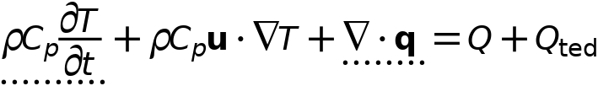



#### Heat conduction, solid

Settings

| **Description** | **Value** |
| --- | --- |
| Thermal conductivity | From material |

#### Thermodynamics, solid

Settings

| **Description** | **Value** |
| --- | --- |
| Density | From material |
| Heat capacity at constant pressure | From material |

#### Coordinate system selection

Settings

| **Description** | **Value** |
| --- | --- |
| Coordinate system | Global coordinate system |

Properties from material

| **Property** | **Material** | **Property group** |
| --- | --- | --- |
| Thermal conductivity | AAC_block 1 | Basic |
| Density | AAC_block 1 | Basic |
| Heat capacity at constant pressure | AAC_block 1 | Basic |
| Thermal conductivity | Standard rcc slab (no insulation) | Basic |
| Density | Standard rcc slab (no insulation) | Basic |
| Heat capacity at constant pressure | Standard rcc slab (no insulation) | Basic |

#### Variables

| **Name** | **Expression** | **Unit** | **Description** | **Selection** | **Details** |
| --- | --- | --- | --- | --- | --- |
| domflux.Tx | ht.dfluxx*ht.d | W/m² | Domain flux, x component | Domains 1–2 |  |
| domflux.Ty | ht.dfluxy*ht.d | W/m² | Domain flux, y component | Domains 1–2 |  |
| domflux.Tz | ht.dfluxz*ht.d | W/m² | Domain flux, z component | Domains 1–2 |  |
| ht.DeltaH | integrate(subst(ht.Cp,ht.solid1.minput_pressure,ht.pref),T,ht.Tref,T)+integrate(ht.mujtT,ht.solid1.minput_pressure,ht.pref,ht.pA) | J/kg | Sensible enthalpy | Domains 1–2 | + operation |
| ht.H | ht.HRef+ht.DeltaH | J/kg | Enthalpy | Domains 1–2 | + operation |
| ht.Ei | ht.H | J/kg | Internal energy | Domains 1–2 | + operation |
| ht.Ek | 0.5*(ht.ux^2+ht.uy^2+ht.uz^2) | J/kg | Kinetic energy | Domains 1–2 | + operation |
| ht.dfluxx | -ht.k_effxx*Tx-ht.k_effxy*Ty-ht.k_effxz*Tz | W/m² | Conductive heat flux, x component | Domains 1–2 | + operation |
| ht.dfluxy | -ht.k_effyx*Tx-ht.k_effyy*Ty-ht.k_effyz*Tz | W/m² | Conductive heat flux, y component | Domains 1–2 | + operation |
| ht.dfluxz | -ht.k_effzx*Tx-ht.k_effzy*Ty-ht.k_effzz*Tz | W/m² | Conductive heat flux, z component | Domains 1–2 | + operation |
| ht.dfluxtestx | -ht.k_effxx*test(Tx)-ht.k_effxy*test(Ty)-ht.k_effxz*test(Tz) | W/m² | Conductive heat flux, x component | Domains 1–2 | + operation |
| ht.dfluxtesty | -ht.k_effyx*test(Tx)-ht.k_effyy*test(Ty)-ht.k_effyz*test(Tz) | W/m² | Conductive heat flux, y component | Domains 1–2 | + operation |
| ht.dfluxtestz | -ht.k_effzx*test(Tx)-ht.k_effzy*test(Ty)-ht.k_effzz*test(Tz) | W/m² | Conductive heat flux, z component | Domains 1–2 | + operation |
| ht.cfluxx | ht.rho*ht.ux*ht.Ei | W/m² | Convective heat flux, x component | Domains 1–2 | + operation |
| ht.cfluxy | ht.rho*ht.uy*ht.Ei | W/m² | Convective heat flux, y component | Domains 1–2 | + operation |
| ht.cfluxz | ht.rho*ht.uz*ht.Ei | W/m² | Convective heat flux, z component | Domains 1–2 | + operation |
| ht.tefluxx | ht.dfluxx+ht.rho*ht.ux*ht.H0 | W/m² | Total energy flux, x component | Domains 1–2 | + operation |
| ht.tefluxy | ht.dfluxy+ht.rho*ht.uy*ht.H0 | W/m² | Total energy flux, y component | Domains 1–2 | + operation |
| ht.tefluxz | ht.dfluxz+ht.rho*ht.uz*ht.H0 | W/m² | Total energy flux, z component | Domains 1–2 | + operation |
| ht.ndflux_u | -uflux_spatial(T)/ht.d | W/m² | Internal normal conductive heat flux, upside | Boundary 6 | + operation |
| ht.ndflux_d | -dflux_spatial(T)/ht.d | W/m² | Internal normal conductive heat flux, downside | Boundary 6 | + operation |
| ht.ndflux_d | -dflux_spatial(T)/ht.d | W/m² | Internal normal conductive heat flux, downside | Boundaries 1–5, 7–17 | + operation |
| ht.dEiInt | ht.solid1.dEiInt | W | Total accumulated heat rate | Global | + operation |
| ht.dEi0Int | ht.solid1.dEi0Int | W | Total accumulated energy rate | Global | + operation |
| ht.WnsInt | ht.solid1.WnsInt | W | Total work source | Global | + operation |
| ht.kxx | material.k11 | W/(m·K) | Thermal conductivity, xx component | Domains 1–2 | Meta |
| ht.kyx | material.k21 | W/(m·K) | Thermal conductivity, yx component | Domains 1–2 | Meta |
| ht.kzx | material.k31 | W/(m·K) | Thermal conductivity, zx component | Domains 1–2 | Meta |
| ht.kxy | material.k12 | W/(m·K) | Thermal conductivity, xy component | Domains 1–2 | Meta |
| ht.kyy | material.k22 | W/(m·K) | Thermal conductivity, yy component | Domains 1–2 | Meta |
| ht.kzy | material.k32 | W/(m·K) | Thermal conductivity, zy component | Domains 1–2 | Meta |
| ht.kxz | material.k13 | W/(m·K) | Thermal conductivity, xz component | Domains 1–2 | Meta |
| ht.kyz | material.k23 | W/(m·K) | Thermal conductivity, yz component | Domains 1–2 | Meta |
| ht.kzz | material.k33 | W/(m·K) | Thermal conductivity, zz component | Domains 1–2 | Meta |
| ht.k_iso | material.k_iso | W/(m·K) | Thermal conductivity, isotropic value | Domains 1–2 | Meta |
| ht.rho | material.rho | kg/m³ | Density | Domains 1–2 | Meta |
| ht.Cp | material.Cp | J/(kg·K) | Heat capacity at constant pressure | Domains 1–2 | Meta |
| ht.solid1.pref | 1[atm] | Pa | Reference pressure level | Domains 1–2 |  |
| ht.res_T | Tt*ht.C_eff-ht.k_effxx*Txx-ht.k_effxy*Txy-ht.k_effxz*Txz-ht.k_effyx*Tyx-ht.k_effyy*Tyy-ht.k_effyz*Tyz-ht.k_effzx*Tzx-ht.k_effzy*Tzy-ht.k_effzz*Tzz-(ht.qs+ht.qs_oop)*T+ht.rho*ht.Cp*(ht.ux*Tx+ht.uy*Ty+ht.uz*Tz)-ht.Q-ht.Qoop | W/m³ | Equation residual | Domains 1–2 | + operation |
| ht.alphap | -d(ht.rho,T)/(ht.rho+eps) | 1/K | Isobaric compressibility coefficient | Domains 1–2 |  |
| ht.pA | ht.pref | Pa | Absolute pressure | Domains 1–2 |  |
| ht.gradTmag | sqrt(ht.gradTx^2+ht.gradTy^2+ht.gradTz^2) | K/m | Temperature gradient magnitude | Domains 1–2 |  |
| ht.Qmet | 0 | W/m³ | Metabolic heat source | Domains 1–2 | + operation |
| ht.pref | ht.solid1.pref | Pa | Reference pressure level | Domains 1–2 |  |
| ht.rhoInit | subst(ht.rho,ht.solid1.minput_pressure,1[atm],T,ht.Tinit) | kg/m³ | Initial density | Domains 1–2 |  |
| ht.rho_eff | ht.rho | kg/m³ | Effective density | Domains 1–2 |  |
| ht.C_eff | ht.rho*ht.Cp | J/(m³·K) | Effective volumetric heat capacity | Domains 1–2 |  |
| ht.mujtT | 0 | m³/kg | Isothermal Joule-Thomson coefficient | Domains 1–2 |  |
| ht.k_effxx | ht.kxx | W/(m·K) | Effective thermal conductivity, xx component | Domains 1–2 |  |
| ht.k_effyx | ht.kyx | W/(m·K) | Effective thermal conductivity, yx component | Domains 1–2 |  |
| ht.k_effzx | ht.kzx | W/(m·K) | Effective thermal conductivity, zx component | Domains 1–2 |  |
| ht.k_effxy | ht.kxy | W/(m·K) | Effective thermal conductivity, xy component | Domains 1–2 |  |
| ht.k_effyy | ht.kyy | W/(m·K) | Effective thermal conductivity, yy component | Domains 1–2 |  |
| ht.k_effzy | ht.kzy | W/(m·K) | Effective thermal conductivity, zy component | Domains 1–2 |  |
| ht.k_effxz | ht.kxz | W/(m·K) | Effective thermal conductivity, xz component | Domains 1–2 |  |
| ht.k_effyz | ht.kyz | W/(m·K) | Effective thermal conductivity, yz component | Domains 1–2 |  |
| ht.k_effzz | ht.kzz | W/(m·K) | Effective thermal conductivity, zz component | Domains 1–2 |  |
| ht.kappaTxx | 0 | W/(m·K) | Turbulent thermal conductivity, xx component | Domains 1–2 |  |
| ht.kappaTyx | 0 | W/(m·K) | Turbulent thermal conductivity, yx component | Domains 1–2 |  |
| ht.kappaTzx | 0 | W/(m·K) | Turbulent thermal conductivity, zx component | Domains 1–2 |  |
| ht.kappaTxy | 0 | W/(m·K) | Turbulent thermal conductivity, xy component | Domains 1–2 |  |
| ht.kappaTyy | 0 | W/(m·K) | Turbulent thermal conductivity, yy component | Domains 1–2 |  |
| ht.kappaTzy | 0 | W/(m·K) | Turbulent thermal conductivity, zy component | Domains 1–2 |  |
| ht.kappaTxz | 0 | W/(m·K) | Turbulent thermal conductivity, xz component | Domains 1–2 |  |
| ht.kappaTyz | 0 | W/(m·K) | Turbulent thermal conductivity, yz component | Domains 1–2 |  |
| ht.kappaTzz | 0 | W/(m·K) | Turbulent thermal conductivity, zz component | Domains 1–2 |  |
| ht.kmean | (ht.k_effxx+ht.k_effyy+ht.k_effzz)/3 | W/(m·K) | Mean effective thermal conductivity | Domains 1–2 |  |
| ht.ux | 0 | m/s | Velocity field, x component | Domains 1–2 | + operation |
| ht.uy | 0 | m/s | Velocity field, y component | Domains 1–2 | + operation |
| ht.uz | 0 | m/s | Velocity field, z component | Domains 1–2 | + operation |
| ht.gradTx | Tx | K/m | Temperature gradient, x component | Domains 1–2 |  |
| ht.gradTy | Ty | K/m | Temperature gradient, y component | Domains 1–2 |  |
| ht.gradTz | Tz | K/m | Temperature gradient, z component | Domains 1–2 |  |
| ht.cellPe | 0.5*ht.rho*ht.Cp*h*sqrt(ht.ux^2+ht.uy^2+ht.uz^2)/ht.kmean | 1 | Cell Péclet number | Domains 1–2 |  |
| ht.Qltot | 0 | W/m | Total line heat source | Edges 1–32 | + operation |
| ht.Qptot | 0 | W | Total point heat source | Points 1–20 | + operation |
| ht.alphaTdxx | ht.k_effxx/ht.C_eff | m²/s | Thermal diffusivity, xx component | Domains 1–2 |  |
| ht.alphaTdyx | ht.k_effyx/ht.C_eff | m²/s | Thermal diffusivity, yx component | Domains 1–2 |  |
| ht.alphaTdzx | ht.k_effzx/ht.C_eff | m²/s | Thermal diffusivity, zx component | Domains 1–2 |  |
| ht.alphaTdxy | ht.k_effxy/ht.C_eff | m²/s | Thermal diffusivity, xy component | Domains 1–2 |  |
| ht.alphaTdyy | ht.k_effyy/ht.C_eff | m²/s | Thermal diffusivity, yy component | Domains 1–2 |  |
| ht.alphaTdzy | ht.k_effzy/ht.C_eff | m²/s | Thermal diffusivity, zy component | Domains 1–2 |  |
| ht.alphaTdxz | ht.k_effxz/ht.C_eff | m²/s | Thermal diffusivity, xz component | Domains 1–2 |  |
| ht.alphaTdyz | ht.k_effyz/ht.C_eff | m²/s | Thermal diffusivity, yz component | Domains 1–2 |  |
| ht.alphaTdzz | ht.k_effzz/ht.C_eff | m²/s | Thermal diffusivity, zz component | Domains 1–2 |  |
| ht.alphaTdMean | ht.kmean/ht.C_eff | m²/s | Mean thermal diffusivity | Domains 1–2 |  |
| ht.Tradu | ht.Tu | K | Upside temperature | Domains 1–2 |  |
| ht.Tradu | ht.Tu | K | Upside temperature | Boundaries 1–17 |  |
| ht.Tradd | ht.Td | K | Downside temperature | Domains 1–2 |  |
| ht.Tradd | ht.Td | K | Downside temperature | Boundaries 1–17 |  |
| ht.solid1.dEiInt | ht.solid1.intDom((ht.dEi-ht.Qm*ht.Ei)*ht.solid1.varIntSpa) | W | Total accumulated heat rate | Global |  |
| ht.dEi | d(ht.rho*ht.Ei,t) | W/m³ | Total accumulated heat rate density | Domains 1–2 |  |
| ht.solid1.dEi0Int | ht.solid1.intDom((ht.dEi0-ht.Qm*ht.H)*ht.solid1.varIntSpa) | W | Total accumulated energy rate | Global |  |
| ht.dEi0 | d(ht.rho*ht.Ei0,t) | W/m³ | Total accumulated energy rate density | Domains 1–2 |  |
| ht.solid1.ntfluxInt | ht.solid1.intExtBnd(ht.ntflux*ht.solid1.varIntSpa)+ht.solid1.intExtBndUp(ht.ntflux_u*ht.solid1.varIntSpa)+ht.solid1.intExtBndDown(ht.ntflux_d*ht.solid1.varIntSpa) | W | Total net heat rate | Global |  |
| ht.solid1.ntefluxInt | ht.solid1.intExtBnd(ht.nteflux*ht.solid1.varIntSpa)+ht.solid1.intExtBndUp(ht.nteflux_u*ht.solid1.varIntSpa)+ht.solid1.intExtBndDown(ht.nteflux_d*ht.solid1.varIntSpa) | W | Total net energy rate | Global |  |
| ht.solid1.QInt | ht.solid1.intDom(ht.Qtot*ht.solid1.varIntSpa)-ht.solid1.intIntBnd((ht.ndflux_u+ht.ndflux_d)*ht.solid1.varIntSpa) | W | Total heat source | Global |  |
| ht.solid1.WnsInt | ht.solid1.intDom(ht.pA*(d(ht.ux,x)+d(ht.uy,y)+d(ht.uz,z))*ht.solid1.varIntSpa) | W | Total work source | Global |  |
| ht.solid1.WInt | 0 | W | Total work source | Global |  |
| ht.solid1.varIntSpa | ht.d | 1 | Intermediate variable | Domains 1–2 |  |
| ht.timeDerivative | Tt | K/s | Temperature, first time derivative | Domains 1–2 |  |
| ht.gamma | 1 | 1 | Ratio of specific heats | Domains 1–2 |  |
| ht.Trho | ht.Tref | K | Temperature for density evaluation | Domains 1–2 |  |
| ht.dfltopaque | 1 | 1 | Default opacity | Domains 1–2 |  |
| ht.helem | h_spatial | m | Element size | Domains 1–2 |  |

#### Shape functions

| **Name** | **Shape function** | **Unit** | **Description** | **Shape frame** | **Selection** |
| --- | --- | --- | --- | --- | --- |
| T | Lagrange (Quadratic) | K | Temperature | Spatial | Domains 1–2 |

#### Weak expressions

| **Weak expression** | **Integration order** | **Integration frame** | **Selection** |
| --- | --- | --- | --- |
| ht.streamline | 4 | Spatial | Domains 1–2 |
| (ht.dfluxx*test(Tx)+ht.dfluxy*test(Ty)+ht.dfluxz*test(Tz))*ht.d | 4 | Spatial | Domains 1–2 |
| -ht.C_eff*ht.timeDerivative*test(T)*ht.d | 4 | Spatial | Domains 1–2 |
| -ht.rho*ht.Cp*(ht.ux*Tx+ht.uy*Ty+ht.uz*Tz)*test(T)*ht.d | 4 | Spatial | Domains 1–2 |

* + 1. Initial Values 1



Initial Values 1

Selection

|  |  |
| --- | --- |
| Geometric entity level | Domain |
| Selection | Domains 1–2 |

#### Initial values

Settings

| **Description** | **Value** |
| --- | --- |
| Temperature | User defined |
| Temperature | 303.15[K] |

#### Variables

| **Name** | **Expression** | **Unit** | **Description** | **Selection** |
| --- | --- | --- | --- | --- |
| ht.Tinit | 303.15[K] | K | Temperature | Domains 1–2 |

* + 1. Thermal Insulation 1

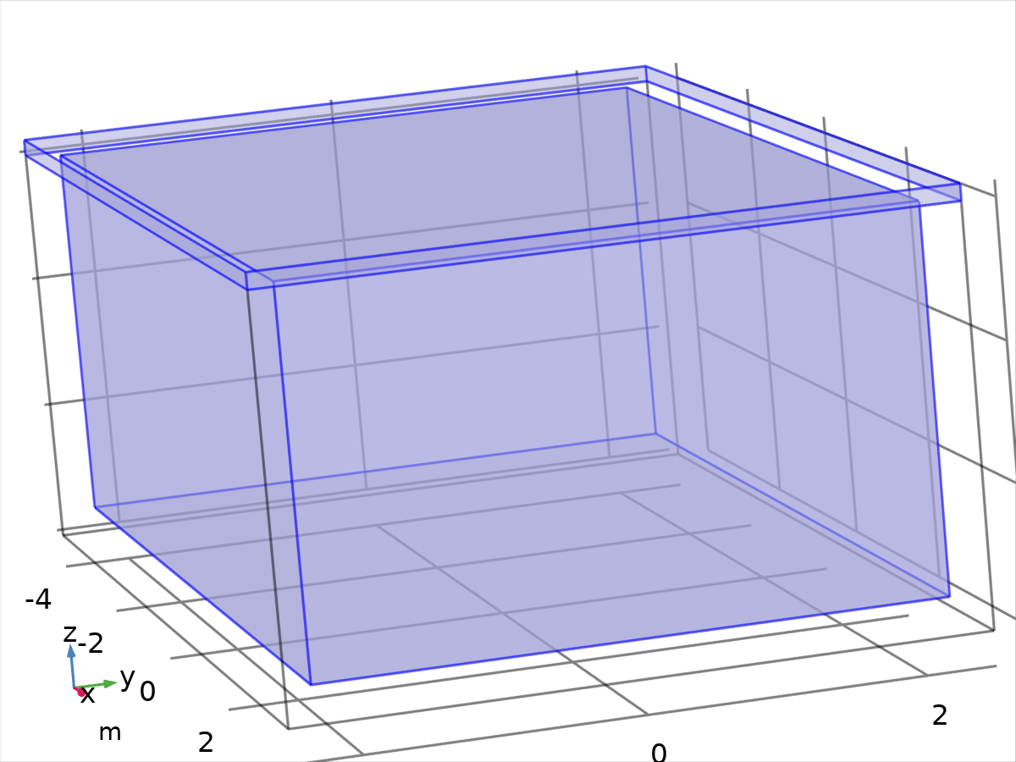

Thermal Insulation 1

Selection

|  |  |
| --- | --- |
| Geometric entity level | Boundary |
| Selection | Boundaries 4–5, 9–15, 17 |

Equations



#### Variables

| **Name** | **Expression** | **Unit** | **Description** | **Selection** |
| --- | --- | --- | --- | --- |
| ht.ins1.Tave | nojac(ht.ins1.intBnd(ht.ins1.varIntSpa*ht.rho*ht.Cp*T*max(abs(ht.ux*ht.nx+ht.uy*ht.ny+ht.uz*ht.nz),eps)))/nojac(ht.ins1.intBnd(ht.ins1.varIntSpa*ht.rho*ht.Cp*max(abs(ht.ux*ht.nx+ht.uy*ht.ny+ht.uz*ht.nz),eps))) | K | Weighted average temperature | Global |
| ht.ins1.ntfluxInt | ht.ins1.intExtBnd(ht.ntflux*ht.ins1.varIntSpa) | W | Total net heat rate | Global |
| ht.ins1.ntefluxInt | ht.ins1.intExtBnd(ht.nteflux*ht.ins1.varIntSpa) | W | Total net energy rate | Global |
| ht.ins1.ntfluxInt_u | ht.ins1.intIntBnd(ht.ntflux_u*ht.ins1.varIntSpa) | W | Total net heat rate, upside | Global |
| ht.ins1.ntefluxInt_u | ht.ins1.intIntBnd(ht.nteflux_u*ht.ins1.varIntSpa) | W | Total net energy rate, upside | Global |
| ht.ins1.ntfluxInt_d | ht.ins1.intIntBnd(ht.ntflux_d*ht.ins1.varIntSpa) | W | Total net heat rate, downside | Global |
| ht.ins1.ntefluxInt_d | ht.ins1.intIntBnd(ht.nteflux_d*ht.ins1.varIntSpa) | W | Total net energy rate, downside | Global |
| ht.ins1.varIntSpa | ht.d | 1 | Intermediate variable | Boundaries 4–5, 9–15, 17 |

#### Shape functions

| **Name** | **Shape function** | **Unit** | **Description** | **Shape frame** | **Selection** | **Details** |
| --- | --- | --- | --- | --- | --- | --- |
| T | Lagrange (Quadratic) | K | Temperature | Spatial | No boundaries | Slit |
| T | Lagrange (Quadratic) | K | Temperature | Material | No boundaries | Slit |
| T | Lagrange (Quadratic) | K | Temperature | Geometry | No boundaries | Slit |
| T | Lagrange (Quadratic) | K | Temperature | Mesh | No boundaries | Slit |

* + 1. Heat Flux 1

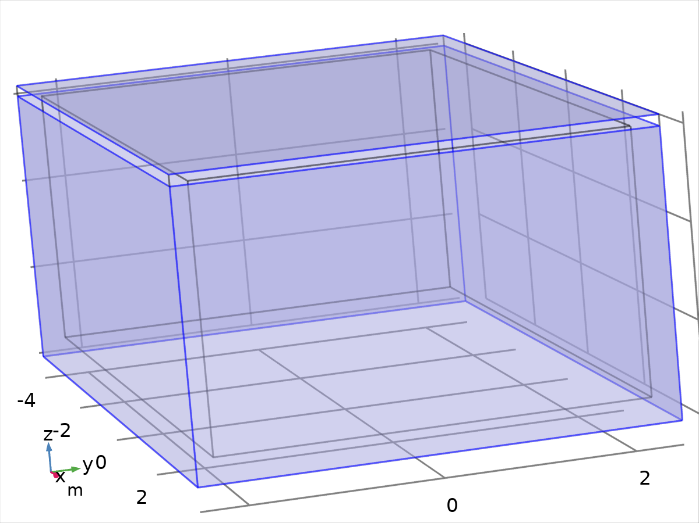

Heat Flux 1

Selection

|  |  |
| --- | --- |
| Geometric entity level | Boundary |
| Selection | Boundaries 1–2, 7–8, 16 |

Equations





#### Heat flux

Settings

| **Description** | **Value** |
| --- | --- |
| Heat flux | Convective heat flux |
| Heat transfer coefficient | User defined |
| Heat transfer coefficient | 10 |
| External temperature | User defined |
| External temperature | Toutdoor(t) |

#### Variables

| **Name** | **Expression** | **Unit** | **Description** | **Selection** | **Details** |
| --- | --- | --- | --- | --- | --- |
| ht.q0 | ht.hf1.q0 | W/m² | Inward heat flux | Boundaries 1–2, 7–8, 16 | + operation |
| ht.hf1.h | 10 | W/(m²·K) | Heat transfer coefficient | Boundaries 1–2, 7–8, 16 |  |
| ht.hf1.Text | Toutdoor(t) | K | External temperature | Boundaries 1–2, 7–8, 16 |  |
| ht.hf1.q0 | ht.hf1.h*(ht.hf1.Text-ht.hf1.Tvar) | W/m² | Boundary convective heat flux | Boundaries 1–2, 7–8, 16 | + operation |
| ht.hf1.Tvar | ht.Tu | K | Temperature | Boundaries 1–2, 7–8, 16 |  |
| ht.hf1.Tave | nojac(ht.hf1.intBnd(ht.hf1.varIntSpa*ht.rho*ht.Cp*T*max(abs(ht.ux*ht.nx+ht.uy*ht.ny+ht.uz*ht.nz),eps)))/nojac(ht.hf1.intBnd(ht.hf1.varIntSpa*ht.rho*ht.Cp*max(abs(ht.ux*ht.nx+ht.uy*ht.ny+ht.uz*ht.nz),eps))) | K | Weighted average temperature | Global |  |
| ht.hf1.ntfluxInt | ht.hf1.intExtBnd(ht.ntflux*ht.hf1.varIntSpa) | W | Total net heat rate | Global |  |
| ht.hf1.ntefluxInt | ht.hf1.intExtBnd(ht.nteflux*ht.hf1.varIntSpa) | W | Total net energy rate | Global |  |
| ht.hf1.ntfluxInt_u | ht.hf1.intIntBnd(ht.ntflux_u*ht.hf1.varIntSpa) | W | Total net heat rate, upside | Global |  |
| ht.hf1.ntefluxInt_u | ht.hf1.intIntBnd(ht.nteflux_u*ht.hf1.varIntSpa) | W | Total net energy rate, upside | Global |  |
| ht.hf1.ntfluxInt_d | ht.hf1.intIntBnd(ht.ntflux_d*ht.hf1.varIntSpa) | W | Total net heat rate, downside | Global |  |
| ht.hf1.ntefluxInt_d | ht.hf1.intIntBnd(ht.nteflux_d*ht.hf1.varIntSpa) | W | Total net energy rate, downside | Global |  |
| ht.hf1.varIntSpa | ht.d | 1 | Intermediate variable | Boundaries 1–2, 7–8, 16 |  |

#### Weak expressions

| **Weak expression** | **Integration order** | **Integration frame** | **Selection** |
| --- | --- | --- | --- |
| ht.hf1.q0*test(ht.hf1.Tvar)*ht.d | 4 | Spatial | Boundaries 1–2, 7–8, 16 |

* + 1. Temperature 1

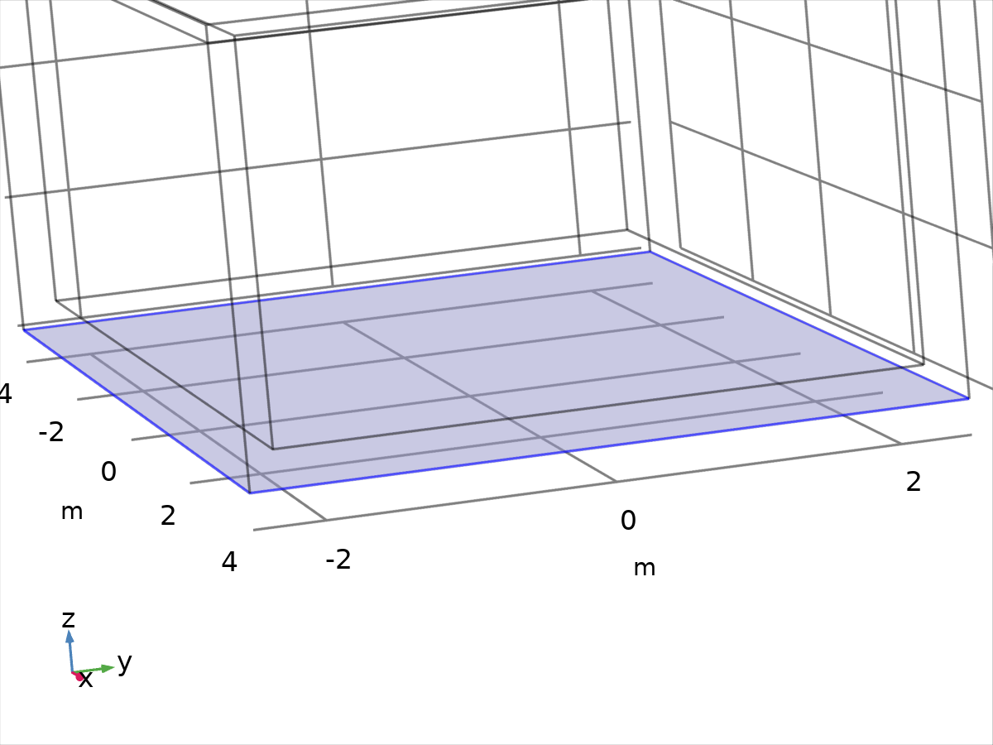

Temperature 1

Selection

|  |  |
| --- | --- |
| Geometric entity level | Boundary |
| Selection | Boundary 3 |

Equations



#### Temperature

Settings

| **Description** | **Value** |
| --- | --- |
| Temperature | User defined |
| Temperature | 300.15[K] |

#### Variables

| **Name** | **Expression** | **Unit** | **Description** | **Selection** | **Details** |
| --- | --- | --- | --- | --- | --- |
| ht.T0 | 300.15[K] | K | Temperature | Boundary 3 | + operation |
| ht.temp1.Tave | nojac(ht.temp1.intBnd(ht.temp1.varIntSpa*ht.rho*ht.Cp*T*max(abs(ht.ux*ht.nx+ht.uy*ht.ny+ht.uz*ht.nz),eps)))/nojac(ht.temp1.intBnd(ht.temp1.varIntSpa*ht.rho*ht.Cp*max(abs(ht.ux*ht.nx+ht.uy*ht.ny+ht.uz*ht.nz),eps))) | K | Weighted average temperature | Global |  |
| ht.temp1.ntfluxInt | ht.temp1.intExtBnd(ht.ntflux*ht.temp1.varIntSpa) | W | Total net heat rate | Global |  |
| ht.temp1.ntefluxInt | ht.temp1.intExtBnd(ht.nteflux*ht.temp1.varIntSpa) | W | Total net energy rate | Global |  |
| ht.temp1.ntfluxInt_u | ht.temp1.intIntBnd(ht.ntflux_u*ht.temp1.varIntSpa) | W | Total net heat rate, upside | Global |  |
| ht.temp1.ntefluxInt_u | ht.temp1.intIntBnd(ht.nteflux_u*ht.temp1.varIntSpa) | W | Total net energy rate, upside | Global |  |
| ht.temp1.ntfluxInt_d | ht.temp1.intIntBnd(ht.ntflux_d*ht.temp1.varIntSpa) | W | Total net heat rate, downside | Global |  |
| ht.temp1.ntefluxInt_d | ht.temp1.intIntBnd(ht.nteflux_d*ht.temp1.varIntSpa) | W | Total net energy rate, downside | Global |  |
| ht.temp1.varIntSpa | ht.d | 1 | Intermediate variable | Boundary 3 |  |

#### Constraints

| **Constraint** | **Constraint force** | **Shape function** | **Selection** | **Details** |
| --- | --- | --- | --- | --- |
| ht.T0-ht.Tvar | test(ht.T0-ht.Tvar) | Lagrange (Quadratic) | Boundary 3 | Elemental |

* 1. Mesh 1

Mesh statistics

| **Description** | **Value** |
| --- | --- |
| Minimum element quality | 0.2307 |
| Average element quality | 0.777 |
| Tetrahedron | 19119 |
| Triangle | 12448 |
| Edge element | 664 |
| Vertex element | 20 |

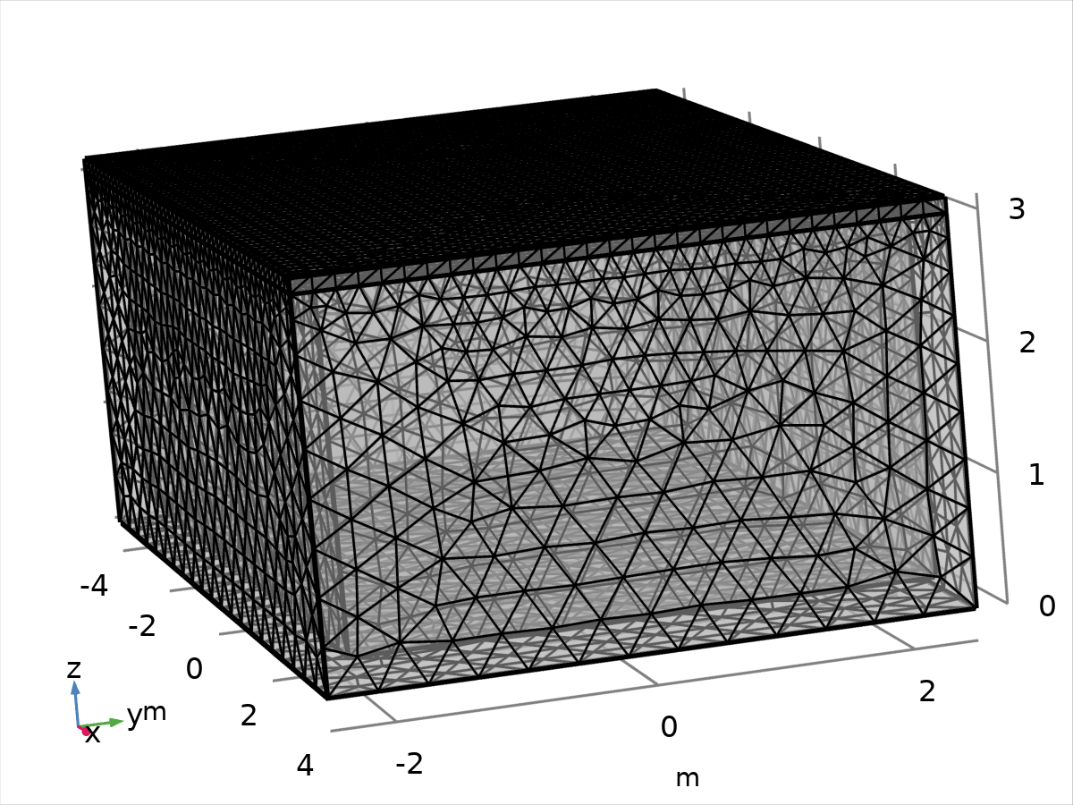

Mesh 1

* + 1. Size (size)

Settings

| **Description** | **Value** |
| --- | --- |
| Maximum element size | 0.44 |
| Minimum element size | 0.032 |
| Curvature factor | 0.4 |
| Resolution of narrow regions | 0.7 |
| Maximum element growth rate | 1.4 |
| Predefined size | Finer |

* + 1. Free Tetrahedral 1 (ftet1)

Selection

|  |  |
| --- | --- |
| Geometric entity level | Remaining |

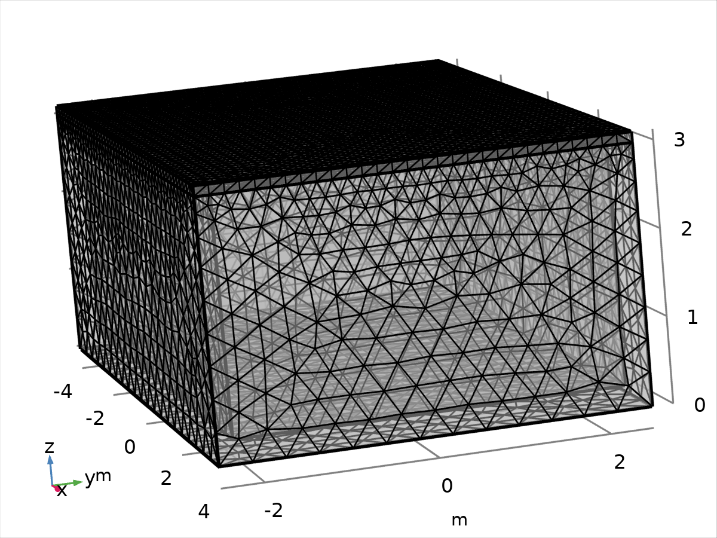

Free Tetrahedral 1

1. Study 1

Computation information

|  |  |
| --- | --- |
| Computation time | 3 min 33 s |
| CPU | AMD64 Family 25 Model 80 Stepping 0, 8 cores |
| Operating system | Windows 10 |

* 1. Time Dependent

| **Times** | **Unit** |
| --- | --- |
| range(0, 0.05, 48) | h |

Study settings

| **Description** | **Value** |
| --- | --- |
| Include geometric nonlinearity | Off |

Mesh selection

| **Geometry** | **Mesh** |
| --- | --- |
| mesh1 | mesh1 |

Physics and variables selection

| **Physics interface** | **Discretization** |
| --- | --- |
| Heat Transfer in Solids (ht) | physics |

Mesh selection

| **Geometry** | **Mesh** |
| --- | --- |
| Geometry 1 (geom1) | mesh1 |

* 1. Solver Configurations
     1. Solution 1

#### Compile Equations: Time Dependent (st1)

Study and step

| **Description** | **Value** |
| --- | --- |
| Use study | Study 1 |
| Use study step | Time Dependent |

Log

<---- Compile Equations: Time Dependent in Study 1/Solution 1 (sol1) -----------

Started at Apr 28, 2025 3:14:12 PM.

Geometry shape order: Quadratic

Running on AMD64 Family 25 Model 80 Stepping 0, AuthenticAMD.

Using 1 socket with 8 cores in total on LAPTOP-4NK4IIF2.

Available memory: 15.77 GB.

Time: 2 s.

Physical memory: 2.26 GB

Virtual memory: 2.76 GB

Ended at Apr 28, 2025 3:14:14 PM.

----- Compile Equations: Time Dependent in Study 1/Solution 1 (sol1) ---------->

#### Dependent Variables 1 (v1)

General

| **Description** | **Value** |
| --- | --- |
| Defined by study step | Time Dependent |

Residual scaling

| **Description** | **Value** |
| --- | --- |
| Method | Manual |

Initial value calculation constants

| **Constant name** | **Initial value source** |
| --- | --- |
| t | range(0, 0.05, 48) |
| timestep | 0.048[h] |

Log

<---- Dependent Variables 1 in Study 1/Solution 1 (sol1) -----------------------

Started at Apr 28, 2025 3:14:15 PM.

Solution time: 0 s.

Physical memory: 2.26 GB

Virtual memory: 2.76 GB

Ended at Apr 28, 2025 3:14:15 PM.

----- Dependent Variables 1 in Study 1/Solution 1 (sol1) ---------------------->

##### Temperature (comp1.T) (comp1_T)

General

| **Description** | **Value** |
| --- | --- |
| Field components | comp1.T |

#### Time-Dependent Solver 1 (t1)

General

| **Description** | **Value** |
| --- | --- |
| Defined by study step | Time Dependent |
| Times | {0, 0.05, 0.1, 0.15000000000000002, 0.2, 0.25, 0.30000000000000004, 0.35000000000000003, 0.4, 0.45, 0.5, 0.55, 0.6000000000000001, 0.65, 0.7000000000000001, 0.75, 0.8, 0.8500000000000001, 0.9, 0.9500000000000001, 1, 1.05, 1.1, 1.1500000000000001, 1.2000000000000002, 1.25, 1.3, 1.35, 1.4000000000000001, 1.4500000000000002, 1.5, 1.55, 1.6, 1.6500000000000001, 1.7000000000000002, 1.75, 1.8, 1.85, 1.9000000000000001, 1.9500000000000002, 2, 2.0500000000000003, 2.1, 2.15, 2.2, 2.25, 2.3000000000000003, 2.35, 2.4000000000000004, 2.45, 2.5, 2.5500000000000003, 2.6, 2.6500000000000004, 2.7, 2.75, 2.8000000000000003, 2.85, 2.9000000000000004, 2.95, 3, 3.0500000000000003, 3.1, 3.1500000000000004, 3.2, 3.25, 3.3000000000000003, 3.35, 3.4000000000000004, 3.45, 3.5, 3.5500000000000003, 3.6, 3.6500000000000004, 3.7, 3.75, 3.8000000000000003, 3.85, 3.9000000000000004, 3.95, 4, 4.05, 4.1000000000000005, 4.15, 4.2, 4.25, 4.3, 4.3500000000000005, 4.4, 4.45, 4.5, 4.55, 4.6000000000000005, 4.65, 4.7, 4.75, 4.800000000000001, 4.8500000000000005, 4.9, 4.95, 5, 5.050000000000001, 5.1000000000000005, 5.15, 5.2, 5.25, 5.300000000000001, 5.3500000000000005, 5.4, 5.45, 5.5, 5.550000000000001, 5.6000000000000005, 5.65, 5.7, 5.75, 5.800000000000001, 5.8500000000000005, 5.9, 5.95, 6, 6.050000000000001, 6.1000000000000005, 6.15, 6.2, 6.25, 6.300000000000001, 6.3500000000000005, 6.4, 6.45, 6.5, 6.550000000000001, 6.6000000000000005, 6.65, 6.7, 6.75, 6.800000000000001, 6.8500000000000005, 6.9, 6.95, 7, 7.050000000000001, 7.1000000000000005, 7.15, 7.2, 7.25, 7.300000000000001, 7.3500000000000005, 7.4, 7.45, 7.5, 7.550000000000001, 7.6000000000000005, 7.65, 7.7, 7.75, 7.800000000000001, 7.8500000000000005, 7.9, 7.95, 8, 8.05, 8.1, 8.15, 8.200000000000001, 8.25, 8.3, 8.35, 8.4, 8.450000000000001, 8.5, 8.55, 8.6, 8.65, 8.700000000000001, 8.75, 8.8, 8.85, 8.9, 8.950000000000001, 9, 9.05, 9.1, 9.15, 9.200000000000001, 9.25, 9.3, 9.35, 9.4, 9.450000000000001, 9.5, 9.55, 9.600000000000001, 9.65, 9.700000000000001, 9.75, 9.8, 9.850000000000001, 9.9, 9.950000000000001, 10, 10.05, 10.100000000000001, 10.15, 10.200000000000001, 10.25, 10.3, 10.350000000000001, 10.4, 10.450000000000001, 10.5, 10.55, 10.600000000000001, 10.65, 10.700000000000001, 10.75, 10.8, 10.850000000000001, 10.9, 10.950000000000001, 11, 11.05, 11.100000000000001, 11.15, 11.200000000000001, 11.25, 11.3, 11.350000000000001, 11.4, 11.450000000000001, 11.5, 11.55, 11.600000000000001, 11.65, 11.700000000000001, 11.75, 11.8, 11.850000000000001, 11.9, 11.950000000000001, 12, 12.05, 12.100000000000001, 12.15, 12.200000000000001, 12.25, 12.3, 12.350000000000001, 12.4, 12.450000000000001, 12.5, 12.55, 12.600000000000001, 12.65, 12.700000000000001, 12.75, 12.8, 12.850000000000001, 12.9, 12.950000000000001, 13, 13.05, 13.100000000000001, 13.15, 13.200000000000001, 13.25, 13.3, 13.350000000000001, 13.4, 13.450000000000001, 13.5, 13.55, 13.600000000000001, 13.65, 13.700000000000001, 13.75, 13.8, 13.850000000000001, 13.9, 13.950000000000001, 14, 14.05, 14.100000000000001, 14.15, 14.200000000000001, 14.25, 14.3, 14.350000000000001, 14.4, 14.450000000000001, 14.5, 14.55, 14.600000000000001, 14.65, 14.700000000000001, 14.75, 14.8, 14.850000000000001, 14.9, 14.950000000000001, 15, 15.05, 15.100000000000001, 15.15, 15.200000000000001, 15.25, 15.3, 15.350000000000001, 15.4, 15.450000000000001, 15.5, 15.55, 15.600000000000001, 15.65, 15.700000000000001, 15.75, 15.8, 15.850000000000001, 15.9, 15.950000000000001, 16, 16.05, 16.1, 16.150000000000002, 16.2, 16.25, 16.3, 16.35, 16.400000000000002, 16.45, 16.5, 16.55, 16.6, 16.650000000000002, 16.7, 16.75, 16.8, 16.85, 16.900000000000002, 16.95, 17, 17.05, 17.1, 17.150000000000002, 17.2, 17.25, 17.3, 17.35, 17.400000000000002, 17.45, 17.5, 17.55, 17.6, 17.650000000000002, 17.7, 17.75, 17.8, 17.85, 17.900000000000002, 17.95, 18, 18.05, 18.1, 18.150000000000002, 18.2, 18.25, 18.3, 18.35, 18.400000000000002, 18.45, 18.5, 18.55, 18.6, 18.650000000000002, 18.7, 18.75, 18.8, 18.85, 18.900000000000002, 18.95, 19, 19.05, 19.1, 19.150000000000002, 19.200000000000003, 19.25, 19.3, 19.35, 19.400000000000002, 19.450000000000003, 19.5, 19.55, 19.6, 19.650000000000002, 19.700000000000003, 19.75, 19.8, 19.85, 19.900000000000002, 19.950000000000003, 20, 20.05, 20.1, 20.150000000000002, 20.200000000000003, 20.25, 20.3, 20.35, 20.400000000000002, 20.450000000000003, 20.5, 20.55, 20.6, 20.650000000000002, 20.700000000000003, 20.75, 20.8, 20.85, 20.900000000000002, 20.950000000000003, 21, 21.05, 21.1, 21.150000000000002, 21.200000000000003, 21.25, 21.3, 21.35, 21.400000000000002, 21.450000000000003, 21.5, 21.55, 21.6, 21.650000000000002, 21.700000000000003, 21.75, 21.8, 21.85, 21.900000000000002, 21.950000000000003, 22, 22.05, 22.1, 22.150000000000002, 22.200000000000003, 22.25, 22.3, 22.35, 22.400000000000002, 22.450000000000003, 22.5, 22.55, 22.6, 22.650000000000002, 22.700000000000003, 22.75, 22.8, 22.85, 22.900000000000002, 22.950000000000003, 23, 23.05, 23.1, 23.150000000000002, 23.200000000000003, 23.25, 23.3, 23.35, 23.400000000000002, 23.450000000000003, 23.5, 23.55, 23.6, 23.650000000000002, 23.700000000000003, 23.75, 23.8, 23.85, 23.900000000000002, 23.950000000000003, 24, 24.05, 24.1, 24.150000000000002, 24.200000000000003, 24.25, 24.3, 24.35, 24.400000000000002, 24.450000000000003, 24.5, 24.55, 24.6, 24.650000000000002, 24.700000000000003, 24.75, 24.8, 24.85, 24.900000000000002, 24.950000000000003, 25, 25.05, 25.1, 25.150000000000002, 25.200000000000003, 25.25, 25.3, 25.35, 25.400000000000002, 25.450000000000003, 25.5, 25.55, 25.6, 25.650000000000002, 25.700000000000003, 25.75, 25.8, 25.85, 25.900000000000002, 25.950000000000003, 26, 26.05, 26.1, 26.150000000000002, 26.200000000000003, 26.25, 26.3, 26.35, 26.400000000000002, 26.450000000000003, 26.5, 26.55, 26.6, 26.650000000000002, 26.700000000000003, 26.75, 26.8, 26.85, 26.900000000000002, 26.950000000000003, 27, 27.05, 27.1, 27.150000000000002, 27.200000000000003, 27.25, 27.3, 27.35, 27.400000000000002, 27.450000000000003, 27.5, 27.55, 27.6, 27.650000000000002, 27.700000000000003, 27.75, 27.8, 27.85, 27.900000000000002, 27.950000000000003, 28, 28.05, 28.1, 28.150000000000002, 28.200000000000003, 28.25, 28.3, 28.35, 28.400000000000002, 28.450000000000003, 28.5, 28.55, 28.6, 28.650000000000002, 28.700000000000003, 28.75, 28.8, 28.85, 28.900000000000002, 28.950000000000003, 29, 29.05, 29.1, 29.150000000000002, 29.200000000000003, 29.25, 29.3, 29.35, 29.400000000000002, 29.450000000000003, 29.5, 29.55, 29.6, 29.650000000000002, 29.700000000000003, 29.75, 29.8, 29.85, 29.900000000000002, 29.950000000000003, 30, 30.05, 30.1, 30.150000000000002, 30.200000000000003, 30.25, 30.3, 30.35, 30.400000000000002, 30.450000000000003, 30.5, 30.55, 30.6, 30.650000000000002, 30.700000000000003, 30.75, 30.8, 30.85, 30.900000000000002, 30.950000000000003, 31, 31.05, 31.1, 31.150000000000002, 31.200000000000003, 31.25, 31.3, 31.35, 31.400000000000002, 31.450000000000003, 31.5, 31.55, 31.6, 31.650000000000002, 31.700000000000003, 31.75, 31.8, 31.85, 31.900000000000002, 31.950000000000003, 32, 32.050000000000004, 32.1, 32.15, 32.2, 32.25, 32.300000000000004, 32.35, 32.4, 32.45, 32.5, 32.550000000000004, 32.6, 32.65, 32.7, 32.75, 32.800000000000004, 32.85, 32.9, 32.95, 33, 33.050000000000004, 33.1, 33.15, 33.2, 33.25, 33.300000000000004, 33.35, 33.4, 33.45, 33.5, 33.550000000000004, 33.6, 33.65, 33.7, 33.75, 33.800000000000004, 33.85, 33.9, 33.95, 34, 34.050000000000004, 34.1, 34.15, 34.2, 34.25, 34.300000000000004, 34.35, 34.4, 34.45, 34.5, 34.550000000000004, 34.6, 34.65, 34.7, 34.75, 34.800000000000004, 34.85, 34.9, 34.95, 35, 35.050000000000004, 35.1, 35.15, 35.2, 35.25, 35.300000000000004, 35.35, 35.4, 35.45, 35.5, 35.550000000000004, 35.6, 35.65, 35.7, 35.75, 35.800000000000004, 35.85, 35.9, 35.95, 36, 36.050000000000004, 36.1, 36.15, 36.2, 36.25, 36.300000000000004, 36.35, 36.4, 36.45, 36.5, 36.550000000000004, 36.6, 36.65, 36.7, 36.75, 36.800000000000004, 36.85, 36.9, 36.95, 37, 37.050000000000004, 37.1, 37.15, 37.2, 37.25, 37.300000000000004, 37.35, 37.4, 37.45, 37.5, 37.550000000000004, 37.6, 37.65, 37.7, 37.75, 37.800000000000004, 37.85, 37.9, 37.95, 38, 38.050000000000004, 38.1, 38.15, 38.2, 38.25, 38.300000000000004, 38.35, 38.400000000000006, 38.45, 38.5, 38.550000000000004, 38.6, 38.650000000000006, 38.7, 38.75, 38.800000000000004, 38.85, 38.900000000000006, 38.95, 39, 39.050000000000004, 39.1, 39.150000000000006, 39.2, 39.25, 39.300000000000004, 39.35, 39.400000000000006, 39.45, 39.5, 39.550000000000004, 39.6, 39.650000000000006, 39.7, 39.75, 39.800000000000004, 39.85, 39.900000000000006, 39.95, 40, 40.050000000000004, 40.1, 40.150000000000006, 40.2, 40.25, 40.300000000000004, 40.35, 40.400000000000006, 40.45, 40.5, 40.550000000000004, 40.6, 40.650000000000006, 40.7, 40.75, 40.800000000000004, 40.85, 40.900000000000006, 40.95, 41, 41.050000000000004, 41.1, 41.150000000000006, 41.2, 41.25, 41.300000000000004, 41.35, 41.400000000000006, 41.45, 41.5, 41.550000000000004, 41.6, 41.650000000000006, 41.7, 41.75, 41.800000000000004, 41.85, 41.900000000000006, 41.95, 42, 42.050000000000004, 42.1, 42.150000000000006, 42.2, 42.25, 42.300000000000004, 42.35, 42.400000000000006, 42.45, 42.5, 42.550000000000004, 42.6, 42.650000000000006, 42.7, 42.75, 42.800000000000004, 42.85, 42.900000000000006, 42.95, 43, 43.050000000000004, 43.1, 43.150000000000006, 43.2, 43.25, 43.300000000000004, 43.35, 43.400000000000006, 43.45, 43.5, 43.550000000000004, 43.6, 43.650000000000006, 43.7, 43.75, 43.800000000000004, 43.85, 43.900000000000006, 43.95, 44, 44.050000000000004, 44.1, 44.150000000000006, 44.2, 44.25, 44.300000000000004, 44.35, 44.400000000000006, 44.45, 44.5, 44.550000000000004, 44.6, 44.650000000000006, 44.7, 44.75, 44.800000000000004, 44.85, 44.900000000000006, 44.95, 45, 45.050000000000004, 45.1, 45.150000000000006, 45.2, 45.25, 45.300000000000004, 45.35, 45.400000000000006, 45.45, 45.5, 45.550000000000004, 45.6, 45.650000000000006, 45.7, 45.75, 45.800000000000004, 45.85, 45.900000000000006, 45.95, 46, 46.050000000000004, 46.1, 46.150000000000006, 46.2, 46.25, 46.300000000000004, 46.35, 46.400000000000006, 46.45, 46.5, 46.550000000000004, 46.6, 46.650000000000006, 46.7, 46.75, 46.800000000000004, 46.85, 46.900000000000006, 46.95, 47, 47.050000000000004, 47.1, 47.150000000000006, 47.2, 47.25, 47.300000000000004, 47.35, 47.400000000000006, 47.45, 47.5, 47.550000000000004, 47.6, 47.650000000000006, 47.7, 47.75, 47.800000000000004, 47.85, 47.900000000000006, 47.95, 48} |

Time stepping

| **Description** | **Value** |
| --- | --- |
| Maximum BDF order | 2 |
| Error estimation | Exclude algebraic |

Results while solving

| **Description** | **Value** |
| --- | --- |
| Plot | On |
| Plot group | Temperature (ht) |

Log

   -       17640           - out

   -       17820           - out

   -       18000           - out

   -       18180           - out

   -       18360           - out

   -       18540           - out

   -       18720           - out

   -       18900           - out

   -       19080           - out

   -       19260           - out

   -       19440           - out

   -       19620           - out

   -       19800           - out

   -       19980           - out

   -       20160           - out

   -       20340           - out

   -       20520           - out

   -       20700           - out

   -       20880           - out

   -       21060           - out

   -       21240           - out

   -       21420           - out

   -       21600           - out

   -       21780           - out

   -       21960           - out

   -       22140           - out

   -       22320           - out

   -       22500           - out

   -       22680           - out

   -       22860           - out

   -       23040           - out

   -       23220           - out

   -       23400           - out

   -       23580           - out

   -       23760           - out

   -       23940           - out

   -       24120           - out

   -       24300           - out

   -       24480           - out

   -       24660           - out

   -       24840           - out

   -       25020           - out

  13       25139       12570       29   16   29     1     0      0  3.4e-14  2.1e-14

   -       25200           - out

   -       25380           - out

   -       25560           - out

   -       25740           - out

   -       25920           - out

   -       26100           - out

   -       26280           - out

   -       26460           - out

   -       26640           - out

   -       26820           - out

   -       27000           - out

   -       27180           - out

   -       27360           - out

   -       27540           - out

   -       27720           - out

   -       27900           - out

   -       28080           - out

   -       28260           - out

   -       28440           - out

   -       28620           - out

   -       28800           - out

   -       28980           - out

   -       29160           - out

   -       29340           - out

   -       29520           - out

   -       29700           - out

   -       29880           - out

   -       30060           - out

   -       30240           - out

   -       30420           - out

   -       30600           - out

   -       30780           - out

   -       30960           - out

   -       31140           - out

   -       31320           - out

   -       31500           - out

   -       31680           - out

   -       31860           - out

   -       32040           - out

   -       32220           - out

   -       32400           - out

   -       32580           - out

   -       32760           - out

   -       32940           - out

   -       33120           - out

   -       33300           - out

   -       33480           - out

   -       33660           - out

   -       33840           - out

   -       34020           - out

   -       34200           - out

   -       34380           - out

   -       34560           - out

   -       34740           - out

   -       34920           - out

   -       35100           - out

   -       35280           - out

   -       35460           - out

   -       35640           - out

   -       35820           - out

   -       36000           - out

   -       36180           - out

   -       36360           - out

  14       36383       11244       31   17   31     1     0      0  1.1e-13  2.2e-14

   -       36540           - out

   -       36720           - out

   -       36900           - out

   -       37080           - out

   -       37260           - out

   -       37440           - out

   -       37620           - out

   -       37800           - out

   -       37980           - out

   -       38160           - out

   -       38340           - out

   -       38520           - out

   -       38700           - out

   -       38880           - out

   -       39060           - out

   -       39240           - out

   -       39420           - out

   -       39600           - out

   -       39780           - out

   -       39960           - out

   -       40140           - out

   -       40320           - out

   -       40500           - out

   -       40680           - out

   -       40860           - out

   -       41040           - out

   -       41220           - out

   -       41400           - out

   -       41580           - out

   -       41760           - out

   -       41940           - out

   -       42120           - out

   -       42300           - out

   -       42480           - out

   -       42660           - out

   -       42840           - out

   -       43020           - out

   -       43200           - out

   -       43380           - out

   -       43560           - out

   -       43740           - out

   -       43920           - out

   -       44100           - out

   -       44280           - out

   -       44460           - out

   -       44640           - out

   -       44820           - out

   -       45000           - out

   -       45180           - out

   -       45360           - out

   -       45540           - out

   -       45720           - out

   -       45900           - out

   -       46080           - out

   -       46260           - out

   -       46440           - out

  15       46502       10119       33   18   33     1     0      0  3.2e-14  1.8e-14

   -       46620           - out

   -       46800           - out

   -       46980           - out

   -       47160           - out

   -       47340           - out

   -       47520           - out

   -       47700           - out

   -       47880           - out

   -       48060           - out

   -       48240           - out

   -       48420           - out

   -       48600           - out

   -       48780           - out

   -       48960           - out

   -       49140           - out

   -       49320           - out

   -       49500           - out

   -       49680           - out

   -       49860           - out

   -       50040           - out

   -       50220           - out

   -       50400           - out

   -       50580           - out

   -       50760           - out

   -       50940           - out

   -       51120           - out

   -       51300           - out

   -       51480           - out

   -       51660           - out

   -       51840           - out

   -       52020           - out

   -       52200           - out

   -       52380           - out

   -       52560           - out

   -       52740           - out

   -       52920           - out

   -       53100           - out

   -       53280           - out

   -       53460           - out

   -       53640           - out

   -       53820           - out

   -       54000           - out

   -       54180           - out

   -       54360           - out

   -       54540           - out

   -       54720           - out

   -       54900           - out

   -       55080           - out

   -       55260           - out

   -       55440           - out

   -       55620           - out

   -       55800           - out

   -       55980           - out

   -       56160           - out

   -       56340           - out

   -       56520           - out

  16       56622       10119       35   19   35     1     0      0  1.9e-14  2.1e-14

   -       56700           - out

   -       56880           - out

   -       57060           - out

   -       57240           - out

   -       57420           - out

   -       57600           - out

   -       57780           - out

   -       57960           - out

   -       58140           - out

   -       58320           - out

   -       58500           - out

   -       58680           - out

   -       58860           - out

   -       59040           - out

   -       59220           - out

   -       59400           - out

   -       59580           - out

   -       59760           - out

   -       59940           - out

   -       60120           - out

   -       60300           - out

   -       60480           - out

   -       60660           - out

   -       60840           - out

   -       61020           - out

   -       61200           - out

   -       61380           - out

   -       61560           - out

   -       61740           - out

   -       61920           - out

   -       62100           - out

   -       62280           - out

   -       62460           - out

   -       62640           - out

   -       62820           - out

   -       63000           - out

   -       63180           - out

   -       63360           - out

   -       63540           - out

   -       63720           - out

   -       63900           - out

   -       64080           - out

   -       64260           - out

   -       64440           - out

   -       64620           - out

   -       64800           - out

   -       64980           - out

   -       65160           - out

   -       65340           - out

   -       65520           - out

   -       65700           - out

   -       65880           - out

   -       66060           - out

   -       66240           - out

   -       66420           - out

  17       66599      9976.8       39   21   39     1     1      0  3.1e-14  2.3e-14

   -       66600           - out

   -       66780           - out

   -       66960           - out

   -       67140           - out

   -       67320           - out

   -       67500           - out

   -       67680           - out

   -       67860           - out

   -       68040           - out

   -       68220           - out

   -       68400           - out

   -       68580           - out

   -       68760           - out

   -       68940           - out

   -       69120           - out

   -       69300           - out

   -       69480           - out

   -       69660           - out

   -       69840           - out

   -       70020           - out

   -       70200           - out

   -       70380           - out

   -       70560           - out

   -       70740           - out

   -       70920           - out

   -       71100           - out

   -       71280           - out

   -       71460           - out

   -       71640           - out

   -       71820           - out

   -       72000           - out

   -       72180           - out

   -       72360           - out

   -       72540           - out

   -       72720           - out

   -       72900           - out

   -       73080           - out

   -       73260           - out

   -       73440           - out

   -       73620           - out

   -       73800           - out

   -       73980           - out

   -       74160           - out

   -       74340           - out

   -       74520           - out

   -       74700           - out

   -       74880           - out

   -       75060           - out

   -       75240           - out

   -       75420           - out

   -       75600           - out

   -       75780           - out

   -       75960           - out

   -       76140           - out

   -       76320           - out

   -       76500           - out

  18       76575      9976.8       41   22   41     1     1      0    2e-14  2.1e-14

   -       76680           - out

   -       76860           - out

   -       77040           - out

   -       77220           - out

   -       77400           - out

   -       77580           - out

   -       77760           - out

   -       77940           - out

   -       78120           - out

   -       78300           - out

   -       78480           - out

   -       78660           - out

   -       78840           - out

   -       79020           - out

   -       79200           - out

   -       79380           - out

   -       79560           - out

   -       79740           - out

   -       79920           - out

   -       80100           - out

   -       80280           - out

   -       80460           - out

   -       80640           - out

   -       80820           - out

   -       81000           - out

   -       81180           - out

   -       81360           - out

   -       81540           - out

   -       81720           - out

   -       81900           - out

   -       82080           - out

   -       82260           - out

   -       82440           - out

   -       82620           - out

   -       82800           - out

   -       82980           - out

   -       83160           - out

   -       83340           - out

   -       83520           - out

   -       83700           - out

   -       83880           - out

   -       84060           - out

   -       84240           - out

   -       84420           - out

   -       84600           - out

   -       84780           - out

   -       84960           - out

   -       85140           - out

   -       85320           - out

   -       85500           - out

   -       85680           - out

   -       85860           - out

   -       86040           - out

   -       86220           - out

   -       86400           - out

  19       86552      9976.8       43   23   43     1     1      0  3.4e-14  1.9e-14

   -       86580           - out

   -       86760           - out

   -       86940           - out

   -       87120           - out

   -       87300           - out

   -       87480           - out

   -       87660           - out

   -       87840           - out

   -       88020           - out

   -       88200           - out

   -       88380           - out

   -       88560           - out

   -       88740           - out

   -       88920           - out

   -       89100           - out

   -       89280           - out

   -       89460           - out

   -       89640           - out

   -       89820           - out

   -       90000           - out

   -       90180           - out

   -       90360           - out

   -       90540           - out

   -       90720           - out

   -       90900           - out

   -       91080           - out

   -       91260           - out

   -       91440           - out

   -       91620           - out

   -       91800           - out

   -       91980           - out

   -       92160           - out

   -       92340           - out

   -       92520           - out

   -       92700           - out

   -       92880           - out

   -       93060           - out

   -       93240           - out

   -       93420           - out

   -       93600           - out

   -       93780           - out

   -       93960           - out

   -       94140           - out

   -       94320           - out

   -       94500           - out

   -       94680           - out

   -       94860           - out

   -       95040           - out

   -       95220           - out

   -       95400           - out

   -       95580           - out

   -       95760           - out

   -       95940           - out

   -       96120           - out

   -       96300           - out

   -       96480           - out

  20       96529      9976.8       45   24   45     2     1      0  3.8e-14  2.2e-14

   -       96660           - out

   -       96840           - out

   -       97020           - out

   -       97200           - out

   -       97380           - out

   -       97560           - out

   -       97740           - out

   -       97920           - out

   -       98100           - out

   -       98280           - out

   -       98460           - out

   -       98640           - out

   -       98820           - out

   -       99000           - out

   -       99180           - out

   -       99360           - out

   -       99540           - out

   -       99720           - out

   -       99900           - out

   -  1.0008e+05           - out

   -  1.0026e+05           - out

   -  1.0044e+05           - out

   -  1.0062e+05           - out

   -   1.008e+05           - out

   -  1.0098e+05           - out

   -  1.0116e+05           - out

   -  1.0134e+05           - out

   -  1.0152e+05           - out

   -   1.017e+05           - out

   -  1.0188e+05           - out

   -  1.0206e+05           - out

   -  1.0224e+05           - out

   -  1.0242e+05           - out

   -   1.026e+05           - out

   -  1.0278e+05           - out

   -  1.0296e+05           - out

   -  1.0314e+05           - out

   -  1.0332e+05           - out

   -   1.035e+05           - out

   -  1.0368e+05           - out

   -  1.0386e+05           - out

   -  1.0404e+05           - out

   -  1.0422e+05           - out

   -   1.044e+05           - out

   -  1.0458e+05           - out

   -  1.0476e+05           - out

   -  1.0494e+05           - out

   -  1.0512e+05           - out

   -   1.053e+05           - out

   -  1.0548e+05           - out

   -  1.0566e+05           - out

   -  1.0584e+05           - out

   -  1.0602e+05           - out

   -   1.062e+05           - out

   -  1.0638e+05           - out

   -  1.0656e+05           - out

   -  1.0674e+05           - out

   -  1.0692e+05           - out

   -   1.071e+05           - out

   -  1.0728e+05           - out

   -  1.0746e+05           - out

  21  1.0746e+05       10932       49   26   49     1     2      0  5.5e-14  2.3e-14

   -  1.0764e+05           - out

   -  1.0782e+05           - out

   -    1.08e+05           - out

   -  1.0818e+05           - out

   -  1.0836e+05           - out

   -  1.0854e+05           - out

   -  1.0872e+05           - out

   -   1.089e+05           - out

   -  1.0908e+05           - out

   -  1.0926e+05           - out

   -  1.0944e+05           - out

   -  1.0962e+05           - out

   -   1.098e+05           - out

   -  1.0998e+05           - out

   -  1.1016e+05           - out

   -  1.1034e+05           - out

   -  1.1052e+05           - out

   -   1.107e+05           - out

   -  1.1088e+05           - out

   -  1.1106e+05           - out

   -  1.1124e+05           - out

   -  1.1142e+05           - out

   -   1.116e+05           - out

   -  1.1178e+05           - out

   -  1.1196e+05           - out

   -  1.1214e+05           - out

   -  1.1232e+05           - out

   -   1.125e+05           - out

   -  1.1268e+05           - out

   -  1.1286e+05           - out

   -  1.1304e+05           - out

   -  1.1322e+05           - out

   -   1.134e+05           - out

   -  1.1358e+05           - out

   -  1.1376e+05           - out

   -  1.1394e+05           - out

   -  1.1412e+05           - out

   -   1.143e+05           - out

   -  1.1448e+05           - out

   -  1.1466e+05           - out

   -  1.1484e+05           - out

   -  1.1502e+05           - out

   -   1.152e+05           - out

   -  1.1538e+05           - out

   -  1.1556e+05           - out

   -  1.1574e+05           - out

   -  1.1592e+05           - out

   -   1.161e+05           - out

   -  1.1628e+05           - out

   -  1.1646e+05           - out

   -  1.1664e+05           - out

   -  1.1682e+05           - out

   -    1.17e+05           - out

   -  1.1718e+05           - out

   -  1.1736e+05           - out

   -  1.1754e+05           - out

   -  1.1772e+05           - out

   -   1.179e+05           - out

   -  1.1808e+05           - out

   -  1.1826e+05           - out

  22  1.1839e+05       10932       51   27   51     1     2      0  3.2e-14  2.2e-14

   -  1.1844e+05           - out

   -  1.1862e+05           - out

   -   1.188e+05           - out

   -  1.1898e+05           - out

   -  1.1916e+05           - out

   -  1.1934e+05           - out

   -  1.1952e+05           - out

   -   1.197e+05           - out

   -  1.1988e+05           - out

   -  1.2006e+05           - out

   -  1.2024e+05           - out

   -  1.2042e+05           - out

   -   1.206e+05           - out

   -  1.2078e+05           - out

   -  1.2096e+05           - out

   -  1.2114e+05           - out

   -  1.2132e+05           - out

   -   1.215e+05           - out

   -  1.2168e+05           - out

   -  1.2186e+05           - out

   -  1.2204e+05           - out

   -  1.2222e+05           - out

   -   1.224e+05           - out

   -  1.2258e+05           - out

   -  1.2276e+05           - out

   -  1.2294e+05           - out

   -  1.2312e+05           - out

   -   1.233e+05           - out

   -  1.2348e+05           - out

   -  1.2366e+05           - out

   -  1.2384e+05           - out

   -  1.2402e+05           - out

   -   1.242e+05           - out

   -  1.2438e+05           - out

   -  1.2456e+05           - out

   -  1.2474e+05           - out

   -  1.2492e+05           - out

   -   1.251e+05           - out

   -  1.2528e+05           - out

   -  1.2546e+05           - out

   -  1.2564e+05           - out

   -  1.2582e+05           - out

   -    1.26e+05           - out

   -  1.2618e+05           - out

   -  1.2636e+05           - out

   -  1.2654e+05           - out

   -  1.2672e+05           - out

   -   1.269e+05           - out

   -  1.2708e+05           - out

   -  1.2726e+05           - out

   -  1.2744e+05           - out

   -  1.2762e+05           - out

   -   1.278e+05           - out

   -  1.2798e+05           - out

   -  1.2816e+05           - out

  23  1.2823e+05      9838.9       53   28   53     1     2      0    5e-14    2e-14

   -  1.2834e+05           - out

   -  1.2852e+05           - out

   -   1.287e+05           - out

   -  1.2888e+05           - out

   -  1.2906e+05           - out

   -  1.2924e+05           - out

   -  1.2942e+05           - out

   -   1.296e+05           - out

   -  1.2978e+05           - out

   -  1.2996e+05           - out

   -  1.3014e+05           - out

   -  1.3032e+05           - out

   -   1.305e+05           - out

   -  1.3068e+05           - out

   -  1.3086e+05           - out

   -  1.3104e+05           - out

   -  1.3122e+05           - out

   -   1.314e+05           - out

   -  1.3158e+05           - out

   -  1.3176e+05           - out

   -  1.3194e+05           - out

   -  1.3212e+05           - out

   -   1.323e+05           - out

   -  1.3248e+05           - out

   -  1.3266e+05           - out

   -  1.3284e+05           - out

   -  1.3302e+05           - out

   -   1.332e+05           - out

   -  1.3338e+05           - out

   -  1.3356e+05           - out

   -  1.3374e+05           - out

   -  1.3392e+05           - out

   -   1.341e+05           - out

   -  1.3428e+05           - out

   -  1.3446e+05           - out

   -  1.3464e+05           - out

   -  1.3482e+05           - out

   -    1.35e+05           - out

   -  1.3518e+05           - out

   -  1.3536e+05           - out

   -  1.3554e+05           - out

   -  1.3572e+05           - out

   -   1.359e+05           - out

   -  1.3608e+05           - out

   -  1.3626e+05           - out

   -  1.3644e+05           - out

   -  1.3662e+05           - out

   -   1.368e+05           - out

   -  1.3698e+05           - out

   -  1.3716e+05           - out

   -  1.3734e+05           - out

   -  1.3752e+05           - out

   -   1.377e+05           - out

   -  1.3788e+05           - out

   -  1.3806e+05           - out

  24  1.3807e+05      9838.9       55   29   55     1     2      0  1.7e-14  8.8e-15

   -  1.3824e+05           - out

   -  1.3842e+05           - out

   -   1.386e+05           - out

   -  1.3878e+05           - out

   -  1.3896e+05           - out

   -  1.3914e+05           - out

   -  1.3932e+05           - out

   -   1.395e+05           - out

   -  1.3968e+05           - out

   -  1.3986e+05           - out

   -  1.4004e+05           - out

   -  1.4022e+05           - out

   -   1.404e+05           - out

   -  1.4058e+05           - out

   -  1.4076e+05           - out

   -  1.4094e+05           - out

   -  1.4112e+05           - out

   -   1.413e+05           - out

   -  1.4148e+05           - out

   -  1.4166e+05           - out

   -  1.4184e+05           - out

   -  1.4202e+05           - out

   -   1.422e+05           - out

   -  1.4238e+05           - out

   -  1.4256e+05           - out

   -  1.4274e+05           - out

   -  1.4292e+05           - out

   -   1.431e+05           - out

   -  1.4328e+05           - out

   -  1.4346e+05           - out

   -  1.4364e+05           - out

   -  1.4382e+05           - out

   -    1.44e+05           - out

   -  1.4418e+05           - out

   -  1.4436e+05           - out

   -  1.4454e+05           - out

   -  1.4472e+05           - out

   -   1.449e+05           - out

   -  1.4508e+05           - out

   -  1.4526e+05           - out

   -  1.4544e+05           - out

   -  1.4562e+05           - out

   -   1.458e+05           - out

   -  1.4598e+05           - out

   -  1.4616e+05           - out

   -  1.4634e+05           - out

   -  1.4652e+05           - out

   -   1.467e+05           - out

   -  1.4688e+05           - out

   -  1.4706e+05           - out

   -  1.4724e+05           - out

   -  1.4742e+05           - out

   -   1.476e+05           - out

   -  1.4778e+05           - out

   -  1.4796e+05           - out

   -  1.4814e+05           - out

   -  1.4832e+05           - out

   -   1.485e+05           - out

   -  1.4868e+05           - out

   -  1.4886e+05           - out

   -  1.4904e+05           - out

   -  1.4922e+05           - out

   -   1.494e+05           - out

   -  1.4958e+05           - out

   -  1.4976e+05           - out

   -  1.4994e+05           - out

   -  1.5012e+05           - out

   -   1.503e+05           - out

   -  1.5048e+05           - out

   -  1.5066e+05           - out

   -  1.5084e+05           - out

   -  1.5102e+05           - out

   -   1.512e+05           - out

   -  1.5138e+05           - out

   -  1.5156e+05           - out

   -  1.5174e+05           - out

   -  1.5192e+05           - out

   -   1.521e+05           - out

   -  1.5228e+05           - out

   -  1.5246e+05           - out

   -  1.5264e+05           - out

   -  1.5282e+05           - out

   -    1.53e+05           - out

   -  1.5318e+05           - out

   -  1.5336e+05           - out

   -  1.5354e+05           - out

   -  1.5372e+05           - out

   -   1.539e+05           - out

   -  1.5408e+05           - out

   -  1.5426e+05           - out

   -  1.5444e+05           - out

   -  1.5462e+05           - out

   -   1.548e+05           - out

   -  1.5498e+05           - out

   -  1.5516e+05           - out

   -  1.5534e+05           - out

  25  1.5535e+05       17280       57   30   57     1     2      0  2.2e-14  2.3e-14

   -  1.5552e+05           - out

   -   1.557e+05           - out

   -  1.5588e+05           - out

   -  1.5606e+05           - out

   -  1.5624e+05           - out

   -  1.5642e+05           - out

   -   1.566e+05           - out

   -  1.5678e+05           - out

   -  1.5696e+05           - out

   -  1.5714e+05           - out

   -  1.5732e+05           - out

   -   1.575e+05           - out

   -  1.5768e+05           - out

   -  1.5786e+05           - out

   -  1.5804e+05           - out

   -  1.5822e+05           - out

   -   1.584e+05           - out

   -  1.5858e+05           - out

   -  1.5876e+05           - out

   -  1.5894e+05           - out

   -  1.5912e+05           - out

   -   1.593e+05           - out

   -  1.5948e+05           - out

   -  1.5966e+05           - out

   -  1.5984e+05           - out

   -  1.6002e+05           - out

   -   1.602e+05           - out

   -  1.6038e+05           - out

   -  1.6056e+05           - out

   -  1.6074e+05           - out

   -  1.6092e+05           - out

   -   1.611e+05           - out

   -  1.6128e+05           - out

   -  1.6146e+05           - out

   -  1.6164e+05           - out

   -  1.6182e+05           - out

   -    1.62e+05           - out

   -  1.6218e+05           - out

   -  1.6236e+05           - out

   -  1.6254e+05           - out

   -  1.6272e+05           - out

   -   1.629e+05           - out

   -  1.6308e+05           - out

   -  1.6326e+05           - out

   -  1.6344e+05           - out

   -  1.6362e+05           - out

   -   1.638e+05           - out

   -  1.6398e+05           - out

   -  1.6416e+05           - out

   -  1.6434e+05           - out

   -  1.6452e+05           - out

   -   1.647e+05           - out

   -  1.6488e+05           - out

   -  1.6506e+05           - out

   -  1.6524e+05           - out

   -  1.6542e+05           - out

   -   1.656e+05           - out

   -  1.6578e+05           - out

   -  1.6596e+05           - out

   -  1.6614e+05           - out

   -  1.6632e+05           - out

   -   1.665e+05           - out

   -  1.6668e+05           - out

   -  1.6686e+05           - out

   -  1.6704e+05           - out

   -  1.6722e+05           - out

   -   1.674e+05           - out

   -  1.6758e+05           - out

   -  1.6776e+05           - out

   -  1.6794e+05           - out

  26  1.6803e+05       12683       59   31   59     1     2      0  2.5e-14  2.1e-14

   -  1.6812e+05           - out

   -   1.683e+05           - out

   -  1.6848e+05           - out

   -  1.6866e+05           - out

   -  1.6884e+05           - out

   -  1.6902e+05           - out

   -   1.692e+05           - out

   -  1.6938e+05           - out

   -  1.6956e+05           - out

   -  1.6974e+05           - out

   -  1.6992e+05           - out

   -   1.701e+05           - out

   -  1.7028e+05           - out

   -  1.7046e+05           - out

   -  1.7064e+05           - out

   -  1.7082e+05           - out

   -    1.71e+05           - out

   -  1.7118e+05           - out

   -  1.7136e+05           - out

   -  1.7154e+05           - out

   -  1.7172e+05           - out

   -   1.719e+05           - out

   -  1.7208e+05           - out

   -  1.7226e+05           - out

   -  1.7244e+05           - out

   -  1.7262e+05           - out

   -   1.728e+05           - out

  27  1.7869e+05       10653       61   32   61     1     2      0  1.5e-14  1.7e-14

Time-stepping completed.

Solution time: 210 s. (3 minutes, 30 seconds)

Physical memory: 2.14 GB

Virtual memory: 2.63 GB

Ended at Apr 28, 2025 3:17:45 PM.

----- Time-Dependent Solver 1 in Study 1/Solution 1 (sol1) -------------------->

##### Fully Coupled 1 (fc1)

General

| **Description** | **Value** |
| --- | --- |
| Linear solver | PARDISO (ht) |

Method and termination

| **Description** | **Value** |
| --- | --- |
| Damping factor | 0.9 |
| Jacobian update | Once per time step |
| Maximum number of iterations | 5 |
| Stabilization and acceleration | Anderson acceleration |
| Dimension of iteration space | 5 |
| Mixing parameter | 0.9 |
| Iteration delay | 1 |

##### PARDISO (ht) (d1)

General

| **Description** | **Value** |
| --- | --- |
| Solver | PARDISO |
| Pivoting perturbation | 1.0E-13 |

1. Results
   1. Data Sets
      1. Study 1/Solution 1

Solution

| **Description** | **Value** |
| --- | --- |
| Solution | Solution 1 |
| Component | Save Point Geometry 1 |

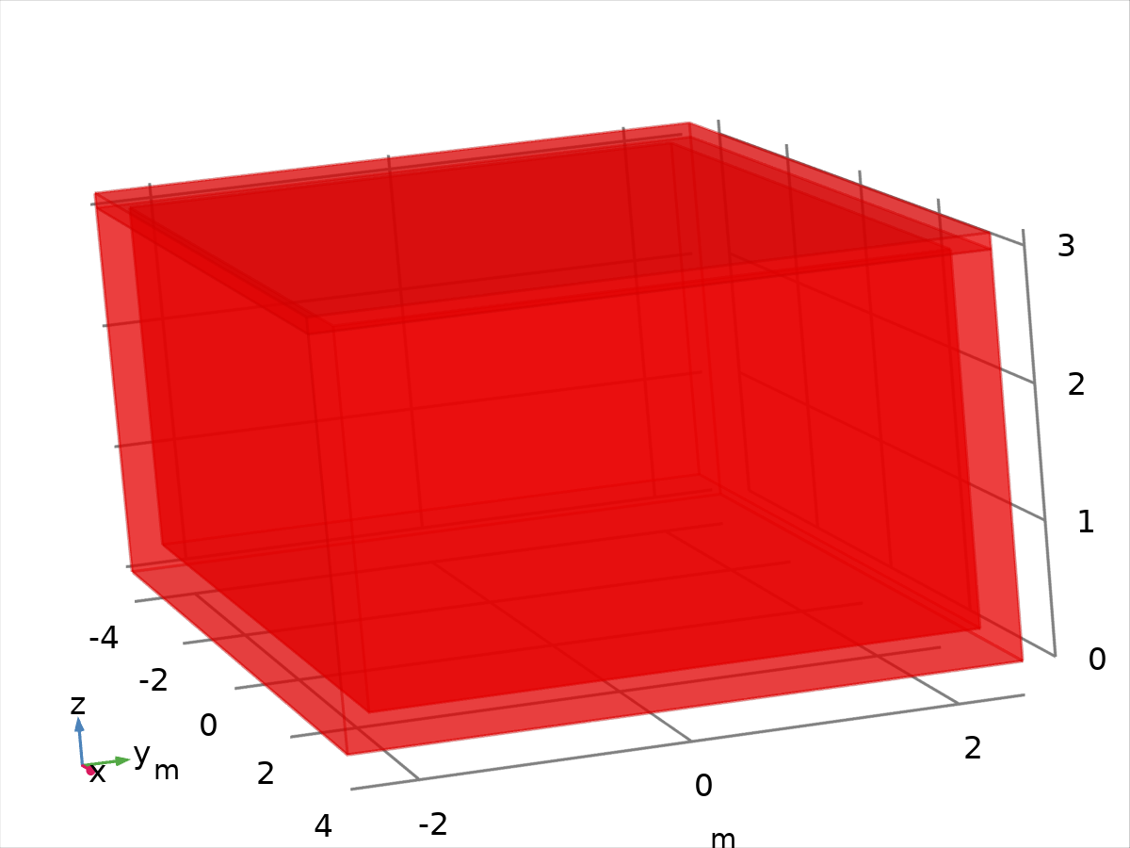

Data set: Study 1/Solution 1

* 1. Tables
     1. Evaluation 3D

Interactive 3D values

| **x** | **y** | **z** | **Value** |
| --- | --- | --- | --- |
| 2.5285 | 0.0000 | 1.9869 | 304.79 |
| 5.5641 | 0.15360 | 3.0000 | 305.02 |
| 1.9701 | 2.4047 | 3.0000 | 304.99 |
| 3.8971 | 1.3323E-15 | 2.8803 | 305.17 |
| 2.4998 | 0.70721 | 0.24612 | 303.32 |
| 4.0000 | -2.2400 | 2.2242 | 305.06 |
| -0.24855 | -2.5000 | 2.1010 | 304.94 |
| 0.76478 | -1.8783 | 3.1200 | 306.22 |
| 4.0000 | -2.0841 | 2.0557 | 305.00 |

* 1. Plot Groups
     1. Temperature (ht)

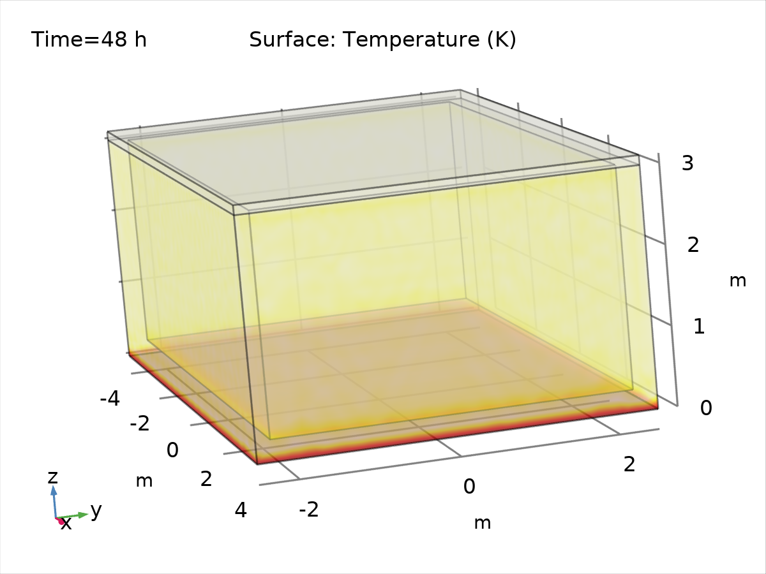

Surface: Temperature (K)

* + 1. Isothermal Contours (ht)

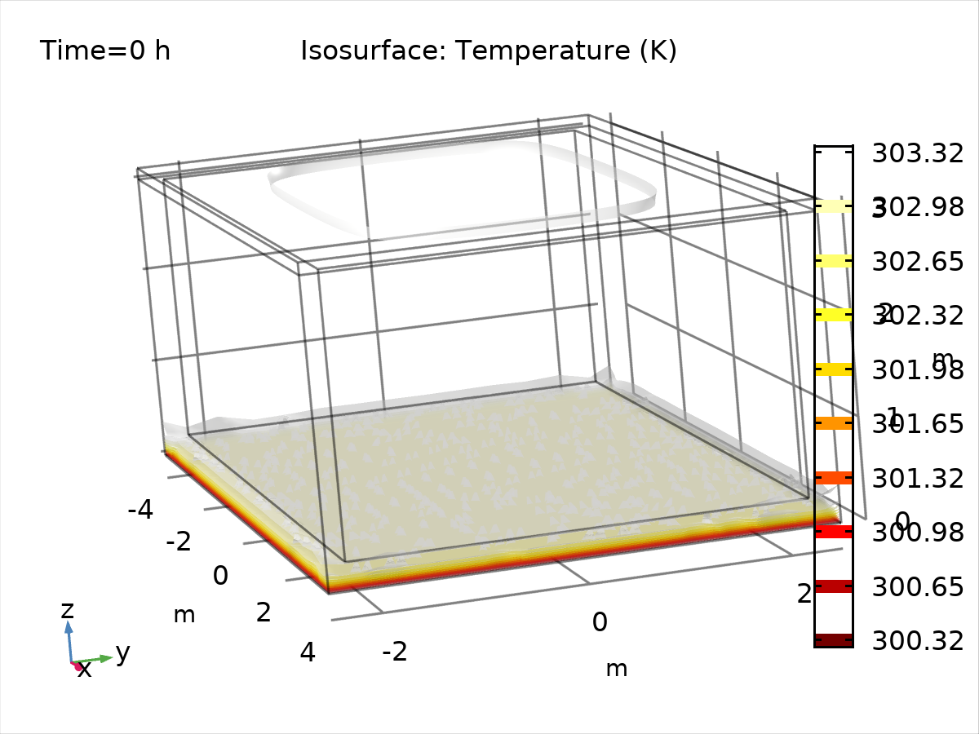

Isosurface: Temperature (K)

* + 1. 1D Plot Group 3

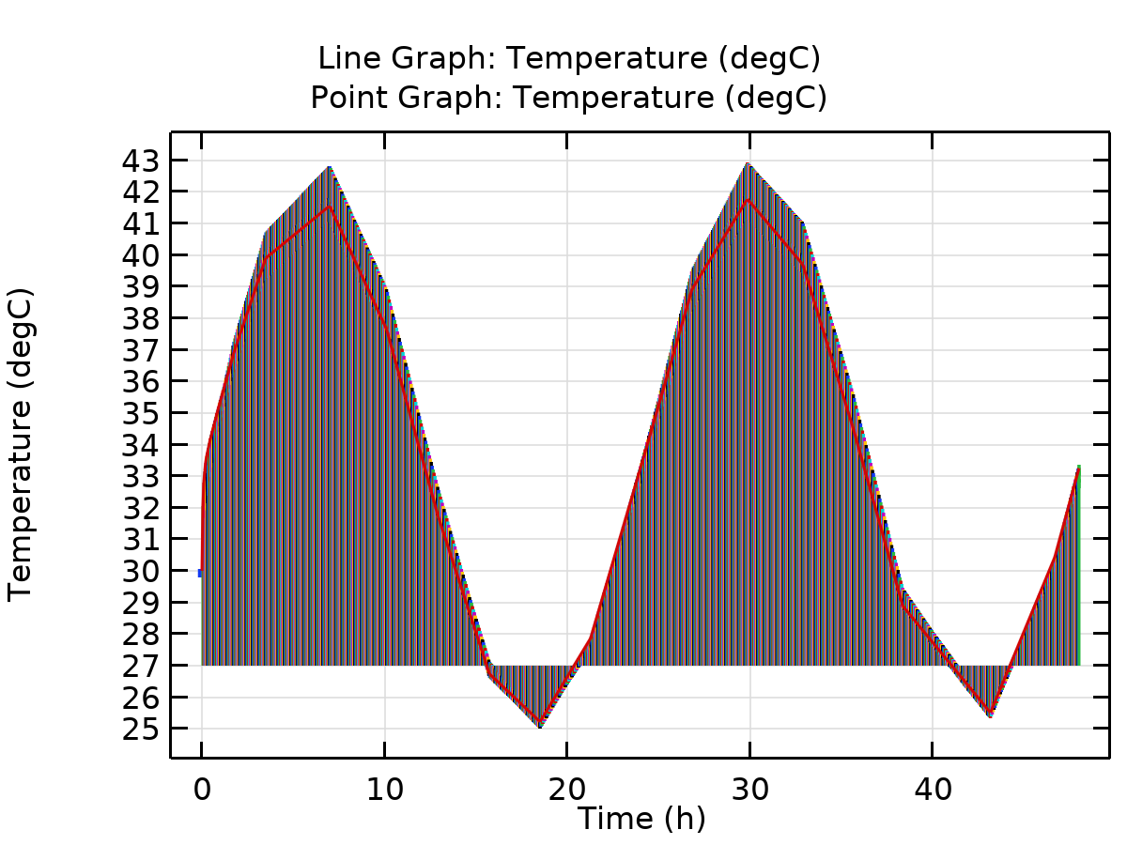

Line Graph: Temperature (degC) Point Graph: Temperature (degC)