Home Agent & Foreign Agent Tunneling (Mobile IPv4)

1. What is Mobile IPv4?
- Mobile IPv4 is a network-layer protocol that supports mobility across different IPv4 networks.
- It allows a Mobile Node (MN) to retain its permanent Home Address while changing its network attachment.
- The MN registers its current Care-of Address (CoA) with its Home Agent (HA).
- The HA forwards packets sent to the Home Address through a tunnel to the current CoA.

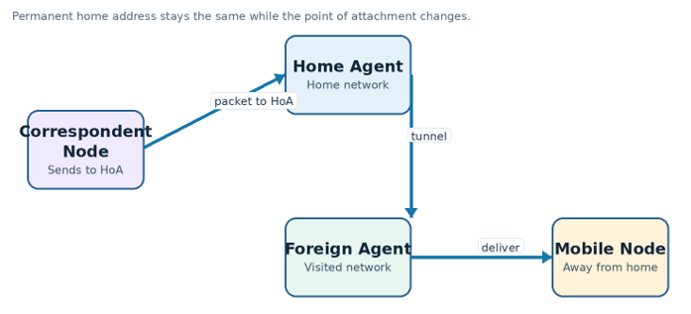

2. Why is Mobile IPv4 required?
- Normal IP addresses identify both a host and its point of attachment to a network.
- When a device moves to another network, its old address may no longer be reachable through normal routing.
- Changing the IP address can interrupt existing communication sessions.
- Mobile IPv4 maintains reachability by keeping the Home Address unchanged and updating the CoA.

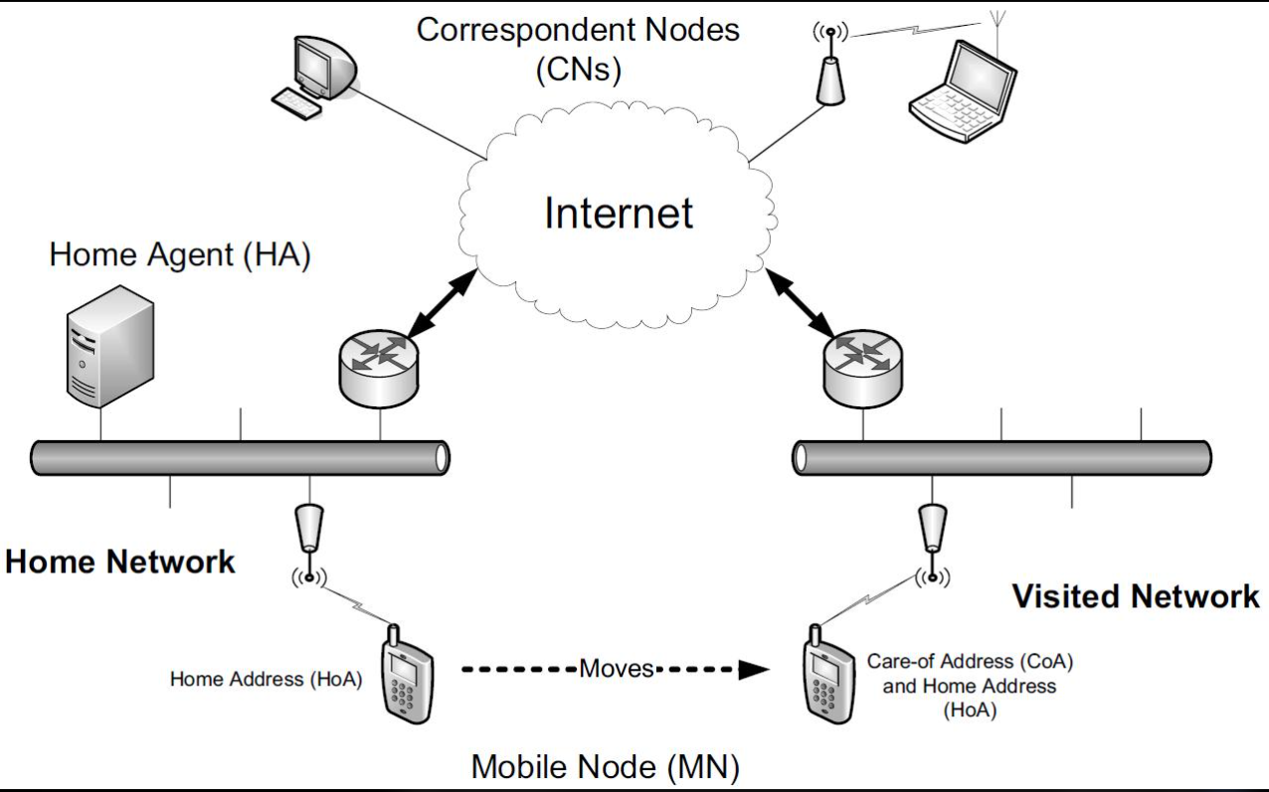

3. Explain the architecture of Mobile IPv4.
- The main entities are Mobile Node (MN), Home Agent (HA), Foreign Agent (FA) and Correspondent Node (CN).
- MN is the mobile device that changes its point of attachment.
- HA is a router on the home network that maintains the MN's mobility binding.
- FA assists the MN in the visited network and may provide a Foreign Agent CoA.
- CN is the host communicating with the MN.

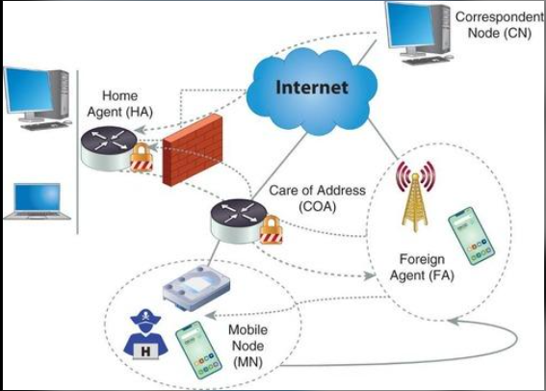

4. What are the functions of MN, HA and FA?
- Mobile Node (MN): moves between networks, discovers agents and requests registration.
- Home Agent (HA): stores the Home Address-to-CoA binding, intercepts packets for the MN and tunnels them to the CoA.
- Foreign Agent (FA): advertises mobility services, provides an FA CoA when used, relays registration messages and delivers decapsulated packets.
- Correspondent Node (CN): communicates with the MN using its Home Address.

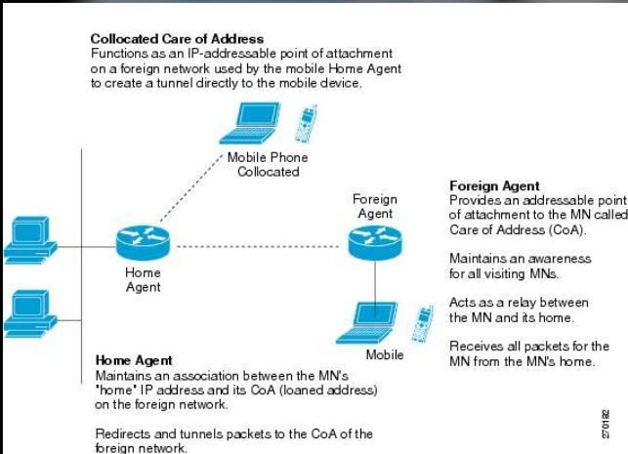

5. Differentiate Home Address and Care-of Address.
- Home Address (HoA) is the permanent IP address assigned to the MN on its home network.
- HoA remains unchanged when the MN moves to another network.
- Care-of Address (CoA) identifies the MN's current point of attachment.
- HA uses the CoA as the destination of the tunnel carrying packets to the MN.

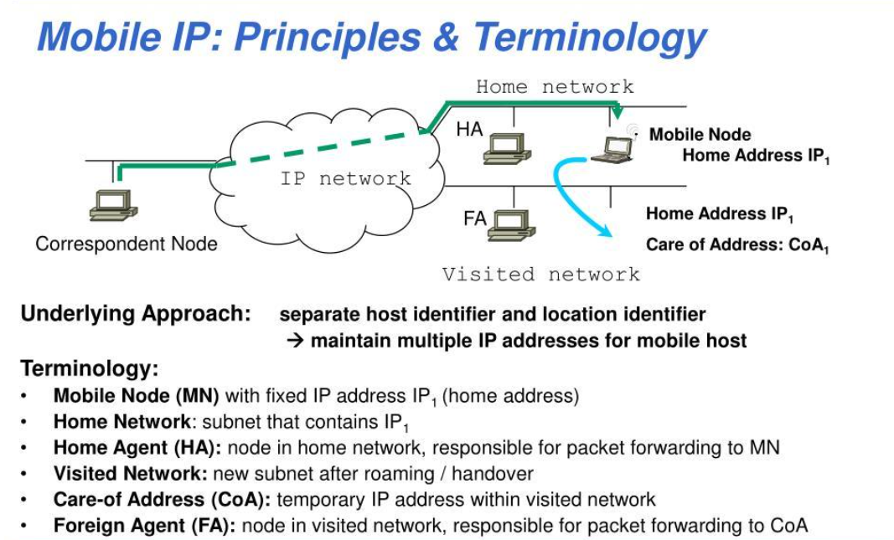

6. What is Agent Discovery?
- Agent Discovery allows an MN to detect whether it is on its home network or a foreign network.
- Mobility agents periodically send Agent Advertisements.
- The advertisements provide information about the agent and available Care-of Addresses.
- If an advertisement is not received, the MN may send an Agent Solicitation.

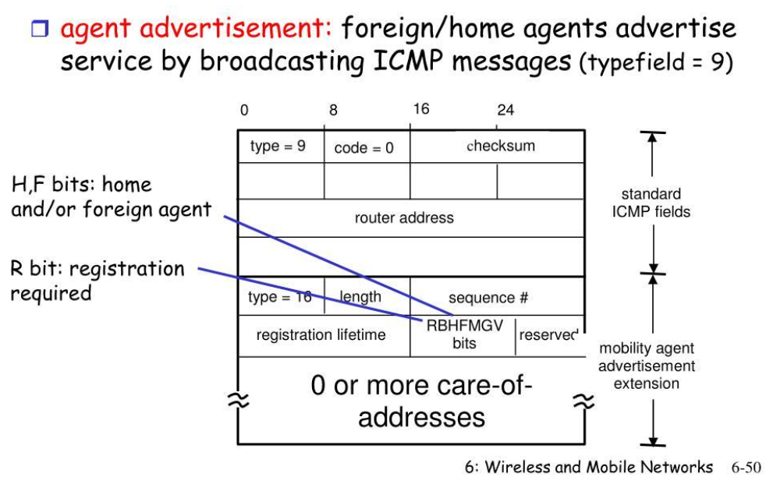

7. Explain Agent Advertisement and Agent Solicitation.
- Agent Advertisement is an ICMP Router Advertisement containing a Mobile IPv4 extension.
- It announces the agent's mobility role and may include one or more CoAs and registration information.
- Agent Solicitation is an ICMP message sent by an MN to request an advertisement.
- Solicitation helps the MN discover an agent sooner instead of waiting for the next periodic advertisement.

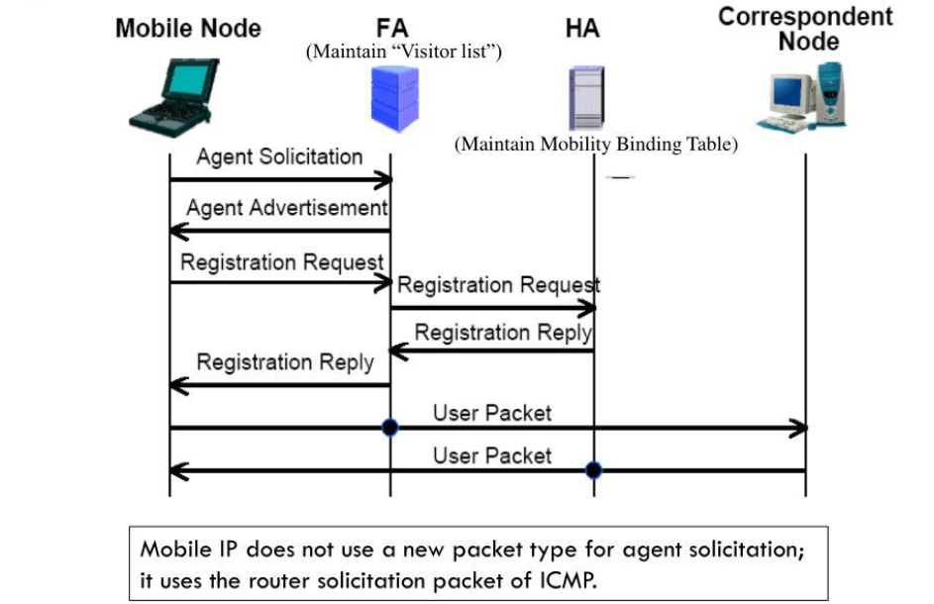

8. Explain the Mobile IPv4 registration process.
- MN discovers a Foreign Agent or obtains a co-located CoA.
- MN sends a Registration Request containing its Home Address, HA address, CoA, lifetime and identification value.
- If an FA is used, it forwards the request to the HA.
- HA authenticates and validates the request, then creates or updates the mobility binding.
- HA sends a Registration Reply; the FA relays it to the MN when applicable.

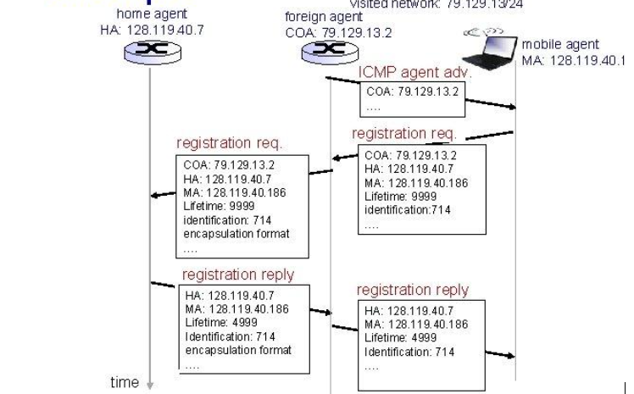

- The request travels MN → FA → HA.
- The reply returns HA → FA → MN.
- A successful reply confirms that the binding has been accepted.

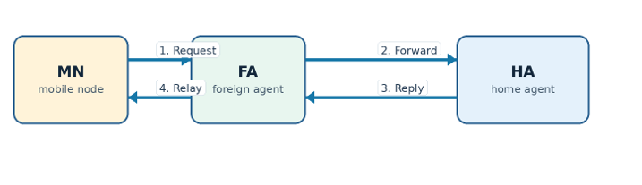

9. What are Registration Request and Registration Reply?
- Registration Request asks the HA to register or renew the MN's current location.
- It includes fields such as flags, requested lifetime, Home Address, HA address, CoA and identification.
- Registration Reply reports whether the request was accepted or rejected.
- It includes a result code, granted lifetime and matching identification value.

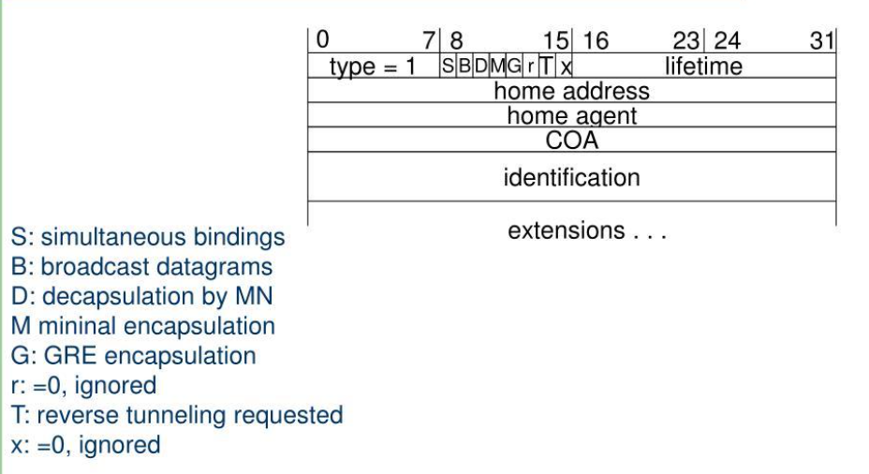

10. How are packets delivered to a Mobile Node in a foreign network?
- CN sends an IP packet to the MN's permanent Home Address.
- The HA intercepts the packet on the home network.
- HA encapsulates the original packet in a new IP packet addressed to the CoA.
- The tunnel carries the packet to the FA or co-located CoA.
- The outer header is removed and the original packet is delivered to the MN.

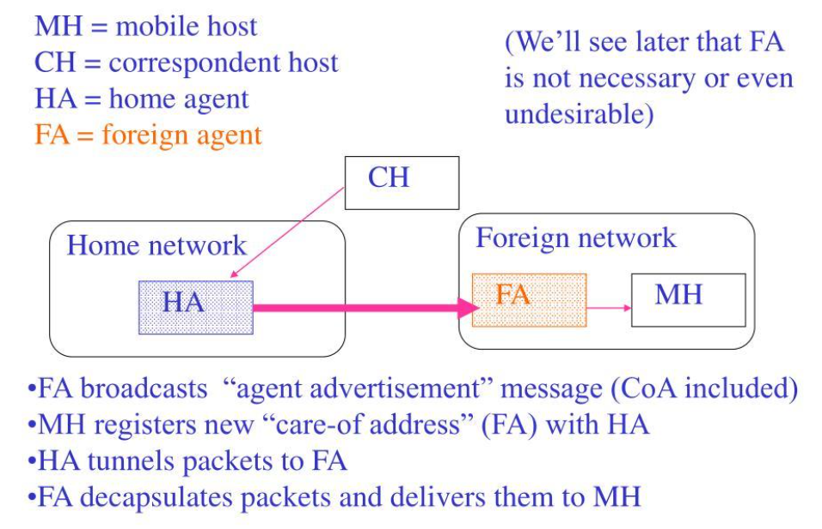

11. What is tunneling in Mobile IPv4?
- Tunneling is the process of carrying an original IP packet inside another IP packet.
- The HA acts as the tunnel entry point.
- The CoA acts as the tunnel endpoint.
- The outer IP header routes the packet to the current location while the inner packet retains the original source and destination addresses.

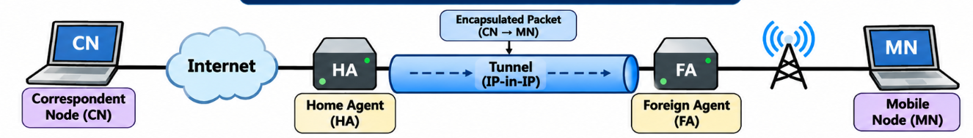

12. Explain encapsulation and decapsulation.
- Encapsulation is performed at the HA by adding a new outer IP header around the original packet.
- The outer header contains the HA as source and the CoA as destination.
- The original packet remains unchanged as the inner packet.
- Decapsulation removes the outer header at the tunnel endpoint.
- The original packet is then delivered to the MN.

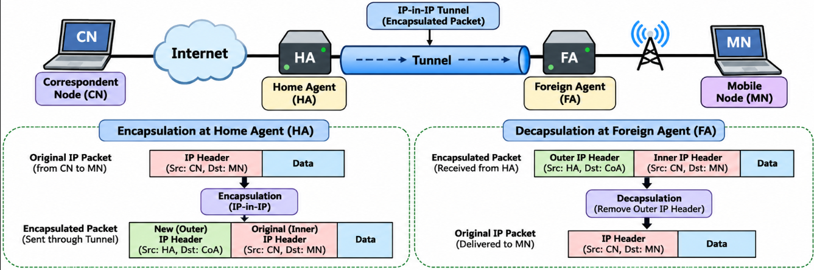

13. Explain IP-in-IP encapsulation.
- IP-in-IP is a tunneling method in which an entire original IP packet is placed inside a new IP packet.
- The outer header has the HA's address as source and the CoA as destination.
- The inner header retains the original CN source address and MN Home Address destination.
- The tunnel routers forward using the outer header; the inner packet is used after decapsulation.

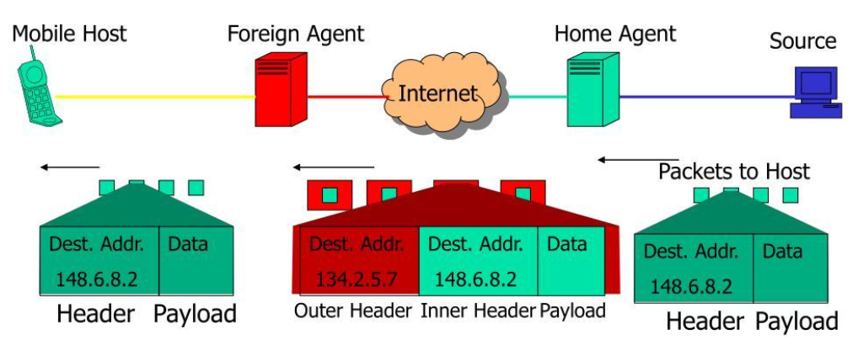

14. What is Reverse Tunneling?
- Reverse tunneling carries packets sent by the MN through a tunnel back to the HA.
- The MN's outgoing packet is sent to the FA or other tunnel entry point.
- The packet is tunneled from the CoA to the HA.
- HA decapsulates or processes the packet and forwards it toward the CN.
- It can help when visited-network ingress filtering or routing policies prevent direct delivery.
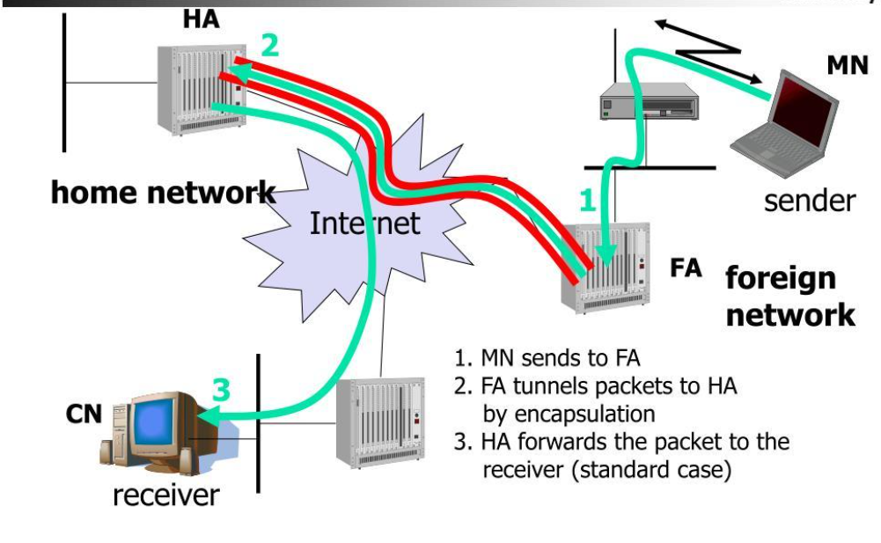

15. Differentiate Foreign Agent CoA and co-located CoA.
- Foreign Agent CoA is an address advertised by an FA in the visited network.
- With an FA CoA, the FA is the tunnel endpoint and forwards the decapsulated packet to the MN.
- A co-located CoA is an address obtained by the MN itself on the visited network.
- With a co-located CoA, the MN is the tunnel endpoint and performs decapsulation.

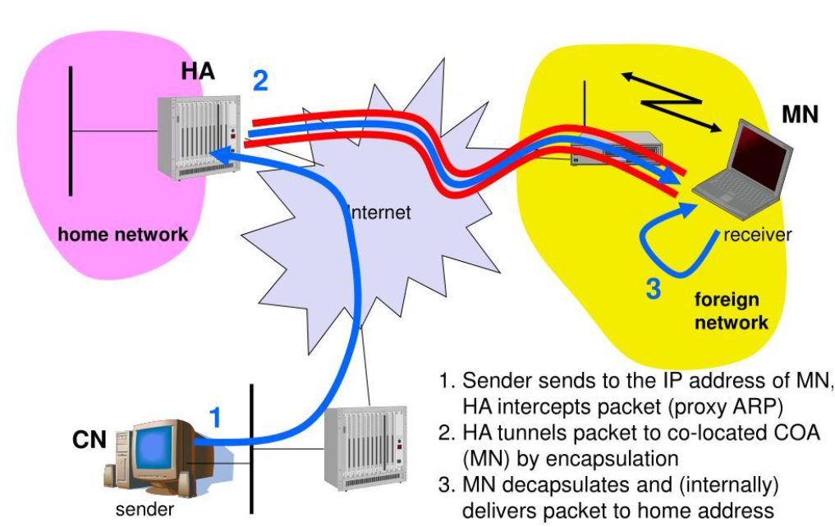

16. What is a Mobility Binding?
- A mobility binding is an entry maintained by the HA for a registered MN.
- It associates the MN's Home Address with its current CoA.
- The binding also includes a registration lifetime and related state.
- HA uses the binding to determine the tunnel destination for packets sent to the MN.
- The binding is refreshed or replaced when the MN re-registers.
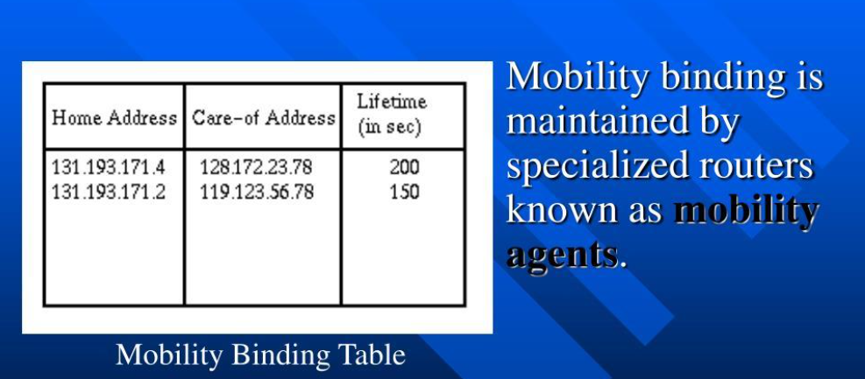

17. What happens when a Mobile Node moves to another foreign network?
- MN detects movement by receiving advertisements from a new agent or by another supported detection method.
- MN obtains a new CoA in the new visited network.
- MN sends a new Registration Request to its HA.
- HA updates the mobility binding with the new CoA.
- Subsequent packets are tunneled to the new location.
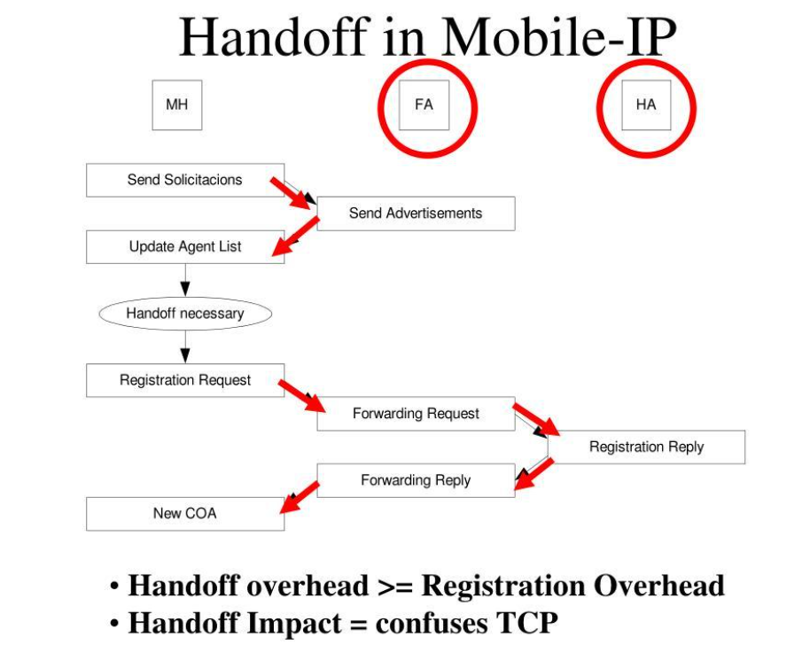

18. What is Triangle Routing?
- CN sends packets to the MN's Home Address, so traffic first reaches the home network.
- HA intercepts the packet and tunnels it to the MN's CoA.
- The MN may send return packets directly to the CN.
- The forward and return paths form a triangle.
- This can cause longer paths and additional delay compared with route-optimized communication.

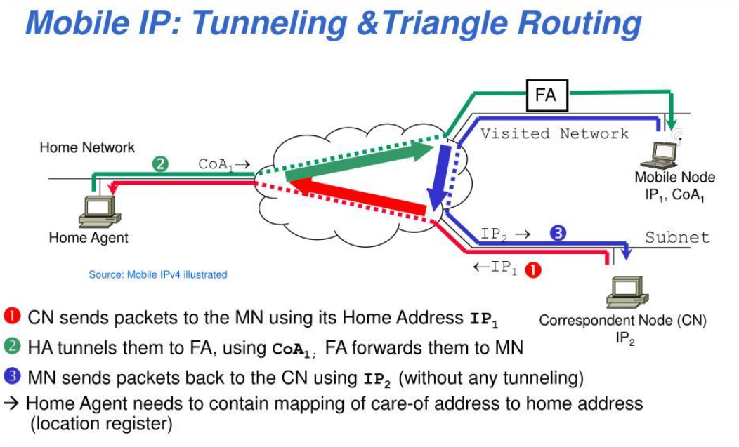

19. Explain security in Mobile IPv4.
- Registration security is important because false updates could redirect a mobile node's traffic.
- Mobile IPv4 uses authentication extensions, especially the Mobile-Home Authentication Extension.
- The HA verifies the authentication information before accepting a registration update.
- Security associations and shared keys are used to authenticate the parties.
- Replay protection helps prevent an attacker from reusing an old registration message.
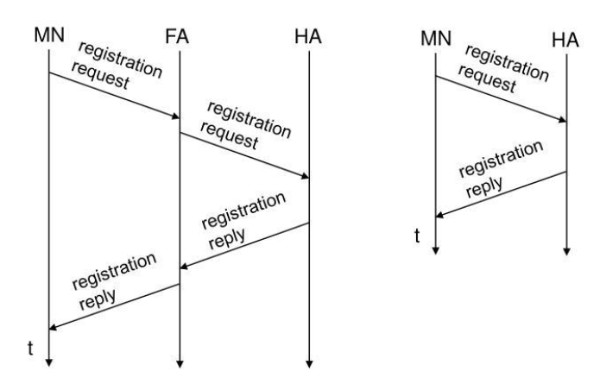

20. State the advantages and limitations of Mobile IPv4.
Advantages
- MN retains its permanent Home Address while moving between IPv4 networks.
- Communication can continue without requiring the correspondent node to track every movement.
- Advantages mobility support is provided at the network layer.

Limitations

- Encapsulation adds header overhead.
- Limitations: triangle routing may increase path length and delay.
- Limitations: agent discovery and registration introduce signaling overhead.
- Limitations: secure deployment requires careful key and security-association management.



