A Survey Of Compiler Optimization Techniques

Paul B Schneck

https://ntrs.nasa.gov/api/citations/19730021416/downloads/19730021416.pdf

Compiler Optimization can be broadly classified as:

- Machine dependent
- Architecture dependent
- Architecture independent

1. Machine Dependent Optimization:

- Tend to be local and are applied on short spans of generated code using particular properties of instruction sets.
- Reduce time or space required by the program.
- Mckeeman (4) proposes a post processing technique (window technique).
- Bagwell (5) describes several coding tricks that can be implemented on almost any machine.

2. Architecture Dependent Optimization:

- Three characteristics of machines:
- Has n accumulators
- use lesser number of registers for the update by:
i. looking ahead and generating RHS of expression first.
ii. using the deferred store technique, eliminates storing of partial results within loops.

- Parallel independent instruction execution.
- reordering of instructions can result in ability to execute in parallel.
- independent functional units are kept busy.
- improvement attained by reordering is limited by the inherent parallelism in original ordering of instructions.

- Arithmetic and logical operations executed on multiple data streams.
- takes advantage of inherent parallelism in procedural code, 3 steps:
i. Determine data dependencies.
ii. Examine flow within loops.
iii. Determine expression ordering.

3. Architecture Independent optimization.

- These techniques are global in nature.
- Common sub-expression elimination.
- Elimination of Dead variable.
- Code Motion
- Constant propagation
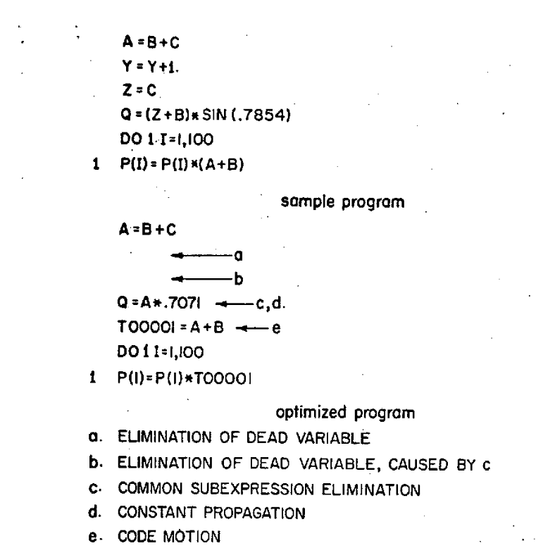

Analysis Of Source:

- Frequency Analysis
Original Fortran compiler:
  - Source program analyzed and broken into set of basic blocks
  - Table listing predecessors of each basic block created
  - Monte Carlo simulation used to find relative frequency of execution for each basic block.
  - Blocks optimized in order from lowest to highest frequency.

- Matrix Analysis
  - Prosser (27) describes a Boolean-matrix approach to flow graph analysis that avoids lengthy Monte Carlo techniques.
  - Predecessor information is used to construct a connection matrix.
  - Repeated matrix multiplications are used to determine the set of blocks participating in loops.
  - Boolean-matrix multiplication can also be reduced to O( n² ) making it more practical.

- Graph-Theoretic Analysis
  - Busam (36) reviews a three pass optimizing compiler.
  - First pass encodes all operations into a uniform tabular format.
  - Second pass scans the code in reverse order and performs common-sub-expression elimination and movement of loop invariant computations.
  - Third pass (along with second is concerned with register assignment and code generation)

REFERENCES:

1. W. M. McKeeman, "Peephole Optimization," Communica-tions of the ACMI, 8, 1 965.

2. J. T. Bagwcll, Jr., "Local Optimizations," ACM SIGPLANNotices, 5, No. 7, 1970.

3. R. T. Prosser, "Applications of Boolean Matrices to the Analysis Of Flow Diagrams,” Proceedings of the Eastern Joint Computer Conference, 1959.

4. V. A. Busam and D. E. Englund, "Optimization of Expressions in FORTRAN," Communications of the,ACM, 12,1969.

