Analysis Of YACS Logs

# Analysis of Jobs

## RANDOM Scheduling algorithm:

1. Mean Completion Time : 6.3077 seconds  
 2. Median Completion Time : 6.1736 seconds

## RR Scheduling algorithm:

1. Mean Completion Time : 6.4862 seconds  
 2. Median Completion Time : 6.7417 seconds

## LL Scheduling algorithm:

1. Mean Completion Time : 7.0138 seconds  
 2. Median Completion Time : 7.1412 seconds

# Mean Comparison

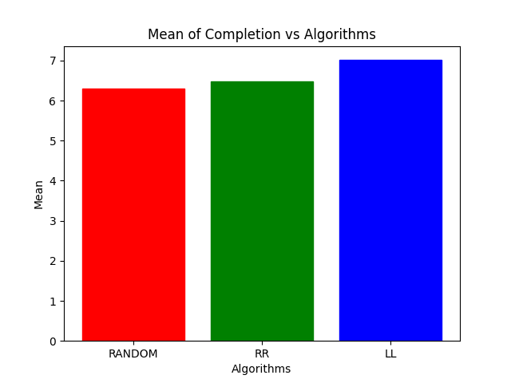

# Median Comparison

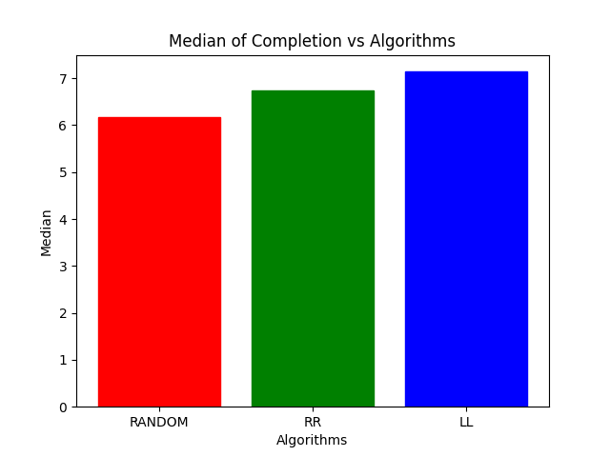

# Analysis of Tasks

## RANDOM Scheduling algorithm:

1. Mean Completion Time : 2.5274 seconds  
 2. Median Completion Time : 2.0027 seconds

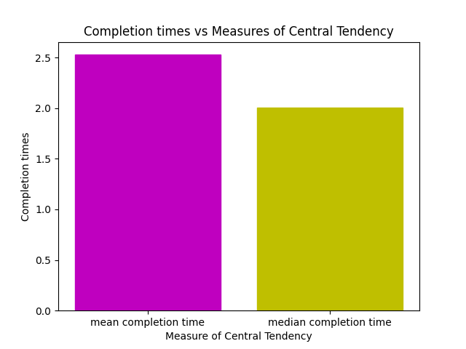

**Plot**

DATE ARRIVAL TIME X-AXIS EQUIVALENTS  
2020-12-01 20:49:41.113287 1  
2020-12-01 20:49:41.165216 2  
2020-12-01 20:49:41.217191 3  
2020-12-01 20:49:42.525255 4  
2020-12-01 20:49:42.576697 5  
2020-12-01 20:49:42.671919 6  
2020-12-01 20:49:42.723766 7  
2020-12-01 20:49:42.775985 8  
2020-12-01 20:49:42.827761 9  
2020-12-01 20:49:42.905347 10  
2020-12-01 20:49:42.957276 11  
2020-12-01 20:49:45.265559 12  
2020-12-01 20:49:45.266063 13  
2020-12-01 20:49:45.360719 14  
2020-12-01 20:49:45.669091 15  
2020-12-01 20:49:45.669514 16  
2020-12-01 20:49:45.715692 17  
2020-12-01 20:49:45.767369 18  
2020-12-01 20:49:46.053181 19  
2020-12-01 20:49:46.873947 20  
2020-12-01 20:49:47.502648 21  
2020-12-01 20:49:47.554522 22  
2020-12-01 20:49:47.606363 23  
2020-12-01 20:49:47.658384 24  
2020-12-01 20:49:48.357701 25  
2020-12-01 20:49:48.415502 26  
2020-12-01 20:49:48.504162 27  
2020-12-01 20:49:48.769898 28  
2020-12-01 20:49:48.857414 29  
2020-12-01 20:49:49.691739 30  
2020-12-01 20:49:49.846063 31  
2020-12-01 20:49:49.877696 32  
2020-12-01 20:49:49.878036 33  
2020-12-01 20:49:50.958627 34  
2020-12-01 20:49:50.959003 35  
2020-12-01 20:49:51.561832 36  
2020-12-01 20:49:53.937641 37  
2020-12-01 20:49:53.938032 38  
2020-12-02 13:39:19.560532 39  
2020-12-02 13:39:19.615122 40  
2020-12-02 13:39:19.667378 41  
2020-12-02 13:39:19.719665 42  
2020-12-02 13:39:21.295309 43  
2020-12-02 13:39:21.347948 44  
2020-12-02 13:39:21.395885 45  
2020-12-02 13:39:21.794249 46  
2020-12-02 13:39:21.910278 47  
2020-12-02 13:39:23.705715 48  
2020-12-02 13:39:23.706474 49  
2020-12-02 13:39:24.992812 50  
2020-12-02 13:39:25.453734 51  
2020-12-02 13:39:25.454584 52  
2020-12-02 13:39:27.733362 53  
2020-12-02 13:39:27.786109 54  
2020-12-02 13:39:27.838840 55  
2020-12-02 13:39:28.968758 56  
2020-12-02 13:39:31.777215 57  
2020-12-02 13:39:31.777287 58  
2020-12-02 13:39:33.038458 59  
2020-12-02 13:39:33.038663 60  
2020-12-04 13:21:14.017879 61  
2020-12-04 13:21:14.511054 62  
2020-12-04 13:21:14.558480 63  
2020-12-04 13:21:14.611095 64  
2020-12-04 13:21:14.664872 65  
2020-12-04 13:21:16.922015 66  
2020-12-04 13:21:16.951790 67  
2020-12-04 13:21:16.994299 68  
2020-12-04 13:21:17.075069 69  
2020-12-04 13:21:17.128159 70  
2020-12-04 13:21:17.175500 71  
2020-12-04 13:21:17.409773 72  
2020-12-04 13:21:18.207792 73  
2020-12-04 13:21:18.753949 74  
2020-12-04 13:21:18.754089 75  
2020-12-04 13:21:19.014766 76  
2020-12-04 13:21:19.015463 77  
2020-12-04 13:21:20.514357 78  
2020-12-04 13:21:20.515074 79  
2020-12-04 13:21:21.228370 80  
2020-12-04 13:21:21.228873 81  
2020-12-04 13:25:53.914461 82  
2020-12-04 13:25:53.967583 83  
2020-12-04 13:25:54.020109 84  
2020-12-04 13:25:57.113892 85  
2020-12-04 13:25:57.114654 86  
2020-12-04 13:25:57.827788 87  
2020-12-04 13:25:59.675761 88  
2020-12-04 13:25:59.728233 89  
2020-12-04 13:25:59.782465 90  
2020-12-04 13:26:00.392369 91  
2020-12-04 13:26:00.445154 92  
2020-12-04 13:26:00.497697 93  
2020-12-04 13:26:00.541026 94  
2020-12-04 13:26:01.321495 95  
2020-12-04 13:26:01.950534 96  
2020-12-04 13:26:01.951255 97  
2020-12-04 13:26:03.739641 98  
2020-12-04 13:26:03.740117 99  
2020-12-04 13:26:04.406284 100  
2020-12-04 13:26:04.406881 101  
2020-12-04 13:26:04.407477 102  
2020-12-04 13:27:18.008932 103  
2020-12-04 13:27:18.061436 104  
2020-12-04 13:27:18.412282 105  
2020-12-04 13:27:18.465353 106  
2020-12-04 13:27:18.517968 107  
2020-12-04 13:27:18.611054 108  
2020-12-04 13:27:18.664510 109  
2020-12-04 13:27:19.689730 110  
2020-12-04 13:27:19.742056 111  
2020-12-04 13:27:19.795235 112  
2020-12-04 13:27:19.848036 113  
2020-12-04 13:27:20.948748 114  
2020-12-04 13:27:20.996598 115  
2020-12-04 13:27:21.049896 116  
2020-12-04 13:27:21.088457 117  
2020-12-04 13:27:21.089073 118  
2020-12-04 13:27:22.646484 119  
2020-12-04 13:27:22.797774 120  
2020-12-04 13:27:23.910034 121  
2020-12-04 13:27:24.145851 122  
2020-12-04 13:27:24.147131 123  
2020-12-04 13:29:28.679853 124  
2020-12-04 13:29:28.732002 125  
2020-12-04 13:29:28.783964 126  
2020-12-04 13:29:29.677333 127  
2020-12-04 13:29:29.729632 128  
2020-12-04 13:29:30.729988 129  
2020-12-04 13:29:31.839672 130  
2020-12-04 13:29:31.892960 131  
2020-12-04 13:29:31.945772 132  
2020-12-04 13:29:31.993435 133  
2020-12-04 13:29:33.038838 134  
2020-12-04 13:29:33.039953 135  
2020-12-04 13:29:34.947595 136  
2020-12-04 13:29:35.084407 137  
2020-12-04 13:29:35.128010 138  
2020-12-04 13:29:35.128533 139  
2020-12-04 13:29:35.160679 140  
2020-12-04 13:29:37.263061 141  
2020-12-04 13:29:39.140630 142  
2020-12-04 13:30:14.650304 143  
2020-12-04 13:30:14.687769 144  
2020-12-04 13:30:14.741989 145  
2020-12-04 13:30:14.763990 146  
2020-12-04 13:30:16.068578 147  
2020-12-04 13:30:16.121843 148  
2020-12-04 13:30:16.892386 149  
2020-12-04 13:30:16.945749 150  
2020-12-04 13:30:18.134564 151  
2020-12-04 13:30:18.853261 152  
2020-12-04 13:30:18.891922 153  
2020-12-04 13:30:20.201527 154  
2020-12-04 13:30:20.201877 155  
2020-12-04 13:30:20.954772 156  
2020-12-04 13:30:20.955634 157  
2020-12-04 13:30:21.191197 158  
2020-12-04 13:30:21.191397 159  
2020-12-04 13:30:21.874707 160

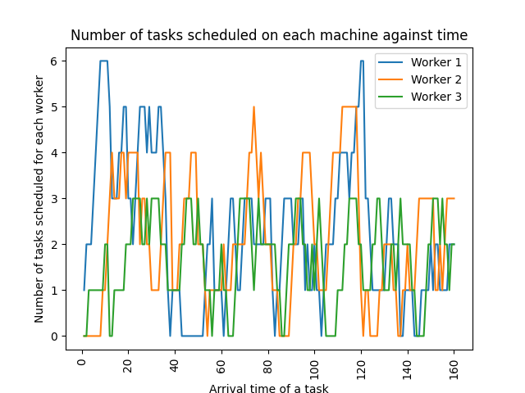

## RR Scheduling algorithm:

1. Mean Completion Time : 2.6257 seconds  
 2. Median Completion Time : 3.0021 seconds

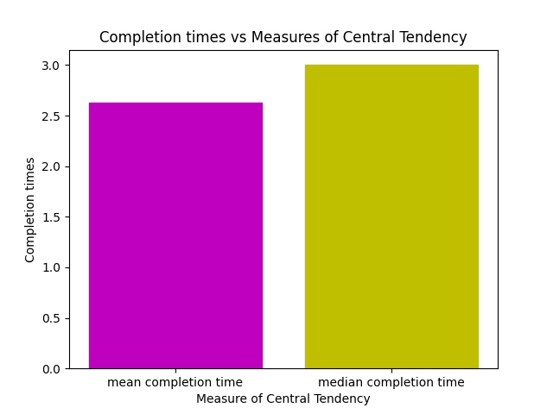

**Plot**

DATE ARRIVAL TIME X-AXIS EQUIVALENTS  
2020-12-01 21:10:33.736770 1  
2020-12-01 21:10:33.796727 2  
2020-12-01 21:10:33.813123 3  
2020-12-01 21:10:33.813544 4  
2020-12-01 21:10:33.813974 5  
2020-12-01 21:10:33.814348 6  
2020-12-01 21:10:34.490693 7  
2020-12-01 21:10:34.542149 8  
2020-12-01 21:10:34.593814 9  
2020-12-01 21:10:35.265547 10  
2020-12-01 21:10:35.812389 11  
2020-12-01 21:10:36.878315 12  
2020-12-01 21:10:37.838318 13  
2020-12-01 21:10:37.838671 14  
2020-12-01 21:10:38.666701 15  
2020-12-01 21:10:38.732988 16  
2020-12-01 21:10:38.785056 17  
2020-12-01 21:10:39.366615 18  
2020-12-01 21:10:40.109213 19  
2020-12-01 21:10:40.161036 20  
2020-12-01 21:10:40.212854 21  
2020-12-01 21:10:40.782369 22  
2020-12-01 21:10:40.916532 23  
2020-12-01 21:10:41.066600 24  
2020-12-01 21:10:41.066927 25  
2020-12-01 21:10:43.238015 26  
2020-12-01 21:10:43.289880 27  
2020-12-01 21:10:43.541567 28  
2020-12-01 21:10:43.593397 29  
2020-12-01 21:10:43.645635 30  
2020-12-01 21:10:44.305197 31  
2020-12-01 21:10:44.880774 32  
2020-12-01 21:10:46.323153 33  
2020-12-01 21:10:46.323153 34  
2020-12-01 21:10:47.694347 35  
2020-12-01 21:10:47.694526 36  
2020-12-02 13:47:31.150534 37  
2020-12-02 13:47:31.202722 38  
2020-12-02 13:47:32.025292 39  
2020-12-02 13:47:32.073394 40  
2020-12-02 13:47:32.125872 41  
2020-12-02 13:47:33.206869 42  
2020-12-02 13:47:33.259376 43  
2020-12-02 13:47:33.312398 44  
2020-12-02 13:47:33.365691 45  
2020-12-02 13:47:34.244537 46  
2020-12-02 13:47:34.245135 47  
2020-12-02 13:47:34.743415 48  
2020-12-02 13:47:34.786045 49  
2020-12-02 13:47:34.839334 50  
2020-12-02 13:47:34.891706 51  
2020-12-02 13:47:35.141760 52  
2020-12-02 13:47:35.496110 53  
2020-12-02 13:47:37.214663 54  
2020-12-02 13:47:37.367093 55  
2020-12-02 13:47:37.596780 56  
2020-12-02 13:47:37.596861 57  
2020-12-02 13:47:38.570995 58  
2020-12-02 13:47:38.610858 59  
2020-12-02 13:47:38.886330 60  
2020-12-02 13:47:38.886571 61  
2020-12-02 13:47:39.125572 62  
2020-12-02 13:47:39.173364 63  
2020-12-02 13:47:40.826066 64  
2020-12-02 13:47:40.853171 65  
2020-12-02 13:47:40.854207 66  
2020-12-02 13:47:41.597974 67  
2020-12-02 13:47:41.625441 68  
2020-12-02 13:47:42.366552 69  
2020-12-02 13:47:42.366621 70  
2020-12-02 13:47:43.994318 71  
2020-12-02 13:47:44.060965 72  
2020-12-02 13:47:44.108864 73  
2020-12-02 13:47:44.162094 74  
2020-12-02 13:47:44.215088 75  
2020-12-02 13:47:45.675725 76  
2020-12-02 13:47:48.205508 77

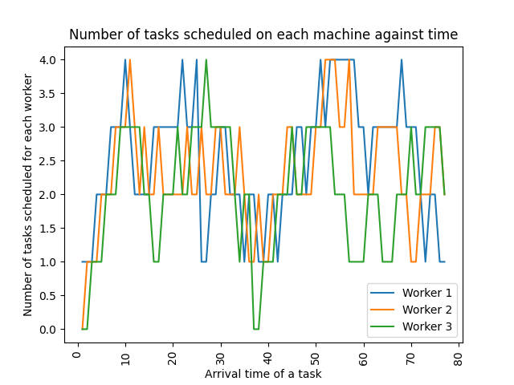

## LL Scheduling algorithm:

1. Mean Completion Time : 3.0708 seconds  
 2. Median Completion Time : 3.0034 seconds

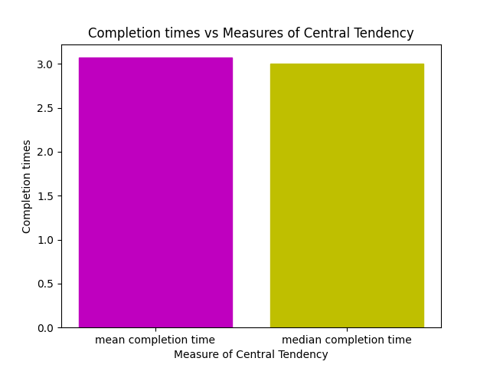

**Plot**

DATE ARRIVAL TIME X-AXIS EQUIVALENTS  
2020-12-01 21:11:26.608816 1  
2020-12-01 21:11:26.660679 2  
2020-12-01 21:11:27.795968 3  
2020-12-01 21:11:27.847723 4  
2020-12-01 21:11:28.732654 5  
2020-12-01 21:11:28.733480 6  
2020-12-01 21:11:28.743583 7  
2020-12-01 21:11:30.133424 8  
2020-12-01 21:11:30.169889 9  
2020-12-01 21:11:30.211824 10  
2020-12-01 21:11:30.886647 11  
2020-12-01 21:11:30.980079 12  
2020-12-01 21:11:31.088724 13  
2020-12-01 21:11:31.161599 14  
2020-12-01 21:11:31.249341 15  
2020-12-01 21:11:31.250225 16  
2020-12-01 21:11:31.845916 17  
2020-12-01 21:11:31.901858 18  
2020-12-01 21:11:32.488435 19  
2020-12-01 21:11:32.540220 20  
2020-12-01 21:11:32.602741 21  
2020-12-01 21:11:32.654702 22  
2020-12-01 21:11:32.997172 23  
2020-12-01 21:11:34.315625 24  
2020-12-01 21:11:34.717288 25  
2020-12-01 21:11:34.768816 26  
2020-12-01 21:11:34.890089 27  
2020-12-01 21:11:35.211281 28  
2020-12-01 21:11:36.574994 29  
2020-12-01 21:11:36.733597 30  
2020-12-01 21:11:38.782866 31  
2020-12-01 21:11:38.993370 32  
2020-12-01 21:12:11.479986 33  
2020-12-01 21:12:11.531936 34  
2020-12-01 21:12:12.286390 35  
2020-12-01 21:12:12.338540 36  
2020-12-01 21:12:12.385500 37  
2020-12-01 21:12:12.767122 38  
2020-12-01 21:12:12.818758 39  
2020-12-01 21:12:12.870492 40  
2020-12-01 21:12:12.922577 41  
2020-12-01 21:12:13.247885 42  
2020-12-01 21:12:13.997746 43  
2020-12-01 21:12:14.049519 44  
2020-12-01 21:12:14.101574 45  
2020-12-01 21:12:14.343211 46  
2020-12-01 21:12:15.582969 47  
2020-12-01 21:12:15.583568 48  
2020-12-01 21:12:16.017223 49  
2020-12-01 21:12:16.604694 50  
2020-12-01 21:12:16.604841 51  
2020-12-01 21:12:18.472153 52  
2020-12-01 21:12:19.227532 53  
2020-12-01 21:12:19.279512 54  
2020-12-01 21:12:19.330489 55  
2020-12-01 21:12:19.382129 56  
2020-12-01 21:12:19.536966 57  
2020-12-01 21:12:19.568047 58  
2020-12-01 21:12:19.619782 59  
2020-12-01 21:12:19.671861 60  
2020-12-01 21:12:20.105546 61  
2020-12-01 21:12:20.991342 62  
2020-12-01 21:12:21.044191 63  
2020-12-01 21:12:22.482312 64  
2020-12-01 21:12:22.482536 65  
2020-12-01 21:12:23.090786 66  
2020-12-01 21:12:23.090802 67  
2020-12-01 21:12:23.181804 68  
2020-12-01 21:12:23.789291 69  
2020-12-01 21:12:26.870198 70  
2020-12-01 21:12:26.943327 71  
2020-12-01 21:12:27.123130 72  
2020-12-01 21:12:29.969862 73  
2020-12-01 21:12:29.970222 74  
2020-12-02 13:45:36.327050 75  
2020-12-02 13:45:36.379445 76  
2020-12-02 13:45:36.432169 77  
2020-12-02 13:45:37.951059 78  
2020-12-02 13:45:38.003198 79  
2020-12-02 13:45:38.632622 80  
2020-12-02 13:45:38.681043 81  
2020-12-02 13:45:38.750613 82  
2020-12-02 13:45:39.426941 83  
2020-12-02 13:45:39.849378 84  
2020-12-02 13:45:39.896939 85  
2020-12-02 13:45:39.950133 86  
2020-12-02 13:45:40.348957 87  
2020-12-02 13:45:41.827952 88  
2020-12-02 13:45:41.828197 89  
2020-12-02 13:45:42.051507 90  
2020-12-02 13:45:42.052025 91  
2020-12-02 13:45:42.818432 92  
2020-12-02 13:45:42.818881 93  
2020-12-02 13:45:42.835269 94  
2020-12-02 13:45:42.893379 95  
2020-12-02 13:45:43.031874 96  
2020-12-02 13:45:43.183705 97  
2020-12-02 13:45:43.480526 98  
2020-12-02 13:45:43.480822 99  
2020-12-02 13:45:43.600900 100  
2020-12-02 13:45:43.654107 101  
2020-12-02 13:45:43.691615 102  
2020-12-02 13:45:43.739179 103  
2020-12-02 13:45:44.138642 104  
2020-12-02 13:45:44.139194 105  
2020-12-02 13:45:46.127857 106  
2020-12-02 13:45:46.207866 107  
2020-12-02 13:45:46.261539 108  
2020-12-02 13:45:46.999484 109  
2020-12-02 13:45:47.784283 110  
2020-12-02 13:45:48.326399 111  
2020-12-04 15:00:21.992119 112  
2020-12-04 15:00:22.043827 113  
2020-12-04 15:00:22.995312 114  
2020-12-04 15:00:23.047001 115  
2020-12-04 15:00:24.009178 116  
2020-12-04 15:00:24.060801 117  
2020-12-04 15:00:25.018267 118  
2020-12-04 15:00:25.070332 119  
2020-12-04 15:00:26.029271 120  
2020-12-04 15:00:26.081179 121  
2020-12-04 15:00:27.074986 122  
2020-12-04 15:00:27.220067 123  
2020-12-04 15:00:27.251344 124  
2020-12-04 15:00:28.057858 125  
2020-12-04 15:00:28.120435 126  
2020-12-04 15:00:28.158346 127  
2020-12-04 15:00:29.156640 128  
2020-12-04 15:00:30.161424 129  
2020-12-04 15:00:31.231776 130  
2020-12-04 15:00:32.288518 131  
2020-12-04 15:00:33.214083 132

