**RESEARCH PROJECT ON COVID-19 CLASSIFICATION**

**Dataset Description**

The dataset we consider for our study is obtained from Kaggle’s dataset.

This dataset contains two folders for COVID and non-COVID images. The im-

ages in the dataset have been augmented to produce 5,500 non-COVID images

and 4,044 COVID images. Some of the augmentations include geometric image

transformations such as flipping, rotation, translation and scaling. The dataset

does not contain proper image distribution for training purposes. So, in order to

avoid the problem of class imbalance, we manually split the data to have equal

images in both classes, resulting in 4,044 images for each class (both COVID

and non-COVID). The non-COVID dataset also contains the X-ray images of

other respiratory diseases such as viral pneumonia, SARS, streptococcus and

pneumocystis. This dataset includes anteroposterior, posteroanterior and lateral

X-ray images. All the images are converted into 227×227×3 dimensional images

before passing it on to the models.

**Experiment 1 (CNN as a classifier)**

As our first experiment, we use various CNN models (including three pre-trained

models) to classify the images as COVID positives and negatives. The dataset

containing 8,088 images is split in such a way that 80% of the input raw images

are used for training the model while the remaining 20% are used up for testing.

We use customised CNN models as well as pretrained ResNet-152, AlexNet and

VGG-16 as the models for performance evaluation. All the models are run for

15 epochs, with a learning rate of 0.001, using Adam optimiser.

**Experiment 2 (Flattened Layer Output)**

Since CNNs have the exceptional capability of converting lower-dimensional fea-

tures to higher dimensional features, we use it as a feature extractor.

We obtain the higher dimensional features from the flattened layer of

the model. Since the flattened output is very large, PCA is done on the features

to reduce the dimensions. These features are then passed on to five different ML

classifiers (SVM, Decision Tree (DT), XGBoost, Multilayer Perceptron, and RF) for the task of classification.

**Experiment 3 (Fully Connected Layer output)**

Similar to Experiment 2, we now add a fully connected layer of 512 neurons to the

flattened layer and obtain the outputs from respective CNN models considered

for our study. The output with a dimension of 512 is then used as the input

feature vectors for ML classifiers. The same set of ML classifiers mentioned in

is used for classification purposes in this experiment as well.

**Performance Metrics**

The evaluation of the classifier is based on how accurately it distinguishes be-

tween positive and negative COVID-19 samples. Based on this, four outcomes

are considered: true positives (TP), true negatives (TN), false positives (FP) and

false negatives (FN). These values are used to predict the accuracy, precision,

recall and F1 score.

**Performance of CNN Classifier**

The performance of the trained CNN models are evaluated by testing the models’

ability to accurately predict the target classes of the test dataset. The test set,

which contains 1,618 images (20% of the dataset), are provided as the inputs for

the CNN models (5 layer CNN, VGG-16, ResNet-152 and AlexNet). Based on

the learning that the models have obtained from the train set (6,470 images),

the CNN models achieve state-of-the-art results as shown. VGG-16

outperforms all the other models with a test accuracy score of 96.22%.

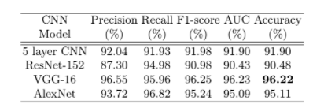

**Performance of features extracted from the Flattened Layer**

From the flattened layer of the CNN models, the corresponding higher dimen-

sional features for the inputted 1,618 test images and 6,470 train images are

extracted. These features that have the ability to distinguish between different

target classes, are then passed on to ML classifiers for training and testing pur-

poses. Five different classifiers (SVM, MLP, DT, RF and XGBoost) are trained

with features of the train set. The performance of classifiers test the CNN’s

ability to capture distinguishable features. The below mentioned table shows the comparison of per-

formances that are exhibited by the five ML classifiers for every model by means

of test accuracy.

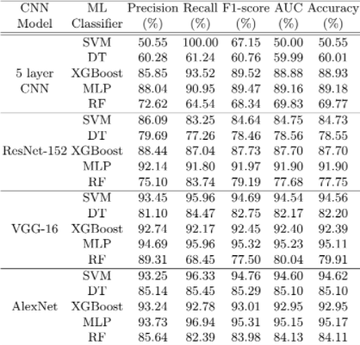

**Performance of features extracted from the Fully Connected Layer:**

Features are extracted from the fully connected layer of the CNN models for

the respective input images (6,470 train images and 1,618 test images). These

features are then handed over to the ML classifiers for classification purposes.

The ML classifiers are trained with the train set that were extracted by the CNN

models and are then evaluated using the test set. The results in terms of test

accuracy obtained by the ML classifiers for the four CNN models are tabulated

in Table below.

