

SIMATS ENGINEERING

Saveetha Institute of Medical and Technical Sciences
Chennai- 602105

Student Name: CH.V.N.V.S SRIRAM Reg. No.:192511011
Course Code: CSA0907
Course Name: Programming in Java
Course Faculty: Dr.A . MOHAN
Project Title: Hospital Management System
Module Photographs: Module 1: Patient and Doctor Management
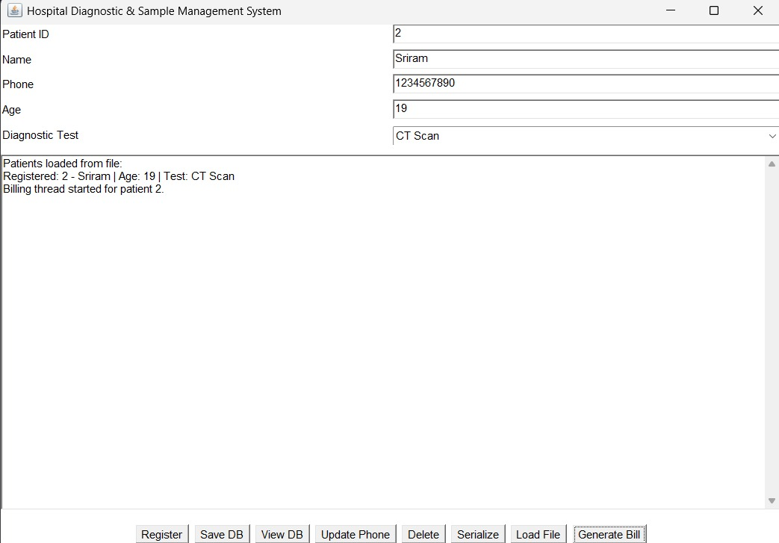
Project Description: (here you write what you did in this project (contribution) including Model Description
This module is responsible for managing all basic information related to patients and doctors in the hospital. It provides facilities for registering new patients, updating patient details, searching patient information, and maintaining doctor profiles. Patient information such as patient ID, name, age, contact details, and medical history can be stored and managed. Doctor information such as doctor ID, name, specialization, department, and availability is also maintained. This module demonstrates classes and objects, inheritance, polymorphism, method overloading, interfaces, packages, String handling, ArrayList, HashMap, HashSet, and exception handling. Validation is performed to prevent invalid patient details and duplicate records. The module provides an organized way for hospital staff to access patient and doctor information
CH. SRIRAM

Student Signature Guide Signature

