DSA0111 – Assignment
Implementation and Evaluation of Object-Oriented Programming Concepts Using C++

Course Outcomes | CO1: Apply classes & objects for modular, reusable C++ programs.  CO2: Implement encapsulation & polymorphism for security, flexibility, maintainability.
Bloom's Taxonomy Level | BL5 – Evaluate
Deliverables | 1. Pseudo code 2. Implementation & Results 3. GitHub Upload
Application chosen: A C++ Employee Management System that models real-world employee entities (Manager and Developer) to demonstrate encapsulation, inheritance and polymorphism (function overloading and function overriding using virtual functions).
1. Pseudo Code

START

CLASS Employee
PRIVATE: empId, name PROTECTED: baseSalary PUBLIC:
Employee(id, name, salary) // constructor setName(newName) // controlled write access getName(), getEmpId(), getBaseSalary() // controlled read access
VIRTUAL calculateSalary() // returns baseSalary (default) VIRTUAL getRole() // returns "Employee"
displayInfo() // overloaded version 1 (no args)
displayInfo(bonus) // overloaded version 2 (with bonus)

CLASS Manager INHERITS Employee PRIVATE: teamAllowance
Manager(id, name, salary, allowance) : Employee(id, name, salary) OVERRIDE calculateSalary() -> RETURN baseSalary + teamAllowance OVERRIDE getRole() -> RETURN "Manager"

CLASS Developer INHERITS Employee
PRIVATE: projectsCompleted, perProjectBonus
Developer(id, name, salary, projects, bonusPerProject) : Employee(id, name, salary) OVERRIDE calculateSalary() -> RETURN baseSalary + (projectsCompleted * perProjectBonus) OVERRIDE getRole() -> RETURN "Developer"

MAIN:
CREATE Manager m1 (101, "Arun Kumar", 55000, allowance = 8000)
CREATE Developer d1 (102, "Priya Sharma", 48000, projects = 5, bonus = 1500)
CREATE Developer d2 (103, "Rahul Verma", 45000, projects = 3, bonus = 2000)

// Base class pointer array -> enables runtime polymorphism staff[3] = { &m1, &d1, &d2 }

PRINT "Salary Report (Without Bonus)" FOR EACH employee IN staff:
employee.displayInfo() // dynamic dispatch calls correct
// calculateSalary() and getRole()

PRINT "Salary Report (With Festival Bonus = 2000)" FOR EACH employee IN staff:
employee.displayInfo(2000) // overloaded call

// Encapsulation demonstration PRINT staff[0].getName()
staff[0].setName("Arun Kumar Reddy") PRINT staff[0].getName()

END

2. Implementation (C++ Source Code)
File: employee_management.cpp — compiled and tested using g++ -std=c++17.
#include <iostream> #include <string> #include <iomanip> using namespace std;

// Base Class: Employee
// Demonstrates ENCAPSULATION: data members are private,
// access is controlled strictly through public member functions. class Employee {
private:
int empId; string name;

protected:
double baseSalary; // protected so derived classes can use it directly

public:
// Constructor
Employee(int id, string n, double salary) { empId = id;
name = n;
baseSalary = salary;
}

// Setter (controlled access to private data) void setName(string n) {
name = n;
}

// Getter
string getName() const { return name;
}

int getEmpId() const { return empId;
}

double getBaseSalary() const { return baseSalary;
}

// Virtual function -> enables RUNTIME POLYMORPHISM (function overriding) virtual double calculateSalary() {
return baseSalary;
}

// Function to be overridden for role-specific description virtual string getRole() {
return "Employee";
}

// Overloaded function #1: no arguments void displayInfo() {
cout << left << setw(6) << empId << setw(15) << name
<< setw(12) << getRole() << setw(12) << fixed << setprecision(2)
<< calculateSalary() << endl;
}

// Overloaded function #2: with a bonus argument
// Demonstrates COMPILE-TIME POLYMORPHISM (function overloading) void displayInfo(double bonus) {
cout << left << setw(6) << empId << setw(15) << name
<< setw(12) << getRole() << setw(12) << fixed << setprecision(2)
<< (calculateSalary() + bonus) << " (with bonus)" << endl;
}

virtual ~Employee() {}
};

// Derived Class: Manager
// Demonstrates INHERITANCE + FUNCTION OVERRIDING

class Manager : public Employee { private:
double teamAllowance;

public:
Manager(int id, string n, double salary, double allowance)
: Employee(id, n, salary) { teamAllowance = allowance;
}

// Overriding base class virtual function double calculateSalary() override {
return baseSalary + teamAllowance;
}

string getRole() override { return "Manager";
}
};

// Derived Class: Developer class Developer : public Employee {
private:
int projectsCompleted; double perProjectBonus;

public:
Developer(int id, string n, double salary, int projects, double bonusPerProject)
: Employee(id, n, salary) { projectsCompleted = projects; perProjectBonus = bonusPerProject;
}

// Overriding base class virtual function double calculateSalary() override {
return baseSalary + (projectsCompleted * perProjectBonus);
}

string getRole() override { return "Developer";
}
};

// Main Function
int main() {
cout << "=======================================================\n"; cout << " EMPLOYEE MANAGEMENT SYSTEM - OOP DEMONSTRATION\n";
cout << "=======================================================\n\n";

// Creating objects of derived classes Manager m1(101, "Arun Kumar", 55000, 8000);
Developer d1(102, "Priya Sharma", 48000, 5, 1500);
Developer d2(103, "Rahul Verma", 45000, 3, 2000);

// Storing different object types using BASE CLASS POINTERS
// This enables RUNTIME POLYMORPHISM via virtual functions Employee* staff[3];
staff[0] = &m1; staff[1] = &d1; staff[2] = &d2;

cout << "---- Salary Report (Without Bonus) \n";
cout << left << setw(6) << "ID" << setw(15) << "Name"
<< setw(12) << "Role" << setw(12) << "Salary" << endl;
cout << " \n";

for (int i = 0; i < 3; i++) {
staff[i]->displayInfo(); // calls overloaded version (no args)
}

cout << "\n---- Salary Report (With Festival Bonus = 2000) \n";
cout << left << setw(6) << "ID" << setw(15) << "Name"
<< setw(12) << "Role" << setw(20) << "Salary" << endl;
cout << " \n";

for (int i = 0; i < 3; i++) {
staff[i]->displayInfo(2000); // calls overloaded version (with bonus)

}

cout << "\n---- Direct Access Demonstration (Encapsulation) \n";
cout << "Employee Name via getter: " << staff[0]->getName() << endl; staff[0]->setName("Arun Kumar Reddy");
cout << "Updated Name via setter : " << staff[0]->getName() << endl;

cout << "\n=======================================================\n";
cout << "Program executed successfully.\n";
cout << "=======================================================\n";

return 0;
}

3. Results (Program Output)
Actual console output produced by running the compiled program:
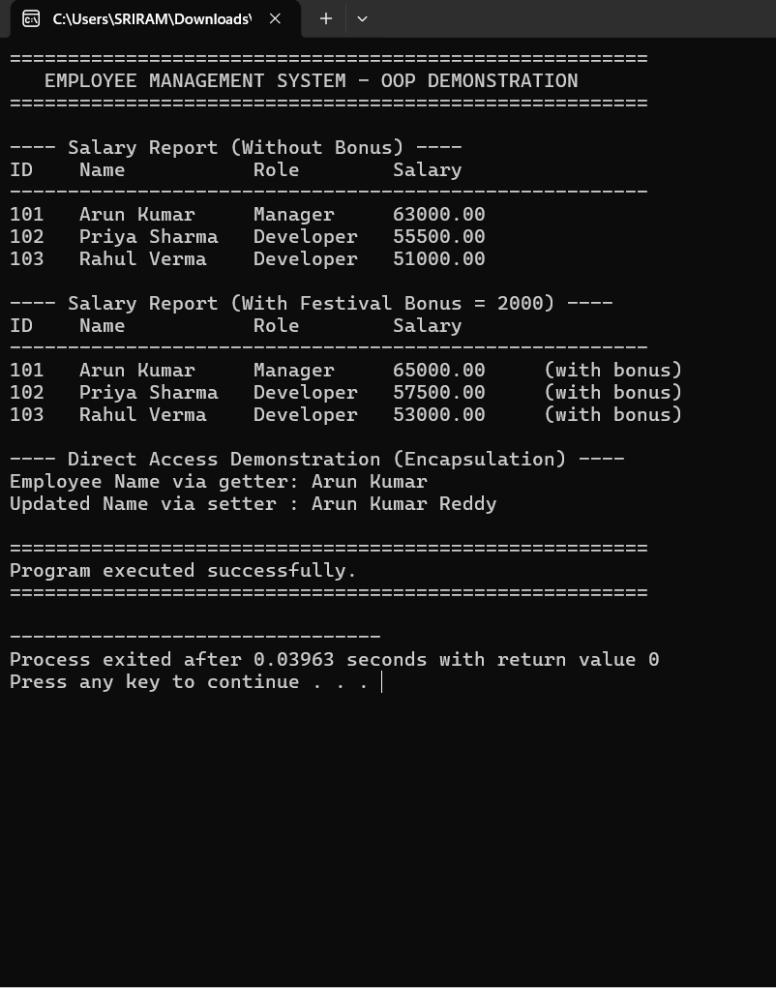

The output confirms that: (1) the correct overridden version of calculateSalary() executes for each object type through the base-class pointer, demonstrating runtime polymorphism; (2) the two overloaded displayInfo() functions are correctly resolved at compile time based on the number of arguments; and
(3) private data (name) can only be read or modified through public getter/setter functions, confirming

encapsulation.

4. Analysis and Evaluation of OOP Concepts

Classes and Objects
Purpose: A class is a user-defined blueprint (Employee, Manager, Developer) bundling attributes and behaviour; an object (m1, d1, d2) is a concrete instance holding actual data. Advantage: Real-world entities map naturally to classes, improving code organisation and reusability — the same Employee blueprint can generate any number of employee records without duplicating logic. Limitation: Overuse of small classes for trivial data can add unnecessary design overhead in very small programs.

Encapsulation and Access Specifiers
Purpose: Encapsulation binds data (empId, name, baseSalary) with the functions that operate on it, and restricts direct external access using private and protected specifiers. Implementation: name and empId are private and reachable only through getName()/setName(); baseSalary is protected so only derived classes (not external code) can use it directly. Advantage: This enforces data security — invalid or unauthorised changes are blocked because all modification passes through controlled member functions, which can validate input. It also supports abstraction, since users of the class need not know its internal representation. Limitation: Excessive getters/setters for every field can sometimes reduce encapsulation benefits if they simply expose the internal state without any real control logic.

Polymorphism (Overloading and Overriding)
Purpose: Polymorphism allows the same interface to behave differently depending on context. Implementation: Compile-time polymorphism is shown via the overloaded displayInfo() and displayInfo(double bonus) functions, resolved by the compiler based on argument count. Runtime polymorphism is shown via the virtual function calculateSalary(), overridden in Manager and Developer; the correct version executes dynamically when called through an Employee* pointer. Advantage: New employee types (e.g., Intern) can be added later by simply overriding the same two virtual functions, without changing existing client code — this greatly improves flexibility, extensibility and maintainability. Limitation: Virtual function calls carry a small runtime overhead (vtable lookup) compared to normal function calls, and excessive overloading can occasionally reduce code readability if signatures are not chosen carefully.

Comparative Summary

Concept | Purpose | Key Advantage | Key Limitation
Class & Object | Model real-world entities | Reusability, organisation | Overhead for trivial data
Encapsulation | Restrict/control data access | Data security, abstraction | Boilerplate getters/setters
Overloading (Compile-time) | Same name, different parameters | Improves readability & flexibility of calls | Ambiguity if signatures overlap
Overriding (Runtime, virtual fn) | Same signature, redefined in derived class | Extensibility, dynamic behaviour | Small runtime (vtable) overhead

  - Effect of Access Specifiers and Polymorphic Behaviour on Design
Choosing private for identity fields and protected for the inheritable salary field directly shaped the class hierarchy: it forced all external interaction through a stable public interface while still allowing derived classes controlled internal access. Combined with virtual functions, this design lets main() operate uniformly on an array of Employee* pointers without knowing the concrete type of each object, which is the essence of

polymorphic, loosely-coupled design. Overall, the program shows measurable gains in data security (protected internal state), reusability (shared base class logic), flexibility (new roles pluggable via inheritance) and maintainability (change isolated to one overridden function).

5. Student Reflection and Learning

What I Learned
I learned how classes act as blueprints and objects as their instances, how encapsulation uses private/protected access specifiers together with getter and setter functions to protect data, and how polymorphism lets one interface (a function name) behave differently — either chosen at compile time (overloading) or resolved at runtime through virtual functions (overriding).

Concept Understanding
Encapsulation was the easiest to understand because it directly mirrors the idea of a 'capsule' protecting data with getters and setters. Runtime polymorphism using virtual functions and base-class pointers was the most difficult, since it required understanding how the compiler defers the function call decision to execution time using a vtable, rather than binding it immediately.

Programming Challenges
Initially I forgot to mark calculateSalary() as virtual in the base class, so calling it through an Employee* pointer always ran the base version instead of the derived one (no runtime polymorphism). I also had a compiler warning about ambiguous overload resolution before I gave the two displayInfo() versions clearly different parameter lists.

Problem Solving
I resolved the virtual-function issue by adding the virtual keyword to the base class declaration and using override in the derived classes, which also let the compiler catch signature mismatches. For the overload ambiguity, I re-checked the parameter list of each version and re-compiled with g++ -std=c++17 to confirm the correct function was chosen for each call.

Real-World Application
These concepts are used constantly in real software: encapsulation protects sensitive data such as bank balances or employee salaries from unauthorised modification; classes and objects model entities such as customers, products or vehicles in ERP and e-commerce systems; and polymorphism enables frameworks (such as GUI toolkits or payroll systems) to treat many different object types uniformly through a common interface, e.g. computing pay for any employee type through one calculateSalary() call.

Further Learning
I would like to explore further C++ OOP features such as abstract classes and pure virtual functions (interfaces), operator overloading, multiple inheritance and the diamond problem, templates for generic programming, and smart pointers for safer memory management in polymorphic object hierarchies.
6. Deliverables Checklist

    - 1. Pseudo code — Section 1 above.
    - 2. Implementation & Results — Sections 2 and 3 above (source code + actual compiled output).
    - 3. GitHub Upload — Upload employee_management.cpp to a GitHub repository and include the repository link here before submission:

Code of Conduct
I CH.V.N.V.S SRIRAM(192511011)(Name / Reg No) certify that this submission is my original work and that I have adhered to the guidelines specified for this assessment. I understand that any violation of academic integrity rules will result in disciplinary action.
Signature of the Student: CH.SRIRAM

