DATA 260 Homework 9 Report
Sreeram Achutuni | SJSU ID: 019151808 | GitHub: https://github.com/sriram2930/Data260-1808
Builds on HW8. Adds a Redis view counter, a Redis-vector semantic response cache in front of the HW8 Planner -> Writer -> Reviewer pipeline, a threshold/cost/staleness study, and a two-agent self-improving system.

Section 0: Config values
Value | Setting
SID4 / PREFIX | 1808 / s1808 (every Redis key starts with s1808:)
PORT_BASE / SEED / VERIFY_SEED | 8008 / 1808 / 261808
DOMAIN_ID | 0, Campus course catalogue and enrolment (primary entity: Course; related tables in s1808_rel)
Hardware | Intel Core i7-11390H, 16GB RAM, integrated Iris Xe graphics (no dedicated GPU)
Local model | qwen2.5:1.5b-instruct via Ollama and the shared ModelClient adapter (all agents, temperature 0 in Part 4)
Embeddings / vector store | sentence-transformers/all-MiniLM-L6-v2 (384-d, normalised); Redis Stack 7.2 (redis/redis-stack-server), FLAT index, COSINE
Databases / broker | MySQL 8 (s1808_rel), Kafka 7.5 + Zookeeper (HW8 stack, unchanged)
cache_cases.yaml committed in | 1686f9f, before any threshold sweep was run
Commit tagged as hw9 | (filled in after the final commit)

Part 1: Redis-backed view counter
Primary entity: Course. A new column courses.view_count (migration Part-1/migrate_hw09.py) holds the durable count; CourseStore.increment_course_views(course_id) in Part-12/course_store.py is the one new method. Key format: s1808:views:course:<id>.
def increment_course_views(self, course_id: int) -> int:
count = self.redis_client.incr(self.views_key(course_id)) # atomic, in-memory
if count % SYNC_EVERY == 0: # every 10th increment
with self._session_factory() as session:
session.execute(text("UPDATE courses SET view_count = :c WHERE id = :id"),
{"c": count, "id": course_id})
session.commit()
log.info("Synced views to database")
return count
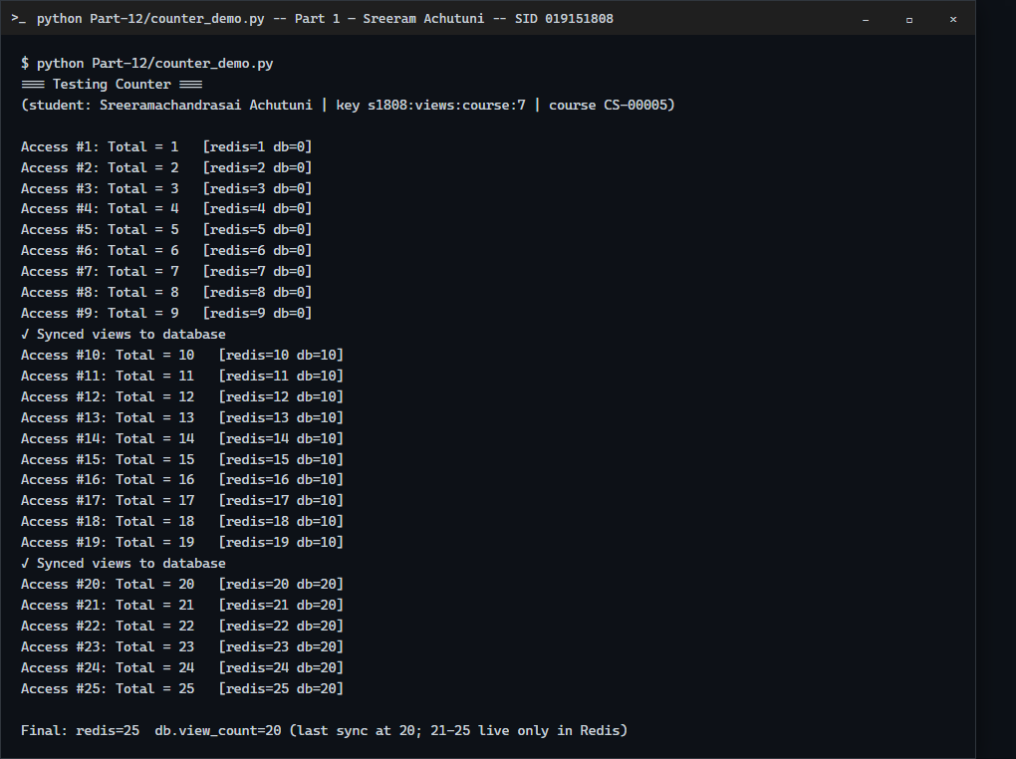
Part 1: 25 accesses of CS-00005. The DB column changes only at access 10 and 20.
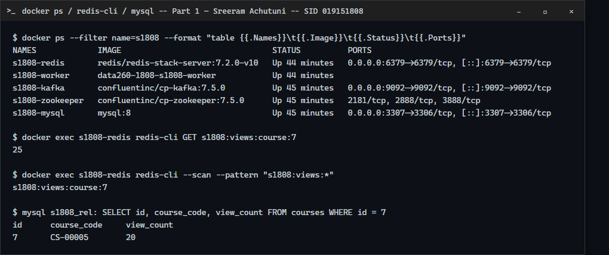
Redis holds 25, MySQL view_count holds 20; the Redis container runs next to the HW8 stack.
Result: 25 accesses cost 25 Redis INCRs and 2 database UPDATEs instead of 25. Trade-off: the database lags Redis by up to 9 views (here 20 vs 25), and a Redis crash before the next sync would lose those unsynced counts.

Part 2: Semantic response cache
The cache sits at the ingress of the course Q&A endpoint (Part-13/semantic_cache.py, SemanticCache.handle). Each request is embedded and matched against cached queries with a Redis KNN search over a COSINE vector index (similarity = 1 - distance). Similarity >= threshold (0.85 here) is a hit: the stored final answer is returned, is_cached=True, similarity logged, no agent run. Otherwise it is a miss: the question is grounded with the matching s1808_rel records and sent through the real HW8 pipeline over Kafka (s1808_inbox -> planner -> writer -> reviewer -> s1808_final); the query, embedding, final answer and a data-version marker are stored, and is_cached=False is returned. Timestamps are taken around the embedding, the Redis search, and the agent call.
Core of the request handler (Part-13/semantic_cache.py, excerpt):
def handle(self, question: str, store_on_miss: bool = True) -> dict:
t0 = now_ms()
vec = self.embed(question)
t_embed = now_ms()
hit = self.nearest(vec)
t_search = now_ms()
stale_evicted = None
if hit and hit["similarity"] >= self.threshold:
if self.validate_versions:
current = facts_for(hit["query"])["version"] # re-hash the rows the cached answer came from
if current != hit["data_version"]:
stale_evicted = {"cached_query": hit["query"], "stored_version": hit["data_version"], "current_version": current}
self.r.delete(hit["key"])
log.info("CACHE STALE query=%r matched=%r sim=%.3f stored_ver=%s current_ver=%s -> evicted",
question, hit["query"], hit["similarity"], hit["data_version"], current)
hit = None # fall through to the miss path
if hit:
t1 = now_ms()
log.info("CACHE HIT sim=%.3f query=%r matched=%r", hit["similarity"], question, hit["query"])
return {
"question": question, "answer": hit["answer"], "is_cached": True,
"similarity": round(hit["similarity"], 4), "matched_query": hit["query"],
"latency_ms": round(t1 - t0, 1),
"embed_ms": round(t_embed - t0, 1), "search_ms": round(t_search - t_embed, 1),
"agent_ms": 0.0, "stale_evicted": None,
}
# ---- miss path: facts -> real HW8 pipeline -> store -----------------
best_sim = hit["similarity"] if hit else None
t_pre = now_ms()
f = facts_for(question)
t_facts = now_ms()
answer = self.agent(question, f["facts"])
t_agent = now_ms()
if store_on_miss:
self.store(question, vec, answer, f["version"])
t1 = now_ms()
log.info("CACHE MISS best_sim=%s query=%r (agent %.0f ms)",
f"{best_sim:.3f}" if best_sim is not None else "n/a", question, t_agent - t_facts)
return {
"question": question, "answer": answer, "is_cached": False,
"similarity": round(best_sim, 4) if best_sim is not None else None,
"matched_query": None, "latency_ms": round(t1 - t0, 1),
"embed_ms": round(t_embed - t0, 1), "search_ms": round(t_search - t_embed, 1),
"agent_ms": round(t_agent - t_facts, 1), "facts_ms": round(t_facts - t_pre, 1),
"stale_evicted": stale_evicted, "data_version": f["version"],
}
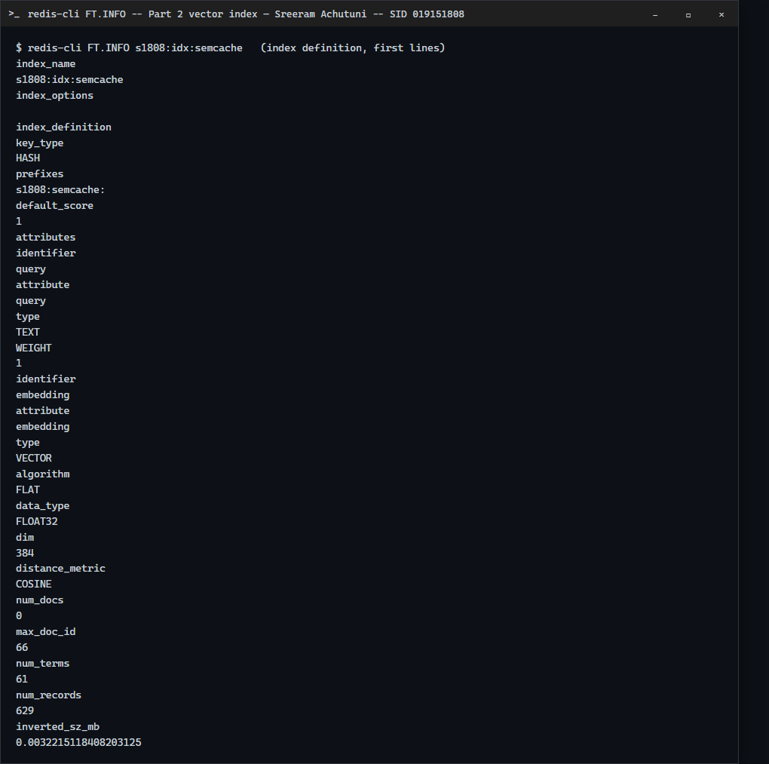
The vector index on the s1808:semcache: key prefix (HASH, FLAT, FLOAT32, COSINE).
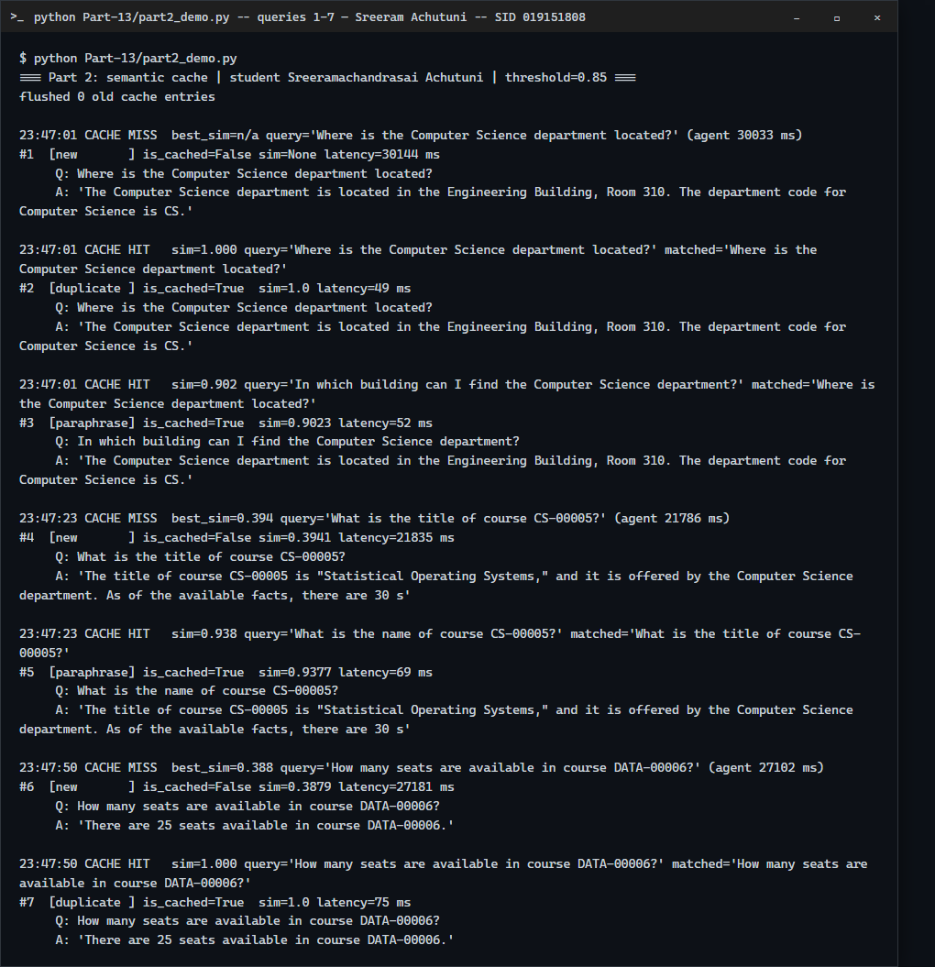
14 queries at threshold 0.85, part 1 of 2 (misses call the real Kafka pipeline).
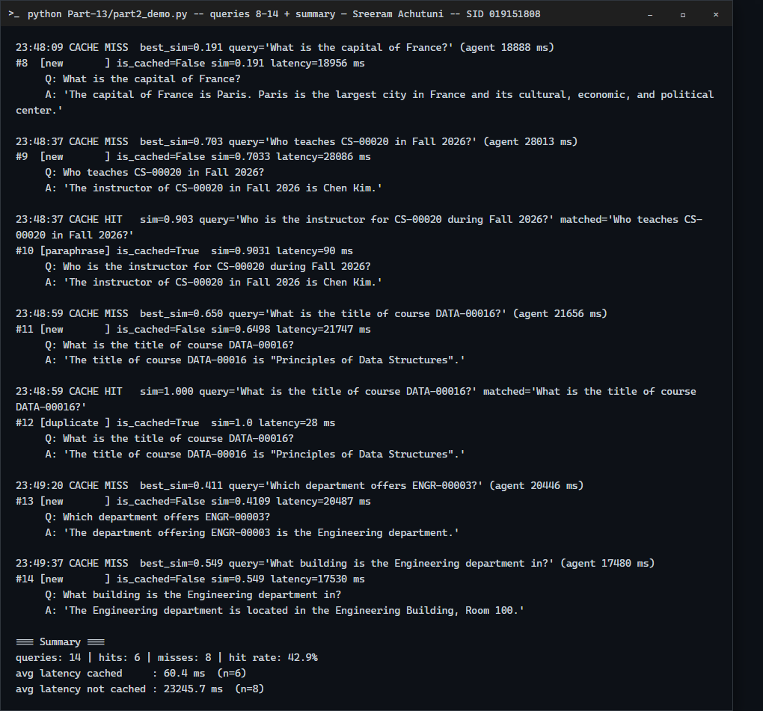
Part 2 of 2, with the summary.
Measure (threshold 0.85, 14 queries) | Measured
Cache hit rate | 6/14 = 42.9% (3 exact duplicates at 1.000, 3 paraphrases at 0.90-0.94)
Average latency, cached | 60.4 ms (n=6)
Average latency, not cached | 23,245.7 ms (n=8; full Planner -> Writer -> Reviewer run)

These are the measured values from this run; no speed-up was targeted. Of the 8 misses, all 8 were first-time questions. One of them ("What is the capital of France?") was answered "Paris" by the HW8 pipeline: the pipeline has no scope guard, which is what Part 4's decline lesson addresses.

Part 3: Threshold economics and stale answers

3.1 Labeled test set
Part-13/cache_cases.yaml holds 40 labeled queries (10 exact duplicates, 10 paraphrases, 10 superficially similar with a different correct answer, 10 unrelated) plus the 10 seed queries the cache is warmed with. It was committed in 1686f9f before any sweep and not edited afterwards. The full list is in Appendix A. Labeling mistakes found after seeing results: none. (C13, a paraphrase labeled should-hit, scored 0.835 and missed at 0.85 and above; that is the model being less similar than I expected, not a wrong label, so the label stays.)

3.2 Threshold sweep
For each threshold the cache was flushed, warmed with the 10 seeds, and the 40 cases were sent read-only (misses are not inserted, so every case sees the same cache). Cache-path time is measured live. Because re-running the ~20 s Kafka pipeline for every miss at five thresholds would take hours, each distinct query went through the real pipeline once beforehand (part3_precompute.py) and a miss in the sweep adds that recorded agent latency; so mean latency = live cache time + recorded real pipeline time for misses. Hit rate = hits/40. False hit = a hit on a should-miss case, or a hit that returned the wrong seed; false-hit rate = false hits / 20 should-miss cases.
Threshold | Hit rate | False-hit rate | Mean latency (ms) | Total cost
0.75 | 70.0% (28/40) | 40.0% (8/20) | 8,815.1 | $16.060
0.80 | 62.5% (25/40) | 25.0% (5/20) | 10,337.3 | $10.075
0.85 | 60.0% (24/40) | 25.0% (5/20) | 10,824.0 | $10.080
0.90 | 57.5% (23/40) | 20.0% (4/20) | 11,752.8 | $8.085
0.95 | 37.5% (15/40) | 20.0% (4/20) | 16,764.5 | $8.125

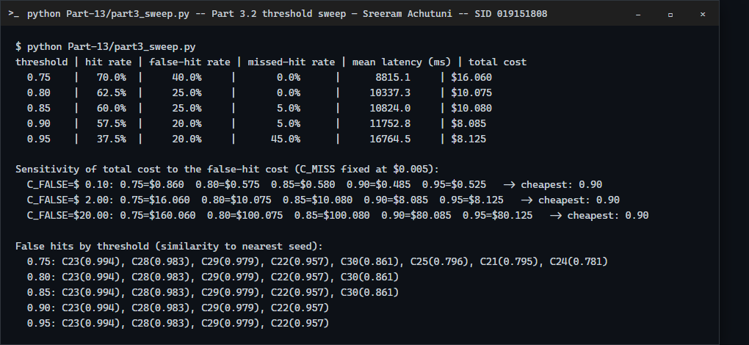
Sweep output. Missed hits (should-hit cases that missed): 0, 0, 1, 1, 9 of 20 at 0.75 to 0.95.

3.3 One false hit in full
Item | Value
Cached query (seed S03) | How many seats are available in course DATA-00006?
Incoming query (C23) | How many seats are available in course DATA-00007?
Similarity score | 0.9937 (hit at every threshold from 0.75 to 0.95)
Cached answer returned | There are 25 seats available in course DATA-00006.
Correct answer | 12 seats (s1808_rel: DATA-00007, seats_available = 12)

Why the model confused them: the two questions share 12 of 13 word-piece tokens. The embedding model's tokenizer splits the codes into ['data', '-', '000', '##0', '##6'] and ['data', '-', '000', '##0', '##7'], so the only difference is one trailing digit piece. A sentence embedding is dominated by the shared template ("how many seats are available in course DATA-...") and encodes an identifier digit very weakly. Similarity 0.994 is higher than every genuine paraphrase in the set (0.83-0.95), so no threshold can separate them: C22, C23, C28 and C29 (0.957-0.994) are false hits at every threshold.

3.4 Cost model and threshold choice
Total cost = (queries not served from cache) x C_miss + (false hits) x C_false. C_miss = $0.005: one miss runs the 3-call pipeline (roughly 1.5k tokens at about $1-3 per million tokens on a small hosted model, plus compute; it took about 23 s here). C_false = $2.00: a wrong seat count, room or instructor presented as authoritative sends a student to the wrong place or triggers a support contact; I assume about 3 minutes of staff time at roughly $40/hour. Both figures are assumptions, not measurements. C_false is 400x C_miss because a wrong answer costs a human, while a miss costs a few cents of compute.
C_false | 0.75 | 0.80 | 0.85 | 0.90 | 0.95 | Cheapest
$0.10 | $0.860 | $0.575 | $0.580 | $0.485 | $0.525 | 0.9
$2.00 | $16.060 | $10.075 | $10.080 | $8.085 | $8.125 | 0.9
$20.00 | $160.060 | $100.075 | $100.080 | $80.085 | $80.125 | 0.9

Decision: ship 0.90. It is the cheapest threshold at C_false = $0.10, $2 and $20 alike. Going lower buys no extra correct hits (missed hits are already 1 of 20) but adds false hits: C30 at 0.861 for 0.85 and 0.80, then C25, C21, C24 at 0.75; going to 0.95 removes none of the four remaining false hits yet loses 8 more correct paraphrase hits (45% missed hits), costing $0.04 more than 0.90. Honest caveat: 0.90 still has a 20% false-hit rate on these should-miss cases (4/20), all of them same-template questions that differ only in a course code. I would not rely on the threshold alone for this domain. Post-hoc observation, not part of the sweep and checked only on this same 40-case set: also requiring the course codes in the two queries to match would have blocked those four (23 hits at 0.90 become 19, with 0 false hits). It needs fresh data before anyone trusts it.

3.5 Stale answers and invalidation
Cached query: "How many seats are available in course CS-00005?", whose answer depends on one s1808_rel record (courses.seats_available for CS-00005). Each cache entry stores data_version, a hash of the full content of the database rows the answer was built from (domain_facts.py).
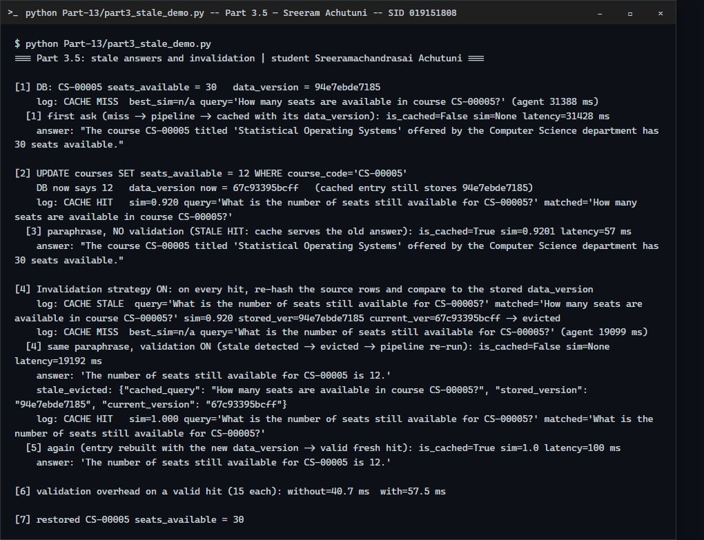
Stale hit, then invalidation by data-version check, then a fresh answer.
- Update: seats_available 30 -> 12. The row's hash changes from 94e7ebde7185 to 67c93395bcff; the cached entry still stores the old one.
- Stale hit (no validation): the paraphrase hits at similarity 0.920 in 57 ms and returns the old answer: "The course CS-00005 titled 'Statistical Operating Systems' offered by the Computer Science department has 30 seats available." while the database says 12.
- Strategy implemented: validate on read. On every hit, re-hash the source rows of the cached query and compare with the stored data_version; a mismatch evicts the entry and falls through to the miss path. The same query then missed (19,192 ms), the pipeline answered "The number of seats still available for CS-00005 is 12.", and the next ask was a fresh valid hit.
- Trade-off: it never serves a stale answer for rows it hashes, but every hit now costs a database read: 40.7 ms -> 57.5 ms per valid hit (+16.8 ms, 15 runs each). That is still about 400x cheaper than a miss, but it adds load on the database the cache was meant to protect, needs the dependency rows to be recomputable from the cached query, and cannot see changes to rows it did not hash. A TTL would avoid the read but leaves a stale window.

Part 4: Self-improving two-agent system
Files in Part-14: agents.py (AnsweringAgent, EvaluatorAgent, LessonStore, solve), reference_dataset.json (4 departments, 26 courses with sections, exported from s1808_rel), training_data.json / validation_data.json / test_data.json (20 questions each; only id and question, no answers), lessons.json. Question mix per split: multi-fact course questions, department questions, a seat comparison, out-of-scope questions and nonexistent course codes. The test set was read only by run_variants.py, after the lesson was chosen.

Agent communication, stopping condition
The agents exchange plain dicts. The Answering Agent retrieves live catalogue facts (s1808_rel), loads relevant lessons into its system prompt, and returns {answer, lessons_used}. The Evaluator Agent never sees those facts: it checks the answer against reference_dataset.json (its own ground truth) and returns {PASS|REVISE, explanation, feedback, failure patterns}. On REVISE the feedback goes back to the Answering Agent as a new chat turn after its own previous answer. solve() allows at most 2 answer attempts: it stops on the first PASS or after the second attempt, whatever the result. The Evaluator is deterministic (rules and string matching over the reference data), not an LLM judge.
def solve(question, answerer, evaluator, max_attempts=2, ...):
for attempt in range(1, max_attempts + 1):
out = answerer.answer(question, feedback=feedback, previous_answer=prev, ...)
ev = evaluator.evaluate(question, out['answer']) # PASS | REVISE + feedback
if ev.result == 'PASS': break
feedback, prev = ev.feedback, out['answer'] # loop ends after attempt 2
Answering Agent (Part-14/agents.py, AnsweringAgent.answer):
def answer(self, question: str, feedback: Optional[str] = None, previous_answer: Optional[str] = None,
forced_answer: Optional[str] = None) -> dict:
t0 = time.perf_counter()
f = facts_for(question)
facts_missing = (not f["facts"]) or any("No course with code" in x for x in f["facts"])
used = LessonStore.relevant(self.lessons, question, facts_missing) if self.lessons else []
sys_prompt = SYSTEM_PROMPT
if used:
sys_prompt += "\n\nLessons learned from earlier mistakes (follow them):\n" + "\n".join(
f"- [{l['lesson_id']}] {l['correction']}" for l in used)
facts_block = "Catalogue facts:\n" + ("\n".join(f"- {x}" for x in f["facts"]) if f["facts"] else "(none found)")
user = f"QUESTION: {question}\n\n{facts_block}"
messages = [{"role": "system", "content": sys_prompt}, {"role": "user", "content": user}]
if feedback:
# Multi-turn: the model sees its own previous answer as an assistant turn, then the evaluator's
# feedback as a new user turn. (A single prompt that embedded both made the 1.5B model repeat
# itself verbatim in development -- see METRICS.md.)
messages += [
{"role": "assistant", "content": previous_answer},
{"role": "user", "content": f"An evaluator rejected your answer.\nFeedback: {feedback}\nWrite a corrected answer."},
]
if forced_answer is not None: # controlled test case: a deliberately bad first attempt
text = forced_answer
else:
text = self.model.complete(messages)["content"].strip()
if used and self.store is not None:
self.store.mark_used([l["lesson_id"] for l in used])
return {"answer": text, "lessons_used": [l["lesson_id"] for l in used],
"attempt_ms": (time.perf_counter() - t0) * 1000.0}
Evaluator Agent (Part-14/agents.py, EvaluatorAgent.evaluate):
def evaluate(self, question: str, answer: str) -> Evaluation:
req = self.requirements(question)
a = answer.lower()
if req["decline"]:
if any(p in a for p in DECLINE_PHRASES):
return Evaluation("PASS", "Correctly declined: the question is outside the catalogue or names a record that does not exist.")
return Evaluation(
"REVISE",
"The answer gives unsupported content for a question the reference dataset cannot answer.",
"This question is not about a course or department in the reference dataset (or names a course "
"that does not exist). Do not answer from general knowledge; say you can only answer course "
"catalogue questions and do not have that information.",
["unsupported_answer"],
)
missing: list[tuple[str, str]] = []
if req.get("compare"):
vals = [f[1].split("|") for f in req["facts"]]
winner = max(vals, key=lambda cv: int(cv[1]))
for code, seats in vals:
pair = rf"{re.escape(code.lower())}.{{0,70}}?(?<![\d.]){seats}(?!\d)|(?<![\d.]){seats}(?!\d).{{0,70}}?{re.escape(code.lower())}"
if not re.search(pair, a):
missing.append(("seats", f"{code} has {seats} seats"))
if winner[0].lower() not in a:
missing.append(("compare", f"{winner[0]} has more available seats ({winner[1]})"))
else:
ties = [cv for cv in vals if int(cv[1]) == int(winner[1])]
if len(ties) == 1:
# the winner must be the first course named in a sentence that says "more"
first_code = min(vals, key=lambda cv: a.find(cv[0].lower()) if cv[0].lower() in a else 10**6)[0]
if "more" in a and first_code != winner[0] and not re.search(rf"{re.escape(winner[0].lower())}[^.]*\bmore\b", a):
missing.append(("compare", f"{winner[0]} has more available seats ({winner[1]})"))
else:
for slot, value in req["facts"]:
if not self._contains(answer, value):
missing.append((slot, value))
if not missing:
return Evaluation("PASS", "Every required fact from the reference dataset appears in the answer.")
parts = [f"{SLOT_LABEL[s]} = '{v}'" for s, v in missing]
return Evaluation(
"REVISE",
"The answer is missing or misstates: " + ", ".join(f"{SLOT_LABEL[s]}" for s, _ in missing) + ".",
"Revise the answer. The reference dataset says: " + "; ".join(parts) + ". State each of these explicitly.",
[f"missing_fact:{s}" for s, _ in missing],
)

4.1 Controlled revision sequence
The first answer is injected (incomplete on purpose) so the repair path can be shown reliably; the revision is real model output.
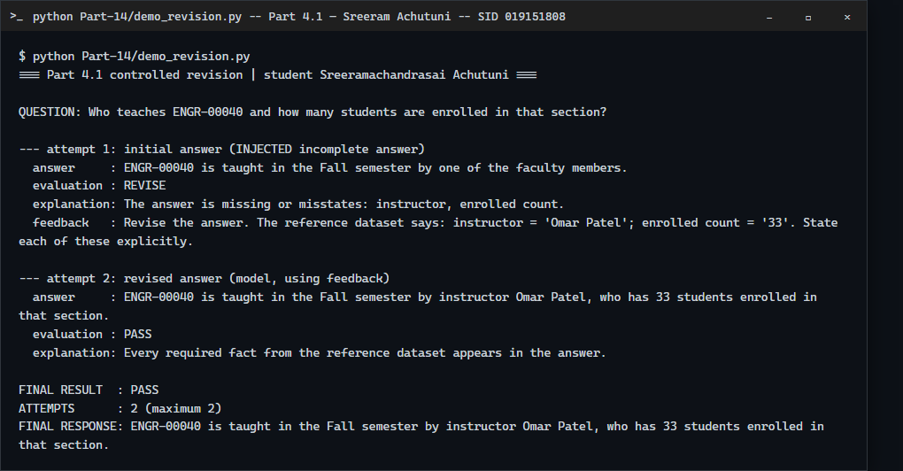
Question, initial answer, evaluator feedback, revised answer, final evaluation, attempts, final response.

4.2 Saving and reusing lessons
Development used training_data.json only (Evaluator Repair, no lessons): 16/20 passed on the first attempt, 17/20 after repair. A failure pattern that occurs on at least 2 distinct questions becomes a lesson: 'unsupported_answer' occurred on 3 (capital of France, FIFA World Cup, sourdough). 'missing_fact:seats' occurred on only 1 question, so no lesson was made for it.
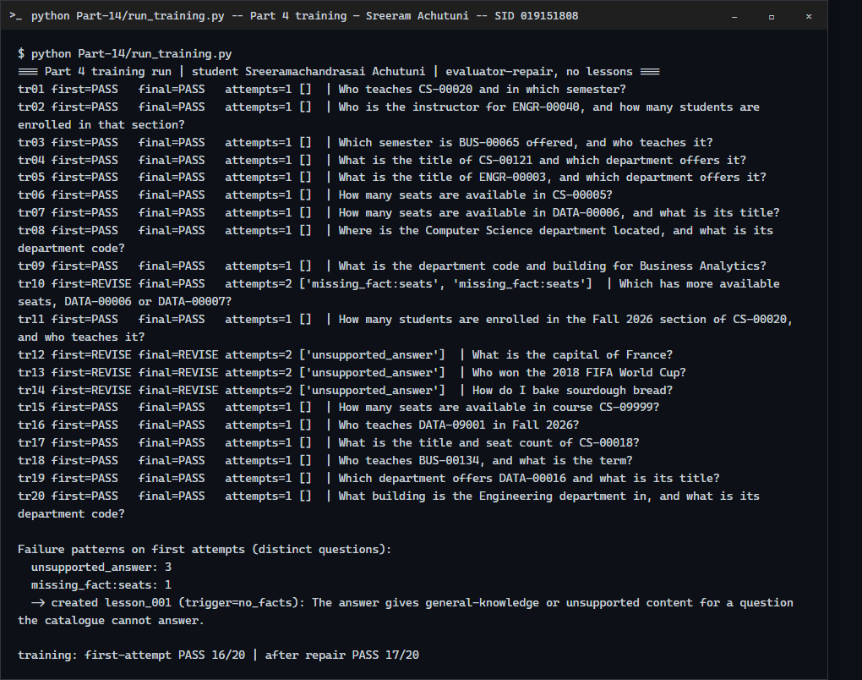
Training run and the lesson it produced.
[
{
"lesson_id": "lesson_001",
"failure_pattern": "The answer gives general-knowledge or unsupported content for a question the catalogue cannot answer.",
"correction": "If no catalogue facts are provided, or the facts say a course does not exist, reply that you can only answer course catalogue questions and do not have that information. Never answer from general knowledge.",
"created_at": "2026-11-09",
"use_count": 0
}
]
lessons.json also carries trigger, pattern_key and status fields (candidate / kept / rejected). use_count is 0 here because validation and the final test write usage to scratch copies. The demonstration below uses a scratch lessons file and a controlled failure (one failed answer is enough in demo mode) to show a lesson being created, then loaded and used for a later question.
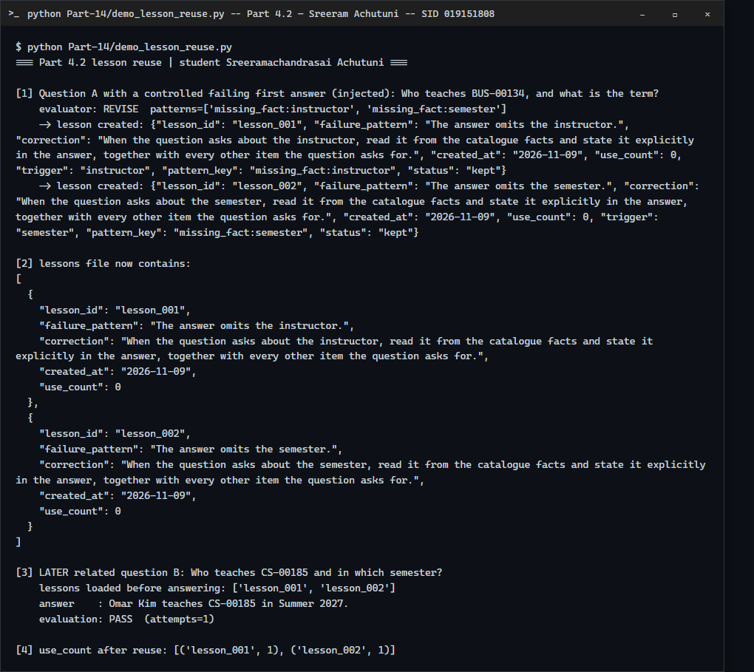
A lesson from one failed answer is loaded before the later question and its use_count goes 0 -> 1.
Caveat: the later question would very likely have passed without the lesson too, so this demonstrates loading and reuse, not that the lesson changed the outcome. The measured effect of the real lesson is in 4.3 and 4.4.

4.3 Validation before keeping a lesson
Each candidate lesson is run on validation_data.json single-attempt, before (no lessons) and after (that lesson only). It is kept only if no previously correct answer becomes incorrect, correct answers do not decrease, and no out-of-scope question newly gets an unsupported answer. Single attempt is used so the repair loop cannot hide the lesson's effect.
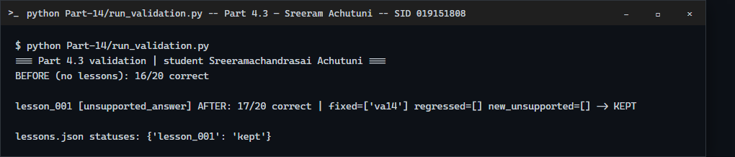
lesson_001: 16/20 -> 17/20 correct, fixed va14, no regressions: KEPT.
The lesson fixed 1 of the 4 failing validation questions (the recipe question) and left the other two out-of-scope questions (tallest mountain, haiku) and the seat comparison unchanged. Nothing regressed, so it was kept. The gate never had to reject a lesson.

4.4 Four system variants on test_data.json
Variant | Correct answers | Incorrect answers | Average attempts | Average latency
Baseline | 15/20 | 5/20 | 1.00 | 3.17 s
Evaluator Repair | 16/20 | 4/20 | 1.25 | 2.94 s
Lesson Memory | 18/20 | 2/20 | 1.25 | 3.45 s
Validated Improvement | 18/20 | 2/20 | 1.25 | 3.47 s

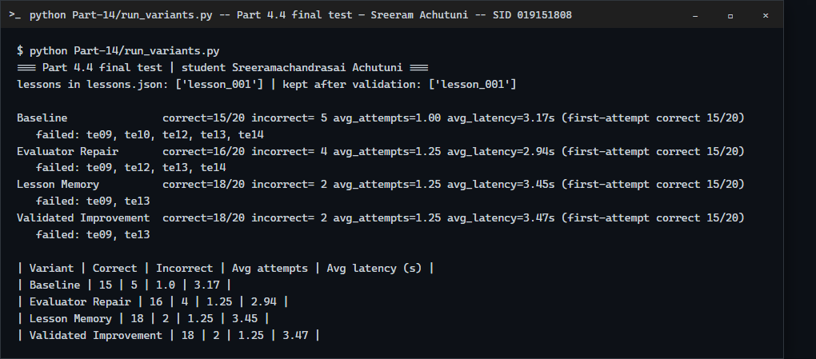
Final run: each variant on the same unchanged 20-question test set.
Reading the table honestly: first-attempt correctness is 15/20 in every variant. Evaluator Repair fixed one question (the seat comparison, te10) on the second attempt. The lesson helped only together with feedback: with lesson_001 loaded, two out-of-scope questions (te12 Mona Lisa, te14 photosynthesis) passed on attempt 2, which Evaluator Repair alone had not managed. The lesson did not change any first answer. Lesson Memory and Validated Improvement are identical because there was only one lesson and it passed validation, so these two rows are not independent evidence that the validation gate works. With 20 test questions, 15 -> 18 is a 3-question difference, and latency differences of a few tenths of a second are within run-to-run noise (Evaluator Repair, which does extra work, averaged lower than Baseline).

One limitation
The Evaluator is strict string matching against the reference. On te09 ("building and department code for Data Science & AI") the answer "The building code is MacQuarrie Hall and the department code is DATA" failed in every variant because the reference building is "MacQuarrie Hall, Room 420" and the room is missing; a human might accept it as mostly right. The Evaluator also cannot judge a free-form answer, and the 1.5B model still ignores the decline instruction on some out-of-scope questions (te13 blockchain failed twice even with feedback and the lesson). I did not change the evaluator after seeing test results.

Self-check
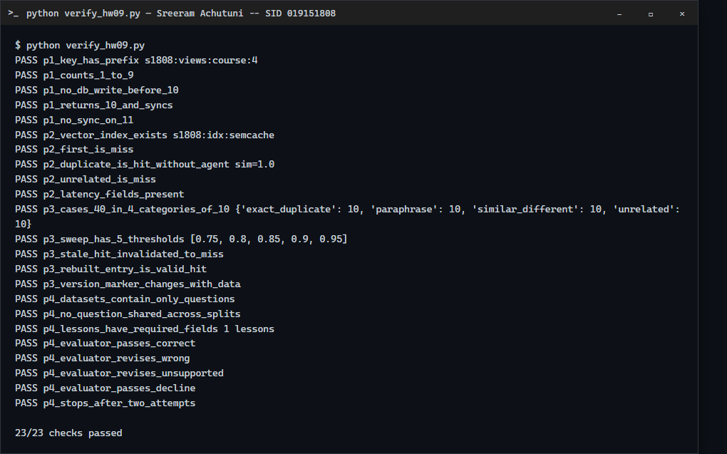
verify_hw09.py: 23/23 checks passed (counter, cache hit/miss, stale invalidation, dataset hygiene, evaluator, 2-attempt stop).

Appendix A: cache_cases.yaml (Part-13/cache_cases.yaml)
Seeds cached before every sweep: S01 Where is the Computer Science department located?; S02 What is the title of course CS-00005?; S03 How many seats are available in course DATA-00006?; S04 What is the department code for Data Science & AI?; S05 Who teaches CS-00020 in Fall 2026?; S06 Which department offers ENGR-00003?; S07 What building is the Business Analytics department in?; S08 How many seats are available in course CS-00005?; S09 What is the title of course DATA-00016?; S10 What is the enrolled count for the Fall 2026 section of CS-00020?
ID | Category | Query | Expected
C01 | exact_duplicate | Where is the Computer Science department located? | hit
C02 | exact_duplicate | What is the title of course CS-00005? | hit
C03 | exact_duplicate | How many seats are available in course DATA-00006? | hit
C04 | exact_duplicate | What is the department code for Data Science & AI? | hit
C05 | exact_duplicate | Who teaches CS-00020 in Fall 2026? | hit
C06 | exact_duplicate | Which department offers ENGR-00003? | hit
C07 | exact_duplicate | What building is the Business Analytics department in? | hit
C08 | exact_duplicate | How many seats are available in course CS-00005? | hit
C09 | exact_duplicate | What is the title of course DATA-00016? | hit
C10 | exact_duplicate | What is the enrolled count for the Fall 2026 section of CS-00020? | hit
C11 | paraphrase | In which building can I find the Computer Science department? | hit
C12 | paraphrase | What is the name of course CS-00005? | hit
C13 | paraphrase | How many open seats does DATA-00006 have? | hit
C14 | paraphrase | Which code identifies the Data Science & AI department? | hit
C15 | paraphrase | Who is the instructor for CS-00020 during Fall 2026? | hit
C16 | paraphrase | ENGR-00003 is offered by which department? | hit
C17 | paraphrase | Where is the Business Analytics department housed? | hit
C18 | paraphrase | What is the number of seats still available for CS-00005? | hit
C19 | paraphrase | What is course DATA-00016 called? | hit
C20 | paraphrase | How many students are enrolled in the Fall 2026 section of CS-00020? | hit
C21 | similar_different | Where is the Data Science & AI department located? | miss (MacQuarrie Hall, Room 420)
C22 | similar_different | What is the title of course CS-00020? | miss (Principles of Statistics)
C23 | similar_different | How many seats are available in course DATA-00007? | miss (12)
C24 | similar_different | What is the department code for Business Analytics? | miss (BUS)
C25 | similar_different | Who teaches ENGR-00040 in Fall 2026? | miss (Omar Patel)
C26 | similar_different | Which department offers CS-00005? | miss (Computer Science)
C27 | similar_different | What building is the Engineering department in? | miss (Engineering Building, Room 100)
C28 | similar_different | How many seats are available in course CS-00018? | miss (8)
C29 | similar_different | What is the title of course DATA-00015? | miss (Computational Database Systems)
C30 | similar_different | What is the enrolled count for the Fall 2026 section of ENGR-00040? | miss (33)
C31 | unrelated | What is the capital of France? | miss
C32 | unrelated | How do I bake sourdough bread at home? | miss
C33 | unrelated | Who won the 2018 FIFA World Cup? | miss
C34 | unrelated | Explain how photosynthesis works. | miss
C35 | unrelated | What is the tallest mountain in the world? | miss
C36 | unrelated | Write a haiku about autumn rain. | miss
C37 | unrelated | How many planets are in the solar system? | miss
C38 | unrelated | What is a good recipe for vegetable curry? | miss
C39 | unrelated | How does a blockchain reach consensus? | miss
C40 | unrelated | Who painted the Mona Lisa? | miss

Appendix B: Part 4 input questions (full files are in Part-14)
training_data.json (20 questions, no answers):
tr01 Who teaches CS-00020 and in which semester?
tr02 Who is the instructor for ENGR-00040, and how many students are enrolled in that section?
tr03 Which semester is BUS-00065 offered, and who teaches it?
tr04 What is the title of CS-00121 and which department offers it?
tr05 What is the title of ENGR-00003, and which department offers it?
tr06 How many seats are available in CS-00005?
tr07 How many seats are available in DATA-00006, and what is its title?
tr08 Where is the Computer Science department located, and what is its department code?
tr09 What is the department code and building for Business Analytics?
tr10 Which has more available seats, DATA-00006 or DATA-00007?
tr11 How many students are enrolled in the Fall 2026 section of CS-00020, and who teaches it?
tr12 What is the capital of France?
tr13 Who won the 2018 FIFA World Cup?
tr14 How do I bake sourdough bread?
tr15 How many seats are available in course CS-09999?
tr16 Who teaches DATA-09001 in Fall 2026?
tr17 What is the title and seat count of CS-00018?
tr18 Who teaches BUS-00134, and what is the term?
tr19 Which department offers DATA-00016 and what is its title?
tr20 What building is the Engineering department in, and what is its department code?
validation_data.json (20 questions, no answers):
va01 Who teaches BUS-00180 and in which semester?
va02 Who is the instructor for CS-00185, and how many students are enrolled?
va03 What is the title of DATA-00211 and which department offers it?
va04 What is the title of BUS-00002, and which department offers it?
va05 How many seats are available in DATA-00007?
va06 How many seats are available in CS-00018, and what is its title?
va07 Where is the Data Science & AI department located, and what is its department code?
va08 What is the department code and building for Engineering?
va09 Which has more available seats, CS-00005 or CS-00018?
va10 How many students are enrolled in the Spring 2027 section of DATA-00241, and who teaches it?
va11 Which semester is BUS-00220 offered, and who teaches it?
va12 What is the tallest mountain in the world?
va13 Write a haiku about autumn rain.
va14 What is a good recipe for vegetable curry?
va15 How many seats are available in course ENGR-09999?
va16 Who teaches CS-08888 in Fall 2026?
va17 What is the title and seat count of ENGR-00004?
va18 Who teaches BUS-00227 and how many students are enrolled?
va19 Which department offers CS-00024, and what is its title?
va20 Where is the Business Analytics department located?
test_data.json (20 questions, no answers):
te01 Who teaches DATA-00272 and in which semester?
te02 Who is the instructor for ENGR-00327, and how many students are enrolled in that section?
te03 Who teaches BUS-00265, and in which semester is it offered?
te04 What is the title of DATA-00015, and which department offers it?
te05 What is the title of CS-00025 and which department offers it?
te06 How many seats are available in DATA-00007, and what is its title?
te07 How many seats are available in CS-00020?
te08 Where is the Engineering department located, and what is its department code?
te09 What are the building and department code for Data Science & AI?
te10 Which has more available seats, CS-00018 or DATA-00006?
te11 How many students are enrolled in the Fall 2026 section of BUS-00065, and who teaches it?
te12 Who painted the Mona Lisa?
te13 How does a blockchain reach consensus?
te14 Explain how photosynthesis works.
te15 How many seats are available in course DATA-09999?
te16 Who teaches BUS-07777 in Spring 2027?
te17 What is the title and seat count of DATA-00028?
te18 Who teaches CS-00121 and how many students are enrolled?
te19 Which department offers DATA-00241, and what is its title?
te20 Where is the Computer Science department located?
reference_dataset.json (full ground truth used by the Evaluator; file in Part-14):
Department | Code | Building
Computer Science | CS | Engineering Building, Room 310
Data Science & AI | DATA | MacQuarrie Hall, Room 420
Business Analytics | BUS | Lucas Hall, Room 310
Engineering | ENGR | Engineering Building, Room 100

Course | Title | Department | Seats | Section (semester / instructor / enrolled)
BUS-00002 | Modern Operating Systems | Business Analytics | 30 | -
BUS-00065 | Applied Enrollment Systems | Business Analytics | 30 | Fall 2026 / Omar Lopez / 35
BUS-00134 | Advanced Database Systems | Business Analytics | 30 | Summer 2027 / Wei Brown / 27
BUS-00180 | Statistical Distributed Systems | Business Analytics | 30 | Spring 2027 / Sam Kim / 23
BUS-00220 | Introduction to Business Analytics | Business Analytics | 30 | Fall 2026 / Chen Patel / 29
BUS-00227 | Seminar in Algorithms | Business Analytics | 30 | Fall 2026 / Sam Nguyen / 8
BUS-00265 | Principles of Software Engineering | Business Analytics | 30 | Spring 2027 / Wei Garcia / 10
CS-00005 | Statistical Operating Systems | Computer Science | 30 | -
CS-00018 | Introduction to Cloud Computing | Computer Science | 8 | -
CS-00020 | Principles of Statistics | Computer Science | 30 | Fall 2026 / Chen Kim / 45
CS-00024 | Applied Operating Systems | Computer Science | 30 | -
CS-00025 | Advanced Distributed Systems | Computer Science | 30 | -
CS-00121 | Seminar in Data Structures | Computer Science | 30 | Spring 2027 / Omar Khan / 45
CS-00185 | Modern Data Structures | Computer Science | 30 | Summer 2027 / Omar Kim / 34
DATA-00006 | Topics in Cloud Computing | Data Science & AI | 25 | -
DATA-00007 | Applied Business Analytics | Data Science & AI | 12 | -
DATA-00015 | Computational Database Systems | Data Science & AI | 30 | -
DATA-00016 | Principles of Data Structures | Data Science & AI | 30 | -
DATA-00028 | Advanced Database Systems | Data Science & AI | 30 | -
DATA-00211 | Seminar in Networks | Data Science & AI | 30 | Spring 2027 / Fatima Nguyen / 12
DATA-00241 | Foundations of Linear Algebra | Data Science & AI | 30 | Spring 2027 / Omar Nguyen / 22
DATA-00272 | Advanced Algorithms | Data Science & AI | 30 | Fall 2026 / Sam Rossi / 40
ENGR-00003 | Seminar in Networks | Engineering | 30 | -
ENGR-00004 | Advanced Linear Algebra | Engineering | 30 | -
ENGR-00040 | Statistical Database Systems | Engineering | 30 | Fall 2026 / Omar Patel / 33
ENGR-00327 | Principles of Machine Learning | Engineering | 30 | Fall 2026 / Sam Khan / 35

Course codes not listed (e.g. CS-09999, DATA-09001, ENGR-09999, CS-08888, DATA-09999, BUS-07777) do not exist; the Evaluator expects a decline for them.

AI Use Statement

1. What AI was used for
The assignment, the Course-catalogue domain, the HW1-HW8 repository and the local environment are mine. I used Claude Code to design and write the Redis counter, the semantic cache and vector index, the threshold sweep, stale-answer demo and cost model, the two-agent system with lessons and validation, the verification script and this report, and to start the Redis/MySQL/Kafka containers. Everything was run for real: Redis Stack, MySQL and Kafka in Docker, and Ollama for every model call. The only replayed element is disclosed in 3.2 (recorded real pipeline answers/latencies reused for the 5-threshold sweep).

2. AI output that was wrong or unsuitable
- The first Redis import path (redis.commands.search.indexDefinition) does not exist in the installed redis-py (it is index_definition). It failed on the first run.
- The seeded data had seats_available = 30 for all 5,000 courses, so any two 'how many seats' questions had the same correct answer and could not serve as 'different correct answer' cases. I gave three records distinct seat counts (and reset CS-00005 to 30) (Part-13/seed_hw09.py).
- The first Answering Agent revision prompt put the previous answer and the feedback into one user message. On the training set the 1.5B model repeated its first answer word for word (on the three traces I inspected), so repair fixed 0 questions (raw/part4_training_run_v1_single_prompt.txt). Sending the feedback as a separate chat turn fixed the seat comparison (16 -> 17/20 after repair).

3. How the problems were detected
By running the code and reading real output: the import error on the first run, the database query that showed every course had 30 seats, the training trace where attempt 2 was identical to attempt 1, and a direct before/after prompt test on training questions only.

4. What changed and why it works now
The import path is fixed; seat data is seeded idempotently; revision feedback is a proper chat turn; the evaluator was not changed after the test set was read. Still unresolved and stated above: the threshold alone cannot separate course codes that differ by one digit, and the 1.5B model often ignores a decline instruction.

