Week 5 - Lesion Segmentation and Cross-Visit Registration
Project: Longitudinal Multimodal AI for Early Prediction of Melanoma Progression and Treatment Response
Module | Lesion Segmentation (M3) and Cross-Visit Registration (M4)
Team Members | Aaditya Rajvinod (R23EF004), Sriram (R23EA122)
Mentor | Dr. Satheesha T.Y.
Deliverable | Week 5 - Implementation and Results (v1.0)

1. Introduction
This week we implemented the first two image-processing modules of the Week 4 design: lesion segmentation (M3) and cross-visit registration (M4). We built and compared three segmentation approaches (automatic Otsu thresholding, semi-automatic GrabCut started from a box drawn by the user, and an automatic U-Net), evaluated them against expert masks on held-out images, implemented and benchmarked registration methods that align images of the same lesion taken at different visits, and generated visit-to-visit visual comparisons. Everything ran on a CPU, and the code is supplied with this report.
What is real and what is simulated. The dermoscopic images, expert lesion masks and diagnoses are real (ISIC 2017 and ISIC 2018). As established in Weeks 1 and 2, no public serial dermoscopy dataset was available to us, so follow-up visits were simulated from real images with known camera motion, lighting change and lesion growth. This makes it possible to score registration and change measurement against a known ground truth; all such results are labelled as simulated.

2. Data and Experimental Setup

2.1 Datasets
Dataset | Images | Ground truth | Use in this work
ISIC 2017 (Parts 1 and 3) | 2,150 | Expert lesion masks; diagnosis: 1,450 nevi, 404 melanomas, 296 seborrhoeic keratoses | Segmentation training (train split) and all evaluation
ISIC 2018 (Task 1) | 2,694 | Expert lesion masks; no diagnosis | Extra segmentation training: the 748 images not already in ISIC 2017
Table 1. Public datasets used.
Both releases were available as 256 × 256 pixel copies (resampled from the originals), so sizes are reported in pixels and as relative changes; pixel spacing was not available. ISIC 2017 was split at lesion level (images flagged as near-duplicates kept together) and stratified by diagnosis into 1,290 training, 430 validation and 430 test images (81 melanomas in the test set). 1,946 of the ISIC 2018 images are copies of ISIC 2017 images, so we matched images by thumbnail correlation and removed the 779 copies of validation or test images from segmentation training; test scores are therefore not inflated by leakage.

2.2 Simulated Follow-Up Visits
Change applied to the follow-up | Parameter range
Camera pose | Rotation ±30°, scale ×0.89 to ×1.13, shift ±16 px
Illumination | Per-channel gain ±10 %, gamma ×0.85 to ×1.15, offset ±4 %
Image quality | Gaussian blur σ 0 to 1 px, sensor noise σ 0.8 %
Lesion growth (scenario B only) | Area ×1.2 to ×1.6, asymmetric (strength 0 to 0.6, random direction); skin beyond a margin unchanged
Colour change (scenario B only) | Darkening plus a blue-grey region, strength 0.3 to 0.8
Table 2. Changes used to simulate a follow-up visit.
Each of the 430 test images served as a baseline visit, and two follow-ups were generated from it: scenario A changes only the acquisition, while scenario B also grows the lesion and changes its colour. Because the true camera transform and the true lesion mask at follow-up are known, alignment error and measured growth can be computed exactly.

3. Lesion Segmentation

3.1 Methods
- Otsu thresholding (automatic baseline). Hair is suppressed with a DullRazor-style black-hat filter and inpainting (Lee et al., 1997). A contrast channel (the mean of CIE L* and the blue channel) is smoothed and thresholded with Otsu's method (Otsu, 1979), ignoring the dark dermatoscope frame; morphological opening and closing, the largest central component and hole filling give the final mask.
- GrabCut (semi-automatic). The clinician drags a box around the lesion; GrabCut (Rother et al., 2004) fits colour models to lesion and skin and solves a graph cut (five iterations), followed by the same clean-up. For evaluation the box was simulated as the expert-mask bounding box with a 12 % margin and ±5 % jitter. A fully automatic variant starts GrabCut from the Otsu mask instead of a box.
- U-Net (automatic). A U-Net (Ronneberger et al., 2015) with an ImageNet-pretrained ResNet-34 encoder (He et al., 2016) and a four-stage decoder (128, 64, 32 and 16 channels), trained on 2,038 images at 192 px with Dice plus binary cross-entropy loss, AdamW and a one-cycle learning-rate schedule, using random crops, rotations, flips, scaling and colour jitter. The stem and first encoder stage were frozen to keep CPU training practical; 5 epochs took 39 minutes, and the checkpoint with the best validation Dice (0.895) was kept. At test time, eight rotated and flipped copies can be averaged (test-time augmentation, TTA); the mean IoU between the eight masks and their average is the mask-confidence score proposed for M3 in Week 4.

3.2 Results
Method | Dice | IoU | Thresholded Jaccard | HD95 (px) | Failures (IoU < 0.65) | Time per image
Otsu (automatic) | 0.754 | 0.665 | 0.560 | 13.0 | 32.6 % | 45 ms
Otsu + GrabCut (automatic) | 0.765 | 0.682 | 0.592 | 12.7 | 29.5 % | -
GrabCut from user box (semi-automatic) | 0.861 | 0.788 | 0.736 | 7.6 | 13.5 % | 381 ms
U-Net (automatic) | 0.896 | 0.828 | 0.782 | 7.2 | 9.8 % | 74 ms
U-Net + 8-way TTA (automatic) | 0.900 | 0.833 | 0.788 | 7.0 | 9.3 % | 546 ms
Table 3. Segmentation on the 430 held-out ISIC 2017 test images (means; HD95 is the median 95th-percentile boundary distance). Thresholded Jaccard is the ISIC challenge score, in which IoU below 0.65 counts as 0.
The U-Net with TTA was the best automatic method (mean Dice 0.900, IoU 0.833, thresholded Jaccard 0.788) and failed on 9.3 % of test images, against 32.6 % for Otsu. TTA added 0.004 Dice at about eight times the inference cost. Semi-automatic GrabCut reached Dice 0.861 from a single box with no training data, which makes it a good correction tool for the dashboard, but it needs user input and struggles where lesion and skin colours overlap. Otsu thresholding was fast but sensitive to hair, ink marks and lesions only slightly darker than the skin. By diagnosis, U-Net + TTA Dice was 0.917 for nevi, 0.892 for melanomas and 0.829 for seborrhoeic keratoses.
The TTA confidence score tracked mask quality (Spearman ρ = 0.67 with IoU; AUROC 0.82 for picking out masks with IoU below 0.8). The 31 test masks with confidence below 0.85 had a mean IoU of 0.51, against 0.86 for the rest, so the planned threshold τ_{seg} = 0.85 is a usable trigger for asking the doctor to confirm or correct a mask.
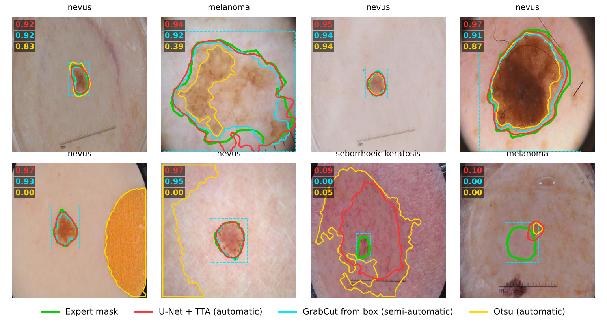
Figure 1. Test-set examples (green: expert mask; red: U-Net + TTA; cyan: GrabCut with the dashed user box; yellow: Otsu; Dice values in the same colours). The last two panels are the U-Net's two worst cases.
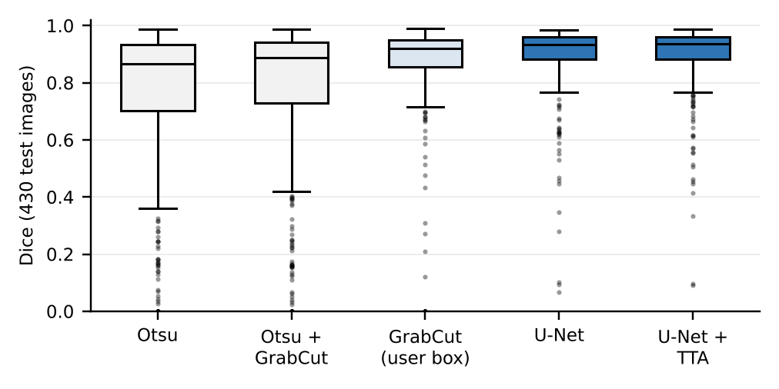
Figure 2. Distribution of Dice scores on the 430 test images.

4. Cross-Visit Registration

4.1 Methods
Registration estimates the transform that maps a follow-up image onto the baseline visit. The design question that matters most is what the transform is allowed to follow: if the lesion itself drives the alignment, part of any real growth is aligned away. We therefore compared methods that use the lesion with methods that use only the surrounding skin (Table 4).
Method | How the transform is estimated
No alignment | Identity (reference point)
Mask moments + scale | Centroid, principal axis and scale (square root of the area ratio) of the two lesion masks
Mask moments, rigid | As above, without scale
ECC, whole image | Intensity-based affine alignment (Evangelidis & Psarakis, 2008), started from rigid moments
SIFT, whole image | SIFT keypoints (Lowe, 2004) anywhere in the field of view; RANSAC similarity transform (Fischler & Bolles, 1981)
ECC, skin only | ECC with the lesion masked out
SIFT, skin only (v1) | Keypoints on skin outside the lesion; accepted when a skin-correlation quality score reached 0.6
SIFT, skin only (v2, proposed) | Contrast-enhanced, more sensitive keypoints on skin outside the dilated lesion and the dermatoscope frame; Lowe ratio test 0.75; RANSAC similarity (3 px). Accepted only with at least 16 inliers and overlapping lesion masks (same-lesion check); otherwise flagged as registration-uncertain, with a rigid mask-moment fallback
Table 4. Registration methods compared.
Listing 1. Core of the proposed registration (Python, simplified from register.py)
1 skin_ref = skin_region(mask_ref, ref) # outside dilated lesion, inside field of view
2 skin_fu = skin_region(mask_fu, fu)
3 kp_r, d_r = sift.detectAndCompute(clahe(gray(ref)), skin_ref)
4 kp_f, d_f = sift.detectAndCompute(clahe(gray(fu)), skin_fu)
5 good = [m for m, n in knn_match(d_f, d_r, k=2) if m.distance < 0.75 * n.distance]
6 A, inl = cv2.estimateAffinePartial2D(pts_f[good], pts_r[good], method=cv2.RANSAC,
7 ransacReprojThreshold=3.0) # similarity
8 ok = plausible(A) and inl.sum() >= 16 and iou(warp(mask_fu, A), mask_ref) >= 0.3
9 if not ok: # too little skin texture
10 A = rigid_from_mask_moments(mask_ref, mask_fu); flags.add('registration_uncertain')

4.2 Evaluation
For every method we measured the alignment error (mean distance between estimated and true positions of 400 skin points away from the lesion), the success rate (error below 2 px), the lesion overlap after alignment (IoU) and, in scenario B, the error in the measured area growth (percentage points) and the fraction of the true growth that survived alignment. In this benchmark both visits used their expert masks, so that registration is judged separately from segmentation; the combined effect with U-Net masks is measured in Week 7.

4.3 Results
Method | A: success (< 2 px) | A: median error (px) | B: success (< 2 px) | B: median error (px) | B: growth error (pp) | B: growth retained | Time (ms)
No alignment | 0 % | 33.00 | 0 % | 33.51 | 15.9 | - | 0
Mask moments + scale | 93 % | 0.14 | 0 % | 17.51 | 38.2 | 0 % | 6
Mask moments, rigid | 15 % | 6.70 | 5 % | 8.52 | 15.7 | 89 % | 4
ECC, whole image | 100 % | 0.10 | 28 % | 9.65 | 21.5 | 46 % | 104
SIFT, whole image | 100 % | 0.11 | 63 % | 0.28 | 16.4 | 99 % | 226
ECC, skin only | 45 % | 2.77 | 31 % | 5.77 | 10.9 | 97 % | 234
SIFT, skin only (v1) | 77 % | 0.17 | 60 % | 0.33 | 6.5 | 100 % | 130
SIFT, skin only (v2, proposed) | 97 % | 0.12 | 78 % | 0.19 | 3.1 | 99 % | 175
Table 5. Registration on 430 simulated follow-ups per scenario (A: acquisition change only; B: acquisition change plus lesion growth). Growth retained is the median ratio of measured to true growth.
Without growth (scenario A), methods that model scale all worked: ECC and SIFT on the whole image each aligned 100 % of pairs to within 2 px, and the proposed method 97 %. With growth (scenario B) the methods separate. Mask moments with scale shrink the grown lesion back to its baseline size: the masks overlap well, but the growth is lost (growth error 38.2 pp, 0 % retained). Whole-image ECC is pulled by the changed lesion (28 % success, 46 % of growth retained), and masking the lesion out of ECC did not help because smooth skin gives it too little signal (31 %).
The proposed skin-only SIFT method kept 99.5 % of the true growth (median) with an overall growth error of 3.1 pp. It accepted 81 % of growth pairs, and 95 % of those were aligned within 2 px with a growth error of 1.0 pp. The remaining 19 % had too few skin keypoints because the lesion filled most of the image: flagged lesions covered a median 48 % of the frame against 10 % for accepted ones, and the flag rate was 1 % for lesions under 20 % of the frame, 84 % for 40 to 60 % and 100 % above 60 %. Flagged pairs are not measured silently but passed on as registration-uncertain, which the Week 4 design routes to the uncertainty gate (M11). The first version (v1) accepted only 63 %; an ablation on 80 pairs showed that the number of RANSAC inliers separates good from bad estimates almost perfectly (at least 16 inliers: 91 to 100 % correct; 15 or fewer: none), which led to version 2.
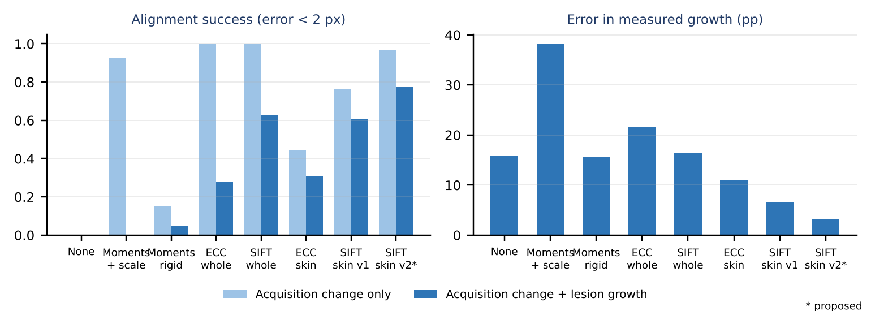
Figure 3. Alignment success and growth-measurement error by method (simulated follow-ups, 430 per scenario).

5. Visit-to-Visit Visual Comparisons
Figures 4 and 5 show the comparison views that the clinician dashboard (S2) will display for a pair of visits, here for two test lesions with simulated growth. Panels (a) to (c) show the baseline, the follow-up as acquired and the follow-up after registration; the checkerboards (d, e) interleave the two images, so misalignment shows as broken skin lines before registration and continuous ones after. Panel (f) overlays both lesion contours in the baseline frame (cyan: baseline; red: follow-up), (g) highlights pixels whose CIEDE2000 colour difference exceeds 10, and (h) is the change map (red: new lesion area; blue: area lost). These views use U-Net masks end to end. The measured area changes, 36.2 % and 41.6 %, compare with true changes of 44.1 % and 44.1 %. In example 1 registration was precise (207 inliers), so the gap comes from the U-Net outlining the two visits slightly differently; Week 7 quantifies this effect over all lesions.
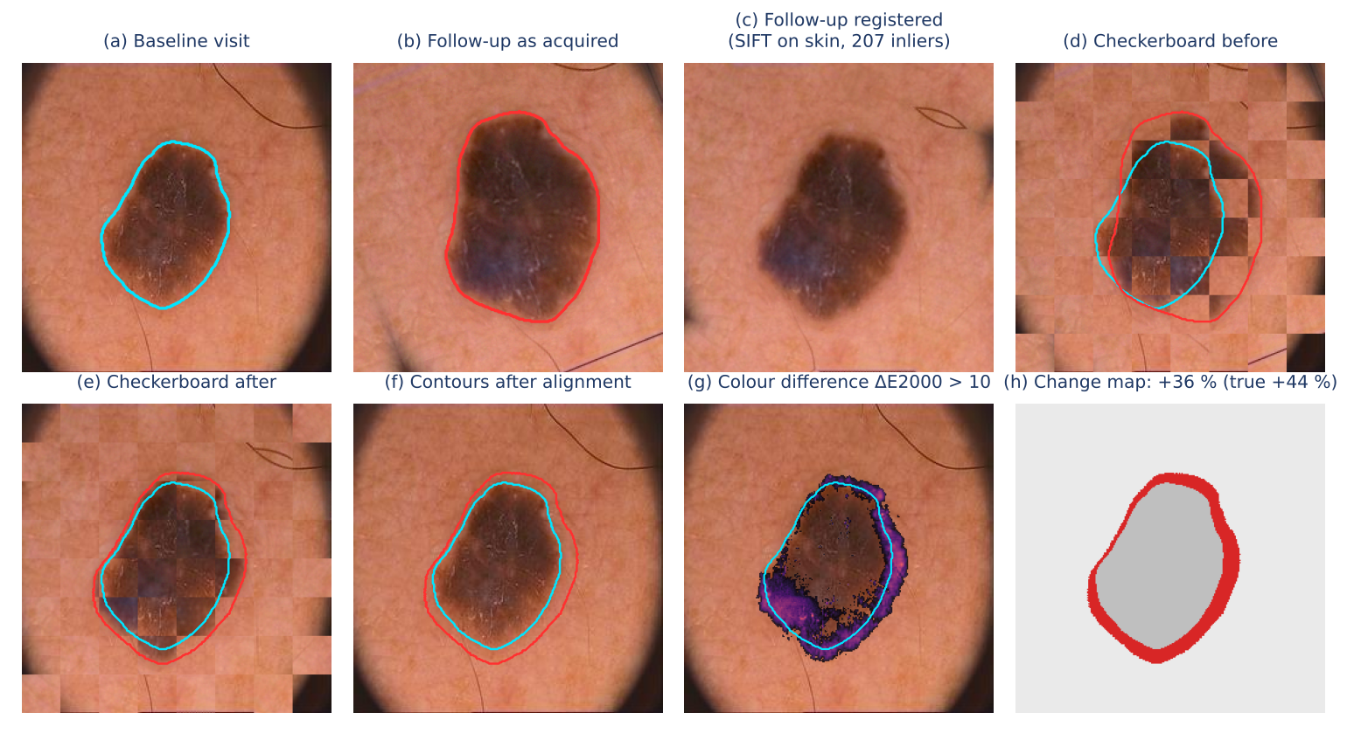
Figure 4. Visit-to-visit comparison, example 1 (simulated follow-up of a real test lesion).
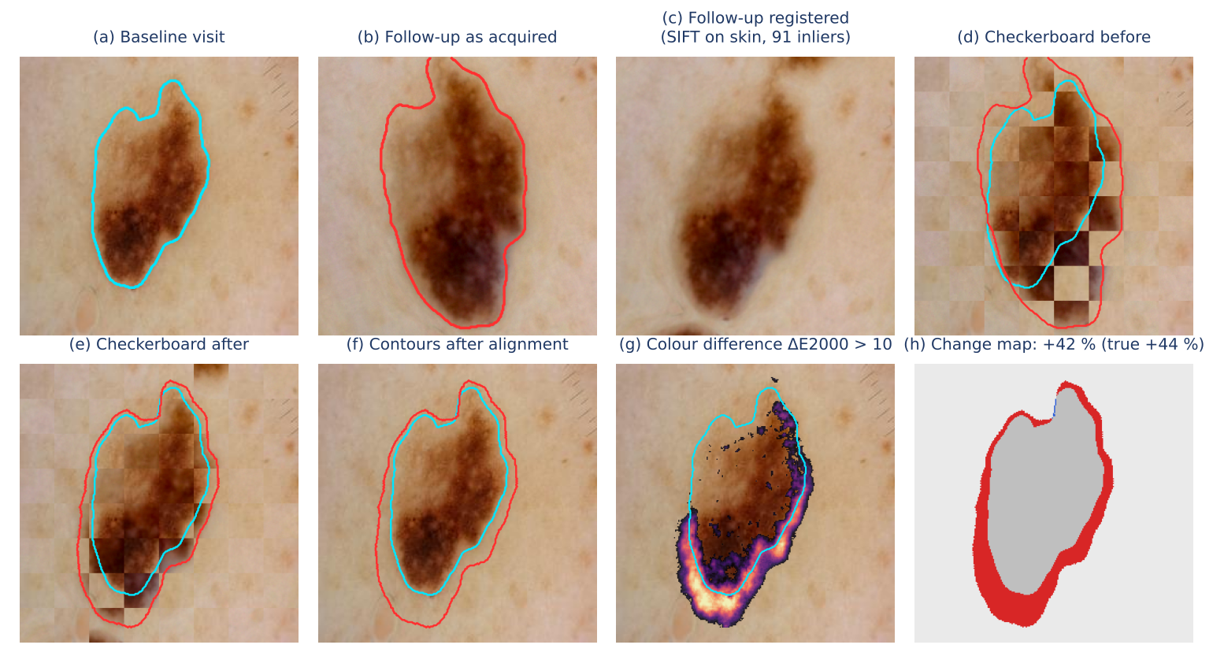
Figure 5. Visit-to-visit comparison, example 2.

6. Discussion and Limitations
- Resolution. The images were 256 × 256 px copies. At the original resolution there is far more skin texture and hair, so we expect more keypoints and fewer registration-uncertain flags; this must be confirmed on full-resolution data.
- Simulated follow-ups. Camera change was modelled as a similarity transform and growth as a smooth radial expansion. Real follow-ups add skin stretching, different dermatoscopes, polarisation modes and compression, so the results here are an upper bound until the method is tested on real serial images (the Basel SDDI1 set).
- Semi-automatic evaluation. GrabCut was scored with simulated user boxes; real boxes may be looser or tighter.
- Units. Without pixel spacing, size is in pixels of the baseline frame and change is relative. Millimetres need the device's pixel size or ruler detection.
- Training budget. The U-Net was trained for 5 epochs on a CPU; longer training, a larger input size and training on full-resolution images should improve it further.

7. Conclusion and Next Steps
For M3 we adopt the U-Net with TTA (Dice 0.900) and its confidence score with τ_{seg} = 0.85, with GrabCut from a box as the doctor's correction tool. For M4 we adopt skin-only SIFT registration with inlier-based acceptance, which, with expert masks, kept the measured growth within about 1.0 percentage points when accepted and flagged the rest. In Week 7 these masks and transforms are used to measure lesion change across visits: diameter, area, asymmetry, border, colour, texture and shape.

References
Codella, N. C. F. et al. (2018). Skin lesion analysis toward melanoma detection: A challenge at the 2017 International Symposium on Biomedical Imaging (ISBI), hosted by the International Skin Imaging Collaboration (ISIC). ISBI 2018, 168-172.
Codella, N. et al. (2019). Skin lesion analysis toward melanoma detection 2018: A challenge hosted by the International Skin Imaging Collaboration (ISIC). arXiv:1902.03368.
Evangelidis, G. D., & Psarakis, E. Z. (2008). Parametric image alignment using enhanced correlation coefficient maximization. IEEE Transactions on Pattern Analysis and Machine Intelligence, 30(10), 1858-1865.
Fischler, M. A., & Bolles, R. C. (1981). Random sample consensus: A paradigm for model fitting with applications to image analysis and automated cartography. Communications of the ACM, 24(6), 381-395.
He, K., Zhang, X., Ren, S., & Sun, J. (2016). Deep residual learning for image recognition. CVPR 2016.
Lee, T. et al. (1997). DullRazor: A software approach to hair removal from images. Computers in Biology and Medicine, 27(6), 533-543.
Lowe, D. G. (2004). Distinctive image features from scale-invariant keypoints. International Journal of Computer Vision, 60(2), 91-110.
Otsu, N. (1979). A threshold selection method from gray-level histograms. IEEE Transactions on Systems, Man, and Cybernetics, 9(1), 62-66.
Ronneberger, O., Fischer, P., & Brox, T. (2015). U-Net: Convolutional networks for biomedical image segmentation. MICCAI 2015.
Rother, C., Kolmogorov, V., & Blake, A. (2004). GrabCut: Interactive foreground extraction using iterated graph cuts. ACM Transactions on Graphics, 23(3), 309-314.
Sharma, G., Wu, W., & Dalal, E. N. (2005). The CIEDE2000 color-difference formula: Implementation notes, supplementary test data, and mathematical observations. Color Research and Application, 30(1), 21-30.
Wightman, R. (2019). PyTorch Image Models (timm). GitHub repository, https://github.com/huggingface/pytorch-image-models.

