Week 6 - Detailed Design and Algorithm Development
Project: Longitudinal Multimodal AI for Early Prediction of Melanoma Progression and Treatment Response
Module | Longitudinal Processing Pipeline and Algorithm Design
Team Members | Aaditya Rajvinod (R23EF004), Sriram (R23EA122)
Mentor | Dr. Satheesha T.Y.
Deliverable | Week 6 - Detailed Design and Algorithm Development (v1.0)

1. Introduction
This document refines the Week 4 design to the level at which it can be coded: the longitudinal pipeline and its flowchart, data-flow and UML views, the method chosen for each stage and why, and pseudocode for the core algorithms. The pipeline sits behind the ModelAdapter interface of the platform implementation document, so it can replace the mock model without changes to the web platform.
Notation. A lesion has visits v₁, ..., v_{T} in date order, each with image x_{t}, mask M_{t} and date d_{t}; Δt_{t} = d_{t} − d_{t−1} in days and D_{t} = d_{t} − d₁. Thresholds τ (for example τ_{seg}) are starting values to be tuned on validation data, not results.

2. Longitudinal Processing Pipeline

2.1 Pipeline Flowchart
Figure 1 gives the control flow of one analysis request. A mask below τ_{seg} waits for the doctor and a lesion with fewer than two usable visits is stored as a baseline only, while a low-quality image or uncertain registration is flagged and passed on. The uncertainty gate then assigns a category or withholds it and refers the case (FR-11, NFR-03), as does any exception or a run over 60 seconds.
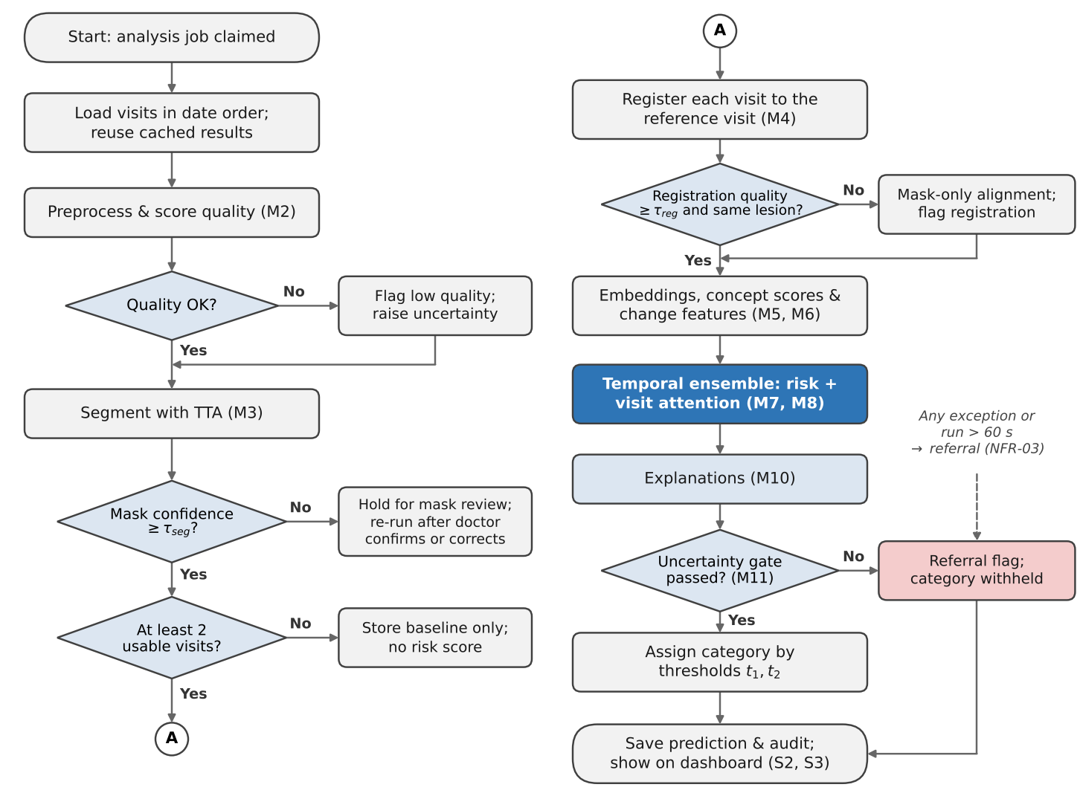
Figure 1. Flowchart of the longitudinal processing pipeline for one analysis request.

2.2 Sequence Assembly and Time Handling
The earliest usable visit (mask accepted or confirmed) is the registration reference and the baseline for change features. Real sequences are short, 2 to 5 images in the serial data we found, so input is capped at T_{max} = 6 visits: the baseline and the five most recent. Spacing ranges from about 3 to 12 months, so each visit carries log(1 + Δt_{t}/30) and D_{t}/365, and changes are also expressed per month.

3. Data-Flow Design
Figure 2 shows the system as one process and what crosses its boundary. Figure 3 opens it into seven processes in Gane-Sarson notation: 1.0 to 6.0 carry out M1-M11 and 7.0 covers S1-S3. Images move between processes only as references into the encrypted store (D2), so every read is checked and logged, and embeddings are cached (D3) under image hash and model version, so a new visit needs only the new image to be encoded (NFR-01).
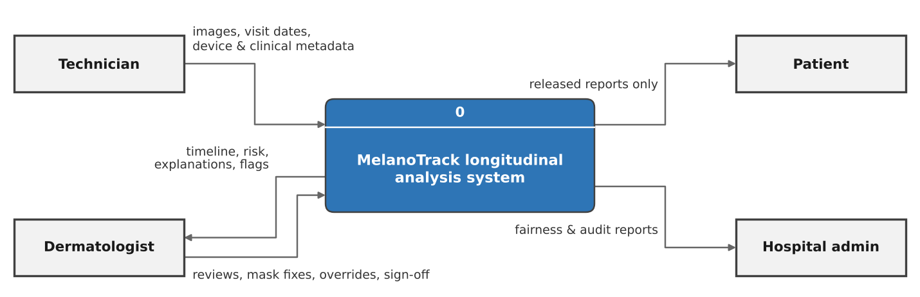
Figure 2. Level-0 data-flow (context) diagram.
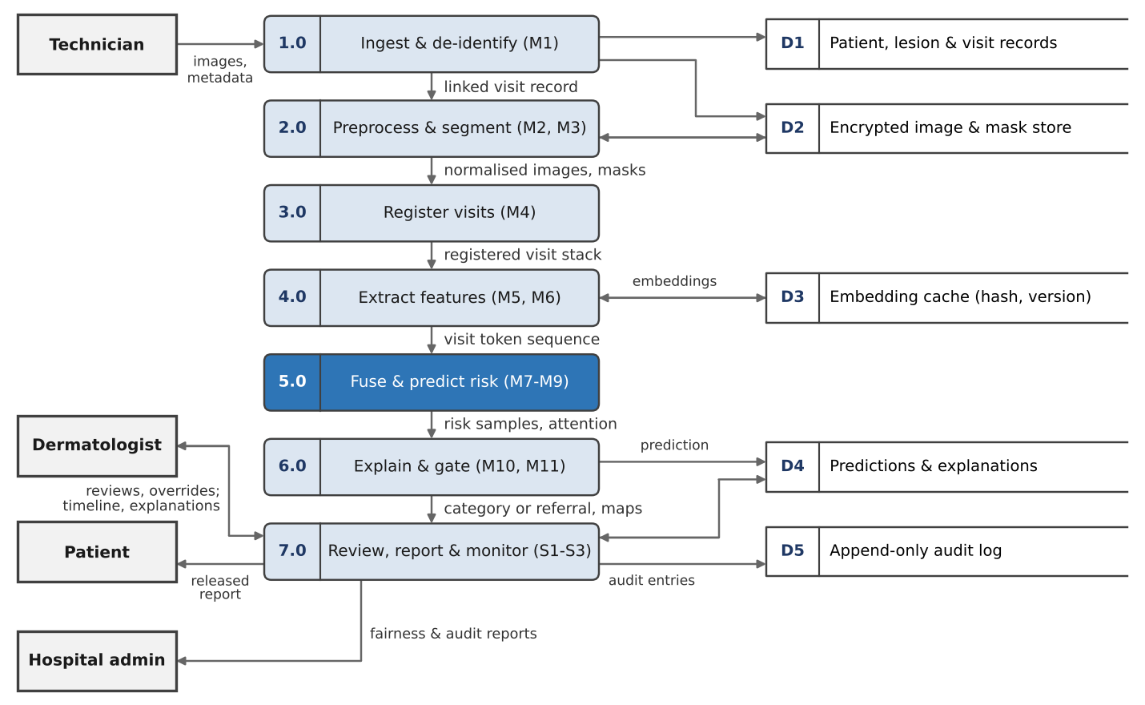
Figure 3. Level-1 data-flow diagram (Gane-Sarson notation).

4. Method Selection
Candidates for each stage were compared on accuracy with little serial data, robustness to device and lighting differences, cost within the 60-second budget (NFR-01) and how well the output can be explained to a clinician (NFR-04).

4.1 Segmentation and Registration
Stage | Candidates considered | Selected | Reason
Segmentation | Otsu; U-Net (Ronneberger et al., 2015); DeepLabV3+; MedSAM (Ma et al., 2024) | U-Net, ResNet-34 encoder, Dice + BCE, ISIC 2018 and HAM10000 masks; MedSAM for click-prompted correction | Accurate on dermoscopy (Codella et al., 2019), light on CPU; Otsu fails on hair
Mask confidence | Softmax; MC dropout; test-time augmentation | 8-way TTA (rotations × flip); mean IoU of TTA masks with fused mask | Model-agnostic; measures mask stability
Coarse alignment | Image centre; mask moments | Rotation and translation from mask centroid and axis | No scale from the mask, so growth is kept
Fine alignment | ECC; ORB; SIFT (Lowe, 2004); SuperPoint + LightGlue | SIFT in the skin ring around the lesion; RANSAC similarity, affine if ≥ 30 inliers | Invariant to scale and rotation; CPU
Non-rigid step | B-spline deformation; optical flow | Difference-map display only, capped | Can absorb true growth
Table 1. Segmentation and registration methods considered and selected (M3, M4).
The key registration decision is what the transform may see. If the lesion drives the alignment, especially its scale, a lesion that has grown by 20 % is shrunk back to match and the change the model needs disappears. The transform is therefore fitted only to matches in a ring of skin around the lesion, quality combines the inlier ratio with the ring's normalised cross-correlation, and an identity check (warped-mask IoU ≥ 0.3) catches wrongly linked lesions. This refines Week 4 (§4.4), where mask overlap alone would penalise real growth.

4.2 Feature Extraction
Group | Features | How computed
Learned embedding | 256-d vector per image | EfficientNet-B3 features, projected
Dermoscopic concepts | 7 scores: pigment network, blue-whitish veil, vascular, streaks, dots/globules, blotches, regression | Heads trained on Derm7pt (Kawahara et al., 2019)
Shape | Asymmetry A₁, A₂; compactness 4πA/P²; border sharpness | Mask mirrored about principal axes; edge gradient
Colour, texture | Count of six dermoscopic colours; Lab* mean and SD; LBP (P = 8, R = 1) | Inside the mask
Size | Area, maximum diameter | mm when pixel size is known, else ratios
Change | Difference and ratio vs previous visit and baseline; rate per month; embedding cosine distance | After registration
3D (M6, conditional) | Relief proxy, surface area, height asymmetry, pathway flag | 3D-TBP, else shading-based proxy
Table 2. Per-visit and change features (M5, M6).
Handcrafted descriptors stay beside the learned embedding because the change summary reports them to the clinician (M10) and, with only a few hundred serial lesions, they give the temporal model a signal it does not have to learn.

4.3 Per-Visit Encoder: CNN or Transformer
Encoder | Type | Params | Data need | Assessment
ResNet-50 | CNN | 25.6 M | Moderate | Baseline; twice the size of B3
EfficientNet-B3 (Tan & Le, 2019) | CNN | 12 M | Moderate | Selected: strong on ISIC data, fits CPU budget
ViT-B/16 | Transformer | 86 M | High | Too data-hungry at our scale
Swin-Tiny | Transformer | 28 M | Mod.-high | Week 4 (§5.3) Transformer alternative
DINOv2 ViT-S/14 (Oquab et al., 2024) | Frozen ViT | 21 M | Low | Frozen-feature baseline
Table 3. Per-visit encoder candidates (M5).
We selected EfficientNet-B3. CNNs carry locality priors that let them fine-tune from thousands rather than millions of images, whereas Vision Transformers need far more data; B3 is about half the size of ResNet-50 with higher ImageNet accuracy (Tan & Le, 2019), and EfficientNets were the backbone of the winning SIIM-ISIC 2020 solution (Ha et al., 2020). A two-layer Transformer over visits remains the alternative temporal model. The encoder is fine-tuned on HAM10000, SIIM-ISIC 2020 and Derm7pt with lesion- and patient-level splits, then frozen for temporal training.

4.4 Temporal Modelling
Model | Variable length | Time gap | Size | Explanation | Role
Siamese pair (latest vs previous) | No | Δt input | 0.1 M | Difference only | Baseline, as in PanDerm (Yan et al., 2025)
LSTM | Yes | In token | 0.2 M | Weak | Not selected
GRU + attention pooling | Yes | In token | 0.15 M | Visit attention α_{t} | Selected (Week 4 §5.3)
Time-aware LSTM (Baytas et al., 2017) | Yes | Decays memory | 0.2 M | Weak | Ablation
Transformer encoder, 2 layers | Yes | Time encoding | 0.3 M | Attention maps | When data allow
Table 4. Temporal model candidates (M7).
The selected model (Figure 4) is a one-layer GRU with 128 units and attention pooling over visit tokens. Each token joins the embedding, concept scores, descriptors, change features, 3D vector (or a missing-modality bit) and the two time encodings. The attention query is built from the clinical metadata, giving the tabular-image cross-attention planned in Week 4 (§4.7), and the weights α_{t} are exported as the visit-attention explanation (FR-09). Five members with different seeds form the ensemble used by M11. Training uses focal loss with γ = 2 (Lin et al., 2017) plus 0.5 times the change loss, modality dropout of 0.3, AdamW and early stopping on validation AUPRC under leave-patient-out cross-validation, then temperature scaling on held-out patients (Guo et al., 2017).
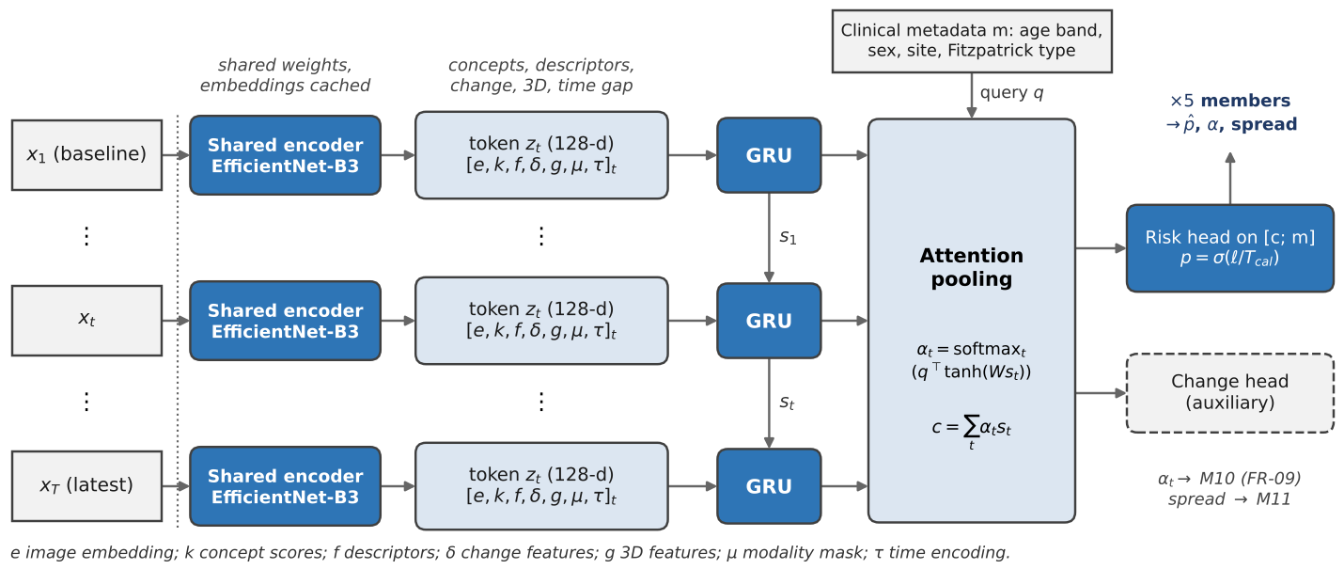
Figure 4. Architecture of the longitudinal model (one of five ensemble members shown).

5. Module-Level Design
Table 5 fixes each module's algorithm, starting parameters, output and time budget. With cached embeddings a new visit costs about 4 s of budget and a five-visit lesion from scratch about 13 s on CPU, inside the 60 s target (NFR-01). M6 and M9 run only when their data exist and keep the Week 4 design.
Module | Algorithm and starting parameters | Output | Time budget
M2 Preprocessing | Shades-of-Gray colour constancy (p = 6); DullRazor-style hair removal; blur if variance of Laplacian < 100; glare and marker fractions; 512 px (M3), 300 px (M5) | Normalised images; quality score q in [0, 1]; flags | 0.3 s per image
M3 Segmentation | U-Net, ResNet-34 encoder, 512 px; 8-way TTA (Table 1); τ_{seg} = 0.85 | Mask, contour, confidence c, area, diameter | 1.5 s per image (CPU)
M4 Registration | Rigid start from mask moments; SIFT in skin ring, ratio test 0.75; RANSAC (3 px) similarity, affine if ≥ 30 inliers; τ_{reg} = 0.6 (Algorithm 2) | 2×3 transform A_{t}, q_{reg}, uncertain flag | 0.5 s per pair
M5 Temporal features | EfficientNet-B3 at 300 px, 1,536 → 256; 7 concept heads; Table 2 descriptors; cache key (SHA-256, model version) | Token inputs and change features | 0.2 s per new image
M7, M8 Fusion and risk | GRU-128, metadata-conditioned attention; 5 members; focal loss γ = 2; temperature T_{cal}; thresholds t₁, t₂ from validation (Algorithm 3) | p̂, α_{t}, member outputs, category | < 0.1 s
M10 Explainability | CIEDE2000 colour difference of registered images inside the dilated mask union, shown above ΔE = 10; Grad-CAM++ (Chattopadhay et al., 2018) on the most-attended visit, dropped if it fails a deletion test; template change summary | Difference map, saliency, attention chart, summary | 1.0 s
M11 Uncertainty | Ensemble mutual information (Lakshminarayanan et al., 2017); split conformal set, α = 0.1; Mahalanobis OOD score; reason codes (Algorithm 4) | Uncertainty u, referral flag, reasons | < 0.1 s
Table 5. Module-level design: algorithms, starting parameters, outputs and time budgets.

6. UML Design
In Figure 5, running the pipeline is included in every analysis request and mask correction extends the review use case, as it is needed only when segmentation confidence is low. In Figure 6, LongitudinalAdapter implements ModelAdapter and owns one instance of each component; components exchange plain data objects rather than shared state, so each can be retrained or replaced on its own (NFR-09). Figure 7 follows one request; the break fragment is the mask-confidence stop of Figure 1.
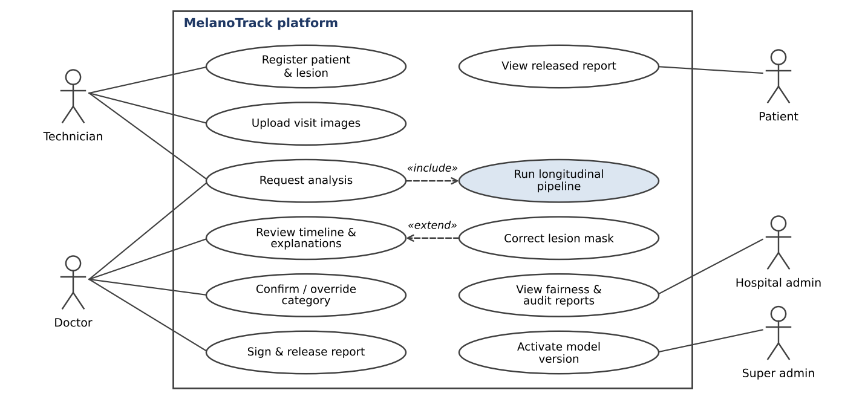
Figure 5. Use case diagram.
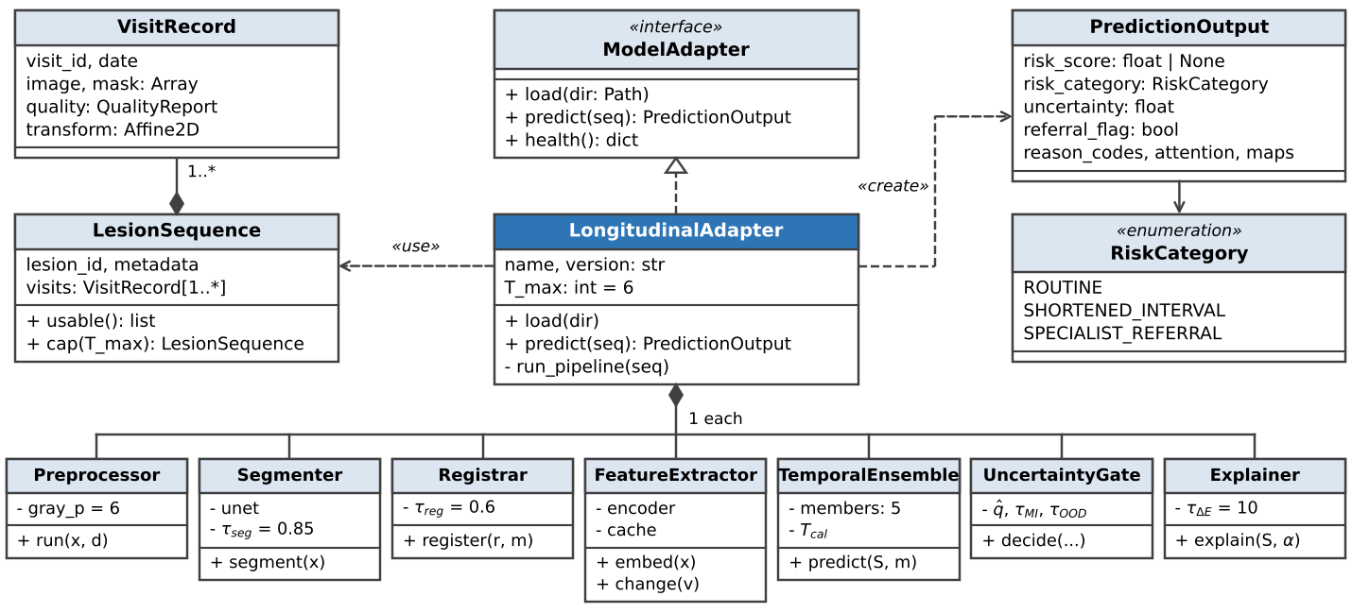
Figure 6. Class diagram of the analysis pipeline.
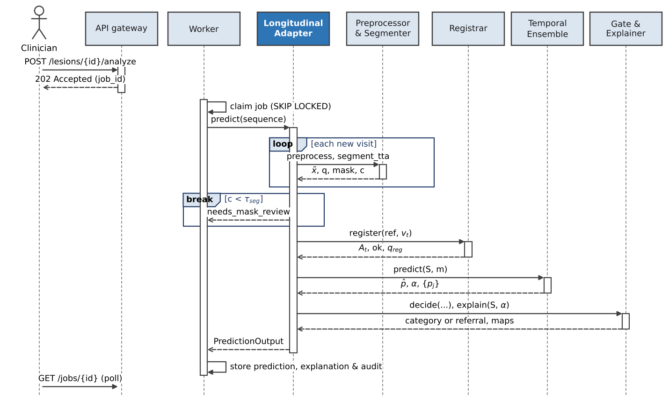
Figure 7. Sequence diagram for one analysis request.

7. Algorithms and Pseudocode
Algorithms 1 to 4 specify the core of the pipeline; REGISTER is Algorithm 2, ← is assignment and comments follow //.
Algorithm 1. Longitudinal lesion analysis (orchestrator, M1-M11)
Input: lesion L with its visits, active model version m
Output: PredictionOutput P
1 F ← ∅ // reason flags for the gate
2 for each visit v of L in date order without a cached result for m do
3 (x̃, q) ← PREPROCESS(primary image of v) // M2
4 if q.score < τ_q then F ← F ∪ {low_quality}
5 (M, c) ← SEGMENT_TTA(x̃) // M3, 8-way TTA, Table 1
6 if c < τ_seg and not v.mask_confirmed then
7 return HOLD(v, needs_mask_review) // no score from a rejected mask
8 U ← usable visits ; if |U| < 2 then return BASELINE_ONLY(L) // Week 4 M5
9 for t ← 2 to |U| do (A_t, ok_t) ← REGISTER(U[1], U[t]) // Algorithm 2
10 if any ok_t is false then F ← F ∪ {registration_uncertain}
11 try (p̂, α, {p_j}) ← PREDICT(U, A, L.metadata) within 60 s // Algorithm 3
12 catch error or timeout: return REFER(L, {model_error}) // NFR-03
13 return GATE({p_j}, p̂, e_T, F) with EXPLAIN(U, α) // Algorithm 4; M10

Algorithm 2. Cross-visit registration anchored on peri-lesional skin (M4)
Input: reference (x_r, M_r), moving visit (x_m, M_m), τ_reg = 0.6
Output: transform A (moving → reference), flag ok, quality q_reg
1 A_0 ← rotation + translation from centroids and principal axes of M_r, M_m
2 R ← DILATE(M_r, 0.25 · equivalent diameter of M_r) \ M_r // skin ring
3 K ← SIFT matches of x_r on R and A_0(x_m) on its ring, Lowe ratio 0.75, mutual
4 if |K| ≥ 8 then
5 (A_1, I) ← RANSAC_SIMILARITY(K, 3 px)
6 if |I| ≥ 30 then (A_1, I) ← RANSAC_AFFINE(K, 3 px)
7 A ← A_1 ∘ A_0 ; ρ ← |I| / |K|
8 else A ← A_0 ; ρ ← 0
9 n ← NCC( x_r, A(x_m) ) over R // skin alignment, not lesion change
10 q_reg ← 0.5 · min(1, ρ / 0.5) + 0.5 · max(0, n)
11 same ← IoU( A(M_m), M_r ) ≥ 0.3 // identity check: same lesion?
12 ok ← (q_reg ≥ τ_reg) and same
13 if not ok then A ← A_0 // mask-only fallback, Week 4 §4.4
14 return A, ok, q_reg

Algorithm 3. Sequence assembly and ensemble prediction (M5, M7, M8)
Input: usable visits u_1..u_T (images x_t, masks M_t, transforms A_t), metadata m
Output: calibrated risk p̂, visit attention α, member probabilities {p_j}
1 keep the baseline and the 5 most recent visits if T > 6
2 for t ← 1 to T do
3 e_t ← W_e · ENC(x_t) // EfficientNet-B3, 1,536 → 256, cached
4 k_t ← CONCEPTS(x_t) ; f_t ← DESCRIPTORS(A_t(x_t), A_t(M_t)) // Table 2
5 δ_t ← [f_t − f_{t−1}, f_t − f_1, 1 − cos(e_t, e_{t−1})] // zero for t = 1
6 append (f_t − f_{t−1}) / max(Δt_t / 30, 1) to δ_t // change per month
7 τ_t ← [log(1 + Δt_t / 30), D_t / 365] ; (g_t, μ_t) ← M6 output, modality mask
8 z_t ← LayerNorm( W_z [e_t; k_t; f_t; δ_t; g_t; μ_t; τ_t] ) // 128-d token
9 for j ← 1 to 5 do // ensemble members, different seeds
10 (s_1, ..., s_T) ← GRU_j(z_1, ..., z_T)
11 q ← w_j + W_q · EMB(m) // metadata-conditioned query
12 α_t^(j) ← softmax_t( qᵀ tanh(W_s s_t) ) ; c ← Σ_t α_t^(j) s_t
13 p_j ← σ( RISK_j([c ; EMB(m)]) / T_cal ) // temperature-scaled
14 p̂ ← mean_j p_j ; α ← mean_j α^(j)
15 return p̂, α, {p_j}

Algorithm 4. Uncertainty gate and category assignment (M11, M8)
Input: member probabilities {p_j}, mean p̂, latest embedding e_T, flags F, quantile q̂
Output: referral flag, category, uncertainty u, reason codes R
1 R ← F
2 u ← h(p̂) ; MI ← h(p̂) − mean_j h(p_j) // h: binary entropy; MI: disagreement
3 C ← { y ∈ {stable, progressed} : 1 − p̂_y ≤ q̂ } // split-conformal set, α = 0.1
4 d ← Mahalanobis(e_T ; μ_train, Σ_train) // out-of-distribution score
5 if |C| ≠ 1 then R ← R ∪ {ambiguous_prediction}
6 if MI > τ_MI then R ← R ∪ {model_disagreement}
7 if d > τ_OOD then R ← R ∪ {out_of_distribution}
8 if R ≠ ∅ then return (true, NULL, u, R) // FR-11, NFR-03: category withheld
9 if p̂ < t_1 then category ← routine
10 else if p̂ < t_2 then category ← shortened_interval
11 else category ← specialist_referral
12 return (false, category, u, ∅)

In Algorithm 4, p̂_{progressed} = p̂ and p̂_{stable} = 1 − p̂. The quantile q̂ is the ⌈(n + 1)(1 − α)⌉/n empirical quantile of the scores 1 − p̂ given to the true class of each of n calibration patients, which gives about 90 % coverage for α = 0.1 (Angelopoulos & Bates, 2021). Thresholds t₁ and t₂ are set on validation data so that referral reaches the sensitivity target agreed with the clinician.

8. Verification and Next Steps
Before integration, segmentation is checked by IoU on held-out ISIC 2018 lesions, registration by recovering known transforms of SDDI1 images with simulated growth that must survive alignment, and the gate by conformal coverage and injected faults that must each end in a referral. We then replace the mock model one module at a time, starting with segmentation and registration. Access to the Basel (SDDI1) sequences remains the main dependency for training the temporal model.

References
Angelopoulos, A. N., & Bates, S. (2021). A gentle introduction to conformal prediction and distribution-free uncertainty quantification. arXiv:2107.07511.
Baytas, I. M. et al. (2017). Patient subtyping via time-aware LSTM networks. KDD 2017, 65-74.
Chattopadhay, A. et al. (2018). Grad-CAM++: Generalized gradient-based visual explanations for deep convolutional networks. WACV 2018.
Codella, N. et al. (2019). Skin lesion analysis toward melanoma detection 2018: A challenge hosted by the International Skin Imaging Collaboration (ISIC). arXiv:1902.03368.
Guo, C. et al. (2017). On calibration of modern neural networks. ICML 2017.
Ha, Q., Liu, B., & Liu, F. (2020). Identifying melanoma images using EfficientNet ensemble: Winning solution to the SIIM-ISIC melanoma classification challenge. arXiv:2010.05351.
Kawahara, J., Daneshvar, S., Argenziano, G., & Hamarneh, G. (2019). Seven-point checklist and skin lesion classification using multitask multimodal neural nets. IEEE Journal of Biomedical and Health Informatics, 23(2).
Lakshminarayanan, B., Pritzel, A., & Blundell, C. (2017). Simple and scalable predictive uncertainty estimation using deep ensembles. NeurIPS 2017.
Lin, T.-Y. et al. (2017). Focal loss for dense object detection. ICCV 2017.
Lowe, D. G. (2004). Distinctive image features from scale-invariant keypoints. International Journal of Computer Vision, 60(2), 91-110.
Ma, J. et al. (2024). Segment anything in medical images. Nature Communications, 15, 654.
Oquab, M. et al. (2024). DINOv2: Learning robust visual features without supervision. Transactions on Machine Learning Research.
Ronneberger, O., Fischer, P., & Brox, T. (2015). U-Net: Convolutional networks for biomedical image segmentation. MICCAI 2015.
Tan, M., & Le, Q. V. (2019). EfficientNet: Rethinking model scaling for convolutional neural networks. ICML 2019.
Yan, S. et al. (2025). A multimodal vision foundation model for clinical dermatology (PanDerm). Nature Medicine.

