Week 7 - Temporal Feature Extraction and Lesion Change Analysis
Project: Longitudinal Multimodal AI for Early Prediction of Melanoma Progression and Treatment Response
Module | Temporal Feature Extraction (M5) and Lesion Change Analysis
Team Members | Aaditya Rajvinod (R23EF004), Sriram (R23EA122)
Mentor | Dr. Satheesha T.Y.
Deliverable | Week 7 - Implementation and Results (v1.0)

1. Introduction
This week we implemented feature extraction (M5): each visit of a lesion is turned into a set of measurements, and the change in those measurements between visits is calculated. Change over time is the "E" of the ABCDE rule and the basis of sequential dermoscopy, which can reveal melanomas that have no suspicious features at a single visit (Kittler et al., 2006). The features cover the quantities named in the task: diameter, area, asymmetry, border irregularity, colour, texture and shape. They are computed on the outputs of Week 5: every visit is segmented by the U-Net and registered to the first visit by the skin-anchored registration, and all sizes are expressed in the units of the first visit, so that a camera held closer at one visit is not mistaken for growth.
What is real and what is simulated. As in Week 5, the lesions are real ISIC 2017 test images, while the follow-up visits are simulated with a known amount of change, because no serial dermoscopy dataset was available. Each of the 430 held-out test lesions was turned into a progressing and a stable four-visit sequence (3,440 visits in total). Because the true change is known, we can report how accurately the pipeline measures change, how much it moves when nothing changes, and which features best separate progressing from stable lesions.

2. Longitudinal Sequences
Element | Design
Visits | Four, at months 0, 6 (±1), 12 (±1.5) and 18 (±2); the latest visit is the real image and earlier visits are reconstructed backwards from it
Progressing version | Area grows ×1.3 to ×2.0 over the follow-up (realised growth of the true masks 28.6 % to 94.8 %, mean 57.8 %), asymmetrically (strength 0.2 to 0.8); colour darkens and becomes more varied over time (strength 0.3 to 0.9)
Stable version | True size varies by about 3 % (standard deviation) only; no colour change
Every visit | Independent camera pose, illumination, blur and noise, as in Week 5 (rotation ±30°, scale ×0.89 to ×1.13, shift ±16 px)
Table 1. Design of the simulated visit sequences.
Generating both versions from the same real lesion means that any difference between the two groups comes from the simulated change alone, not from the groups containing different lesions.

3. Feature Extraction

3.1 Per-Visit Pipeline
For each visit: (1) the U-Net from Week 5 segments the lesion; (2) the visit is registered to visit 1 with skin-only SIFT and RANSAC, and if fewer than 16 inliers are found or the lesion masks do not overlap after alignment, it is flagged as registration-uncertain and aligned by mask moments instead; (3) the descriptors in Table 2 are computed on the visit's own image and mask, and sizes are converted to visit-1 pixels with the scale s of the registration (lengths × s, area × s²). Sizes are in pixels because pixel spacing was not available.
We first measured every follow-up after warping it into the visit-1 frame. Resampling, however, slightly blurs the image and roughens the outline of the warped mask, which shifted perimeter-based shape measures and texture at every follow-up, even for lesions that did not change (Section 4.5). Measuring each visit in its own frame avoids this, while the registration still puts all sizes in the same units and supplies the registration-uncertain flag.

3.2 Descriptors
Group | Features | Definition
Size | Area; equivalent diameter; maximum (Feret) diameter; perimeter | From the visit's mask, converted to visit-1 pixels with the registration scale
Asymmetry | Asymmetry index; its components A₁ and A₂ | A₁, A₂: non-overlap of the mask with its mirror image about the major and minor principal axes, divided by twice the area; the index is their mean (ABCD rule; Stolz et al., 1994)
Border | Compactness; fractal dimension; radial irregularity; border sharpness | P²/(4πA); box-counting dimension of the outline; SD / mean of centre-to-boundary distance; mean L* gradient across a 4-px band
Shape | Solidity; convexity; eccentricity | Pixel area / convex-hull area (can slightly exceed 1 for very compact masks); hull perimeter / perimeter; from the second moments
Colour | Lesion minus skin L*, a*, b* and ΔE; lesion mean L* and its SD; colour heterogeneity; number of colours; dark and blue-grey fractions | CIE L*a*b*, relative to a 12-px skin ring so illumination changes largely cancel; heterogeneity = mean ΔE from the lesion mean; a colour counts if at least 5 % of the lesion lies within ΔE 30 of white, red, light brown, dark brown, blue-grey or black (Kasmi & Mokrani, 2016)
Texture | GLCM contrast, homogeneity, energy, correlation; LBP entropy | L* quantised to 32 levels, distances 1 and 2 px, four angles (Haralick et al., 1973); uniform LBP, P = 8, R = 1 (Ojala et al., 2002)
Table 2. Descriptors computed at every visit (29 values per visit).

3.3 Change Measures
For every feature we compute the change from the first to the last visit (relative change in per cent for size features, absolute change for the others), the rate of change per month (least-squares slope over all visits) and the largest step between consecutive visits (Listing 1). These are the temporal features passed to the progression model in Week 9.
Listing 1. Change measures for one lesion sequence (Python, simplified from build_sequences.py and w9_temporal.py)
1 ref = visits[0] # visit 1 defines the units
2 for v in visits:
3 A, v.reg_ok = (eye(2, 3), True) if v is ref else register_skin_sift(ref, v) # Week 5
4 s = sqrt(abs(det(A[:, :2]))) # registration scale
5 d = describe(v.img, v.mask) # visit's own frame, no resampling
6 for f in ('eq_diameter', 'max_diameter', 'perimeter'): d[f] *= s
7 d['area'] *= s ** 2; d['border_sharpness'] /= s
8 v.desc = d
9 months = [v.month for v in visits]
10 for f in FEATURES:
11 x = array([v.desc[f] for v in visits])
12 if f in SIZE: x = 100 * (x / x[0] - 1) # per cent of visit 1
13 change[f] = x[-1] - x[0] # first to last visit
14 rate[f] = polyfit(months, x, deg=1)[0] # per month
15 step[f] = max(abs(diff(x))) # largest visit-to-visit step
16 uncertain = mean([not v.reg_ok for v in visits[1:]]) # passed on to Week 9

4. Results

4.1 Pipeline Quality on the Sequences
Across the 3,440 visits the U-Net masks agreed with the true masks with a mean Dice of 0.881. Of the follow-up visits, 89 % were aligned to within 2 px of the true position (median error 0.21 px), and 9 % were flagged as registration-uncertain. In 87 % of sequences every follow-up was accepted (83 % of progressing and 90 % of stable sequences); growth leaves less skin visible around the lesion, so flags are more common in progressing lesions. Below, "accepted" refers to those fully accepted sequences, which are the ones the system would report as measured.

4.2 Accuracy of the Measured Change
Figure 1 compares measured and true area change from the first to the last visit. With the true masks and transforms (oracle), the measurement itself is almost exact (mean absolute error 0.6 percentage points, r = 1.00). With the full pipeline on accepted sequences the mean absolute error was 15.0 pp and the median 6.6 pp (r = 0.71, bias -5.2 pp, 95 % limits of agreement -54.7 to 44.4 pp; Bland & Altman, 1986). On the sequences with a flagged registration the mean error was 29.1 pp, so the flag correctly marks measurements that should not be trusted.
To find the source of the error we recomputed the area change with one component replaced by the truth. With U-Net masks and the true transforms the error was 14.9 pp; with true masks and the estimated transforms it was only 0.7 pp. Almost all of the error therefore comes from segmentation, not registration. The typical U-Net area error at a single visit was 10.9 % in either direction (median signed error +0.7 %), and the largest errors came from occasional gross failures in which the mask spread well beyond the lesion. These were most frequent at the first visit of progressing lesions, where the simulated lesion is smallest and lightest (8.1 % of these masks were more than twice the true area, against 3.3 % at other visits). This is the main reason why growth was underestimated on average: accepted progressing lesions grew by 57.6 % but were measured at 46.5 %.
From the stable lesions we estimated the smallest area change that can be told apart from noise (one-sided 95 %; the noise here includes the 3 % true size fluctuation built into the stable lesions): 19.1 pp on accepted sequences, against 5.0 pp with oracle masks. With that threshold, 83 % of progressing lesions were detected as grown, while 5 % of stable lesions were wrongly flagged as grown.
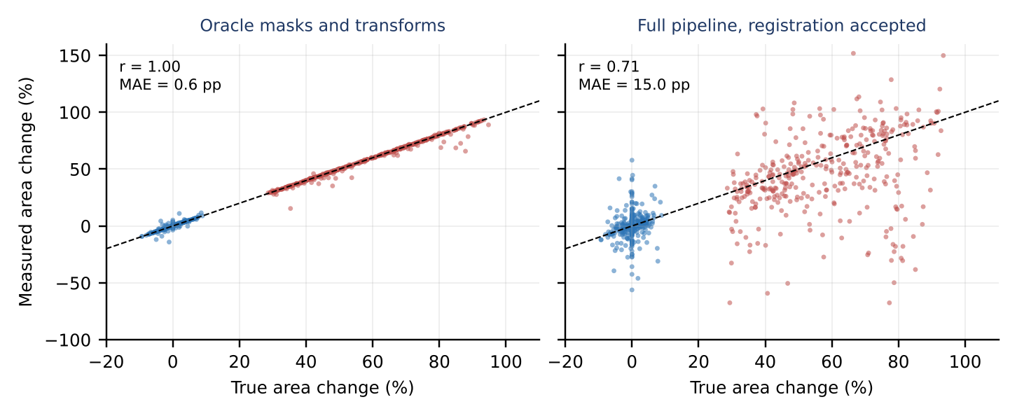
Figure 1. Measured versus true area change from the first to the last visit (red: progressing, blue: stable). Left: true masks and transforms; right: full pipeline on accepted sequences.

4.3 Lesion Progression over Time
Figure 2 shows the mean course of eight features over the four visits, and Table 3 gives the values. Progressing lesions grew steadily: at month 18 their area was 46.5 % and their maximum diameter 22.2 % above visit 1, against 0.4 % and 0.6 % for stable lesions. Their contrast with the skin rose from ΔE 17.0 to 22.2, their colour heterogeneity from 7.4 to 9.8, and their GLCM energy fell from 0.352 to 0.249, meaning less uniform texture. Progressing lesions start lighter and more uniform because the simulation reconstructs earlier visits backwards from the real image; at the last visit both versions show the same real lesion, so the curves meet. Asymmetry, compactness and solidity barely moved in either group, although the simulated growth was asymmetric (Section 4.4). The stable group stayed flat on every feature apart from measurement noise.
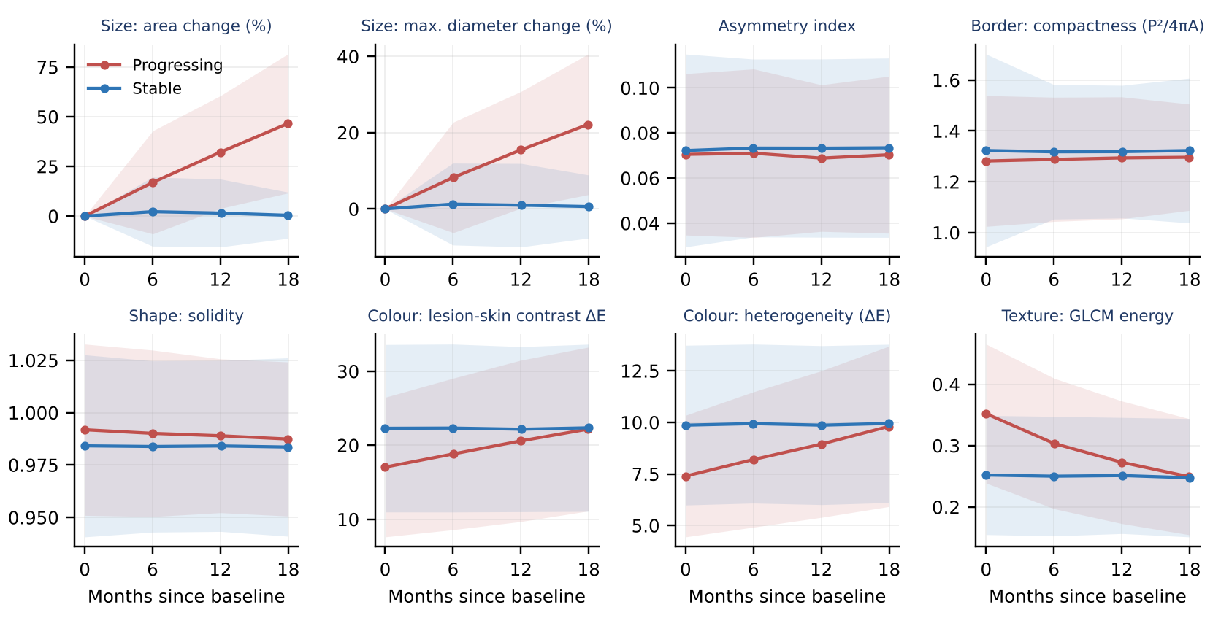
Figure 2. Mean feature trajectories (± 1 SD band) for the progressing and stable versions of the test lesions (accepted sequences).
Feature | Group | Visit 1 (month 0) | Visit 2 (month 6) | Visit 3 (month 12) | Visit 4 (month 18)
Area change (%) | Progressing | 0 (reference) | 17.0 ± 25.9 | 32.2 ± 28.3 | 46.5 ± 34.9
 | Stable | 0 (reference) | 2.2 ± 17.3 | 1.5 ± 17.0 | 0.4 ± 11.6
Max. diameter change (%) | Progressing | 0 (reference) | 8.2 ± 14.5 | 15.5 ± 15.3 | 22.2 ± 18.4
 | Stable | 0 (reference) | 1.3 ± 10.7 | 1.0 ± 10.9 | 0.6 ± 8.3
Asymmetry index | Progressing | 0.071 ± 0.036 | 0.071 ± 0.037 | 0.069 ± 0.033 | 0.070 ± 0.035
 | Stable | 0.072 ± 0.043 | 0.073 ± 0.039 | 0.073 ± 0.040 | 0.073 ± 0.040
Border compactness | Progressing | 1.28 ± 0.26 | 1.29 ± 0.24 | 1.29 ± 0.24 | 1.30 ± 0.21
 | Stable | 1.32 ± 0.38 | 1.32 ± 0.26 | 1.32 ± 0.26 | 1.32 ± 0.28
Solidity | Progressing | 0.992 ± 0.041 | 0.990 ± 0.040 | 0.989 ± 0.037 | 0.987 ± 0.037
 | Stable | 0.984 ± 0.043 | 0.984 ± 0.041 | 0.984 ± 0.041 | 0.984 ± 0.043
Lesion-skin contrast ΔE | Progressing | 17.0 ± 9.4 | 18.8 ± 10.2 | 20.6 ± 10.9 | 22.2 ± 11.1
 | Stable | 22.3 ± 11.3 | 22.3 ± 11.3 | 22.2 ± 11.2 | 22.4 ± 11.3
Colour heterogeneity | Progressing | 7.4 ± 2.9 | 8.2 ± 3.3 | 8.9 ± 3.6 | 9.8 ± 3.9
 | Stable | 9.9 ± 3.9 | 9.9 ± 3.9 | 9.9 ± 3.9 | 9.9 ± 3.8
GLCM energy | Progressing | 0.352 ± 0.113 | 0.303 ± 0.106 | 0.273 ± 0.100 | 0.249 ± 0.095
 | Stable | 0.252 ± 0.097 | 0.250 ± 0.097 | 0.251 ± 0.095 | 0.248 ± 0.096
Table 3. Mean ± SD of each feature at each visit for the progressing and stable versions of the accepted test sequences (the values plotted in Figure 2). Size features are relative to visit 1.

4.4 Which Changes Separate Progressing from Stable Lesions
Feature (change, first to last visit) | Stable mean | Progressing mean | Stable SD (noise) | Effect size d | AUROC, all | AUROC, accepted | AUROC, oracle
Area (%) | 0.2 | 47.5 | 13.5 | 1.60 | 0.892 | 0.895 | 1.000
Max. diameter (%) | 0.3 | 21.7 | 9.5 | 1.37 | 0.869 | 0.876 | 0.996
Asymmetry index | 0.001 | -0.001 | 0.026 | -0.09 | 0.532 | 0.523 | 0.836
Border compactness | -0.005 | 0.010 | 0.233 | 0.06 | 0.604 | 0.622 | 0.956
Radial irregularity | 0.001 | 0.004 | 0.028 | 0.09 | 0.571 | 0.602 | 0.812
Border sharpness | 0.006 | 0.176 | 0.211 | 0.50 | 0.675 | 0.702 | 0.803
Solidity | 0.000 | -0.003 | 0.025 | -0.10 | 0.638 | 0.664 | 0.958
Lesion-skin contrast ΔE | 0.14 | 5.10 | 2.25 | 1.58 | 0.914 | 0.927 | 0.910
Lightness vs skin ΔL* | -0.07 | -4.95 | 1.84 | -1.75 | 0.938 | 0.955 | 0.962
SD of L* | 0.09 | 2.63 | 0.79 | 1.50 | 0.914 | 0.928 | 0.959
Colour heterogeneity | 0.10 | 2.47 | 0.84 | 1.44 | 0.889 | 0.894 | 0.950
No. of colours | 0.01 | 0.26 | 0.57 | 0.40 | 0.596 | 0.605 | 0.595
GLCM contrast | 0.05 | 0.21 | 0.25 | 0.50 | 0.692 | 0.695 | 0.687
GLCM energy | -0.005 | -0.100 | 0.026 | -1.70 | 0.940 | 0.950 | 0.959
LBP entropy | 0.01 | -0.07 | 0.07 | -0.73 | 0.718 | 0.733 | 0.706
Table 4. Change in each feature from the first to the last visit, and how well it separates progressing from stable lesions (AUROC; 0.5 = no separation). Size changes are in per cent; other features are absolute differences. Oracle: true masks and transforms (not a fair reference for the outline-based measures; see text).
The strongest single signals were the darkening of the lesion relative to the skin (ΔL*, AUROC 0.955 on accepted sequences), the loss of texture uniformity (GLCM energy, 0.950) and the colour contrast and spread (ΔE 0.927, SD of L* 0.928), followed by size (area 0.895, maximum diameter 0.876). The colour and texture ranking partly reflects the simulation, in which every progressing lesion also darkens; real lesions may grow without changing colour. Asymmetry, border and shape changes separated the groups only weakly (AUROC 0.523 to 0.664): in our growth model the outline changes mostly in size and only slightly in shape, and the visit-to-visit variation of the U-Net outline at 256 px (the "Stable SD" column) is larger than that change. The oracle column is not a fair reference for these outline-based measures. The simulator resamples the true mask with nearest-neighbour interpolation, which leaves a jagged outline at strongly shrunk early visits (mean compactness of the true masks 2.77 at visit 1 of progressing lesions against 1.75 at visit 4; U-Net masks 1.32 and 1.33), so with true masks these measures look separable for the wrong reason. Shape-change measurement therefore still has to be validated on real serial images. Because each feature is noisy on its own, several features, rather than one, are passed to the temporal model.
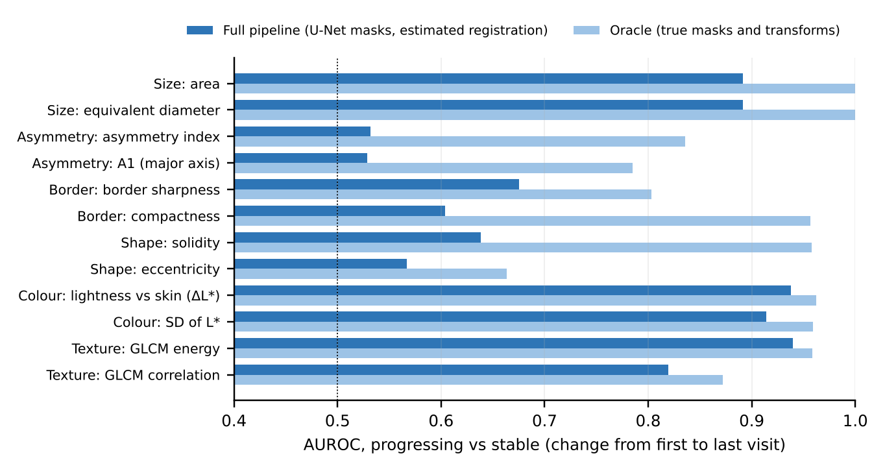
Figure 3. The two best features of each group: separation of progressing from stable lesions with the full pipeline and with oracle masks and transforms (all sequences). Oracle values for asymmetry, border and shape are inflated by the jagged outline of the simulated true masks.

4.5 Measuring in the Visit's Own Frame
Table 5 compares the two ways of measuring the same sequences. When each follow-up was warped into the visit-1 frame before measurement, stable lesions appeared to change: their perimeter grew by 5.5 % and their compactness by 0.145 between the first and last visit, and LBP entropy fell by 0.231. The shift appeared as a step at visit 2 (mean compactness of stable lesions 1.34, 1.48, 1.47, 1.48 over the four visits), because visit 1 is the only visit that is never resampled. Measured in each visit's own frame, the same lesions stayed flat (1.34, 1.33, 1.33, 1.33), separation improved for compactness (AUROC 0.528 to 0.604), convexity and LBP entropy, and size measures were unchanged. A few features separated marginally better after resampling, most clearly GLCM contrast (0.728 against 0.692), probably because the blur also suppresses noise; we keep the own-frame measurement because it does not invent change in stable lesions.
Feature | Stable mean change: resampled | Stable mean change: own frame | AUROC: resampled | AUROC: own frame
Perimeter (%) | 5.5 | 0.1 | 0.869 | 0.867
Border compactness | 0.145 | -0.005 | 0.528 | 0.604
Convexity | -0.048 | 0.000 | 0.506 | 0.557
Fractal dimension | 0.016 | -0.003 | 0.537 | 0.541
GLCM contrast | -0.065 | 0.048 | 0.728 | 0.692
LBP entropy | -0.231 | 0.009 | 0.619 | 0.718
Area (%), for comparison | -0.2 | 0.2 | 0.892 | 0.892
Table 5. Measuring after resampling into the visit-1 frame versus in each visit's own frame (all test sequences, U-Net masks). For stable lesions the true mean change is zero.

4.6 Example Lesion
Figure 4 follows one test lesion (ISIC_0009933, nevus) through both versions. The registered views show the baseline outline (cyan) with each visit's outline (red), so growth appears as a widening gap. Table 6 lists the measurements for the progressing version: the true area increase over the follow-up was 91.4 %, and the pipeline measured 100.5 %.
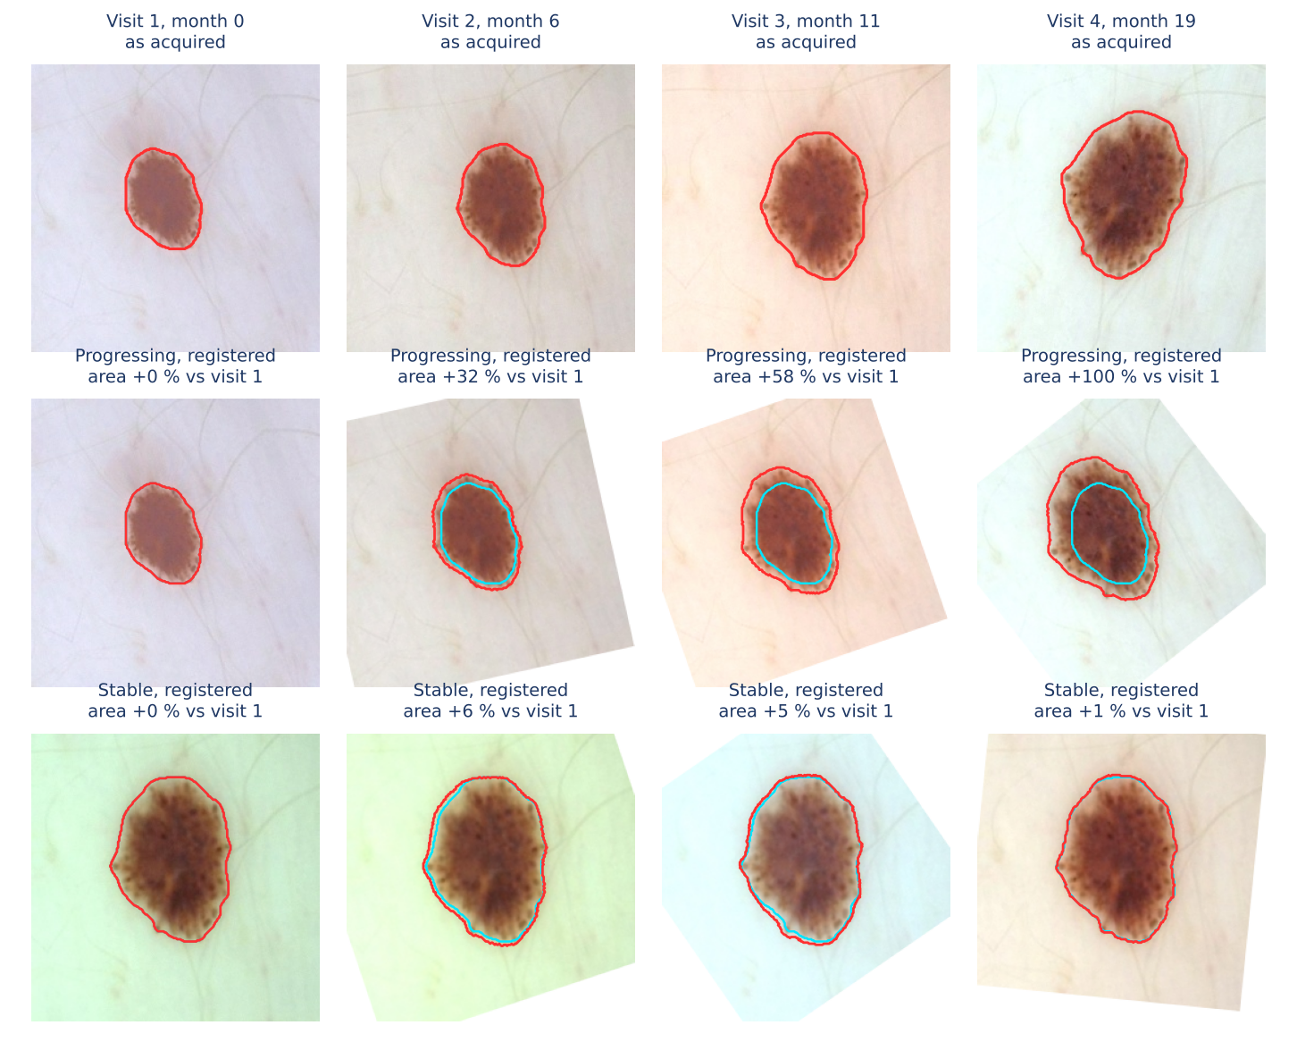
Figure 4. Example lesion. Top: progressing version as acquired; middle: the same visits registered to visit 1; bottom: stable version registered to visit 1. White corners are outside the follow-up image.
Visit | Month | Area change (%) | Max. diameter (px) | Asymmetry | Compactness | Contrast ΔE | No. colours
1 | 0.0 | 0.0 | 94.2 | 0.037 | 1.19 | 33.2 | 2
2 | 5.6 | 31.8 | 108.0 | 0.046 | 1.20 | 38.2 | 1
3 | 10.5 | 58.1 | 119.2 | 0.053 | 1.21 | 39.1 | 1
4 | 19.0 | 100.5 | 135.3 | 0.051 | 1.26 | 47.2 | 3
Table 6. Measurements at each visit for the progressing version of the example lesion.

5. Discussion and Limitations
- Segmentation, not registration, limits the measurement. Registration alone produced 0.7 pp of error, while U-Net masks alone produced 14.9 pp, mostly through occasional gross failures. Two remedies follow: withhold measurements whose segmentation confidence is low (the test-time-augmentation agreement score from Week 5 detected masks with IoU below 0.8 with an AUROC of 0.82), and segment each follow-up with the registered mask of the previous visit as a prior, so that the outline cannot jump between visits.
- Flagged registrations must reach the uncertainty gate (M11). Measurements from flagged sequences were twice as inaccurate and should be shown as unreliable rather than as numbers.
- Resolution and units. The 256-pixel copies limit fine shape and texture measures, and size is in pixels. Pixel spacing from the device, or ruler detection, is needed to report millimetres and the 6 mm diameter criterion.
- Simulated change. Growth, asymmetry and colour change follow our simulation model, in which progressing lesions always darken and change shape only slightly, and whose true masks have jagged outlines after resampling. Real progression can be subtler (for example new structures without growth), so the feature ranking, and shape change in particular, must be re-checked on real serial data before thresholds are fixed.
- Choice of baseline. Change is measured against visit 1. If visit 1 is of poor quality, every later comparison inherits that; a robust alternative is to compare each visit with the best-quality earlier visit.

6. Conclusion and Next Steps
The feature-extraction step now produces 29 descriptors per visit and their changes over time, with sizes expressed in the units of the first visit. On accepted sequences, area change was measured with a median absolute error of 6.6 percentage points (mean 15.0), changes larger than about 19 % could be told apart from noise, and 83 % of growing lesions were detected at a 5 % false-alarm rate. Colour, texture and size changes separated progressing from stable lesions well; shape changes will need better segmentation. In Week 9 these change features are combined with deep image features to predict progression risk.

References
Bland, J. M., & Altman, D. G. (1986). Statistical methods for assessing agreement between two methods of clinical measurement. The Lancet, 327(8476), 307-310.
Haralick, R. M., Shanmugam, K., & Dinstein, I. (1973). Textural features for image classification. IEEE Transactions on Systems, Man, and Cybernetics, SMC-3(6), 610-621.
Kasmi, R., & Mokrani, K. (2016). Classification of malignant melanoma and benign skin lesions: Implementation of automatic ABCD rule. IET Image Processing, 10(6), 448-455.
Kittler, H. et al. (2006). Identification of clinically featureless incipient melanoma using sequential dermoscopy imaging. Archives of Dermatology, 142(9), 1113-1119.
Ojala, T., Pietikäinen, M., & Mäenpää, T. (2002). Multiresolution gray-scale and rotation invariant texture classification with local binary patterns. IEEE Transactions on Pattern Analysis and Machine Intelligence, 24(7), 971-987.
Stolz, W. et al. (1994). ABCD rule of dermatoscopy: A new practical method for early recognition of malignant melanoma. European Journal of Dermatology, 4, 521-527.

