Week 9 - Deep Learning and Temporal Model Development
Project: Longitudinal Multimodal AI for Early Prediction of Melanoma Progression and Treatment Response
Module | Image Encoders (M5) and Temporal Progression Model (M7, M8)
Team Members | Aaditya Rajvinod (R23EF004), Sriram (R23EA122)
Mentor | Dr. Satheesha T.Y.
Deliverable | Week 9 - Implementation and Results (v1.0)

1. Introduction
This week we developed the learning components of the pipeline in two steps. First, single-visit baselines: three convolutional networks (CNNs) and a vision Transformer were used as image encoders for melanoma detection on real ISIC 2017 images, and compared with the handcrafted descriptors from Week 7 and with a combination of both. Second, temporal models for sequences of visits, following serial-dermoscopy work such as Yu et al. (2020): the GRU with attention pooling selected in the detailed design, and a small Transformer encoder, were compared with simpler ways of combining the latest image with the change features from Week 7.
What is real and what is simulated. The baseline experiments use only real images and real diagnoses. The temporal experiments use the simulated four-visit sequences from Week 7, so the benefit of temporal information depends on how often lesions change in the simulation. We therefore state that link explicitly, vary it in a sensitivity analysis, and include a control in which change carries no information about diagnosis. The temporal results show that the models and the fusion work as intended; they are not estimates of clinical accuracy.

2. Single-Visit Baselines

2.1 Setup
- Task. Melanoma versus benign lesion (nevus or seborrhoeic keratosis) from one dermoscopic image of the ISIC 2017 data (Codella et al., 2018), on the lesion-level splits of Week 5: 1,290 training, 430 validation and 430 test images (81 melanomas in the test set).
- Encoders. ImageNet-pretrained CNNs (ResNet-50, He et al., 2016; EfficientNet-B0 and B3, Tan & Le, 2019) and a Transformer (Swin-Tiny, Liu et al., 2021), with weights from the timm and official Swin releases. Each image gives one embedding from the network's final pooled features, averaged over the image and its mirror image.
- Head. A class-balanced logistic regression on the frozen embedding (a linear probe), with the regularisation strength chosen on validation AUROC. Full fine-tuning was not practical on the CPU available; the linear probe compares the representations themselves on equal terms.
- Handcrafted and fusion. The Week-7 descriptors computed on U-Net masks (the 29 listed there plus the lesion's absolute mean a* and b*, 31 values), and a fusion of the best encoder's embedding (chosen on validation and reduced to 64 principal components) with these descriptors.
- Metrics. AUROC with a 1,000-sample bootstrap 95 % confidence interval (Efron & Tibshirani, 1993), area under the precision-recall curve (AUPRC), sensitivity at 80 % specificity, and balanced accuracy at a threshold chosen on the validation split.

2.2 Results
Model | Params (M) | AUROC (95 % CI) | AUPRC | Sensitivity at 80 % specificity | Balanced accuracy
ResNet-50 (CNN) | 25.6 | 0.764 (0.709-0.815) | 0.459 | 53 % | 68 %
EfficientNet-B0 (CNN) | 5.3 | 0.802 (0.744-0.849) | 0.530 | 59 % | 70 %
EfficientNet-B3 (CNN) | 12.2 | 0.775 (0.712-0.831) | 0.519 | 60 % | 70 %
Swin-Tiny (Transformer) | 28.3 | 0.773 (0.716-0.821) | 0.454 | 54 % | 66 %
Handcrafted ABCD + texture (U-Net masks) | - | 0.762 (0.701-0.820) | 0.443 | 60 % | 72 %
EfficientNet-B0 + ABCD descriptors (fusion) | 5.3 | 0.790 (0.735-0.843) | 0.532 | 64 % | 70 %
Table 1. Single-visit melanoma detection on the 430 test images (81 melanomas; prevalence 18.8 %, so a random model has AUPRC about 0.19).
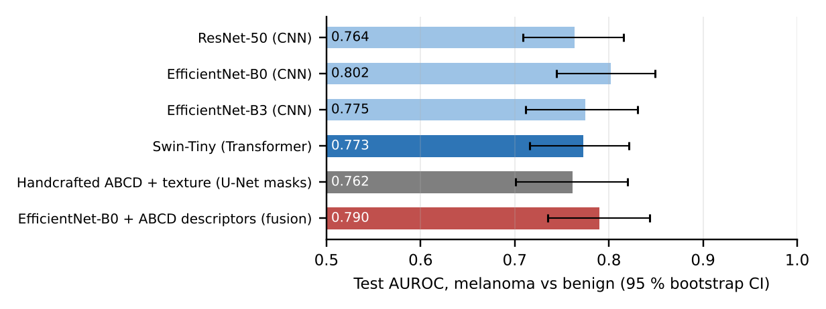
Figure 1. Test AUROC of the single-visit baselines with 95 % bootstrap intervals.
EfficientNet-B0 gave the highest test AUROC, 0.802 (95 % CI 0.744-0.849), and was also the best encoder on validation. The other CNNs reached 0.764 (ResNet-50) and 0.775 (EfficientNet-B3), and the Transformer, Swin-Tiny, reached 0.773. The confidence intervals overlap widely: with 81 melanomas in the test set, differences smaller than about 0.05 AUROC cannot be resolved. The handcrafted descriptors alone reached 0.762, and adding them to the image embedding gave 0.790, no better than the embedding alone: for a single image, the network already captures most of what the descriptors measure. These numbers come from frozen ImageNet features on 256-pixel images; fine-tuning on dermoscopy and using full-resolution images would be expected to raise them. In this frozen setting the smaller EfficientNet-B0 did at least as well as EfficientNet-B3, the encoder chosen in the detailed design (B3's advantages show mainly when fine-tuned at higher resolution), so B0 was used for the visit images in the temporal experiments below, and B3 remains the candidate for fine-tuning.

3. Temporal Models

3.1 Inputs
Each visit becomes one token: the EfficientNet-B0 embedding of the visit image reduced to 32 principal components, the 29 Week-7 descriptors (standardised), their change since visit 1, the logarithm of the time since the previous visit and the months since baseline. The sequence-level models instead use the Week-7 change features: change, rate per month and largest step for 15 descriptors, plus the fraction of visits whose registration was flagged as uncertain (46 values). EfficientNet-B0 was used for the visit images because it was the strongest encoder in Section 2 and the cheapest to run over the 17,200 visit images on a CPU (without the mirror-image view, to halve the time).

3.2 Models
Model | Description
Image only (last visit) | Logistic regression on the latest visit's embedding (256 principal components): the single-visit baseline applied at the last visit
Change features only | Logistic regression on the 46 change features (no image appearance)
Early fusion | Logistic regression on the last-visit embedding (64 principal components) concatenated with the change features
Late fusion | The image-only and change-only scores combined by a logistic regression fitted on the validation split
GRU + attention (proposed) | Tokens → linear layer, LayerNorm, GELU (64) → GRU (64; Cho et al., 2014) → attention pooling over visits (Bahdanau et al., 2015) → output. AdamW (learning rate 2 × 10⁻³, weight decay 10⁻²), class-weighted binary cross-entropy, early stopping on validation AUROC
Transformer encoder | Same tokens with a learned time encoding → two Transformer layers (Vaswani et al., 2017; 4 heads, width 64) → attention pooling → output
GRU, no image features | The proposed GRU with the image embedding removed from each token (ablation)
Table 2. Temporal and fusion models compared.
Compared with the detailed design, the GRU is narrower (64 units instead of 128) because of the small training set, is trained with class-weighted cross-entropy instead of focal loss, and is a single model rather than a five-member ensemble; the concept heads and metadata-conditioned attention are not yet included. Listing 1 shows the model.
Listing 1. GRU with attention pooling over visits (PyTorch, simplified from w9_temporal.py)
1 class SeqNet(nn.Module):
2 def __init__(self, d_in, d=64):
3 super().__init__()
4 self.proj = nn.Sequential(nn.Linear(d_in, d), nn.LayerNorm(d),
5 nn.GELU(), nn.Dropout(0.2))
6 self.gru = nn.GRU(d, d, batch_first=True)
7 self.att = nn.Linear(d, 1) # one score per visit
8 self.head = nn.Sequential(nn.Dropout(0.2), nn.Linear(d, 1))
9 def forward(self, x): # x: (batch, visits, d_in)
10 h, _ = self.gru(self.proj(x))
11 a = torch.softmax(self.att(torch.tanh(h)).squeeze(-1), dim=1) # visit attention
12 c = (a.unsqueeze(-1) * h).sum(1) # attention-weighted summary
13 return self.head(c).squeeze(-1), a # risk logit, weights for M10
14 # token per visit: [image PCA-32 | 29 descriptors | change since visit 1 | log dt | month]
15 # loss: BCEWithLogitsLoss(pos_weight); AdamW; early stopping on validation AUROC

3.3 Endpoints and Scenario
Two endpoints were used. Endpoint A follows the project's label definition from Week 4 (M8): a lesion has progressed if it is a biopsy-confirmed melanoma or shows documented change. Endpoint B is melanoma alone, for which change is only a correlated risk factor. In the main scenario a melanoma changes over the follow-up with probability 0.7 and a benign lesion with probability 0.25. In the sensitivity analysis the benign probability was set to 0.10, 0.40 and 0.55, and a control scenario used 0.4 for both, so that change carries no information about diagnosis; these scenarios retrain the linear models and the proposed GRU.

4. Results

4.1 Main Scenario
Model | Endpoint A: AUROC (95 % CI) | AUPRC | Endpoint B: AUROC (95 % CI) | AUPRC | B: sensitivity at 80 % specificity
Image only (last visit) | 0.582 (0.524-0.638) | 0.501 | 0.756 (0.694-0.815) | 0.492 | 65 %
Change features only | 0.929 (0.898-0.957) | 0.935 | 0.773 (0.716-0.832) | 0.463 | 59 %
Early fusion (LR) | 0.934 (0.905-0.960) | 0.937 | 0.836 (0.785-0.884) | 0.594 | 72 %
Late fusion (stacked) | 0.931 (0.902-0.958) | 0.936 | 0.834 (0.783-0.882) | 0.584 | 72 %
GRU + attention (proposed) | 0.939 (0.911-0.962) | 0.935 | 0.826 (0.779-0.870) | 0.516 | 68 %
Transformer encoder | 0.943 (0.918-0.965) | 0.938 | 0.840 (0.793-0.885) | 0.554 | 74 %
GRU, no image features | 0.947 (0.919-0.970) | 0.946 | 0.831 (0.784-0.879) | 0.499 | 69 %
Table 3. Test results for the main scenario (430 test lesions; prevalence 39 % for endpoint A and 19 % for endpoint B).
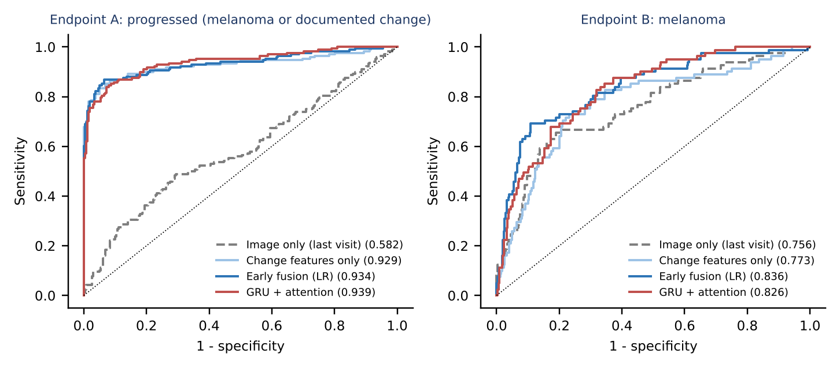
Figure 2. ROC curves for the main scenario (AUROC in brackets).
For endpoint A, the image alone reached an AUROC of 0.582: it sees appearance but cannot know that a benign-looking lesion has changed. The change features alone reached 0.929, and combining both sources gave 0.934 with early fusion, 0.931 with late fusion and 0.939 with the GRU (+0.357 over the image alone). For endpoint B (melanoma), where change is only a risk factor, the image alone reached 0.756, below the 0.802 of Section 2 because the last visit carries simulated acquisition changes and is encoded from a single view; fusion raised this to 0.836 (early fusion) and 0.826 (GRU).
The sequence models performed on a par with early fusion: on endpoint A the GRU reached 0.939 and the Transformer encoder 0.943 (early fusion 0.934), and on endpoint B 0.826 and 0.840 (early fusion 0.836), all well within each other's confidence intervals. With about 1,300 training sequences of four visits, learning from the raw per-visit tokens has no clear advantage over hand-designed change features; the value of the sequence models is that they accept any number of visits at irregular intervals and produce visit-attention weights for the explanation module (M10). Removing the image embedding from the GRU tokens did not lower performance (0.947 on endpoint A, 0.831 on endpoint B): the 29 per-visit descriptors already describe the lesion's appearance, so the 32-component frozen embedding added little inside the sequence model. In the linear models, by contrast, the image remained important for melanoma: the change features alone reached 0.773, and adding the image raised this to 0.836.
Because the simulated sequences depend on which lesions were drawn to change, the linear models were rerun on five further random draws of the same scenario. The AUROC varied little (standard deviation 0.019 for early fusion on endpoint A and 0.014 on endpoint B), so the results above are not due to one lucky draw.

4.2 Sensitivity Analysis and Control
Figure 3 shows how the benefit of temporal information depends on how often benign lesions also change. For endpoint B, the gain of early fusion over the image alone was +0.120 when only 10 % of benign lesions changed and +0.050 when 55 % did. In the control scenario, where melanomas and benign lesions change equally often, the change features alone scored only 0.579 for melanoma; they stay slightly above chance because the size of a simulated change and the rate of registration flags still depend a little on the lesion itself (melanomas are larger and darker). Early fusion added +0.012 over the image alone (0.765), and the GRU +0.029, which is consistent with its per-visit descriptors adding appearance information rather than change. The temporal gain therefore shrinks as change becomes less specific to melanoma and largely disappears when change carries no information, which is the expected behaviour and shows that it comes from the change signal rather than from a shortcut in the pipeline.
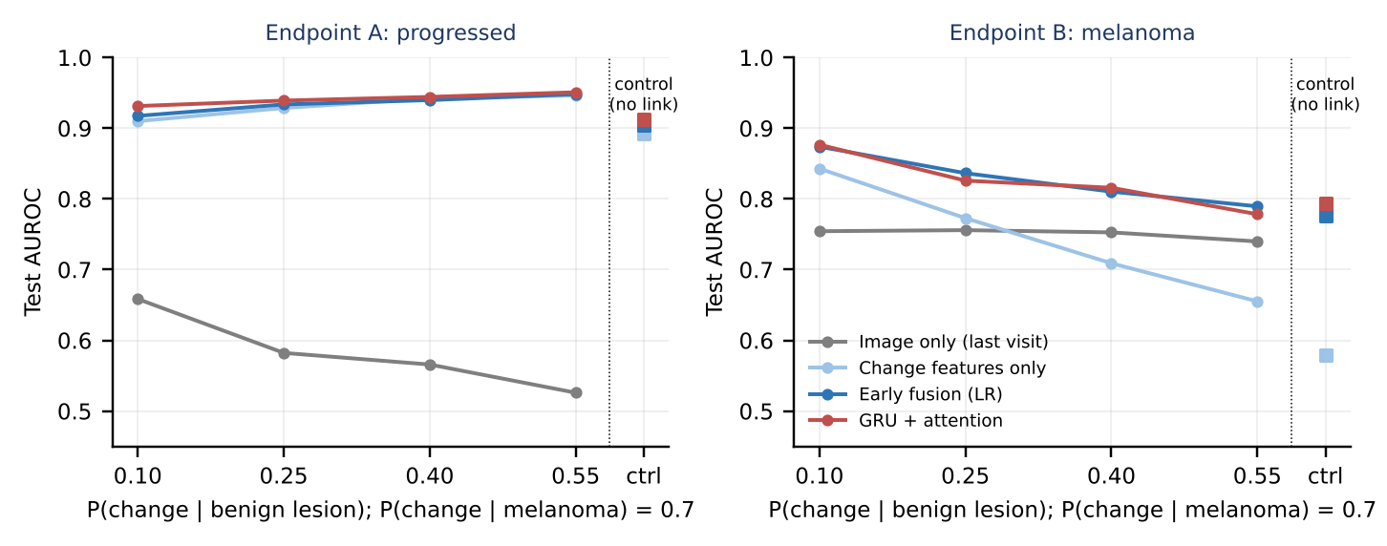
Figure 3. Test AUROC as the probability that a benign lesion changes increases (melanoma change probability fixed at 0.7). Squares: control scenario with no link between change and diagnosis.

4.3 Visit Attention
The GRU's attention weights show which visits drive a prediction (FR-09). For progressing lesions the mean weight on the last visit was 0.62, against 0.04 on the first; for stable lesions the weights were 0.31, 0.22, 0.21, 0.26 from visit 1 to visit 4 (Figure 4). For changing lesions the model therefore concentrates on the later visits, where the change has become visible, while for stable lesions it spreads its attention across the history. This is the behaviour intended in the design, and the weights can be shown to the clinician as part of the explanation.
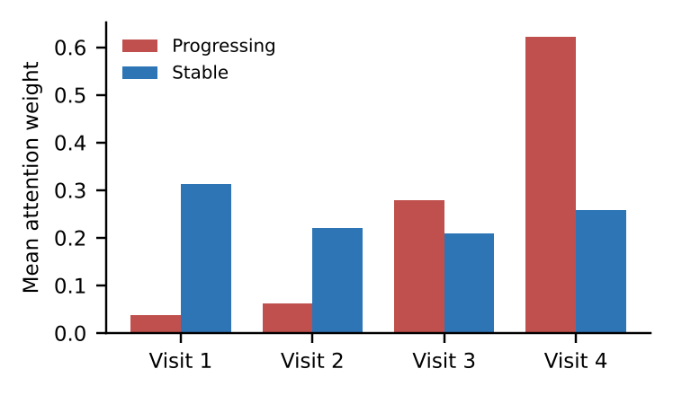
Figure 4. Mean GRU attention weight per visit (test set, endpoint A).

5. Discussion and Limitations
- Frozen encoders. Linear probes on ImageNet features from 256-pixel images understate what fine-tuned dermoscopy models achieve, and inside the sequence models the frozen embedding added nothing beyond the handcrafted descriptors. Fine-tuning the best encoder (on a GPU, at full resolution) is the obvious next step and should lift all image-based results.
- Simulated sequences. The temporal results depend on our simulation of change, including how strongly change is linked to diagnosis. The sensitivity analysis and control show the direction and size of the effect under different assumptions, but real performance can only be measured on real serial data (SDDI1 or a clinical partner's archive).
- Endpoint A is partly defined by change. Following the project's label definition, a benign lesion that changes counts as progressed, so change features are informative by construction. Endpoint B (melanoma) is the stricter test.
- Small data. With about 1,300 training sequences, simple fusion models are as good as recurrent ones. The GRU and Transformer are kept because they scale to longer and irregular histories and provide visit attention.
- Uncertainty not yet included. Ensembles, calibration and the referral gate (M11) are not part of these experiments and are the next modelling step.

6. Conclusion and Next Steps
On real images, frozen encoders reached test AUROCs of 0.764 to 0.802 for melanoma from a single visit, with CNNs and the Swin Transformer within each other's confidence intervals. On simulated sequences, adding the Week-7 change features to the image raised AUROC for both endpoints (for melanoma from 0.756 to 0.836 with early fusion), the gain shrank as change became less specific to melanoma, and the GRU with attention performed on a par with the best fusion model while providing visit-level attention. The next steps are to fine-tune the image encoder, add the ensemble-based uncertainty and referral gate (M11), and validate the full pipeline on real serial dermoscopy.

References
Bahdanau, D., Cho, K., & Bengio, Y. (2015). Neural machine translation by jointly learning to align and translate. ICLR 2015.
Cho, K. et al. (2014). Learning phrase representations using RNN encoder-decoder for statistical machine translation. EMNLP 2014.
Codella, N. C. F. et al. (2018). Skin lesion analysis toward melanoma detection: A challenge at the 2017 International Symposium on Biomedical Imaging (ISBI), hosted by the International Skin Imaging Collaboration (ISIC). ISBI 2018, 168-172.
Efron, B., & Tibshirani, R. J. (1993). An Introduction to the Bootstrap. Chapman & Hall.
He, K., Zhang, X., Ren, S., & Sun, J. (2016). Deep residual learning for image recognition. CVPR 2016.
Liu, Z. et al. (2021). Swin Transformer: Hierarchical vision transformer using shifted windows. ICCV 2021.
Tan, M., & Le, Q. V. (2019). EfficientNet: Rethinking model scaling for convolutional neural networks. ICML 2019.
Vaswani, A. et al. (2017). Attention is all you need. NeurIPS 2017.
Yu, Z. et al. (2020). Melanoma diagnosis with spatio-temporal feature learning on sequential dermoscopic images. MICCAI 2020.

