ASSIGNMENT – 09
NAME : Ch sriram
HALL TICKET NO : 2303A51973
BATCH : 17
Question :
Expected Time to complete 1 Interacting with DeFi Protocols (Testnet) Objective To interact with a decentralized finance (DeFi) protocol on a blockchain testnet by writing and executing a smart contract that deposits and withdraws tokens, demonstrating basic DeFi operations without real funds.
Requirements
- Install Node.js and npm
- Install VS Code
- Install VS Code extensions: o Solidity o Hardhat
- Use a testnet (Sepolia / Goerli / Mumbai) •
Create a smart contract and a script to interact with a DeFi protocol (mock lending contract) • Use functions for deposit and withdrawal
- Test interactions using test tokens • Add inline comments explaining the logic
Tools & Technologies
- Solidity
- Hardhat
- JavaScript (Node.js)
- Ethereum Testnet (Sepolia)
- MetaMask (Testnet account) Practical Description In this practical, we simulate interaction with a DeFi protocol by creating a simple lending contract where:
- Users can deposit ETH
- Users can withdraw ETH
- Contract tracks balances internally This represents how DeFi protocols like Aave or Compound work on testnets.
CODE :
import tkinter as tk from tkinter import messagebox class DeFiLending: def __init__(self): self.balances = {}
def deposit(self, user, amount): if amount <= 0:
return "Deposit must be greater than 0" if user not in self.balances: self.balances[user] = 0 self.balances[user] += amount return f"{user} deposited {amount} ETH" def withdraw(self, user, amount): if user not in self.balances: return "User does not exist" if amount <= 0:
return "Withdrawal must be greater than 0" if self.balances[user] < amount: return "Insufficient balance" self.balances[user] -= amount return f"{user} withdrew {amount} ETH" def get_balance(self, user):
return self.balances.get(user, 0)
class DeFiApp:
def __init__(self, root):
self.contract = DeFiLending() self.root = root self.root.title("DeFi Lending Protocol Simulator") self.root.geometry("400x350") tk.Label(root, text="DeFi Simulator", font=("Arial", 16, "bold")).pack(pady=10) tk.Label(root, text="User Name").pack() self.user_entry = tk.Entry(root) self.user_entry.pack() tk.Label(root, text="Amount (ETH)").pack() self.amount_entry = tk.Entry(root)
self.amount_entry.pack() tk.Button(root, text="Deposit", command=self.deposit).pack(pady=5) tk.Button(root, text="Withdraw", command=self.withdraw).pack(pady=5) tk.Button(root, text="Check Balance", command=self.check_balance).pack(pady=5) self.output = tk.Label(root, text="", fg="blue") self.output.pack(pady=10) def deposit(self):
user = self.user_entry.get()
try:
amount = float(self.amount_entry.get()) result = self.contract.deposit(user, amount) self.output.config(text=result) except:
messagebox.showerror("Error", "Enter valid amount") def withdraw(self):
user = self.user_entry.get()
try:
amount = float(self.amount_entry.get()) result = self.contract.withdraw(user, amount) self.output.config(text=result) except:
messagebox.showerror("Error", "Enter valid amount")

def check_balance(self):
user = self.user_entry.get() balance = self.contract.get_balance(user) self.output.config(text=f"{user} Balance: {balance} ETH")
if __name__ == "__main__":
root = tk.Tk()
app = DeFiApp(root) root.mainloop() IMPLEMENTATION :
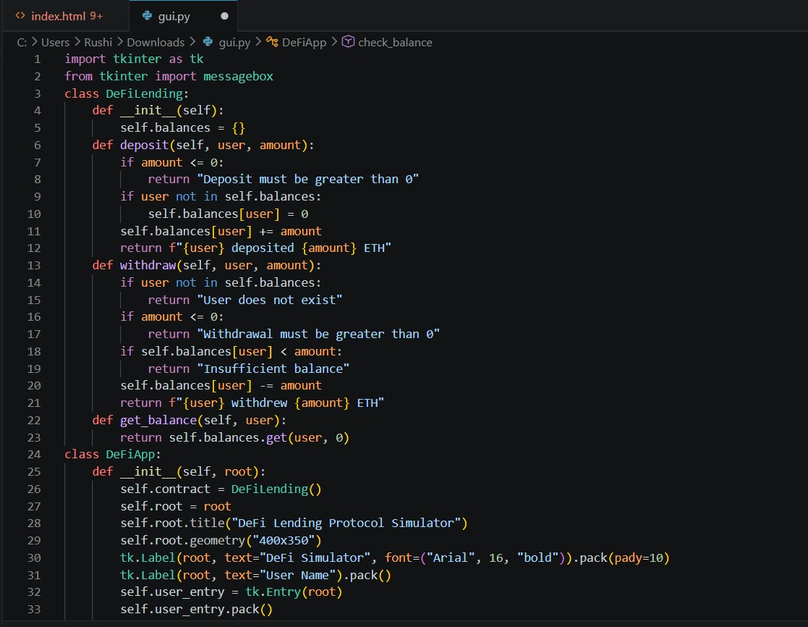

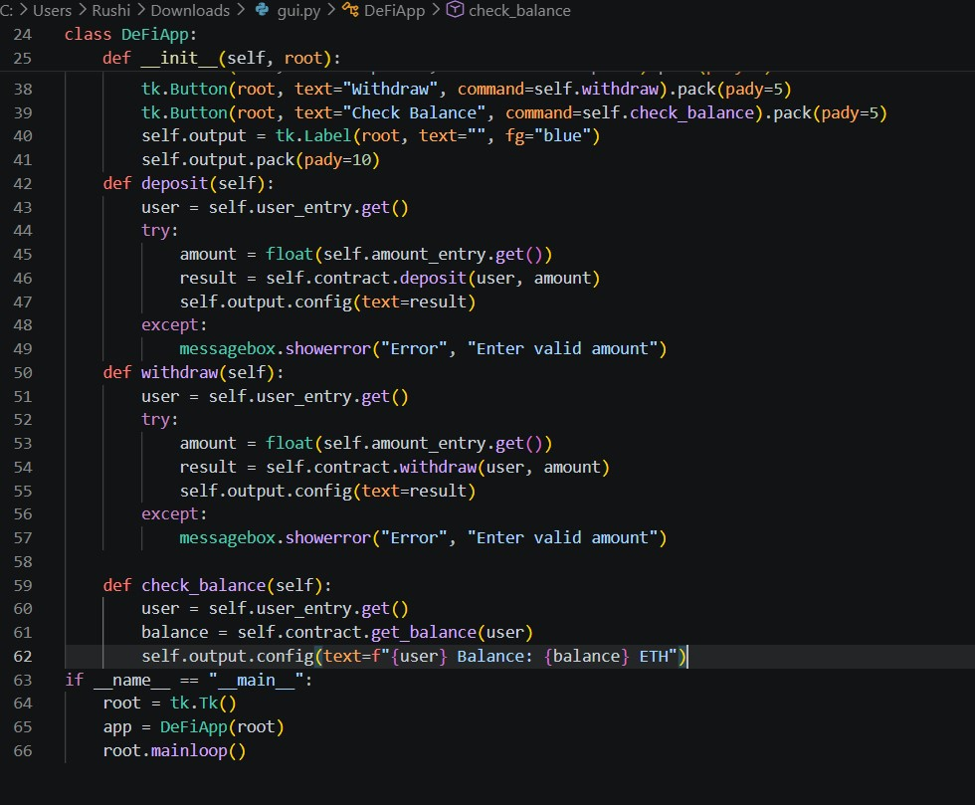

OUTPUT :
