ASSIGNMENT – 10
NAME : Ch sriram
HALL TICKET NO : 2303A51973
BATCH : 17
Question :
Exploring Layer 2 – Testnet
Objective To understand and explore Layer 2 blockchain networks by deploying and interacting with a simple smart contract on a Layer 2 Testnet (e.g., Polygon Mumbai / Arbitrum Sepolia), and observe reduced gas fees and faster transactions compared to Layer
Requirements :
- Basic understanding of blockchain and smart contracts
- MetaMask wallet installed (browser extension)
- Testnet ETH/MATIC from faucet
- VS Code (with Solidity extension installed)
- Node.js and npm installed
- Hardhat development framework Tools & Technologies Used
- Blockchain Type: Layer 2 Testnet
- Network: Polygon Mumbai Testnet (or Arbitrum Sepolia)
Language: Solidity
Framework: Hardhat
Wallet: MetaMask
Execution Key is:- 0x742d35Cc6634C0532925a3b844Bc454e4438f44e
CODE :
import tkinter as tk from tkinter import messagebox import random import time class DeFi:
def __init__(self): self.balances = {} def gas_fee(self):
return round(random.uniform(0.0001, 0.001), 6) def delay(self): time.sleep(0.3) def deposit(self, user, amount): if amount <= 0:
return "Invalid amount"
self.delay() gas = self.gas_fee() if user not in self.balances: self.balances[user] = 0 self.balances[user] += amount return f"Deposit Success\nUser: {user}\nAmount: {amount} ETH\nGas: {gas}" def withdraw(self, user, amount): if user not in self.balances: return "User not found" if self.balances[user] < amount: return "Insufficient balance" self.delay() gas = self.gas_fee() self.balances[user] -= amount return f"Withdraw Success\nUser: {user}\nAmount: {amount} ETH\nGas: {gas}"
def balance(self, user):
return self.balances.get(user, 0) class App:
def __init__(self, root):
self.defi = DeFi() self.root = root self.root.title("DeFi Dashboard") self.root.geometry("600x400") left_frame = tk.Frame(root, bg="#2c3e50", width=200) left_frame.pack(side="left", fill="y") tk.Label(left_frame, text="DeFi Panel", fg="white", bg="#2c3e50", font=("Arial", 14, "bold")).pack(pady=20) tk.Label(left_frame, text="User", fg="white", bg="#2c3e50").pack() self.user_entry = tk.Entry(left_frame) self.user_entry.pack(pady=5) tk.Label(left_frame, text="Amount", fg="white", bg="#2c3e50").pack() self.amount_entry = tk.Entry(left_frame) self.amount_entry.pack(pady=5) tk.Button(left_frame, text="Deposit", width=15, command=self.deposit).pack(pady=10) tk.Button(left_frame, text="Withdraw", width=15, command=self.withdraw).pack(pady=5) tk.Button(left_frame, text="Check Balance", width=15, command=self.check_balance).pack(pady=5) right_frame = tk.Frame(root, bg="#ecf0f1") right_frame.pack(side="right", expand=True, fill="both") tk.Label(right_frame, text="Transaction Output", bg="#ecf0f1", font=("Arial", 14, "bold")).pack(pady=10) self.output = tk.Text(right_frame, height=15, width=50) self.output.pack(padx=10, pady=10) def deposit(self):
user = self.user_entry.get()
try:
amount = float(self.amount_entry.get()) result = self.defi.deposit(user, amount) self.show(result) except:
messagebox.showerror("Error", "Invalid input") def withdraw(self):
user = self.user_entry.get()
try:
amount = float(self.amount_entry.get()) result = self.defi.withdraw(user, amount) self.show(result) except:
messagebox.showerror("Error", "Invalid input") def check_balance(self):
user = self.user_entry.get() balance = self.defi.balance(user) self.show(f"{user} Balance: {balance} ETH") def show(self, text):
self.output.delete(1.0, tk.END) self.output.insert(tk.END, text)
if __name__ == "__main__":
root = tk.Tk() app = App(root) root.mainloop()
IMPLEMENTATION :

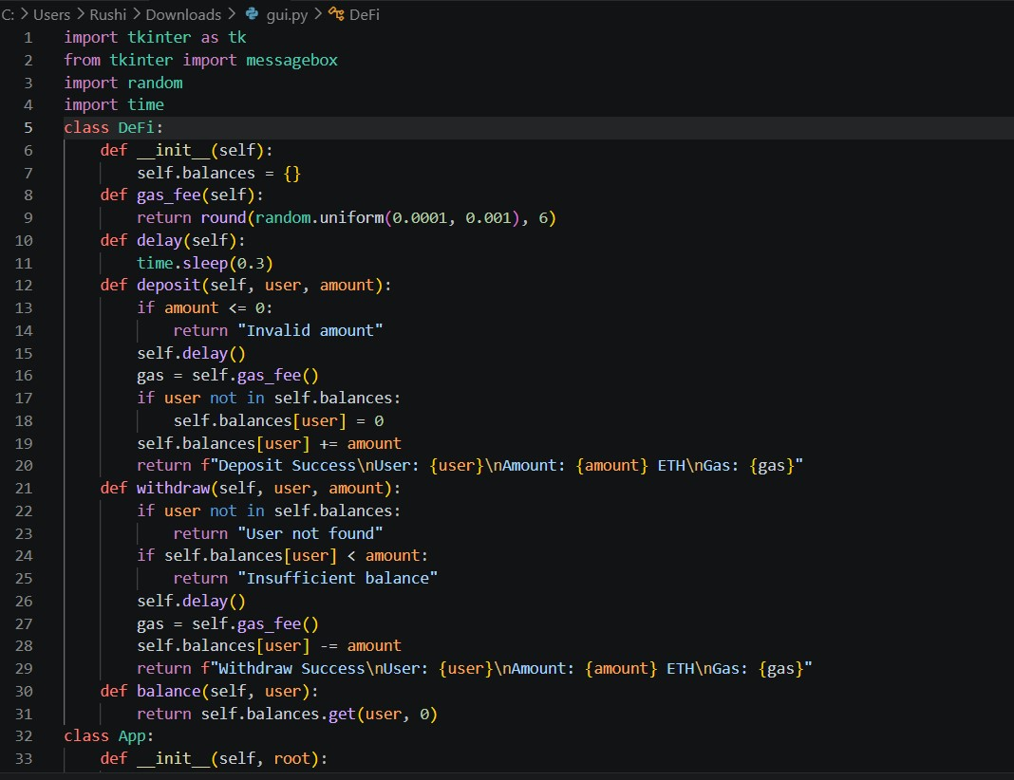
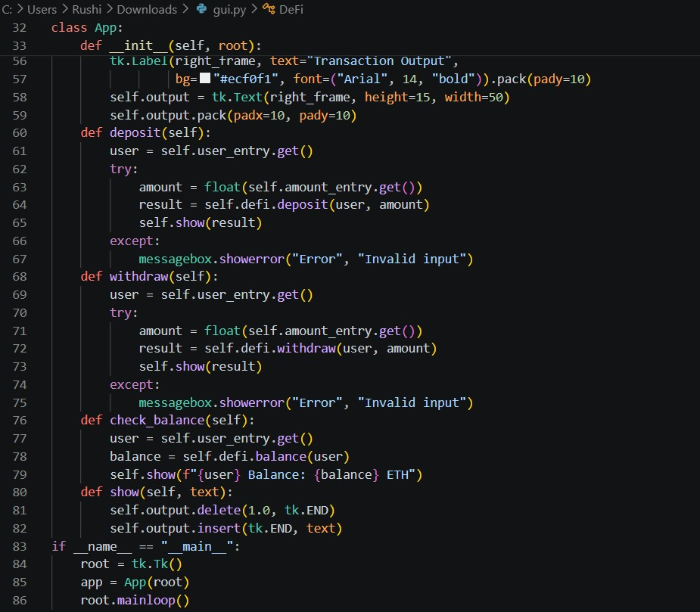
OUTPUT :

