ASSIGNMENT – 11
NAME : Ch sriram
HALL TICKET NO : 2303A51973
BATCH : 17
Question :
Hyperledger Fabric – Comparative Exploration Objective To study and practically explore Hyperledger
Fabric by setting up a basic Fabric test network, deploying a simple chaincode, and comparing Hyperledger Fabric with a public blockchain (Ethereum) based on architecture, consensus, privacy, performance, and use cases.
Requirements :Software Requirements
Operating System: Ubuntu 20.04 / Windows (with WSL) / macOS • Docker & Docker Compose • Git • cURL • Node.js (v16+) or Go (for chaincode) • Hyperledger Fabric binaries and samples Hardware Requirements • Minimum 8 GB RAM • Internet connection
CODE :
import tkinter as tk from tkinter import ttk, messagebox import random import time
class DeFi: def __init__(self): self.balances = {}

def gas(self):
return round(random.uniform(0.0001, 0.001), 6)

def delay(self): time.sleep(0.3)

def deposit(self, user, amount): if amount <= 0:
return "Invalid amount"

self.delay() gas = self.gas()
if user not in self.balances: self.balances[user] = 0

self.balances[user] += amount return f"Deposit Successful\nGas Fee: {gas}"

def withdraw(self, user, amount): if user not in self.balances: return "User not found"

if self.balances[user] < amount: return "Insufficient balance"

self.delay() gas = self.gas()

self.balances[user] -= amount return f"Withdraw Successful\nGas Fee: {gas}"

def balance(self, user):
return self.balances.get(user, 0) class App:
def __init__(self, root): self.defi = DeFi() self.root = root self.root.title("DeFi Tab Interface") self.root.geometry("500x350") notebook = ttk.Notebook(root) notebook.pack(expand=True, fill="both")
# Tabs self.deposit_tab = tk.Frame(notebook) self.withdraw_tab = tk.Frame(notebook) self.balance_tab = tk.Frame(notebook)

notebook.add(self.deposit_tab, text="Deposit") notebook.add(self.withdraw_tab, text="Withdraw") notebook.add(self.balance_tab, text="Balance")

# ------------------ Deposit Tab ------------------
tk.Label(self.deposit_tab, text="User").pack(pady=5) self.d_user = tk.Entry(self.deposit_tab) self.d_user.pack()

tk.Label(self.deposit_tab, text="Amount").pack(pady=5) self.d_amount = tk.Entry(self.deposit_tab) self.d_amount.pack()

tk.Button(self.deposit_tab, text="Deposit", command=self.deposit).pack(pady=10)

self.d_output = tk.Label(self.deposit_tab, text="") self.d_output.pack()
# ------------------ Withdraw Tab ------------------ tk.Label(self.withdraw_tab, text="User").pack(pady=5) self.w_user = tk.Entry(self.withdraw_tab) self.w_user.pack()
tk.Label(self.withdraw_tab, text="Amount").pack(pady=5) self.w_amount = tk.Entry(self.withdraw_tab) self.w_amount.pack()
tk.Button(self.withdraw_tab, text="Withdraw", command=self.withdraw).pack(pady=10)

self.w_output = tk.Label(self.withdraw_tab, text="") self.w_output.pack()

# ------------------ Balance Tab ------------------
tk.Label(self.balance_tab, text="User").pack(pady=5) self.b_user = tk.Entry(self.balance_tab) self.b_user.pack()

tk.Button(self.balance_tab, text="Check Balance", command=self.check_balance).pack(pady=10)

self.b_output = tk.Label(self.balance_tab, text="") self.b_output.pack()

def deposit(self):
try:
user = self.d_user.get() amount = float(self.d_amount.get()) result = self.defi.deposit(user, amount) self.d_output.config(text=result) except:
messagebox.showerror("Error", "Invalid input")
def withdraw(self):
try:
user = self.w_user.get() amount = float(self.w_amount.get()) result = self.defi.withdraw(user, amount) self.w_output.config(text=result) except:
messagebox.showerror("Error", "Invalid input") def check_balance(self): user = self.b_user.get() balance = self.defi.balance(user) self.b_output.config(text=f"Balance: {balance} ETH")
if __name__ == "__main__":
root = tk.Tk() app = App(root) root.mainloop()
IMPLEMENTATION :
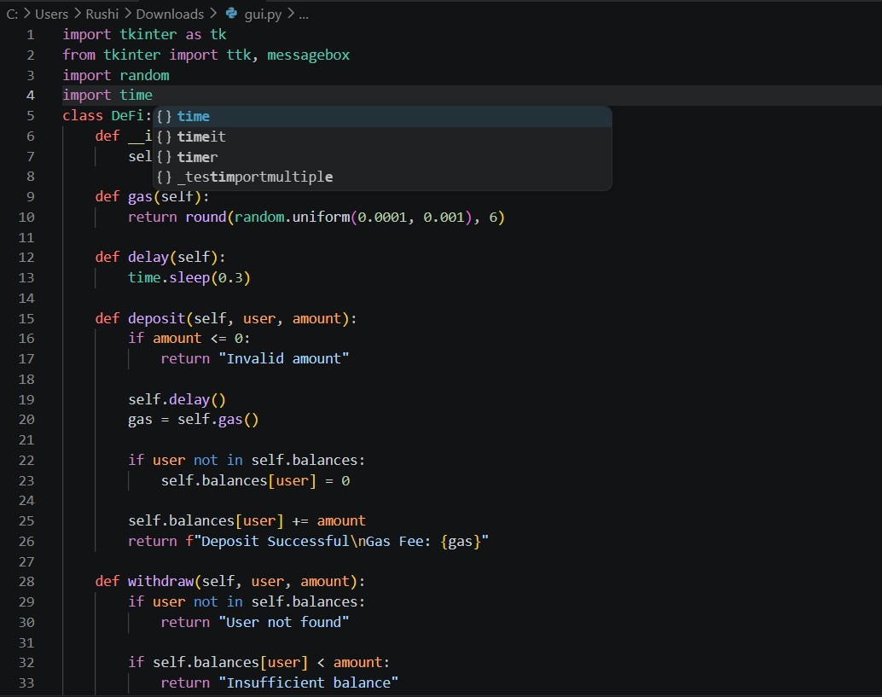
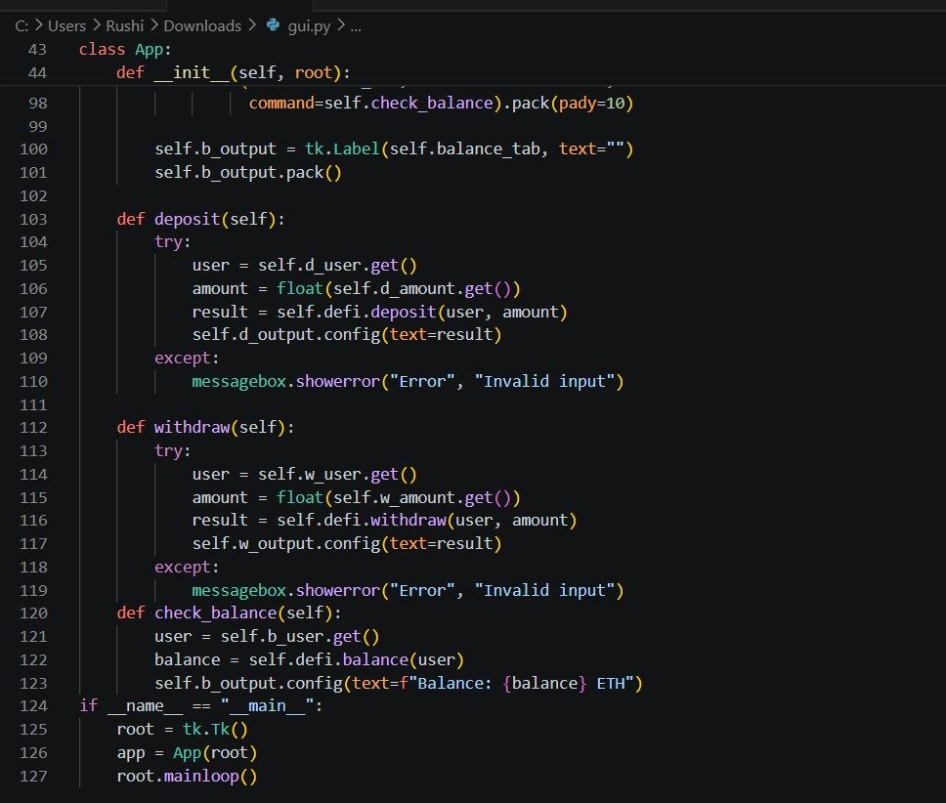
OUTPUT :
