ASSIGNMENT – 12
NAME : Ch sriram
HALL TICKET NO : 2303A51973
BATCH : 17
Question :
Hyperledger Fabric Problem Solving Objective To design and implement a simple Hyperledger Fabric smart contract (chaincode) that manages a personal asset portfolio on a blockchain network. The practical focuses on problem-solving using Fabric concepts such as assets, transactions, ledger state, and queries. Problem Statement Implement a basic blockchain-based portfolio system where a user can: • Create assets (e.g., certificates, projects, or tokens) • View all assets stored on the blockchain • Transfer asset ownership between users This practical demonstrates how Hyperledger Fabric solves realworld problems like data immutability, transparency, and secure ownership transfer.
Requirements Software Requirements • Operating System: Windows / Linux / macOS • Node.js (v16 or later) • Docker & Docker Compose • Git • VS Code (with Docker and JavaScript extensions) Blockchain Platform • Hyperledger Fabric test network
CODE :
import tkinter as tk from tkinter import messagebox import random import time class DeFi: def __init__(self): self.balances = {} def gas(self): return round(random.uniform(0.0001, 0.001), 6) def delay(self): time.sleep(0.3) def deposit(self, user, amount): if amount <= 0:
return "Invalid amount" self.delay() gas = self.gas() if user not in self.balances: self.balances[user] = 0 self.balances[user] += amount return f"Deposit Success\nGas Fee: {gas}" def withdraw(self, user, amount): if user not in self.balances: return "User not found" if self.balances[user] < amount: return "Insufficient balance" self.delay() gas = self.gas() self.balances[user] -= amount return f"Withdraw Success\nGas Fee: {gas}" def balance(self, user):
return self.balances.get(user, 0) class App: def __init__(self, root):
self.defi = DeFi() self.root = root self.root.title("DeFi Menu Interface") self.root.geometry("500x300") menubar = tk.Menu(root) root.config(menu=menubar) action_menu = tk.Menu(menubar, tearoff=0) menubar.add_cascade(label="Actions", menu=action_menu) action_menu.add_command(label="Deposit", command=self.deposit_window) action_menu.add_command(label="Withdraw", command=self.withdraw_window) action_menu.add_command(label="Check Balance", command=self.balance_window) self.label = tk.Label(root, text="Select an action from menu",
font=("Arial", 14)) self.label.pack(pady=50) def deposit_window(self): self.popup("Deposit") def withdraw_window(self): self.popup("Withdraw") def balance_window(self): self.popup("Balance") def popup(self, action): win = tk.Toplevel(self.root) win.title(action) tk.Label(win, text="User").pack() user_entry = tk.Entry(win) user_entry.pack() if action != "Balance":
tk.Label(win, text="Amount").pack() amount_entry = tk.Entry(win) amount_entry.pack() def submit():
user = user_entry.get() if action == "Deposit":
try:
amount = float(amount_entry.get()) result = self.defi.deposit(user, amount) except:
result = "Invalid input" elif action == "Withdraw":
try:
amount = float(amount_entry.get()) result = self.defi.withdraw(user, amount)
except:
result = "Invalid input" else:
result = f"Balance: {self.defi.balance(user)} ETH" messagebox.showinfo("Result", result) tk.Button(win, text="Submit", command=submit).pack(pady=10) if __name__ == "__main__":
root = tk.Tk() app = App(root) root.mainloop()
IMPLEMENTATION :

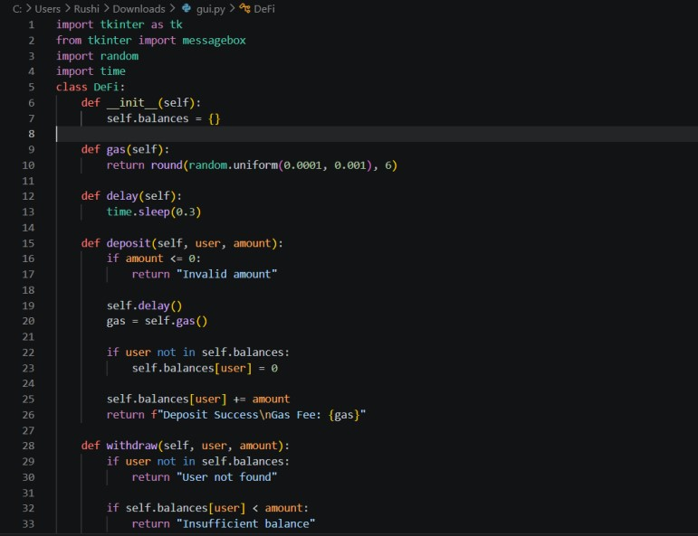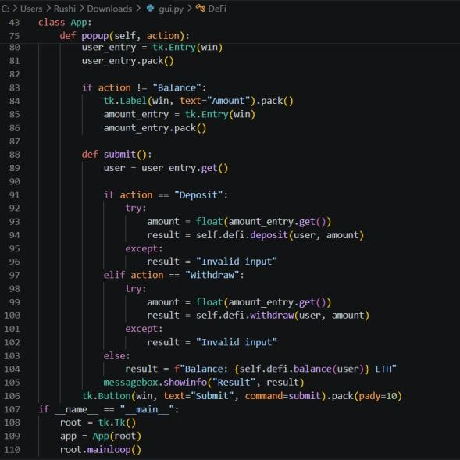

OUTPUT :

