DUAL AXIS SOLAR TRACER
Project Report

Submitted in the partial fulfillment of the requirements for the

Course Title: ELECTRONIC SYSTEM DESIGN
Course code: 23SDECO1L
submitted by
V. NAGA SHARATH 2300049105
A. YUVA KIRAN 2300049016
Y. RAMAN 2300049192
T. SRI RAM 2300049187

UNDER THE GUIDANCE OF
DR.S.ROOBAN

Associate Professor

KL UNIVERSITY
Green fields, Vaddeswaram – 522 302 Guntur Dt., AP, India.



Declaration

The Project Report entitled “Dual Axis Solar Tracer” is a record of Bonafide work of V.Naga Sharath - 2300049105 , A.Yuva Kiran - 2300049016 , Y.Raman – 2300049192 , T.SriRam - 2300049187 submitted in partial fulfillment for the subject titled 23SDEC01L -ELECTRONIC SYSTEM DESIGN in Dept of ECE, KL University.

Certification



This is to certify that the Project Report entitled “Dual Axis Solar Tracer” is being submitted by
V. Naga Sharath -2300049105
A. Yuva Kiran -2300049016
Y. Raman -2300049192
T. Sri Ram -2300049187

in partial fulfillment for the subject titled (23SDEC01L – ELECTRONIC SYSTEM DESIGN in Dept of ECE, KL University is a record of Bonafede work carried out under our guidance and supervision. The results embodied in this report have not been copied from any other departments/ University/ Institute.

Signature of Examiner Signature of Supervisor

Acknowledgement

It is a great pleasure for me to express my gratitude to our honorable President Sri. Koneru Satyanarayana, for giving me the opportunity and platform with facilities in accomplishing the project-based laboratory report.
I express my sincere gratitude to our Principal Dr. T Rama Krishna for his administration towards our academic growth.

I record it as my privilege to deeply thank our pioneer HOD-ECE for providing us with the efficient faculty and facilities to realize our ideas.
I sincerely thank our project supervisor “DR.S.Rooban, Associate Professor, Dept of ECE” for his novel association of ideas, encouragement, appreciation, and intellectual zeal which motivated us to venture into this project successfully.
Finally, it is pleased to acknowledge the indebtedness to all those who devoted themselves directly or indirectly to making this project report successful.

Name: V. Naga Sharath 2300049105

A. Yuva Kiran 2300049016

Y .Raman 2300049192

T. Sri Ram 2300049187

CONTENTS

 | Page No
Abstract | 6
Chapter 1: Introduction | 7
Chapter 2: Block Diagram | 9
Chapter 3: Requirements | 10
Chapter 4: Source Code | 25
Chapter 5: Working Principle | 27
Chapter 6: Output | 29
Chapter 7: Conclusion and Future scope | 30

ABSTRACT

A Dual Axis Solar Tracker is a system designed to optimize the efficiency of solar panels by adjusting their orientation to follow the sun's position throughout the day. This project utilizes an Arduino microcontroller to control two motors that adjust the tilt and azimuth of the solar panel, ensuring maximum sunlight absorption.
The system relies on light-dependent resistors (LDRs) placed on the surface of the solar panel to detect the intensity of sunlight from different angles. The Arduino processes the data from these sensors and adjusts the motors accordingly to keep the solar panel perpendicular to the sun's rays. This tracking mechanism improves the overall performance and energy output of solar power systems, as it can capture sunlight more efficiently compared to fixed panels. The system is cost-effective, simple to implement, and energy-efficient, making it an ideal solution for enhancing solar power applications.

CHAPTER 1: INTRODUCTION

Solar energy is one of the most promising and sustainable sources of power, with the potential to meet the global energy demand while reducing reliance on fossil fuels. However, the efficiency of solar panels is greatly influenced by their orientation relative to the sun. Traditional fixed solar panels are positioned at a fixed angle and direction, limiting their ability to capture the maximum amount of sunlight throughout the day. To address this issue, solar tracking systems are employed to adjust the position of solar panels so that they consistently face the sun, thus enhancing their efficiency and energy output.
A Dual Axis Solar Tracker is an advanced system that enables solar panels to follow the sun in both horizontal (azimuth) and vertical (altitude) directions. This tracking mechanism ensures that the solar panel is constantly positioned perpendicular to the sun's rays, maximizing energy absorption. Unlike single-axis trackers, which can only move in one direction, dual-axis trackers provide more precise tracking, offering improved performance, especially in areas where the sun's path changes significantly.
The integration of Arduino in solar tracking systems provides an affordable, accessible, and effective solution for automating this process. Arduino is a popular microcontroller platform that allows users to design and implement interactive systems. By using Arduino to control the movement of the solar panel based on input from light sensors, a dual-axis solar tracker can continuously adjust its position throughout the day, ensuring that the solar panel is always aligned with the sun.
In this project, a dual-axis solar tracker using Arduino is designed and implemented to demonstrate how solar panels can be automatically positioned for optimal sunlight exposure. The system uses Light Dependent Resistors (LDRs) to detect sunlight intensity and adjusts the position of the solar panel via servo motors or DC motors, controlled by the Arduino. The implementation of such a system can significantly increase the efficiency of solar energy systems, making them more cost-effective and environmentally friendly.
This project highlights the potential of combining renewable energy technologies with microcontroller-based automation to create smarter, more efficient energy solutions for the future.

CHAPTER 2: CIRUIT DIAGRAM

The Dual Axis Solar Tracker system uses LDR sensors to detect sunlight intensity and provides feedback to the Arduino, which processes the data. The Arduino controls the motor driver, adjusting DC/Servo motors to reposition the solar panel in both horizontal and vertical axes. A power supply provides energy to the entire system.

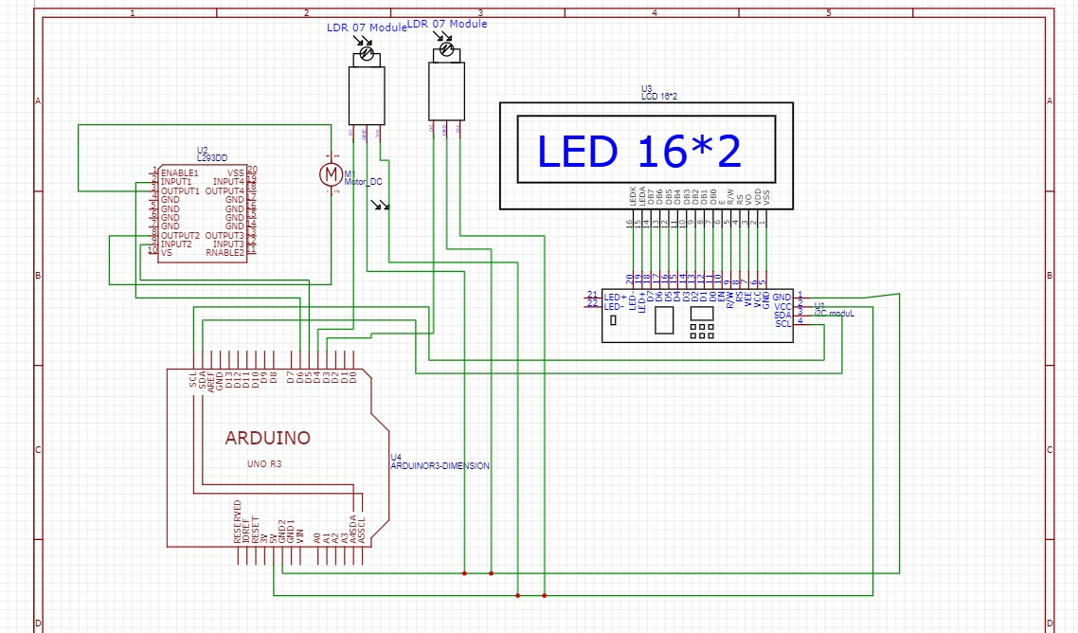

CHAPTER 3 : REQUIREMENTS

S.NO | NAME OF COMPONENT | QUANTITY
1 | ARDUINO UNO | 1
2 | 16 X 2 LCD | 1
3 | I2C MODULE | 1
4 | L293D MOTOR DRIVER | 1
5 | SOLAR PANEL | 1
6 | DC MOTOR | 1
7 | LDR MODULE | 2
8 | POWER ADAPTER | 1
9 | CONNECTING WIRES | 25

COMPONENTS AND EQUIPMENT USED :

ARDUINO UNO :

The Arduino Uno is an open-source microcontroller board based on the ATmega328P chip, designed to be an accessible and easy-to-use platform for building electronics projects. The Arduino Uno has gained widespread popularity in the maker community, education, and professional environments due to its simplicity, flexibility, and extensive support. It serves as a fundamental tool for learning embedded systems, programming, and hardware design.
The board features 14 digital input/output (I/O) pins, 6 of which can be used for Pulse Width Modulation (PWM) output, allowing control of devices like motors or LEDs. It also has 6 analog input pins that can read variable signals from sensors, enabling the board to interact with the physical world. The ATmega328P microcontroller is clocked at 16 MHz and operates with a 5V voltage supply. Power can be supplied either through a USB connection for easy programming or an external DC power supply (7-12V) for standalone use.
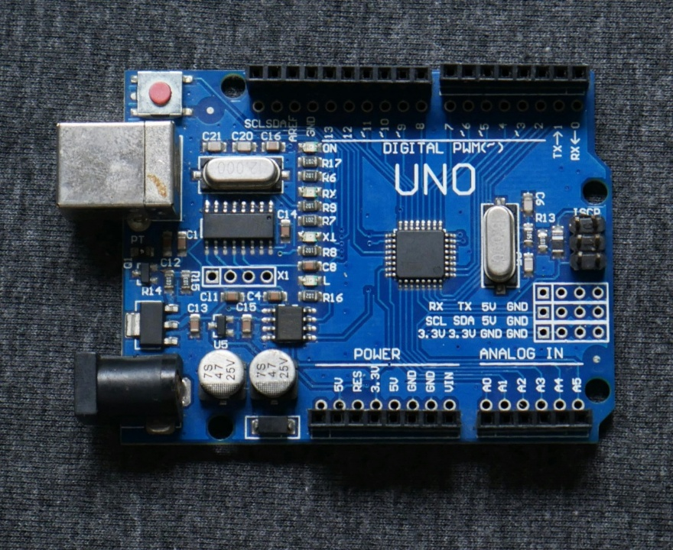

Programming the Arduino Uno is done using the Arduino IDE (Integrated Development Environment), which is compatible with Windows, macOS, and Linux. The IDE allows users to write code (known as sketches) and upload it to the board via a USB cable. The Arduino language is based on C/C++, and the platform supports a vast library of functions and pre-written code, making it easy for beginners and advanced users alike to get started with complex projects.
The Arduino Uno is compatible with a wide range of sensors, actuators, motors, and communication modules, enabling it to be used in diverse applications, such as robotics, home automation, Internet of Things (IoT) devices, automated systems, and educational projects. One of the key reasons for its success is the open-source nature of the Arduino project, which means all hardware designs, software libraries, and documentation are freely available, encouraging collaboration and community-driven innovation.
Its affordable price, ease of use, and the large Arduino community make it a preferred choice for hobbyists, engineers, and educators. Whether you're building simple circuits or creating advanced embedded systems, the Arduino Uno offers a reliable, versatile, and user-friendly solution.

FEATURES
- Operating voltage : 5v
- Digital I/O Pins : 14
- Clock Speed : 16MHz
- Flash Memory : 32Kb
- SPRAM : 2Kb
- EEPROM : 1Kb
- Programming Interface : USB
- Low Power Consumption
- Security

ARDUINO UNO PIN CONFIGURATION :

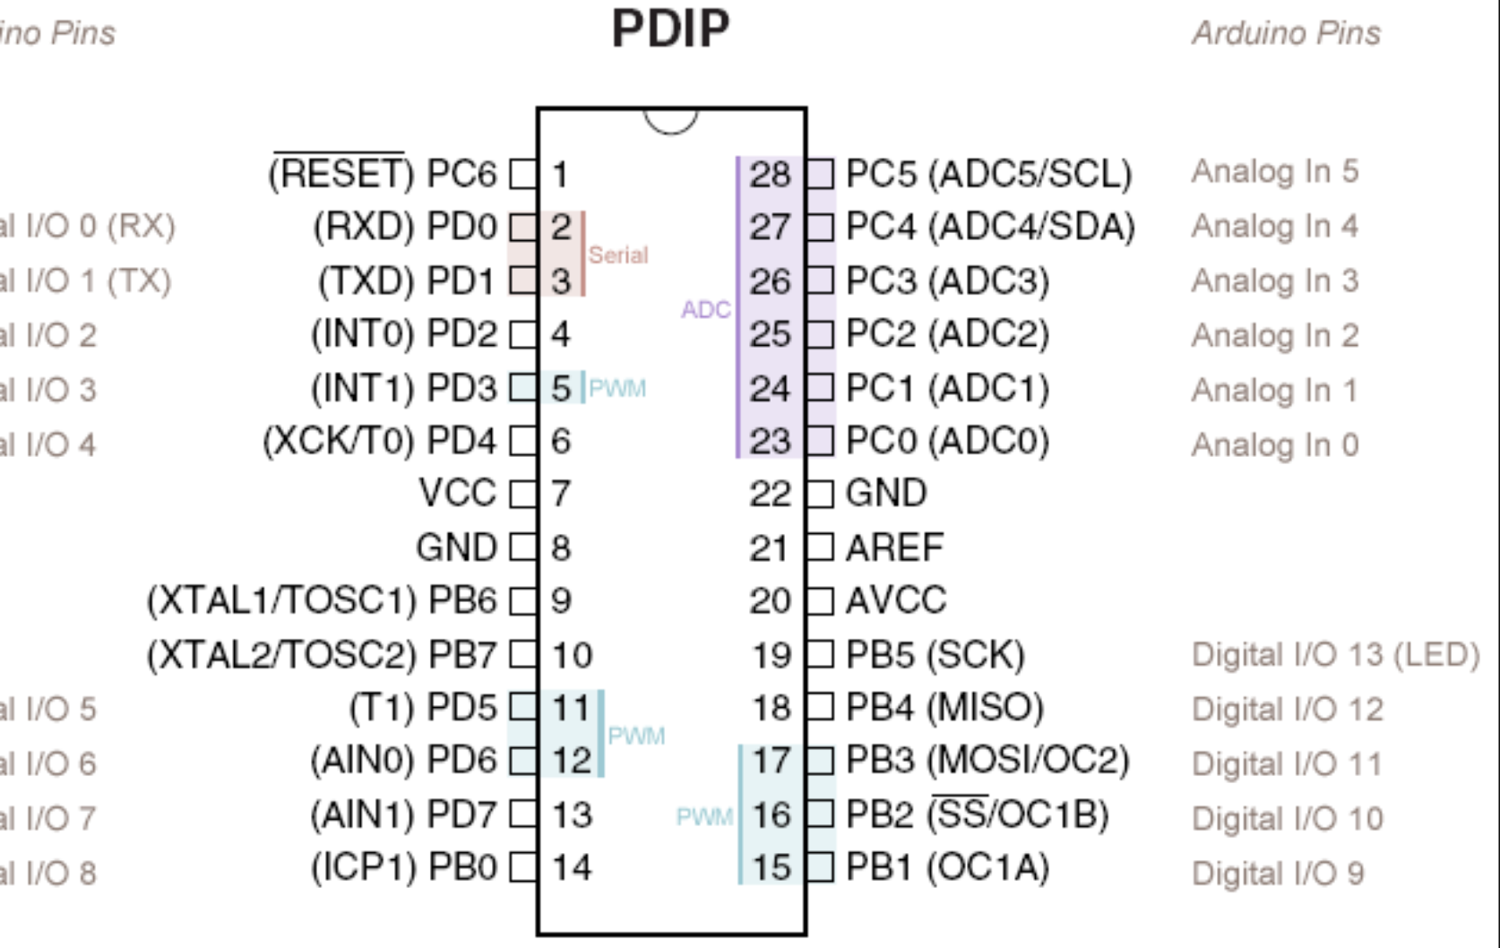

16 x 2 LCD :
The 16x2 LCD is a popular liquid crystal display module commonly used in electronic projects to display text or simple graphics. It has the capability to display 16 characters on each of its 2 rows, hence the name "16x2." Here are key features and characteristics:
- Display Size:
  - The screen can display 16 characters per row and has 2 rows, so a total of 32 characters can be shown.
- Character Type:
  - It uses alphanumeric characters (letters, numbers, and symbols), and each character is displayed in a 5x8 dot matrix format.
- Interface:
  - The 16x2 LCD typically communicates with microcontrollers (like the Arduino) using parallel communication through 16 pins, though a 4-wire (4-bit) communication mode is also supported to reduce the number of pins needed.
- Backlight:
  - Most 16x2 LCDs come with a backlight, usually blue or green, which makes the characters visible in low-light environments. The brightness of the backlight can often be adjusted.
- Low Power Consumption:
  - These displays are energy-efficient, which makes them ideal for battery-powered applications.
- Contrast Adjustment:
  - The contrast of the display can be adjusted, usually with a potentiometer, allowing for clearer visibility of characters.
- Widely Used:
  - It’s commonly used in various embedded systems projects, such as temperature displays, digital clocks, and data output from sensors.

- Affordable and Easy to Use:
  - It’s cost-effective and well-supported with libraries in popular programming environments like Arduino, making it easy for beginners to incorporate into projects Overall, the 16x2 LCD is a versatile, simple, and reliable component for displaying text-based information in many electronics applications.

16 X 2 LCD DISPLAY :
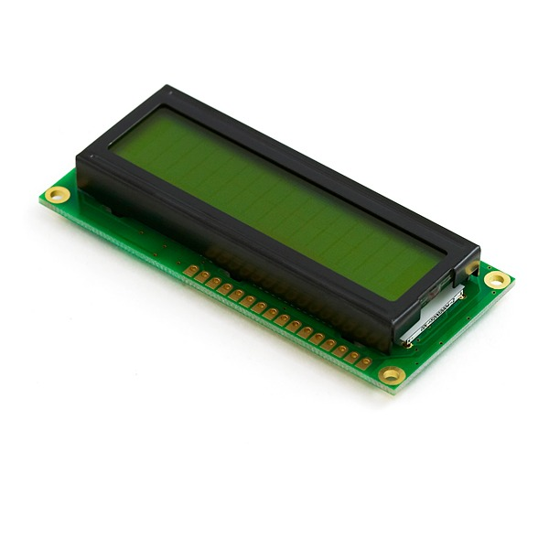

I2C MODULE :
The I2C (Inter-Integrated Circuit) module is a communication protocol designed for connecting multiple devices to a microcontroller using just two wires: SDA (Serial Data) and SCL (Serial Clock). It operates on a master-slave model, where the master device controls communication, and the slave devices respond.

I2C MODULE :
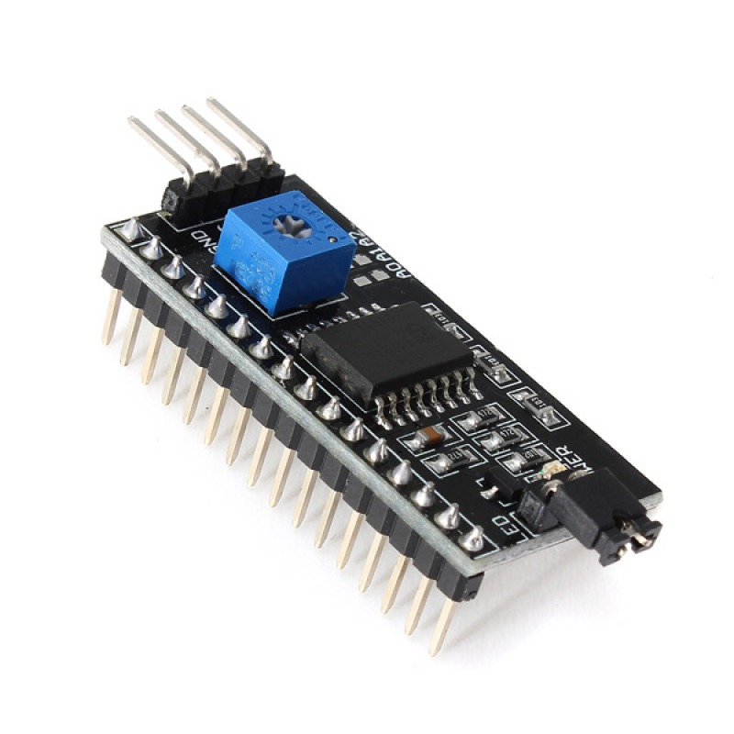

Key Features:
- Two-Wire Communication: Only two lines are needed for communication: SDA and SCL.
- Multi-Device Support: Multiple devices can share the same bus, with each device having a unique address.
- Master-Slave Architecture: One master controls all communication with the slave devices.
- Addressing: Devices on the bus are identified by a unique 7-bit or 10-bit address.
- Speed: Supports multiple speeds, including 100 kbps (Standard), 400 kbps (Fast), and up to 3.4 Mbps (High-Speed).
- Reduced Wiring: Only two lines are required for communication, making it ideal for applications with multiple peripherals.
- Low Power: I2C is energy-efficient, suitable for battery-powered applications.
- Scalable: Easily expand the number of connected devices.
- Data Integrity: Provides reliable data transmission through clock synchronization.
- Commonly Used with Sensors: I2C is widely used in connecting components like LCD displays, RTC modules, sensors, and EEPROMs.

The I2C protocol is commonly used in embedded systems, IoT devices, and robotics due to its simplicity, scalability, and efficiency.

I2C MODULE (I2C to LCD):
For example, when using an I2C LCD module, it simplifies the wiring to just two data lines (SCL, SDA) and provides adjustable contrast and backlight control. This is achieved with the I2C interface, eliminating the need for multiple connections required in standard LCD wiring.

LM293D :
The LM293D is a dual H-Bridge motor driver IC, designed to control the direction and speed of DC motors and stepper motors. It can independently control two motors, making it suitable for applications like robotics and automation.
Key Features :
- Dual H-Bridge: Allows for independent control of two motors.
- Voltage Range: Operates with motor voltages between 4.5V and 36V.
- Current Handling: Can handle up to 600mA of continuous current per motor and 1.2A peak current.
- Direction Control: Controls the motor's direction (forward and reverse).
- Speed Control: Works with PWM signals for speed regulation.
- Built-in Flyback Diodes: Protects the IC from voltage spikes caused by inductive loads like motors.
- Logic-Level Control: Interfaces easily with microcontrollers like Arduino using logic-level signals.
- Thermal Shutdown: Includes protection against overheating.
- Overcurrent Protection: Prevents damage due to excessive current.
- Enable Pins: Allows turning the motors on or off as needed.
The LM293D is used in applications where precise control of motors is required, including robotic systems, motorized projects, and actuators. Its compact 8-pin package makes it easy to integrate into a variety of electronic designs.
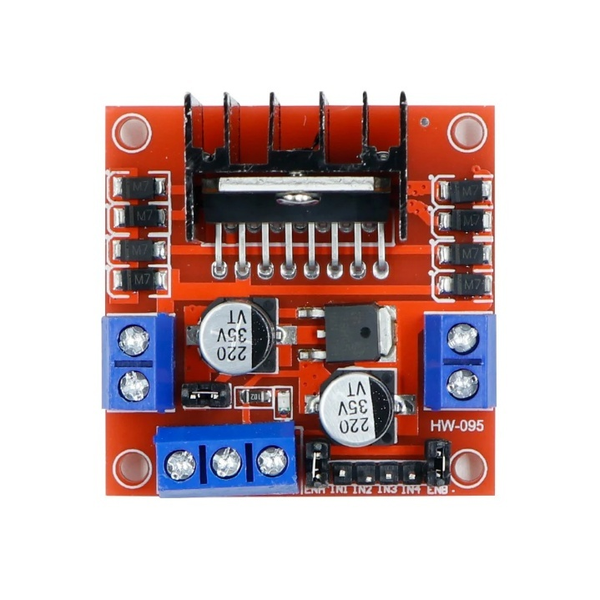

SOLAR PANEL :
A solar panel is a device that converts sunlight into electricity using photovoltaic (PV) cells made from silicon. These panels generate direct current (DC) electricity when exposed to sunlight by exciting electrons in the cells.
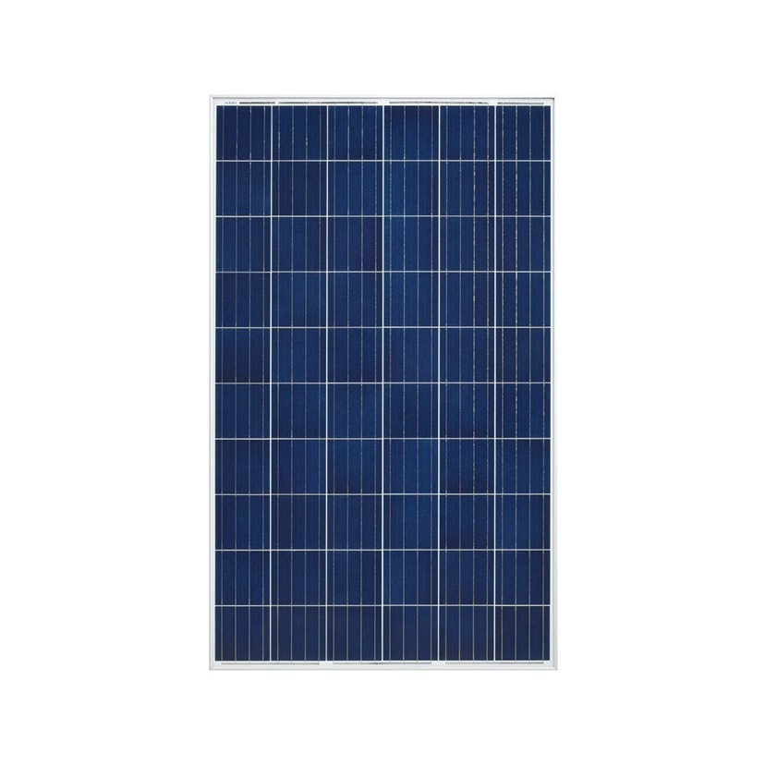

KEY FEATURES :
- Photovoltaic Cells: Convert sunlight into electricity.
- Power Rating: Panels typically range from 100W to 400W in power.
- Efficiency: Modern panels have efficiencies of 15% to 22%.
- Types: Monocrystalline panels are more efficient, while polycrystalline are less expensive.
- Durability: Solar panels are built to withstand harsh weather and typically last 20-25 years.
- Sustainability: They produce clean energy with no emissions during use.
- Grid-Tied vs. Off-Grid: Panels can be connected to the electrical grid or used in standalone systems for remote locations.
- Installation: Panels are usually installed on rooftops or open spaces with direct sunlight exposure.

Solar panels are widely used in residential, commercial, and industrial applications to reduce electricity bills, power homes, and contribute to renewable energy generation. They are an essential part of the push toward sustainable energy.

DC MOTOR :
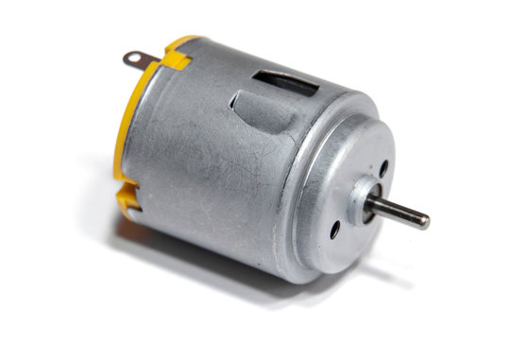
A DC motor (Direct Current motor) is an electric motor that runs on direct current (DC) electricity, converting electrical energy into mechanical motion. It operates by using a magnetic field generated by current flowing through the motor’s windings to spin the rotor.

KEY FEATURES :

- Simple Operation: Converts electrical energy to mechanical motion.
- Speed Control: Easily controlled by adjusting the voltage or using PWM (Pulse Width Modulation).
- Direction Control: Reversing the current direction changes the motor's rotation direction.
- Brushed DC Motors: Use brushes and a commutator to change current direction.
- Brushless DC Motors: Have no brushes, offering higher efficiency and less maintenance.
- Torque: DC motors provide high torque at low speeds.
- Efficiency: Known for efficient energy conversion and speed control.
- Compact: Small and lightweight, suitable for portable applications.
- Applications: Used in fans, robotics, toys, electric vehicles, and appliances.
DC motors are valued for their reliability, ease of control, and adaptability to a variety of applications.

LDR MODULE :
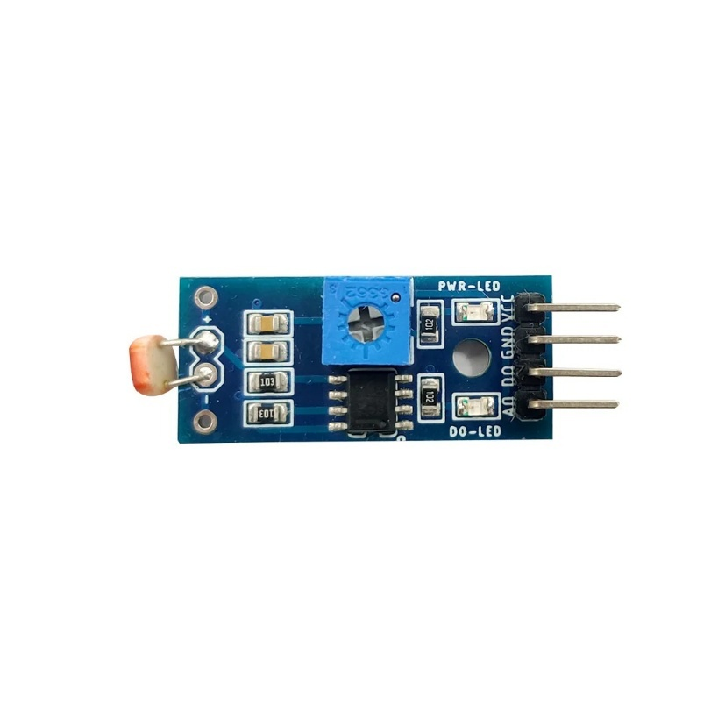
An LDR (Light Dependent Resistor) module is a component that changes its resistance based on the amount of light it receives. It is commonly used in electronics to detect light levels and is often integrated into projects where light sensing or automatic light control is required.

Key Features :
- Light Sensitivity:
  - The resistance of an LDR decreases as the light intensity increases and increases when the light intensity decreases, allowing it to detect changes in lighting.
- Simple Operation:
  - When light hits the LDR, it conducts more electricity, allowing current to flow through the circuit. When it is in darkness, it resists the flow of current, providing a high resistance.
- Voltage Divider:
  - The LDR is typically used in a voltage divider configuration with a fixed resistor, allowing the module to output a variable voltage based on the light intensity.
- Analog Output:
  - Many LDR modules provide analog outputs, which can be read by microcontrollers (like Arduino) to determine the light levels in the environment.
- Adjustable Sensitivity:
  - Some LDR modules come with a built-in potentiometer to adjust sensitivity, allowing users to calibrate the module to detect specific light levels.
- Low Power Consumption:
  - LDR modules typically consume very little power, making them suitable for battery-operated devices or low-power applications.
- Applications:
  - LDR modules are used in applications such as automatic lighting systems, darkness detection, solar panel orientation, and alarm systems. They are also widely used in light meters and photo-sensitive circuits.

CONNECTING WIRES :
A connecting wire allows to travel the electric current from one point to another point without resistivity. we use copper wires because it has low resistivity which is the most important feature of connecting wires that are used to connect the circuits.

POWER ADAPTER :
This AC to DC power supply will do 5V at 1A! They're switch mode power supplies which means the output is regulated to 5V (no more 14V outputs!). These have a standard USB 'A' connector for the output so you can power your Arduino, Raspberry Pi, etc. through a USB cable.

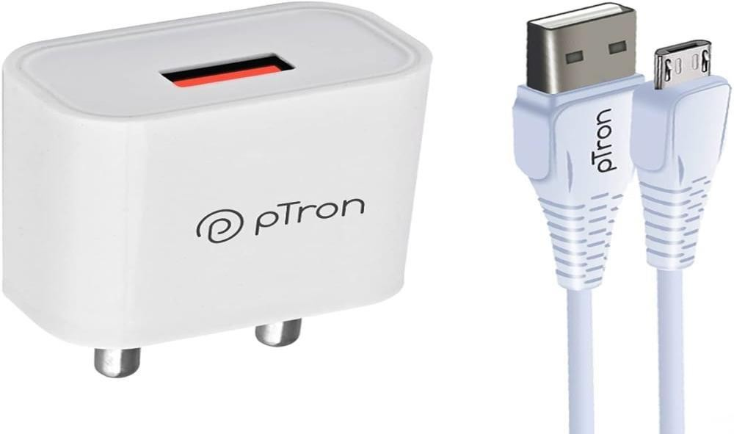

CHAPTER 4 : SOURCE CODE
//#include<LiquidCrystal.h>
#include <Servo.h>
Servo myservo;
/*#define motors PORTD
#define n_rot 0x05
#define s_rot 0x0A
#define e_rot 0xA0
#define w_rot 0x50
#define wait 0x00*/
int e_ldr = 2,w_ldr = 3,m0=4,m1=5;
unsigned int east,west,north,south,ea,we,no,so,du,a[20],i,j;
//RS=13,RW=Gnd,EN=12,D4=11,D5=10,D6=9,D7=8;
#include <LiquidCrystal_I2C.h>
LiquidCrystal_I2C lcd(0x27, 16, 2);
//LiquidCrystal lcd(12, 11, 10, 9, 8, 7);
void setup()
{
lcd.clear();
lcd.init(); // initialize the lcd
lcd.init();
// Print a message to the LCD.
lcd.backlight();
pinMode(m0,OUTPUT);
pinMode(m1,OUTPUT);
pinMode(e_ldr,INPUT);
pinMode(w_ldr,INPUT);
//--------------------
lcd.begin(16,2);
lcd.backlight();
lcd.setCursor(0, 0);
lcd.print("SOLAR TRACKING. ");
lcd.setCursor(0, 1);
lcd.print("SYSTEM........! ");
Serial.begin(9600);
delay(2000);
lcd.setCursor(0, 0);
lcd.print("EAST: TURN: ");
lcd.setCursor(0, 1);
lcd.print("WEST: ");
}
void loop()
{
Serial.print("E:");
Serial.print(digitalRead(e_ldr));
Serial.print(" W:");
Serial.println();
lcd.setCursor(5, 0);
lcd.print(digitalRead(e_ldr));
lcd.setCursor(5, 1);
lcd.print(digitalRead(w_ldr));

if(digitalRead(e_ldr)==0 && digitalRead(w_ldr)==1)
{
//Serial.println("EAST-------------");
lcd.setCursor(12, 0);
lcd.print("EAST");
digitalWrite(m0,HIGH);
digitalWrite(m1,LOW);
delay(100);
digitalWrite(m0,LOW);
digitalWrite(m1,LOW);
delay(200);
}
else if(digitalRead(e_ldr)==1 && digitalRead(w_ldr)==0)
{
//Serial.println("WEST-------------");
lcd.setCursor(12, 0);
lcd.print("WEST");
digitalWrite(m0,LOW);
digitalWrite(m1,HIGH);
delay(100);
digitalWrite(m0,LOW);
digitalWrite(m1,LOW);
delay(200);
}
else
{
digitalWrite(m0,LOW);
digitalWrite(m1,LOW);
lcd.setCursor(12, 0);
lcd.print("STBL");
}
}
CHAPTER 5 : WORKING PRINCIPLE

A Dual Axis Solar Tracker is a device that automatically adjusts the position of a solar panel to face the sun, maximizing its exposure to sunlight and improving energy efficiency. It tracks the sun's movement both horizontally (azimuth) and vertically (elevation), ensuring that the solar panel is always oriented optimally for solar energy capture.
Working Principle of a Dual Axis Solar Tracker:
- Solar Panel and Sensors:
The system consists of a solar panel, light sensors (usually Lig ht Dependent Resistors - LDRs), and a controller (such as Arduino). The LDRs are placed on the panel to detect the intensity of sunlight from different directions.
- Light Detection:
The two primary sensors (placed on the east and west sides for horizontal tracking, and on the north and south sides for vertical tracking) detect the intensity of sunlight. When sunlight hits the sensor, the resistance of the LDR decreases, allowing the system to detect where the sunlight is coming from.
- Feedback to Controller:
The changes in the LDR resistance are fed into a microcontroller (like an Arduino), which processes the sensor data. It compares the light intensity from different sensors to determine the current position of the solar panel relative to the sun.
- Movement Activation:
If the sensors on one side of the panel detect higher light intensity, the microcontroller sends a signal to actuators (typically servo motors) to move the solar panel in the corresponding direction—either azimuth (horizontal) or elevation (vertical)—until it aligns with the sun.
- Continuous Adjustment:
As the sun moves throughout the day, the LDRs continue to monitor sunlight intensity and provide feedback to the controller, which adjusts the solar panel’s position in real time. The panel moves continuously, maximizing energy capture.
- Maximized Solar Power:
By adjusting the position of the panel along both axes (horizontal and vertical), the tracker ensures that the solar panel is always directly facing the sun, capturing the most sunlight possible and improving the system's overall efficiency.
Conclusion:
A Dual Axis Solar Tracker increases solar energy efficiency by keeping the panel aligned with the sun's path. It uses light sensors to detect sunlight direction and adjusts the position of the solar panel through motors, ensuring optimal exposure throughout the day. This technology helps maximize energy generation compared to static solar panels.

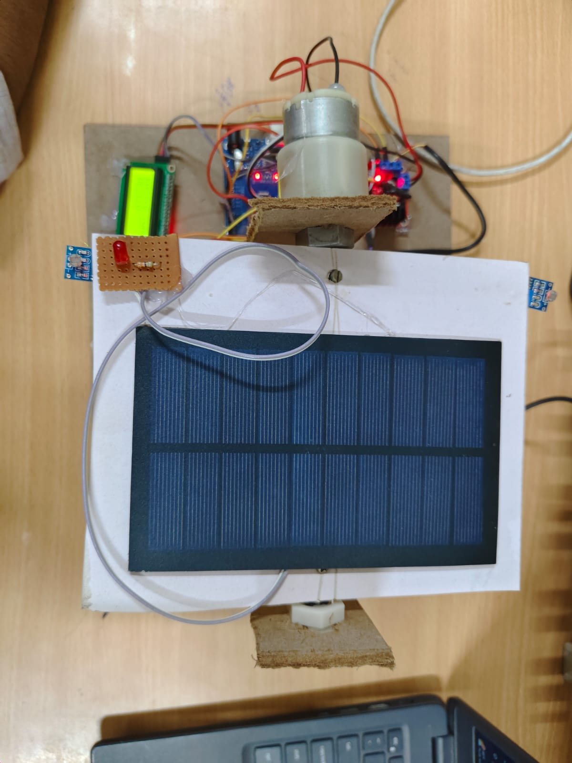
CHAPTER 6 : OUTPUT

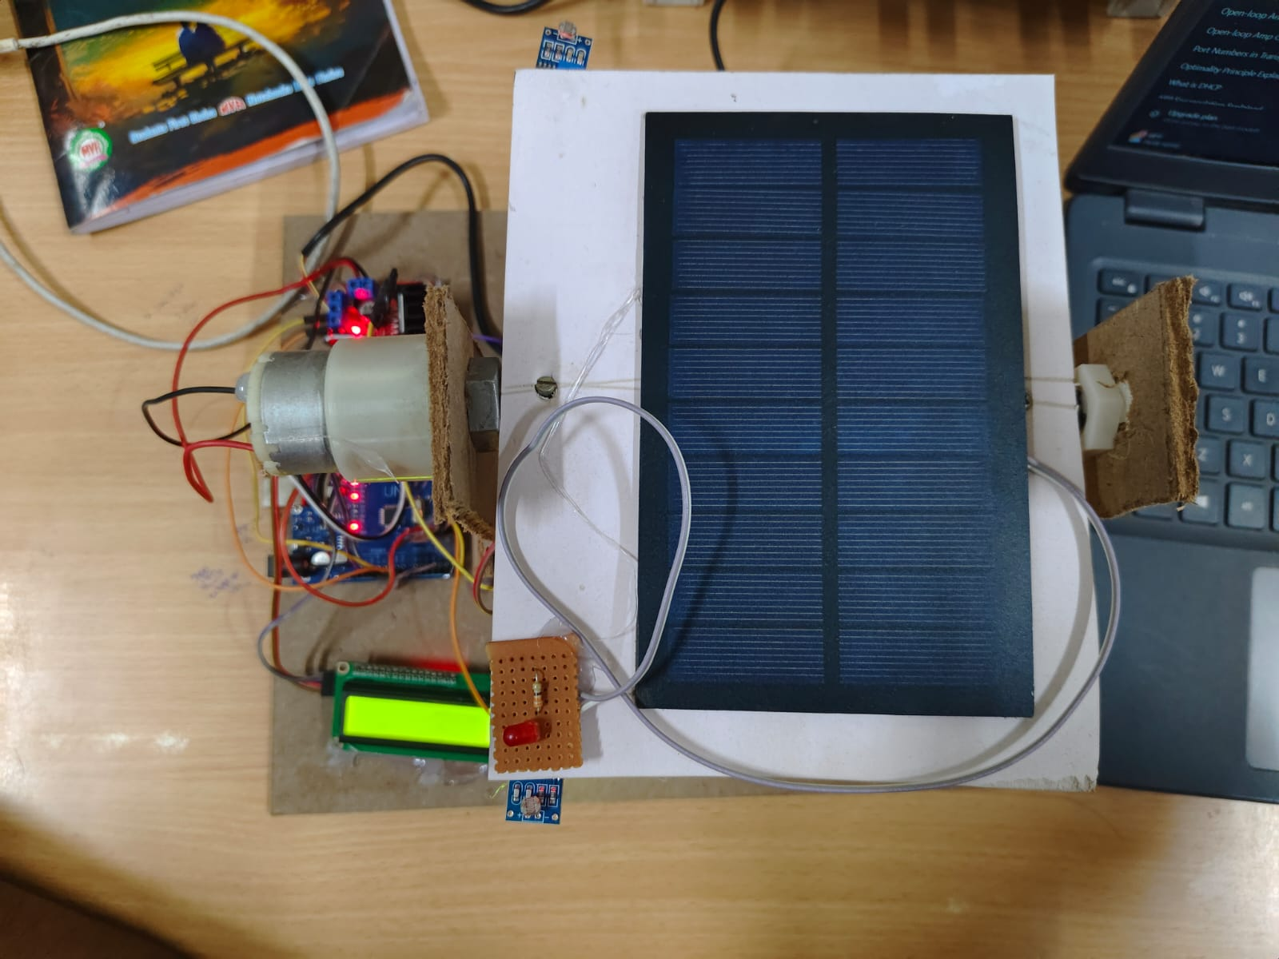

CHAPTER 7 : CONCLUSION & FUTURE SCOPE

FUTURE SCOPE :
AI and Machine Learning Integration:
The system can be enhanced with artificial intelligence and machine learning algorithms to predict the sun's position more accurately and optimize the tracking process. This would reduce dependency on sensor data and improve tracking precision, especially in varying weather conditions.
IoT Integration for Remote Monitoring:
By incorporating IoT technology, the solar tracking system can be monitored and controlled remotely. Data regarding energy generation, panel position, and system health can be accessed via a mobile app or web portal, enabling real-time performance tracking and maintenance alerts.
Energy Storage Integration:
The system can be integrated with energy storage devices such as batteries to store excess energy generated during peak sunlight hours. This would ensure a continuous power supply even during cloudy days or at night.
Smart Grid Integration:
The solar tracking system can be connected to smart grids to feed excess energy into the grid. With real-time data from the system, the smart grid could efficiently manage energy distribution based on demand and supply.
Enhanced Tracking Algorithms:
Further development of the tracking algorithm to consider seasonal variations in the sun's path could improve the system's efficiency in different geographical regions. This would ensure the system adapts to the changing angles of the sun throughout the year.

Larger Scale Implementation:
The system can be scaled up for use in solar farms and large commercial installations. Automated dual-axis tracking would maximize energy generation on a larger scale, making solar energy a more reliable and competitive alternative to conventional power sources.
Cost Reduction:
Research into low-cost materials and components, such as cheaper motors or more efficient sensors, could reduce the overall cost of the system, making it more accessible for residential and small-scale commercial use.
These enhancements would significantly improve the system's performance, scalability, and applicability, further promoting the use of renewable energy in various sectors.

CONCLUSION :
The Dual Axis Solar Panel System successfully demonstrates an efficient solution for maximizing solar energy absorption by continuously tracking the sun's movement in both horizontal and vertical directions. By optimizing panel orientation, the system significantly improves energy output compared to fixed solar panels. This project not only showcases the potential for higher efficiency in renewable energy generation but also offers a scalable and sustainable approach to meeting growing energy demands in various applications.

