1a.

Truth table 1 for AND operation is

|  |  |  |
| --- | --- | --- |
| X1 | X2 | AND |
| 0 | 0 | 0 |
| 0 | 1 | 0 |
| 1 | 0 | 0 |
| 1 | 1 | 1 |

1b.

The values of w1,w2 and b are

w1 = 1

W2 = 1

b = -1

The equation of y will be

y = $∅$ ( x1 + x2 -1 )

1c.

Truth table 2 for OR operation is

|  |  |  |
| --- | --- | --- |
| X1 | X2 | OR |
| 0 | 0 | 0 |
| 0 | 1 | 1 |
| 1 | 0 | 1 |
| 1 | 1 | 1 |

1d.

The values of w1,w2 and b are

w1 = 1

W2 = 1

b = 0

The equation of y will be

y = $∅$ ( x1 + x2 )

1e.

Truth Table 3 for XOR Operation is

|  |  |  |
| --- | --- | --- |
| X1 | X2 | XOR |
| 0 | 0 | 0 |
| 0 | 1 | 1 |
| 1 | 0 | 1 |
| 1 | 1 | 0 |

1f.

The linear separator depicted in figure 1 is given by the formula

y = $∅$ ( x1 + x2 -1 ), this is failing to create an XOR function

If we draw a graph for XOR points we will be having something like

= y = 0

= y =1

= The linear separator for table 1

Clearly if we look at the graph we can say that XOR is not linearly separable and we cannot find a linearly separable equation for XOR operation. The equation given for Truth table 1 cannot be used to create logical XOR because for the case x = [1,1] we have y =1 where as we actually need to get y=0

1g.

The graph for the given question will be as follows

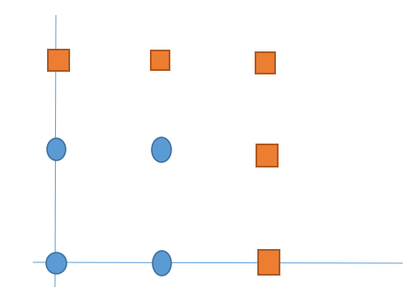

0

1

2

1

2

We can see from the graph clearly that this is not linearly separable. This function cannot be learned from a linear perceptron but it can be learned from a Multilayer perceptron.

Let there be two functions y1 and y2, representing the two linear perceptrons given in the graph.

y1 = $∅$ 1 (x1 -2)

y2 = $∅$ 1 (x2-2)

Where $∅1$ (z) = $\left\{\begin{aligned}0 if z <0 \\ 1 if z>=0 \end{aligned}\right.$

Now the resultant y is OR of y1 and y2.

y = $∅$ (y1 + y2 -1)

Where $∅$ (z) = $\left\{\begin{aligned}0 if z <=0 \\ 1 if z>0 \end{aligned}\right.$

We get the desired output from the equation of y.

2.

The Accuracy Scores are as follows

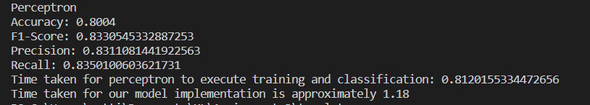

The code is attached when submitting the assignment.