1.1.

In Generative classifiers we assume some functional form for P(X / Y) and P(Y). We estimate the parameters of P(X /Y) and P(Y) directly from the training data and then calculate P(Y /X) based on this. This is not what we do in logistic regression.

In Discriminative classifiers we assume some form for P(Y / X) and estimate the parameters of P(Y / X) directly from the training data. We are following the same thing in Logistic regression we are having some form for P(Y=1 /X) = $\frac{exp(w_{0} + \sum_{i}{w_{i}X_{i}) }}{exp(w_{0} + \sum_{i}{w_{i}X_{i}) + 1}}$ and we estimate w’s based on training data.

So for the above reasons we can say logistic regression is a Discriminative classifier rather than generative classifier.

1.2.

The decision boundary of a logistic regression is a straight line. Let us assume

P(Y=1 /X) = $\frac{exp(w_{0} + \sum_{i}{w_{i}X_{i}) }}{exp(w_{0} + \sum_{i}{w_{i}X_{i}) + 1}}$ and we have P(Y=0 /X) = $\frac{1}{exp(w_{0} + \sum_{i}{w_{i}X_{i}) + 1}}$

for P(Y=1 / X) > P(Y=0 / X)

We need to have $exp(w_{0} + \sum_{i}{w_{i}X_{i}) }$ > 1 , this happens when $(w_{0} + \sum_{i}{w_{i}X_{i}) }$ > 0 .

The equation $(w_{0} + \sum_{i}{w_{i}X_{i})}$ > 0 is a liner decision boundary.

1.3.

1.3a. l(w) = ln $\prod_{j=1}^{n}{p(y^{j}}/ x^{j}$,w) , we know that log(ab) = log(a) + log(b)

= $\sum_{j=1}^{n}{ln(p(y^{j}/x^{j},w))}$, as P(Y=y /X) = ${P(Y=1/X)}^{y}{P(Y=0/X)}^{1−y}$, here

If y =0 we will have P(Y=0/X) = ${P(Y=1/X)}^{0}{P(Y=0/X)}^{1}$ = P(Y=0/X)

If y =1 we will have P(Y=1/X) = ${P(Y=1/X)}^{1}{P(Y=0/X)}^{0}$ = P(Y=0/X)

= $\sum_{j=1}^{n}{ln({p(y^{j}=1/x^{j},w)}^{y_{j}}{p(y^{j}=0/x^{j},w)}^{{1 − y}_{j}})}$, and as we know that log $x^{a}$ = a*log(x) and also log(ab) = log(a) + log(b)

= $\sum_{j=1}^{n}{y_{j}ln({p(y^{j}=1/x^{j},w)}^{}) + ({1 − y}_{j}) ln({p(y^{j}=0/x^{j},w)}^{})}$, and we are given $p(y^{j}=1/x^{j},w)$ = $\frac{exp(w_{0} + w_{1}x_{1}^{j} + w_{2}x_{2}^{j})}{exp(w_{0} + w_{1}x_{1}^{j} + w_{2}x_{2}^{j}) + 1}$ and $p(y^{j}=0/x^{j},w) = 1 − p(y^{j}=1/x^{j},w)$

$p(y^{j}=1/x^{j},w)$ = $\frac{1}{exp(w_{0} + w_{1}x_{1}^{j} + w_{2}x_{2}^{j}) + 1}$, substituting it you get

= $\sum_{j=1}^{n}{y_{j}ln(\frac{exp(w_{0} + w_{1}x_{1}^{j} + w_{2}x_{2}^{j})}{exp(w_{0} + w_{1}x_{1}^{j} + w_{2}x_{2}^{j}) + 1} ) + ({1 − y}_{j}) ln( \frac{1}{exp(w_{0} + w_{1}x_{1}^{j} + w_{2}x_{2}^{j}) + 1} )}$, expanding terms and simplifying it we get,

= $\sum_{j=1}^{n}{y_{j}ln(exp(w_{0} + w_{1}x_{1}^{j} + w_{2}x_{2}^{j}) ) + ln( \frac{1}{exp(w_{0} + w_{1}x_{1}^{j} + w_{2}x_{2}^{j}) + 1} )}$, we know that ln(1 /a) = -ln(a) using that we get

= $\sum_{j=1}^{n}{y_{j}ln(exp(w_{0} + w_{1}x_{1}^{j} + w_{2}x_{2}^{j}) ) − ln( exp(w_{0} + w_{1}x_{1}^{j} + w_{2}x_{2}^{j}) + 1 )}$

Applying partial derivative on both sides.

$\frac{∂(l(w))}{∂w_{i}}$ = $\frac{∂}{∂w_{i}}$ $\sum_{j=1}^{n}{y_{j}ln(exp(w_{0} + w_{1}x_{1}^{j} + w_{2}x_{2}^{j}) )}− \frac{∂}{∂w_{i}} \sum_{j=1}^{n}{ln( exp(w_{0} + w_{1}x_{1}^{j} +} w_{2}x_{2}^{j}) +1)$

The blue part can be simplified down to $\sum_{j=1}^{n}{y_{j}x_{i}^{j} }$

For the red part we can apply the chain rule. We know that partial derivative of log(f(x)) with respect to x is

$\frac{∂( log(f(x)))}{∂x}$ = $\frac{1}{f(x)} ∗ \frac{∂( f(x))}{∂x}$

Now if we apply the above rule to $\frac{∂}{∂w_{i}} \sum_{j=1}^{n}{ln( exp(w_{0} + w_{1}x_{1}^{j} +} w_{2}x_{2}^{j}) +1)$ we get

= $\frac{1}{exp(w_{0} + w_{1}x_{1}^{j} + w_{2}x_{2}^{j}) + 1}$ $\frac{∂}{∂w_{i}}$* ($exp(w_{0} + w_{1}x_{1}^{j} + w_{2}x_{2}^{j}) + 1$) , we know that

$\frac{∂(e^{f(x)})}{∂x}$ = $\frac{∂(f(x))}{∂x}$. $e^{f(x)}$, Applying it we get.

= $\frac{1}{exp(w_{0} + w_{1}x_{1}^{j} + w_{2}x_{2}^{j}) + 1}$ $exp(w_{0} + w_{1}x_{1}^{j} + w_{2}x_{2}^{j})$ $\frac{∂}{∂w_{i}}$* * ($w_{0} + w_{1}x_{1}^{j} + w_{2}x_{2}^{j}$)

$\frac{∂}{∂w_{i}}$ ($w_{0} + w_{1}x_{1}^{j} + w_{2}x_{2}^{j}$) will be equal to $x_{i}^{j}$.

= $\frac{exp(w_{0} + w_{1}x_{1}^{j} + w_{2}x_{2}^{j}) }{exp(w_{0} + w_{1}x_{1}^{j} + w_{2}x_{2}^{j}) + 1}$ $x_{i}^{j}$* , if we substitute this in the red part of the above equation we get.

1.3b.

$\frac{∂(l(w))}{∂w_{i}}$ = $\sum_{j=1}^{n}{y_{j}x_{i}^{j} }$- $\sum_{j=1}^{n}{\frac{exp(w_{0} + w_{1}x_{1}^{j} + w_{2}x_{2}^{j}) }{exp(w_{0} + w_{1}x_{1}^{j} + w_{2}x_{2}^{j}) + 1} ∗ x_{i}^{j}}$, taking $x_{i}^{j}$ common we get

$\frac{∂(l(w))}{∂w_{i}}$ = $\sum_{j=1}^{n}{{x_{i}^{j}(y}_{j}−\frac{exp(w_{0} + w_{1}x_{1}^{j} + w_{2}x_{2}^{j}) }{exp(w_{0} + w_{1}x_{1}^{j} + w_{2}x_{2}^{j}) + 1}) }$ and we know that, $p(y^{j}=1/x^{j},w)$ = $\frac{exp(w_{0} + w_{1}x_{1}^{j} + w_{2}x_{2}^{j})}{exp(w_{0} + w_{1}x_{1}^{j} + w_{2}x_{2}^{j}) + 1}$

$\frac{∂(l(w))}{∂w_{i}}$ = $\sum_{j=1}^{n}{{x_{i}^{j}(y}_{j}−p(y^{j}=1/x^{j},w)) }$

We know that

$W^{t+1}$ = $W^{t}$ + $η$ $\frac{∂(l(w))}{∂w_{i}}$, substituting it we get

$W^{t+1}$ = $W^{t}$ + $η$ ($\sum_{j=1}^{n}{{x_{i}^{j}(y}_{j}−p(y^{j}=1/x^{j},w)) )}$

For initial $W_{0}$ the equation will be

$W_{0}^{t+1}$ = $W_{0}^{t}$ + $η$ ( $\sum_{j=1}^{n}{{x_{0}^{j}(y}_{j}−p(y^{j}=1/x^{j},w)) )}$, for the ith w we will have the update rule as ,

$W_{i}^{t+1}$**= $W_{i}^{t}$ + $η$ ($\sum_{j=1}^{n}{{x_{i}^{j}(y}_{j}−p(y^{j}=1/x^{j},w)) )}$**

2.

I have written the code for logistic regression and attached the folder. I got

optimal learning_rate = 0.028 and optimal epochs = 260.

Training Accuracy:



Validation Accuracy:



Testing Accuracy:



While training the model I have considered the whole dataset as a batch, I believe training the model by splitting training data into batches will give better outputs. I have taken random values for hyper parameters initially and tried to observe the trend how the accuracies are changing. I tried to check for different ranges and for the optimal hyper parameters I found I have drawn the plots which help me analyze better values for hyper parameters and then I got my optimal hyper parameters.

The plots asked in the question are as follows.

1. For this graph I have taken the learning rate at 0.0678 and varied epochs.

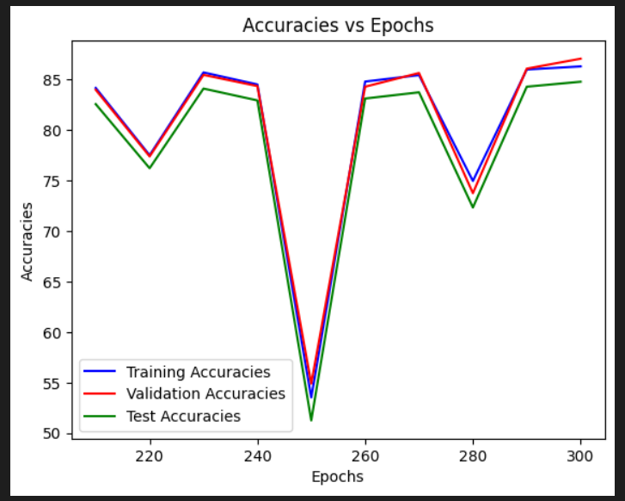

1. For this graph I have taken epochs = 90 and varied the learning rate.

