1.

The Shortest Seek Time First favors the middle cylinders over the inner most or the outermost cylinders. SSTF algorithm selects the request with the least seek time from the current head position. Let us consider that the initial head is at the innermost cylinder and the next position is at the outermost cylinder, in this case the disk head has to move the entire width of the disk. If the initial disk head is at the middle cylinder and the next position is at the ends then the disk head should at max move only half of the disk width. The center of the disk is the location having the lowest average distance to all the other tracks. Thus after servicing the first request, the disk head would be more likely to be closer to the center track than to any other particular track and away from the edges of the disk. Since the total head movement will be less, SSTF is favourable for middle cylinders.

s

2.

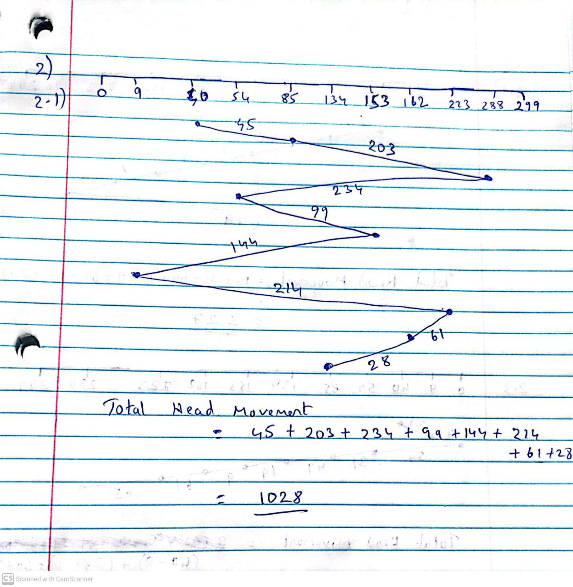

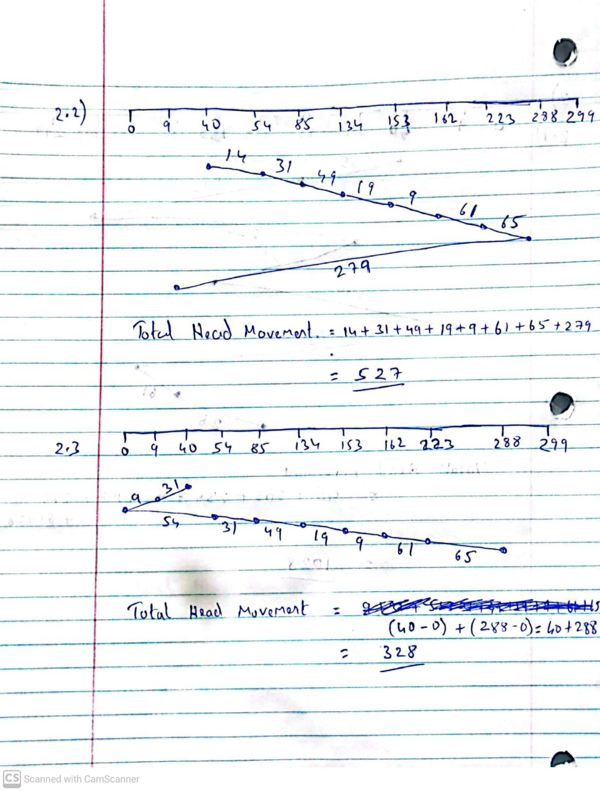

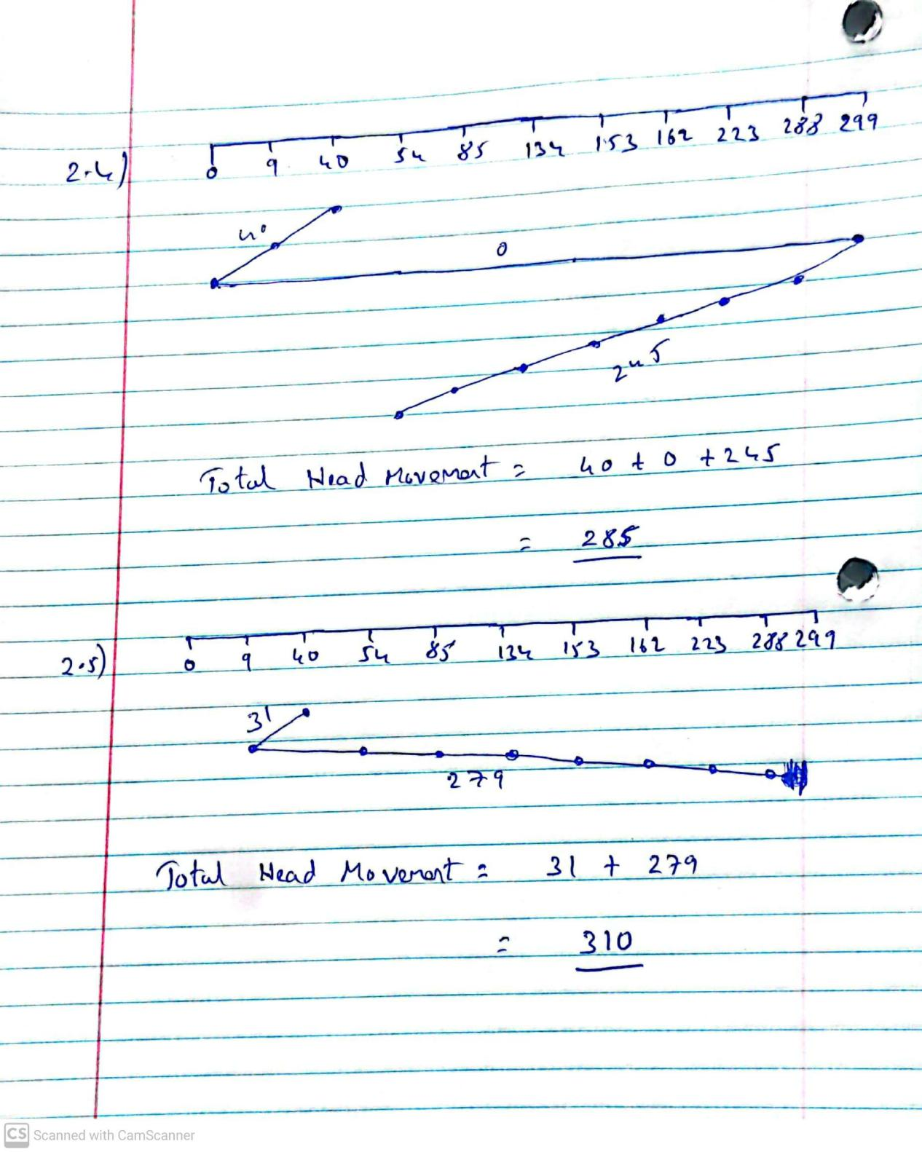

3.

3.1

RAID level 0 refers to disk arrays with striping at the level of

blocks but without any redundancy. RAID 0 offers faster read and write speeds compared with RAID 1, because we use stripping in RAID 0 systems. With multiple disks, we can improve the transfer rate by striping data across the disks. For example, if we have an array of eight disks, we write bit *i* of each byte to disk *i.* The array of eight disks can be treated as a single disk with sectors that are eight times the normal size and, more important, that have eight times the access rate. Every disk participates in every access (read or write); so the number of accesses that can be processed per second is about the same as on a single disk, but each access can read eight times as many data in the same time as on a single disk.

3.2

RAID level 1 refers to disk mirroring. RAID 1 duplicates the data across two drives. So, if one of the disk fails, data can still be recovered because it is intact on the second disk which means RAID 1 is fault tolerant. RAID 1 offers higher reliability because of redundancy, hence even if one of the drives fails outright, data is still available on the other.

4.

RAID level 5, or block-interleaved distributed parity, differs

from level 4 in that it spreads data and parity among all *N*+1 disks, rather

than storing data in *N* disks and parity in one disk. For each block, one of

the disks stores the parity and the others store data. Unfortunately, RAID 5 does not always assure that data are available to the operating system and its users. Two potential problems can be.

* The necessity of calculating check sums causes a lower write speed.
* RAID 5 is expensive in the case of the array reconstruction – if one of the disks have to be replaced after failure. Read and write operations will slowdown in such case due to the need of calculating check sums.