Report

1. In my project I have implemented the following functions in cpmfsys.c

DirStructType *mkDirStruct(int index,uint8_t *e);

void writeDirStruct(DirStructType *d, uint8_t index, uint8_t *e);

void makeFreeList();

void printFreeList();

int findExtentWithName(char *name, uint8_t *block0);

bool checkLegalName(char *name);

void cpmDir();

int cpmRename(char *oldName, char * newName);

int cpmDelete(char * name);

1. Firstly we need to run the makefile using the command

make -f Makefile

1. We can see that cpmRun executable file being created
2. When we run the cpmRun using the command

./cpmRun , we get the following output

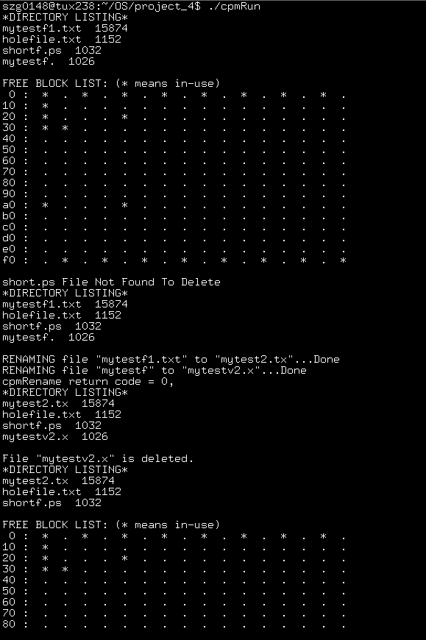

1. We need to specify the commands we want to run in fsysdrive.c

The design for the project is as follows

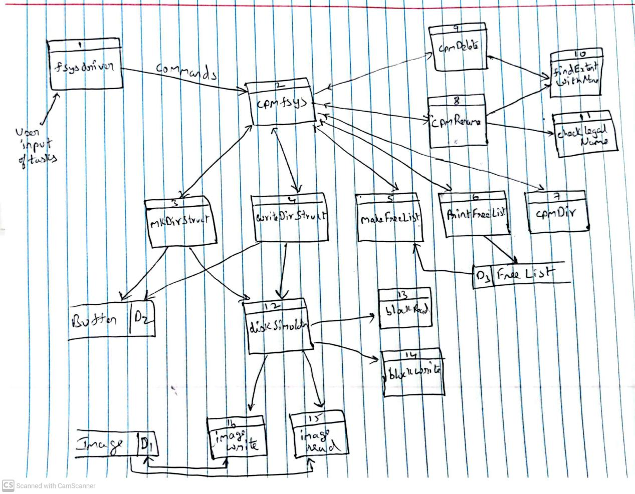

In this project I learned

Memory Allocation and freeing up of space after using the buffer

I learned how to implement a file system

I learned how to debug code using gdb tools.