Veritrace
Verifiable Trust Infrastructure for Production AI Agents
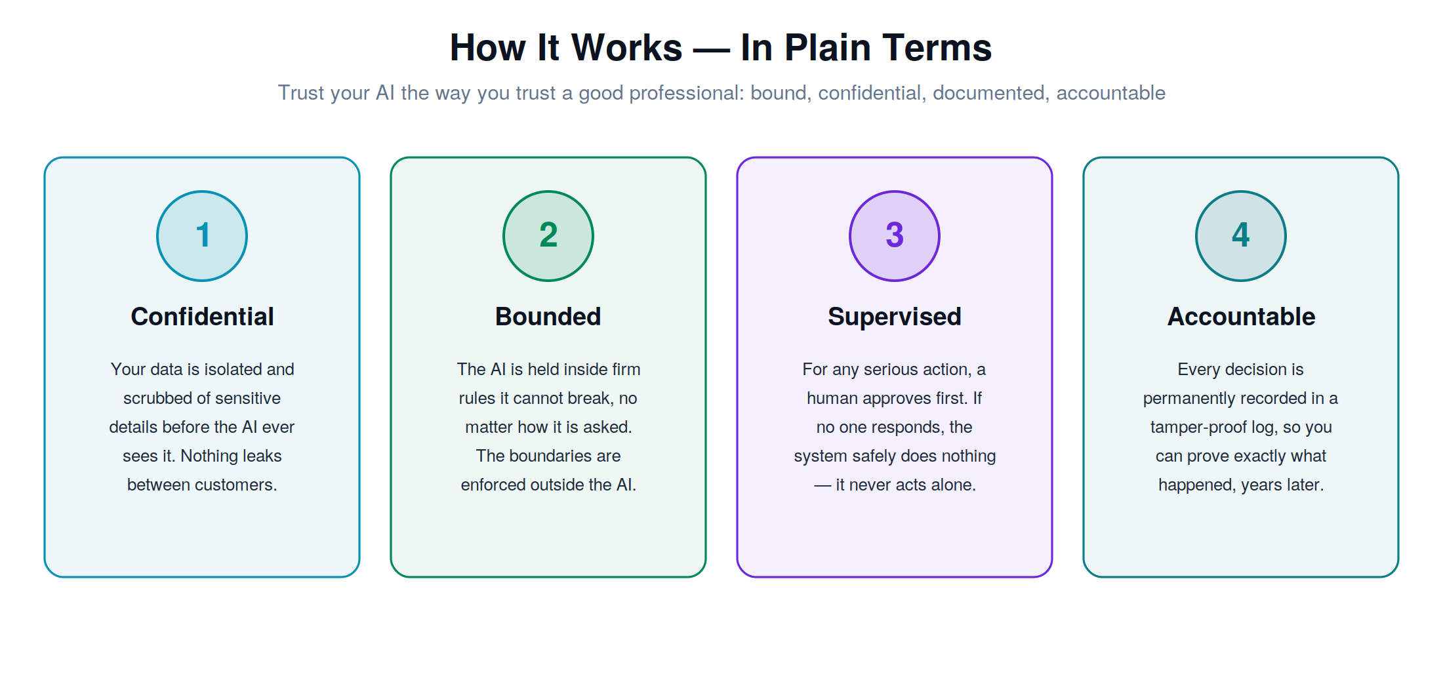

Technical Design & Implementation Document
A single document for every reader — from non-technical leadership to senior engineers.
Version 2.5 · Reference implementation included · Apache-2.0
Author: Sriram Rampelli

How to Read This Document
This document is written for several audiences at once. Each major part is tagged so you can read what is relevant to you and skip the rest.
FOR EVERYONE | Plain-language explanation of what Veritrace is, the problem it solves, how the workflow flows, and what technologies it uses and why. No engineering background required.
FOR TECHNICAL LEADERS | Architecture, the ten-layer trust stack, end-to-end data flow, the provider model, and the repository structure. For architects, eng managers, and technical decision-makers.
FOR SENIOR ENGINEERS | Every layer in full technical detail: data contracts, pipeline ordering, the hash-chain construction, the RCA engine internals, the public API, and how to extend each subsystem. Includes the working reference code.

A glossary at the end defines every technical term used. Wherever a concept first appears, it is explained in plain terms before any code.

Implementation Status — What Is and Isn’t Real
Trust infrastructure is exactly the wrong domain to overstate progress in. This section is a candid readout of what the accompanying code actually does today, what it does only partially, and what is roadmap. Read this before the architecture sections so the rest of the document is calibrated correctly.

Fully implemented and tested
- Orchestrator and pipeline ordering. Single source of truth in core.py; every layer decision lands in the trace; 72 passing tests cover the success and failure paths.
- Tamper-evident hash chain. SHA-256 chain over canonical JSON; tampering detection verified by direct file edit then re-verify.
- Context-guarded PII scrubbing. High-precision patterns for distinct shapes (email, SSN, IBAN); context-window scan for ambiguous shapes (routing numbers, ISO dates) so order IDs and event timestamps are not silently destroyed.
- Deterministic safety rule engine. Regex and predicate rules with strict precedence (BLOCK > ESCALATE > REDACT > ALLOW). Useful as a hard backstop; not a substitute for semantic defense.
- Concurrency, timeout, and circuit breaker. Semaphore-bounded provider calls with a hard timeout; consecutive failures open the breaker.
- HITL with idle-on-silence. No configuration converts silence into approval. Verified by test.
- Persistent storage. SQLiteStore persists traces and the hash chain to a single file across process restarts; verify_chain holds across reopen.
- Encryption at rest. EncryptedSQLiteStore wraps payload columns with Fernet (AES-128-CBC + HMAC-SHA256); indexed columns remain plain for queries; plaintext absence verified by raw-file scan.
- API authentication and cross-tenant guard. API-key-per-tenant; keys stored as SHA-256; tenant derived from key, never from body; cross-tenant access returns 404 (not 403) so existence is not leaked.
- Per-tenant rate limiting. Token bucket per tenant (or per IP unauthenticated). Returns 429 with Retry-After.
- Retention floor and GDPR erasure. Retention endpoint refuses windows shorter than the EU AI Act 180-day minimum; tenant-scoped erasure deletes trace rows while preserving chain payloads for integrity.
- Input size cap + injection heuristics. Per-call byte limit; conservative regex heuristics for the dozen most common injection patterns (override, role hijack, exfiltration, jailbreak personas, encoded payloads, delimiter breaks). Hits are recorded in the trace; default policy is to block.

Partial — useful, but not what a deep-pocketed enterprise will accept as final
- Isolation. Tenant-scoped storage and rate limits are real defenses. Injection heuristics will catch obvious attacks and miss novel ones. A determined attacker who can author new injection prompts will get past the heuristics. Strong defense requires a fine-tuned injection classifier and runtime constraints on the model’s action space — both are roadmap items. The classifier hook is in place.
- Safety rule engine. Regex plus predicates is sufficient as a backstop and for hard policies ("never expose acct numbers"). It is not semantic. Wrapping a real classifier under the same interface is the planned upgrade.
- HITL. The state machine is correct (idle-on-silence is the hard invariant) but no Slack, PagerDuty, or webhook adapter ships in this release. A real deployment needs to bridge the approver callable to whichever channel the on-call team uses.
- RCA engine. Decision replay is genuinely deterministic against the stored trace; counterfactuals work by removing one rule and recomputing the verdict; the causality graph is a linear chain. For complex multi-step agents with branching tool calls, this is a starting point, not a complete forensic toolkit.
- Observability. Counters and p50/p95/p99 latency, in-process. Production deployments would export these to OpenTelemetry or Prometheus; the report shape is small enough to wrap with an exporter.
- Provider integrations. Adapter pattern is clean and provider-agnostic. MockProvider is fully wired and used in every test. AnthropicProvider and OllamaProvider are present and importable; they have not been exercised end-to-end in the included demo (which runs offline).

Not yet implemented
- Production HITL adapters. Slack/PagerDuty/webhook bridges.
- Stronger auth. JWTs with short TTLs and per-key scopes; key rotation; an audit trail of key issuance.
- Enterprise audit anchoring. Ethereum / Hyperledger backends are stubbed; not connected.
- Scale-out storage. Postgres backend, S3 for cold trace archives, Redis for the rate-limit and HITL queue.
- Tool-call guards. Provenance tracking on tool outputs and a constrained action space for the model. These are the defenses that meaningfully address tool-misuse risk for autonomous agents and they are not in this codebase yet.
- OpenTelemetry exporter and Grafana dashboards.
- The QuantumLayer. Research track. The cryptography is feasible today (Dilithium signatures, QRNG over commercial APIs), but it is not implemented here and is not on the near-term path.

Where Veritrace fits today
As of this release, Veritrace is appropriate for: internal-facing assistants in regulated environments where tamper-evident audit and a deterministic safety backstop are the headline requirements; agent prototypes that need a credible audit story before piloting with a real customer; and as the trust spine that a team builds outwards from with their own integrations. It is not yet ready to sit alone in front of autonomous agents handling material financial or clinical decisions. Treat any claim to the contrary — including elsewhere in this document — as aspirational.

Part 1 — For Everyone
FOR EVERYONE

What Veritrace Is, In One Idea
Companies are starting to put AI “agents” to work — software that can read information, make decisions, and take actions on its own. An agent might answer a customer’s banking question, review a medical note, or help an engineer fix a system outage.
The problem is trust. An AI agent that works perfectly in a demo can, in the real world, say something wrong, act without permission, or make a decision nobody can later explain. In ordinary apps that is annoying. In a bank or a hospital it is dangerous and, increasingly, illegal.
Veritrace is a layer of software that sits between the AI and the real world and makes the AI trustworthy. It does not build the AI agent — it supervises one. The simplest way to understand it is by analogy to a profession built entirely on trust.

Figure 1 — The four guarantees Veritrace provides, in plain terms.

The Therapist Analogy
Think about why people trust a good therapist with their most sensitive information. It comes down to four promises:
- Confidential. What you say stays private. It is not shared with other clients or leaked elsewhere.
- Bounded. A therapist works within strict professional and ethical limits. There are things they will simply never do, no matter how they are asked.
- Supervised. For serious decisions, there is oversight and accountability — not one person acting alone in the dark.
- Documented. Sessions are recorded in notes, so there is an accurate record of what happened and why, that can be reviewed later.
Veritrace engineers these same four promises into software, so that an AI agent earns trust the same way a professional does. Confidentiality becomes automatic removal of sensitive data and strict separation between customers. Boundaries become hard rules the AI cannot break. Supervision becomes a human approving important actions. Documentation becomes a tamper-proof record of every decision.

How the Workflow Flows
When someone asks the AI agent to do something, the request does not go straight to the AI. It passes through a series of checkpoints, in order, and the answer passes back out through them. At a high level:
- A request arrives. Someone (or another system) asks the agent to do something.
- Sensitive details are removed. Personal data — names, account numbers, medical identifiers — is stripped out before the AI ever sees it.
- The request is checked against the rules. If it asks for something forbidden, it is stopped here, before anything happens.
- The AI is asked — carefully. The request goes to the AI model, but with limits on how long it can take and how many requests can run at once, so the system never gets overwhelmed.
- The answer is checked again. The AI’s response is screened before it is allowed out.
- A human approves important actions. If the agent wants to do something consequential — move money, delete data, change a live system — it asks a person first. If nobody answers, it does nothing. It never acts alone on something serious.
- Everything is recorded permanently. Every step and every decision is written into a tamper-proof log, so the whole event can be reconstructed and proven later.
If anything ever goes wrong, that permanent record can be replayed step by step to find exactly what caused it — the way a flight recorder explains an incident after the fact.

What Technologies We Use, and Why
Veritrace deliberately reuses proven, well-understood technologies rather than inventing risky new ones. The novelty is in how they are combined, not in unproven parts.
Any AI model provider | Banks, hospitals, and startups all use different AI providers — some in the cloud, some running privately on their own hardware. Veritrace works with all of them, so an organization is never locked in and can even run fully offline.
A rules engine | Simple, predictable “if-this-then-that” logic that the AI cannot override. This is what guarantees the AI stays inside its boundaries — because the boundaries are enforced outside the AI.
A tamper-proof log (hash chain) | The same core idea that makes blockchains tamper-evident: each new record is mathematically linked to the one before it, so altering an old record breaks the chain and the tampering is detected instantly.
Human-approval workflow | Connects to tools teams already use — email, Slack, on-call systems — so a person can approve or reject an action without learning anything new.
Privacy scrubbing | Automatic detection and removal of personal information, to meet privacy laws like GDPR and HIPAA.

Why this matters commercially: regulation is moving toward requiring exactly these guarantees. The EU AI Act already mandates tamper-proof activity logs for high-risk AI systems. An organization that adopts Veritrace is not just safer — it is positioned for compliance that is becoming mandatory.

Part 2 — For Technical Leaders
FOR TECHNICAL LEADERS

Design Principle
The architecture rests on one non-negotiable principle: the LLM is never the last line of defense. Every consequential guarantee — what the agent may do, when a human must intervene, what gets recorded — is enforced by deterministic code that sits outside the model and cannot be altered by model output. The model is treated as a powerful but untrusted component, wrapped in trustworthy infrastructure.
Veritrace is middleware, not a framework. It does not dictate how you build your agent. It wraps an existing agent — built with LangChain, CrewAI, or hand-rolled — and applies a configurable stack of trust layers around every call. Adoption is incremental: a team can start with one layer and add more without rewriting their agent.

The Ten-Layer Trust Stack
Every request descends through the active layers in a fixed order; the response and its trace ascend back out. Each layer is independent, individually configurable, and individually testable.
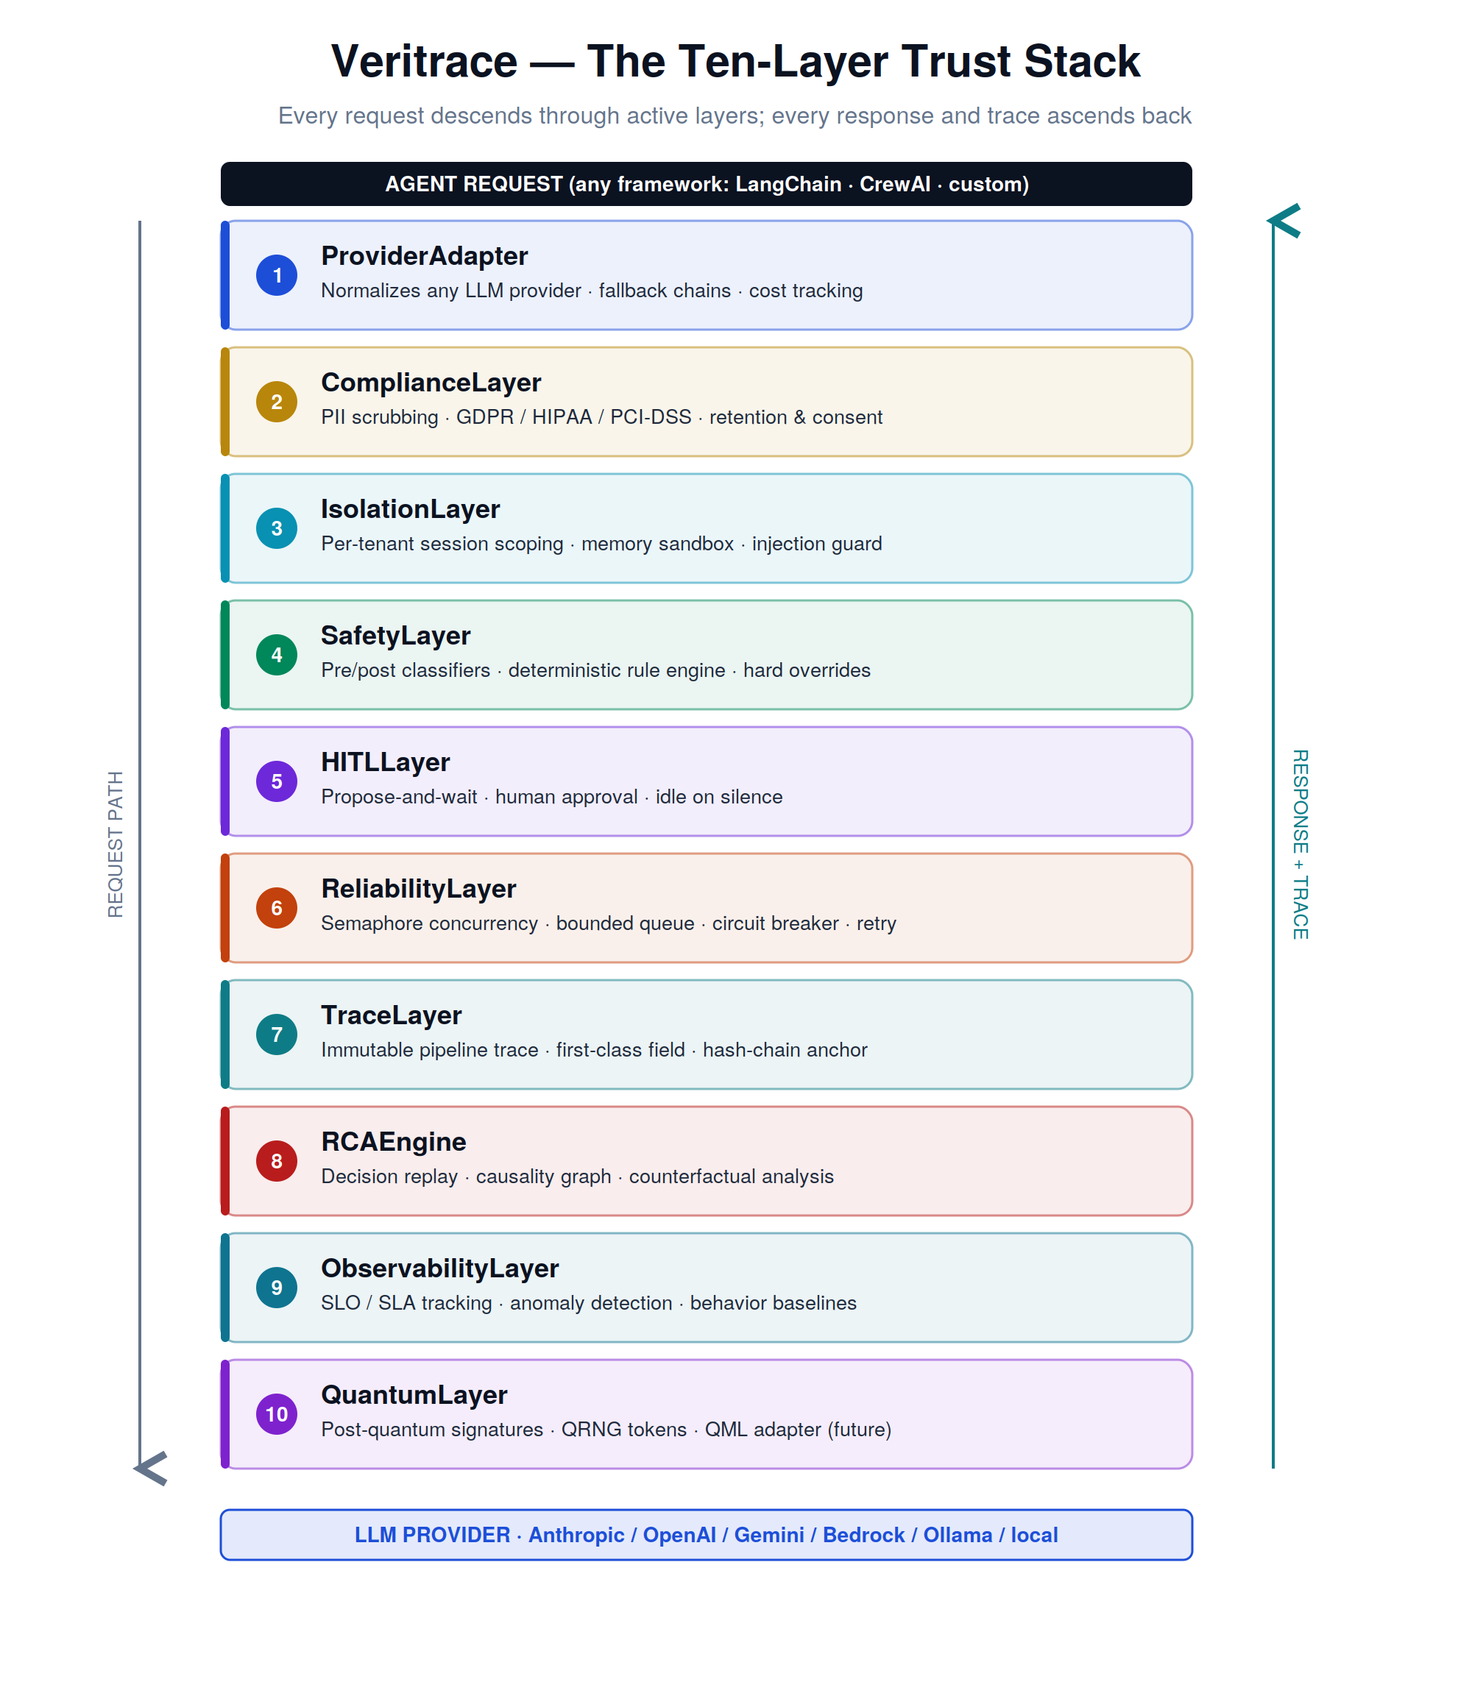
Figure 2 — The ten-layer trust stack. Requests flow down; responses and traces flow up.

Layer Responsibilities at a Glance
# | Layer | What it guarantees
1 | ProviderAdapter | Provider independence; automatic failover; per-call cost and latency accounting
2 | ComplianceLayer | No sensitive data reaches the model; retention and consent are enforced
3 | IsolationLayer | No data crosses tenant or session boundaries, even under adversarial prompting
4 | SafetyLayer | Deterministic boundaries the model cannot cross; input and output screening
5 | HITLLayer | No consequential action without human approval; silence is never consent
6 | ReliabilityLayer | Bounded concurrency, timeouts, and graceful degradation; no crashes, no hangs
7 | TraceLayer | Every decision recorded as a first-class, tamper-evident, hash-chained record
8 | RCAEngine | Any past decision can be replayed, explained, and analyzed counterfactually
9 | ObservabilityLayer | Service-level objectives, anomaly detection, behavioral baselines
10 | QuantumLayer | Forward-compatibility: post-quantum signatures, quantum randomness, QML

The reference implementation accompanying this document ships layers 1 through 8 in working, tested form, plus a FastAPI HTTP service with API-key authentication and cross-tenant guard, SQLite persistence with optional encryption at rest, context-guarded PII scrubbing, per-session isolation, Article 12 retention controls with GDPR erasure, and basic observability metrics. The full test suite has 72 passing tests.

The Provider Model — Why It Is Plug-and-Play
The first layer normalizes every LLM provider behind one interface. The trust layers operate on that normalized interface and have no knowledge of which model is underneath. Swapping Anthropic for a local Ollama model — or adding a brand-new provider — requires no change to any trust layer or to the agent. A fallback chain tries providers in order, so an outage at one provider transparently routes to the next, with the failover recorded in the trace.
# Same trust stack, three different providers — zero changes elsewhere.
from veritrace.providers import AnthropicProvider, OllamaProvider, FallbackProvider

provider = FallbackProvider([
AnthropicProvider(model='claude-sonnet-4-20250514'), # primary (cloud)
OllamaProvider(model='llama3.2:1b'), # fallback (local/offline)
])
armor = Veritrace(provider=provider, safety=..., hitl=...)

End-to-End Data Flow
The diagram below traces a single agent call through every stage. The right-hand column shows the trace record being assembled as the call progresses — every stage contributes fields, and the completed record is returned to the caller and chained into the audit log.
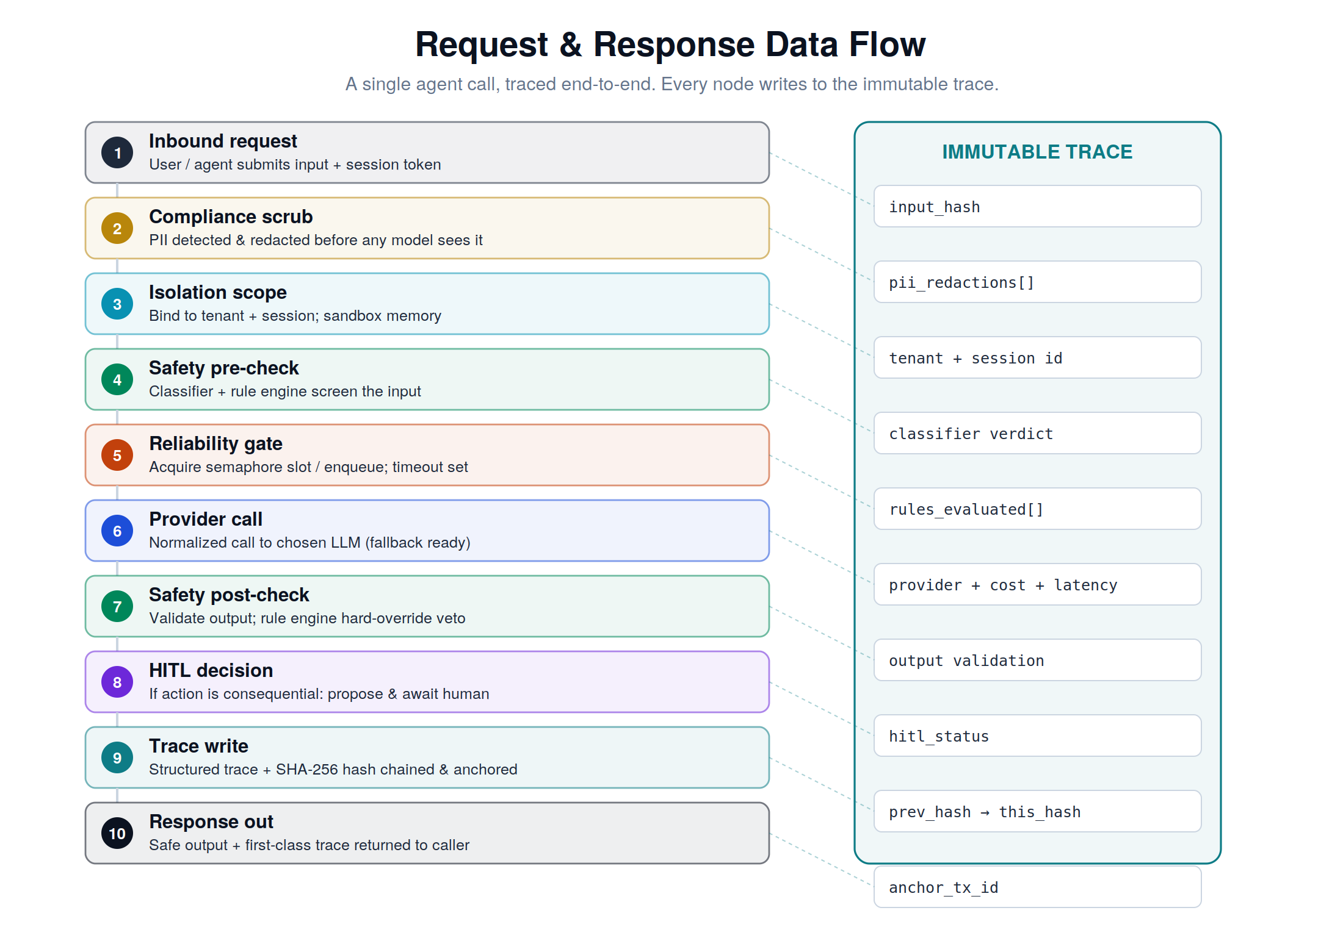
Figure 3 — One agent call, traced end-to-end. Every stage writes to the immutable trace.

Repository Structure
The codebase is small and deliberately legible. The orchestration order lives in exactly one file (core.py), so the behavior of the whole system can be understood by reading a single function.
veritrace/
├── veritrace/
│ ├── __init__.py # public API surface
│ ├── core.py # the orchestrator — pipeline ordering lives here
│ ├── types.py # TraceEvent, AgentResponse, Verdict, RuleResult …
│ ├── store.py # MemoryStore (default) + SQLiteStore (persistent)
│ ├── store_encrypted.py # EncryptedSQLiteStore (Fernet AES-128 at rest)
│ ├── auth.py # APIKeyRegistry — per-tenant keys, SHA-256 stored
│ ├── ratelimit.py # TokenBucket — per-tenant rate limiting
│ ├── providers/ # ProviderAdapter + Mock / Anthropic / Ollama / Fallback
│ ├── layers/ # Compliance (context-guarded PII) · Safety · Reliability · HITL
│ │ ├── isolation.py # injection heuristics · size limits · scope guards
│ │ └── observability.py # call counters · block reasons · p50/p95/p99 latency
│ ├── audit/ # HashChainBackend (tamper-evident) + Ethereum stub
│ ├── api/ # FastAPI sidecar with auth + tenant guard + rate limit
│ └── rca.py # replay · causality · counterfactual · incident report
├── examples/demo.py # runnable end-to-end demo (fully offline)
├── tests/ # 72 passing tests across pipeline, compliance, persistence,
│ # api, auth, encryption, retention, isolation, ratelimit
├── docs/ # this document + diagrams
└── pyproject.toml # packaging; extras: anthropic, ollama, api, encrypted, dev

The HTTP Service (FastAPI Sidecar)
Veritrace ships a FastAPI application that exposes the full pipeline over HTTP. This is what turns the library into a deployable service: any agent, in any language, can wrap its LLM calls in the trust stack by calling these endpoints — no need to embed the Python library. The sidecar runs as a single uvicorn process and serves all endpoints over standard REST.
pip install -e '.[api]'
uvicorn veritrace.api.app:app --port 8000

# or with persistent traces (survives restarts):
VERITRACE_DB=veritrace.db uvicorn veritrace.api.app:app --port 8000
The API surface is deliberately small and complete: one endpoint to run a call through the stack, one to verify the chain, one for each RCA capability, and standard health probes.
Method | Endpoint | Purpose
POST | /v1/run | Run one agent call through the full trust stack
GET | /v1/trace/{call_id} | Fetch the complete immutable trace record
GET | /v1/audit/verify | Verify the tamper-evident hash chain
GET | /v1/metrics | Observability snapshot (total, blocked, avg latency)
POST | /v1/rca/{call_id}/replay | Deterministic decision replay from stored trace
POST | /v1/rca/{call_id}/counterfactual | Recompute verdict with a rule disabled
GET | /v1/rca/{call_id}/incident | Human-readable, regulation-ready incident report
POST | /v1/retention/prune | Delete traces older than N days (≥180, Article 12 floor)
DELETE | /v1/tenant/{id}/traces | GDPR right-to-erasure (own tenant only)
GET | /health, /health/ready | Liveness; readiness with chain-validity check

In persistent mode (VERITRACE_DB set), traces and the audit chain are stored in a single SQLite file. The server can be restarted, and all traces, chain integrity, and RCA replays survive. This is the minimum a real deployment requires.

Multi-Tenant Security
Without authentication, the tenant guard on the store is moot: any caller can claim to be any tenant in the request body. The HTTP service ships with API-key-per-tenant authentication. The critical invariant: when authentication is enabled, the tenant is derived from the key, never from the request body. A holder of tenant A's key cannot fetch tenant B's trace by ID, cannot create a trace tagged as tenant B by spoofing the body, and cannot replay tenant B's calls through the RCA endpoints. Tests prove all four attack paths are blocked.
# Register keys at startup
VERITRACE_API_KEYS='bank:vt_abc...,hospital:vt_def...' \
uvicorn veritrace.api.app:app --port 8000

# Bank reads its own trace — 200 OK
curl /v1/trace/$ID -H 'Authorization: Bearer vt_abc...'

# Hospital tries to read bank's trace — 404 (existence not leaked)
curl /v1/trace/$ID -H 'Authorization: Bearer vt_def...'
Keys are stored as SHA-256 hashes, never plaintext, and compared in constant time to prevent timing-based key recovery. Cross-tenant access attempts return 404 rather than 403 — refusing to confirm that the trace id even exists. This is the minimum useful authentication, not the maximum; production deployments would layer JWT tokens with short TTLs, per-key scopes, key rotation, and an audit trail of key issuance. The interface is small enough that any of those can be added without changing the rest of the codebase.

Encryption at Rest
EncryptedSQLiteStore is a drop-in replacement that encrypts every trace payload and every audit-chain payload with Fernet (AES-128-CBC plus HMAC-SHA256). Indexed columns — call_id, tenant_id, session_id, created_at — remain in plain text so the database can still query them. Sensitive content is ciphertext on disk. The hash chain is computed over the plaintext payload exactly as in the unencrypted store, so verify_chain() works identically — encryption is invisible to the audit semantics.
from cryptography.fernet import Fernet
from veritrace.store_encrypted import EncryptedSQLiteStore

key = Fernet.generate_key() # store in AWS Secrets Manager / Vault
db = EncryptedSQLiteStore('veritrace.db', key=key)
armor = Veritrace(provider=..., store=db, audit=db)
Verified by direct file inspection: a trace containing the phrase "PATIENT-CONFIDENTIAL-XYZ-9876" is written, the file is closed, and a binary search of the raw SQLite file confirms the plaintext is not present anywhere. A second EncryptedSQLiteStore opened with a different key fails to decrypt and verify_chain() returns False rather than crashing — wrong-key access is a clean rejection, not an exception.

Retention & GDPR Erasure
EU AI Act Article 12 requires high-risk AI systems to retain activity logs for a minimum of six months. The retention endpoint enforces this floor: requests for windows shorter than 180 days are rejected with a 400 status. GDPR right-to-erasure is implemented as a tenant-scoped delete — trace records for the tenant are removed, while audit-chain payloads are retained to preserve cryptographic integrity (deleting chain links would invalidate every subsequent hash and destroy the audit value). For full chain rotation, the operator performs a controlled procedure outside this endpoint.

Part 3 — For Senior Engineers
FOR SENIOR ENGINEERS
This part documents the reference implementation in full. All code shown is real and runnable; it is the code in the accompanying repository. The demo runs offline against a deterministic MockProvider and all tests pass.

Core Data Contracts (types.py)
Everything that flows through the pipeline is a typed object. TraceEvent is the spine: it accumulates a LayerEvent per stage and is the unit that is hash-chained and handed to the RCA engine. Verdict is the four-valued outcome of any safety evaluation, with a strict precedence (BLOCK > ESCALATE > REDACT > ALLOW).
class Verdict(str, Enum):
ALLOW = 'allow'; BLOCK = 'block'; ESCALATE = 'escalate'; REDACT = 'redact'

@dataclass
class LayerEvent: # one decision by one layer
layer: str; decision: str; detail: str = ''
latency_ms: float = 0.0; data: dict = field(default_factory=dict)

@dataclass
class TraceEvent: # the complete, immutable record of one call
call_id: str; tenant_id: str; session_id: str; created_at: float
input_text: str; input_hash: str; output_text: str
pii_redactions: list[str]; pre_verdict: str; post_verdict: str
rules_evaluated: list[RuleResult]
provider: str; provider_model: str; provider_cost_usd: float
provider_latency_ms: float; used_fallback: bool
hitl_status: str; layer_events: list[LayerEvent]; total_latency_ms: float
prev_hash: str; this_hash: str; anchor_tx_id: str # hash-chain fields

The Orchestrator (core.py)
Veritrace.run() is the single source of truth for layer ordering. It records a LayerEvent at every step, short-circuits on a hard BLOCK, degrades gracefully on provider failure or an open circuit breaker, and finalizes by chaining the trace. The full pipeline order is: Compliance.scrub → Isolation(scope) → Safety.pre → Reliability.guard(Provider.complete) → Safety.post → HITL.gate → finalize(hash-chain).
async def run(self, prompt, *, tenant_id='default', session_id='default',
action='respond') -> AgentResponse:
tr = TraceEvent(tenant_id=tenant_id, session_id=session_id, input_text=prompt)
tr.input_hash = sha256(prompt)

clean, redactions = self.compliance.scrub(prompt) # 1 Compliance
scope = f'{tenant_id}:{session_id}' # 2 Isolation
pre_verdict, pre_rules = self.safety.pre(clean) # 3 Safety (input)
if pre_verdict == Verdict.BLOCK:
return self._finalize(tr, output='', blocked=True, ...)

result = await self.reliability.guard( # 4 Reliability +
lambda: self.provider.complete(clean)) # Provider call

post_verdict, post_rules = self.safety.post(result.text)# 5 Safety (output)
status = await self.hitl.gate(action, {...}) # 6 HITL
return self._finalize(tr, output=..., ...) # 7 Trace + chain

Graceful Degradation Semantics
- Hard BLOCK on input short-circuits before any provider call; the trace still records the decision and is chained.
- CircuitOpenError returns a safe-default response with blocked=True; no exception escapes to the caller.
- Any provider exception is caught, recorded as a ReliabilityLayer 'degraded' event, and converted to a safe default — the system never crashes on a provider fault.
- Post-verdict BLOCK / REDACT withholds or scrubs the output respectively, without failing the call.

SafetyLayer — The Deterministic Rule Engine (layers)
A Rule is a deterministic predicate: either a compiled regex pattern or an arbitrary Python callable, paired with the Verdict to apply when it fires. The engine evaluates all rules plus an optional ML classifier, then combines outcomes by strict precedence. Crucially, rule outcomes are computed independently of the model and the model has no ability to override them — this is the architectural guarantee that boundaries hold.
@dataclass
class Rule:
rule_id: str; action: Verdict
pattern: str | None = None # regex form
fn: Callable[[str], bool] | None = None # predicate form
def evaluate(self, text) -> RuleResult: ... # fired? -> action : ALLOW

class SafetyLayer:
_PRECEDENCE = {BLOCK:3, ESCALATE:2, REDACT:1, ALLOW:0}
def evaluate(self, text):
results = [r.evaluate(text) for r in self.rules]
clf = self.classifier(text) if self.classifier else None
return self._combine(results, clf), results # max by precedence
pre = evaluate; post = evaluate
Example rule set mixing regex and a custom predicate, including a transaction-threshold rule of the kind a bank would require:
SafetyLayer(rules=[
Rule('block_account_dump', Verdict.BLOCK, pattern=r'dump .*accounts?'),
Rule('escalate_transfer', Verdict.ESCALATE, pattern=r'transfer \$?\d+'),
Rule('txn_limit', Verdict.ESCALATE,
fn=lambda t: extract_amount(t) > 10_000), # arbitrary logic
])

ComplianceLayer — Context-Guarded PII Scrubbing
PII scrubbing uses two classes of pattern. High-precision patterns (email, SSN, IBAN, credit card) have distinctive shapes and are redacted wherever they appear. Ambiguous patterns — a bare nine-digit number (routing number?) or an ISO date (date of birth?) — use a context guard: they are redacted only when a relevant keyword appears within 32 characters. This matters because a naive broad pattern silently destroys data the agent needs (order IDs become [REDACTED:ROUTING_NUMBER], incident timestamps become [REDACTED:DOB]) and the resulting quality degradation is invisible — no error, just worse answers.
# High-precision: redact the whole match wherever it appears
DEFAULT_PATTERNS = {
'email': r'[A-Za-z0-9._%+-]+@[A-Za-z0-9.-]+\.[A-Za-z]{2,}',
'ssn': r'\b\d{3}-\d{2}-\d{4}\b',
'iban': r'\b[A-Z]{2}\d{2}[A-Z0-9]{11,30}\b',
... # credit_card, phone, account
}

# Contextual: redact only when a keyword is nearby
DEFAULT_CONTEXTUAL = {
'routing_number': (r'\b\d{9}\b', ['routing', 'aba', 'rtn']),
'dob': (r'\b\d{4}-\d{2}-\d{2}\b', ['dob', 'birth', 'born']),
}
CONTEXT_WINDOW = 32 # chars on each side to scan for a keyword
The scrub method runs high-precision patterns first (full-match replacement), then contextual patterns (window scan before deciding to redact). Both sets are fully overridable via the ComplianceLayer constructor.

ReliabilityLayer — Concurrency, Timeout, Circuit Breaker
Concurrency is bounded by an asyncio.Semaphore; every call is wrapped in asyncio.wait_for for a hard timeout. Consecutive failures trip a circuit breaker that opens for a cooldown window and then half-opens to probe recovery. The provider call is passed as a factory (a zero-arg coroutine function) so the layer controls exactly when and whether it executes.
class ReliabilityLayer:
def __init__(self, max_concurrent=10, timeout_s=30.0,
breaker_threshold=5, breaker_cooldown_s=30.0): ...
async def guard(self, coro_factory):
if self._breaker_open(): raise CircuitOpenError
async with self._sem:
try:
r = await asyncio.wait_for(coro_factory(), self.timeout_s)
self._consecutive_failures = 0; return r
except Exception:
self._consecutive_failures += 1
if self._consecutive_failures >= self.breaker_threshold:
self._opened_at = time.time()
raise

HITLLayer — Propose-and-Wait, Idle on Silence
The defining invariant: for an action registered as consequential, gate() awaits an approver with a timeout, and on timeout returns IDLE — the action is not taken. There is no configuration that turns silence into approval. The approver is an async callable returning True / False / None, which in production is a webhook, Slack, or PagerDuty integration.
class HITLLayer:
async def gate(self, action, context) -> HITLStatus:
if not self.is_consequential(action): return HITLStatus.AUTO
if self.approver is None: return HITLStatus.IDLE # safe default
try:
answer = await asyncio.wait_for(
self.approver(action, context), timeout=self.timeout_s)
except asyncio.TimeoutError: return HITLStatus.IDLE # silence ≠ consent
return {True: APPROVED, False: DENIED}.get(answer, IDLE)

Audit — The Tamper-Evident Hash Chain (audit)
Each trace is reduced to a canonical JSON payload (keys sorted, whitespace fixed) and hashed together with the previous record’s hash using SHA-256. The chain head advances on every append. Verification recomputes the entire chain; any retroactive edit to an old payload changes its hash and breaks every subsequent link, so tampering is detected deterministically. EthereumBackend and HyperledgerBackend implement the same interface and additionally anchor the head hash to an external ledger.
def canonical_hash(payload, prev_hash):
material = json.dumps(payload, sort_keys=True,
separators=(',', ':')) + '|' + prev_hash
return hashlib.sha256(material.encode()).hexdigest()

class HashChainBackend:
GENESIS = '0'*64
def append(self, payload, prev_hash=None):
prev = prev_hash if prev_hash is not None else self._head
h = canonical_hash(payload, prev)
self._records.append({'payload':payload,'prev_hash':prev,'this_hash':h})
self._head = h; return h, f'local:{h[:16]}'
def verify_chain(self) -> bool: # recompute; False if any link broken
prev = self.GENESIS
for rec in self._records:
if canonical_hash(rec['payload'], prev) != rec['this_hash']: return False
prev = rec['this_hash']
return True
Demonstrated tamper-evidence (from the demo output): the chain verifies True; after directly editing one stored payload, verification returns False.

RCAEngine — Trace as a Forensic Instrument (rca.py)
The RCA engine operates entirely on stored TraceEvents — it never calls production. Because the rule engine and MockProvider are deterministic, replay() re-derives the verdict independently and confirms reproducibility. causality() builds a directed decision graph; counterfactual() recomputes the verdict with a chosen rule disabled; incident_report() renders a regulation-ready summary.
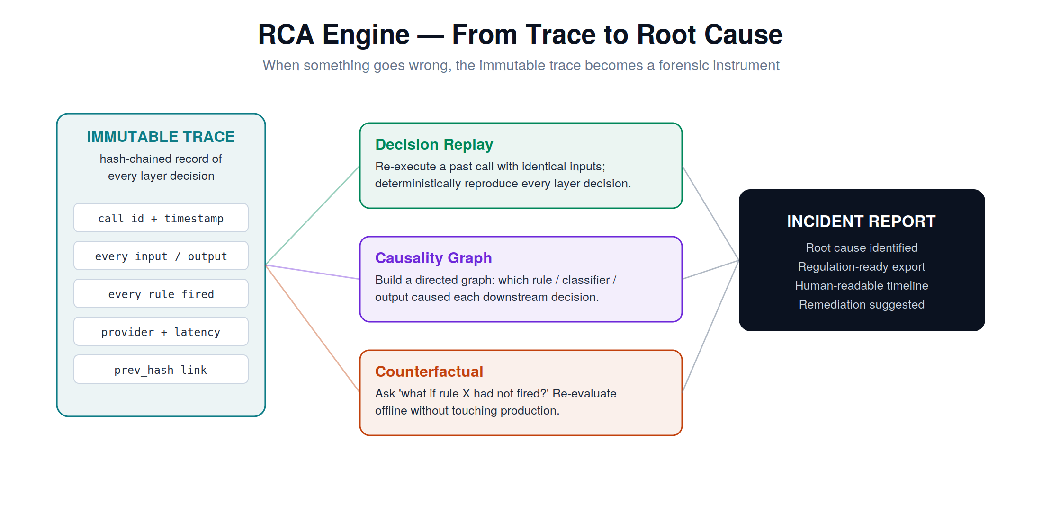
Figure 4 — The RCA engine turns an immutable trace into replay, causality, and counterfactual analysis.
rca = RCAEngine(armor.store)
rca.replay(call_id) # {'derived_from_rules':'block', 'reproducible':True, …}
rca.counterfactual(call_id, disable_rule='block_account_dump')
# {'counterfactual_verdict':'allow', 'changed':True}
rca.causality(call_id) # [CausalNode(input)->Compliance->…->output]
print(rca.incident_report(call_id)) # human-readable, regulation-ready

Public API & Quick Start
import asyncio
from veritrace import Veritrace, Verdict
from veritrace.layers import SafetyLayer, ComplianceLayer, HITLLayer, Rule
from veritrace.providers import MockProvider # or AnthropicProvider / OllamaProvider

armor = Veritrace(
provider=MockProvider(),
compliance=ComplianceLayer(standards=['HIPAA','PCI_DSS']),
safety=SafetyLayer(rules=[Rule('blk', Verdict.BLOCK, pattern=r'dump .*accounts?')]),
hitl=HITLLayer(require_approval_for=['wire_transfer'], timeout_s=300),
)
resp = asyncio.run(armor.run('Summarize notes.', tenant_id='acme', session_id='s1'))
resp.output # safe, validated output
resp.trace.this_hash # tamper-evident audit hash
resp.hitl # human-in-the-loop status

Extending Veritrace
- Add a provider: subclass BaseProvider, implement async complete(prompt) -> ProviderResult. Nothing else changes.
- Add a rule: construct a Rule with a pattern or fn and a Verdict; pass it to SafetyLayer.
- Add an audit backend: implement append(payload, prev_hash) and verify_chain(); pass to Veritrace(audit=…).
- Add an approver: supply an async callable to HITLLayer(approver=…) bridging Slack / webhook / PagerDuty.

From Description to Execution
The complete path from this document to running code:
git clone <repo> && cd veritrace
pip install -e '.[dev]' # core has zero required dependencies
python examples/demo.py # runs all six scenarios offline
pytest -q # 72 passing tests

# run as an HTTP service:
pip install -e '.[api]'
uvicorn veritrace.api.app:app --port 8000

# with persistent traces (survives restarts):
VERITRACE_DB=traces.db uvicorn veritrace.api.app:app --port 8000

# to use a real model:
pip install -e '.[anthropic]' && export ANTHROPIC_API_KEY=sk-...
# then: Veritrace(provider=AnthropicProvider())
# or fully offline/local:
pip install -e '.[ollama]' # with an Ollama daemon running llama3.2:1b

Persistence — SQLiteStore
By default, traces live in memory (MemoryStore) and are lost on restart. For any real deployment, SQLiteStore persists both the trace records and the audit hash chain to a single file. The chain head is restored on startup, so verification and RCA continue to work across restarts. SQLiteStore implements both the TraceStore and AuditBackend interfaces, so a single object replaces both in-memory defaults.
from veritrace.store import SQLiteStore

db = SQLiteStore('veritrace.db')
armor = Veritrace(
provider=AnthropicProvider(),
store=db, # persists traces to SQLite
audit=db, # persists the hash chain to the same file
)
# later, in a new process:
db = SQLiteStore('veritrace.db') # reopens the file
db.verify_chain() # True — chain survived the restart
db.get(call_id) # full TraceEvent reconstructed from JSON
The SQLite backend uses WAL mode for safe concurrent reads, indexes traces by tenant/session and creation time, and supports both list_all() and list_by_tenant() queries. The design is deliberately simple — a single file, standard library sqlite3, no external dependencies — so it works on any machine including edge deployments. Teams that need Postgres or a distributed ledger can implement the same two-method protocol (save/get for traces; append/verify_chain for audit) against their chosen backend.

Appendix A — Trace Record Schema
FOR SENIOR ENGINEERS
Every call produces one TraceEvent with the following fields. This is the contract that audit, RCA, and observability all depend on.
Field | Type | Meaning
call_id | str (uuid) | Unique identifier for the call
tenant_id / session_id | str | Isolation scope keys
created_at | float | Unix timestamp of call start
input_text / input_hash | str | Original input and its SHA-256 hash
output_text | str | Final safe output returned to caller
pii_redactions | list[str] | Labels of PII types redacted (e.g. email, ssn)
pre_verdict / post_verdict | str | Safety verdict on input / output
rules_evaluated | list[RuleResult] | Every rule, whether it fired, and its action
provider / provider_model | str | Provider name and model used
provider_cost_usd / latency_ms | float | Per-call cost and provider latency
used_fallback | bool | Whether a fallback provider served the call
hitl_status | str | not_required / auto / approved / denied / idle
layer_events | list[LayerEvent] | Ordered per-layer decisions with latencies
total_latency_ms | float | Wall-clock latency for the whole pipeline
prev_hash / this_hash | str | Hash-chain links (SHA-256)
anchor_tx_id | str | Audit anchor reference (local or external ledger)

Appendix B — Phased Roadmap
FOR TECHNICAL LEADERS
Phase | Scope | Status
Phase 1 | Core stack: Provider, Safety, Reliability, HITL, Trace, Audit (hash chain), RCA | Implemented & tested
Phase 1.5 | Context-guarded PII, Observability, SQLite persistence, FastAPI sidecar | Implemented & tested
Phase 2 | API-key auth, cross-tenant guard, encryption at rest (Fernet), retention floor + GDPR erasure | Implemented & tested
Phase 2.5 | Real isolation: injection heuristics, size limits, scope assertions; per-tenant rate limiting | Implemented & tested
Phase 3 | Real HITL adapters (Slack/PagerDuty), JWT auth with scopes, OpenTelemetry exporter, ML injection classifier | Planned
Phase 4 | Tool-call provenance, constrained action spaces, Postgres backend, multi-tenant SaaS | Planned
Phase 5 | Enterprise audit anchoring (Ethereum/Hyperledger), QuantumLayer research track | Research

The Phase-5 quantum track is a deliberate forward bet: post-quantum signatures (CRYSTALS-Dilithium) and Merkle-anchored audit trails are already feasible on classical hardware today, and quantum random number generation is available via commercial APIs. As quantum machine learning matures, the same trust stack extends to quantum inference backends with no architectural change.

Appendix C — Glossary
FOR EVERYONE
Agent | Software, usually powered by an AI model, that can take in information, make decisions, and perform actions.
LLM (Large Language Model) | The AI model that generates text, such as Claude, GPT, or Llama.
Provider | The service or software that runs an LLM. Can be a cloud API or a model running on local hardware.
Middleware | Software that sits between two systems and manages what passes between them. Veritrace is middleware between an agent and the real world.
PII | Personally Identifiable Information — data that identifies a person, such as a name, email, or social security number.
Rule engine | A set of fixed, predictable rules the system applies. Unlike the AI, its behavior is fully deterministic.
Deterministic | Always produces the same result from the same input. The opposite of the AI’s variability.
Hash / hash chain | A hash is a fixed-length fingerprint of data. A hash chain links each record’s fingerprint to the next, making tampering detectable.
HITL (Human-in-the-Loop) | A workflow where a human must approve an action before it happens.
Trace | A complete, structured record of everything that happened during one agent call.
RCA (Root Cause Analysis) | The process of determining why something went wrong, by examining the recorded trace.
Circuit breaker | A safety mechanism that stops sending requests to a failing service to prevent cascading failure.
Counterfactual | A “what if” analysis — recomputing what would have happened under different conditions.
Post-quantum cryptography | Encryption and signature methods designed to remain secure even against future quantum computers.
QRNG | Quantum Random Number Generator — produces true randomness from quantum physics, rather than a predictable algorithm.

Veritrace — Any LLM. Any industry. Any scale. Built from production scars; designed for the AI era.

