UNIT-1
- A company stores employee IDs in ascending order. Write a C program that accepts n employee IDs, searches for a required ID using Binary Search, displays its position when found, reports when it is absent, and counts the number of comparisons. Test the program for both successful and unsuccessful searches.
Source code:-
#include <stdio.h>
int main() {
int n, searchId, found = 0, comparisons = 0;
printf("Enter the number of employees: ");
scanf("%d", &n);
int empIDs[n];
printf("Enter %d employee IDs in ascending (sorted) order:\n", n);
for (int i = 0; i < n; i++) {
scanf("%d", &empIDs[i]);
}
printf("Enter the employee ID to search for: ");
scanf("%d", &searchId);
int low = 0;
int high = n - 1;
while (low <= high) {
comparisons++; // Increment comparison count for this iteration
int mid = low + (high - low) / 2;
if (empIDs[mid] == searchId) {
printf("\nEmployee ID %d found at position %d.\n", searchId, mid + 1);
found = 1;
break;
} else if (empIDs[mid] < searchId) {
low = mid + 1;
} else {
high = mid - 1;
}
}
if (!found) {
printf("\nEmployee ID %d is absent from the records.\n", searchId);
}
printf("Total number of comparisons made: %d\n", comparisons);
return 0;
}
output:-
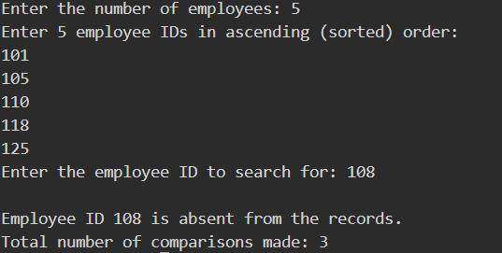

- A teacher wants to arrange student marks in ascending order and also measure how much rearrangement is necessary. Write a C program using Insertion Sort that accepts n marks, displays the array after every pass, counts the total number of element shifts, and displays the final sorted list and shift count.
Source code:-
#include <stdio.h>
void printArray(int arr[], int size) {
for (int i = 0; i < size; i++) {
printf("%d ", arr[i]);
}
printf("\n");
}
int main() {
int n, totalShifts = 0;
printf("Enter the number of students: ");
scanf("%d", &n);
int marks[n];
printf("Enter the marks of %d students:\n", n);
for (int i = 0; i < n; i++) {
scanf("%d", &marks[i]);
}
printf("\nInitial array: ");
printArray(marks, n);
printf("---------------------------------------\n");
for (int i = 1; i < n; i++) {
int key = marks[i];
int j = i - 1;

while (j >= 0 && marks[j] > key) {
marks[j + 1] = marks[j];
j--;
totalShifts++;
}
marks[j + 1] = key;
printf("After Pass %d: ", i);
printArray(marks, n);
}
printf("---------------------------------------\n");
printf("Final Sorted Marks: ");
printArray(marks, n);
printf("Total number of element shifts: %d\n", totalShifts);
return 0;
}

output:-
