A PROJECT TITLE ON
Movie Recommendation System Using Collaborative Filtering and Deep Learning

project report submitted in partial fulfilment of the requirements for the Course

MACHINE LEARNING

BACHELOR OF TECHNOLOGY
in

A.Y.: 2026-27

by

Name-Sriram roll no.-252003021

Name-vedadithya roll no. -2520030481

Under the Esteemed guidance of
joythsna mam
ASST.prof , CSE
<COUMPTER SCIENCE ENGINEERING >





DEPARTMENT OF COUMPTER SCIENCE ENGINEERING

Name of Title: Movie Recommendation System Using Collaborative Filtering and Deep Learning

- Abstract:
- The rapid growth of online streaming platforms has significantly increased the amount of digital entertainment content available to users, making it difficult to identify movies that match individual preferences. Recommendation systems have become an essential solution for improving user experience by providing personalized suggestions based on user interests and historical interactions. This project presents a Movie Recommendation System Using Collaborative Filtering and Deep Learning to generate accurate and personalized movie recommendations. The system is developed using the MovieLens 32M Latest (ml-latest) dataset, which contains information about movies, user ratings, tags, and links. The dataset is preprocessed by handling missing values, removing duplicate records, encoding user and movie identifiers, and preparing the data for model training. Two recommendation approaches are implemented: a Collaborative Filtering model using Singular Value Decomposition (SVD) as the baseline and a Neural Collaborative Filtering (NCF) model developed using TensorFlow/Keras with embedding layers to learn complex user–movie relationships. The performance of both models is evaluated using Root Mean Square Error (RMSE), Mean Absolute Error (MAE), and Mean Squared Error (MSE) to measure prediction accuracy and recommendation quality. The project also includes exploratory data analysis, feature engineering, model comparison, visualization of results, and a recommendation engine capable of generating personalized movie suggestions for users. The deep learning model is expected to capture nonlinear interactions between users and movies more effectively than the traditional collaborative filtering approach, thereby improving recommendation accuracy. The complete implementation is carried out using Google Colab, Python, TensorFlow/Keras, Scikit-learn, Surprise, Pandas, NumPy, and Matplotlib. The proposed recommendation system demonstrates the practical application of machine learning and deep learning techniques in solving real-world personalization problems and highlights how intelligent recommendation algorithms can enhance user satisfaction, increase content discovery, and support modern online entertainment platforms through efficient and accurate movie recommendations.

- INTRODUCTION:
The rapid growth of online streaming platforms has led to an unprecedented increase in the availability of digital entertainment content. While this provides users with a wide variety of choices, it also creates the challenge of information overload, making it difficult to identify movies that match individual preferences. Traditional search methods and generic recommendations often fail to capture the unique interests of each user, resulting in lower user satisfaction and reduced content discovery. Recommendation systems have therefore become an essential component of modern streaming platforms, as they analyze user behavior and historical interactions to generate personalized movie suggestions. By delivering relevant recommendations, these systems enhance user experience, reduce search time, and improve engagement with digital entertainment services.
The motivation behind this project is to develop an intelligent and accurate Movie Recommendation System Using Collaborative Filtering and Deep Learning that addresses the limitations of conventional recommendation techniques. Collaborative Filtering utilizes user rating patterns to identify similar preferences, while Deep Learning models, particularly Neural Collaborative Filtering (NCF), are capable of learning complex and nonlinear relationships between users and movies. By combining these approaches, the proposed system aims to generate highly personalized and reliable movie recommendations. The project demonstrates the practical application of machine learning and deep learning techniques in solving real-world recommendation problems, ultimately enhancing content discovery, increasing user satisfaction, and supporting the evolving needs of modern online entertainment platforms.
- SOFTWARE REQUIREMENTS:

The proposed Movie Recommendation System is developed using Google Colab as the development environment with Python as the programming language. The project utilizes machine learning and deep learning libraries such as TensorFlow/Keras, Scikit-learn, Surprise, Pandas, NumPy, and Matplotlib for data preprocessing, model training, evaluation, and visualization. The MovieLens Latest (ml-latest) dataset is used to train and evaluate the recommendation models. A computer with standard hardware specifications and a stable internet connection is sufficient to develop, train, and test the proposed system.

Category | Requirement
Operating System | Windows 10/11, Linux, or macOS
Development Environment | Google Collab
Programming Language | Python 3.x
Dataset | MovieLens 32 Latest (ml-latest)
Machine Learning Libraries | Scikit-learn, Surprise
Deep Learning Framework | TensorFlow / Keras
Data Processing Libraries | Pandas, NumPy
Visualization Library | Matplotlib
Evaluation Metrics | RMSE, MAE, MSE
Processor | Intel Core i5 or equivalent
RAM | Minimum 8 GB
Storage | Minimum 2 GB free space
Internet | Required

*Signature of the Guide Course Instructor

EDA

1. Import Libraries¶
In [35]:
import pandas as pd
import numpy as np
import seaborn as sns
import matplotlib.pyplot as plt
import os
from matplotlib.backends.backend_pdf import PdfPages
import zipfile
import io
import shutil

2. Load the Dataset¶
In [44]:
file_path = "/ml-100k.zip"
if zipfile.is_zipfile(file_path):
print(f"Detected a ZIP file: {file_path}. Extracting and loading 'u.data'...")
try:
extract_dir = "ml-100k-extracted"
os.makedirs(extract_dir, exist_ok=True)
with zipfile.ZipFile(file_path, 'r') as zip_ref:
zip_ref.extractall(extract_dir)
data_file_in_zip = os.path.join(extract_dir, 'ml-100k', 'u.data')
column_names = ['user_id', 'item_id', 'rating', 'timestamp']
df = pd.read_csv(data_file_in_zip, sep='\t', header=None, names=column_names, engine='python')
print(f"Dataset '{data_file_in_zip}' loaded successfully. First 5 rows:")
display(df.head())
print("\nDataFrame Information:")
df.info()
except FileNotFoundError:
print(f"Error: Could not find 'u.data' inside the ZIP archive or the ZIP file itself. Please ensure the ZIP contains 'ml-100k/u.data'.")
except Exception as e:
print(f"An unexpected error occurred while processing the ZIP file: {e}")
else:
try:
df = pd.read_csv(file_path)
print(f"Dataset '{file_path}' loaded successfully. First 5 rows:")
display(df.head())
print("\nDataFrame Information:")
df.info()
except FileNotFoundError:
print(f"Error: The file '{file_path}' was not found. Please ensure it's uploaded to the Colab environment.")
data = {
'StudentID': range(1, 11),
'AttendancePercent': [75, 80, 65, 90, 70, 85, 92, 78, 60, 88],
'Internships': [1, 2, 0, 3, 1, 2, 1, 0, 2, 3],
'Projects': [2, 3, 1, 4, 2, 3, 3, 1, 2, 4],
'Certifications': [1, 2, 0, 3, 1, 2, 1, 0, 2, 3],
'Publications': [0, 1, 0, 2, 0, 1, 1, 0, 1, 2],
'AptitudeTestScore': [60, 75, 50, 88, 65, 80, 90, 70, 45, 85],
'SoftSkillsRating': [3, 4, 2, 5, 3, 4, 4, 2, 3, 5],
'PlacementStatus': ['Placed', 'Placed', 'Not Placed', 'Placed', 'Not Placed', 'Placed', 'Placed', 'Not Placed', 'Not Placed', 'Placed'],
'Specialisation': ['CSE', 'ECE', 'CSE', 'IT', 'EEE', 'ECE', 'IT', 'CSE', 'EEE', 'IT']
}
df = pd.DataFrame(data)
print("Created a dummy DataFrame for demonstration.")
display(df.head())
except pd.errors.EmptyDataError:
print(f"Error: The file '{file_path}' is empty or has no columns. Please check the file content.")
except Exception as e:
print(f"An unexpected error occurred while reading the CSV: {e}")
Detected a ZIP file: /ml-100k.zip. Extracting and loading 'u.data'...
Dataset 'ml-100k-extracted/ml-100k/u.data' loaded successfully. First 5 rows:
 | user_id | item_id | rating | timestamp
0 | 196 | 242 | 3 | 881250949
1 | 186 | 302 | 3 | 891717742
2 | 22 | 377 | 1 | 878887116
3 | 244 | 51 | 2 | 880606923
4 | 166 | 346 | 1 | 886397596
DataFrame Information:
<class 'pandas.core.frame.DataFrame'>
RangeIndex: 100000 entries, 0 to 99999
Data columns (total 4 columns):
# Column Non-Null Count Dtype
--- ------ -------------- -----
0 user_id 100000 non-null int64
1 item_id 100000 non-null int64
2 rating 100000 non-null int64
3 timestamp 100000 non-null int64
dtypes: int64(4)
memory usage: 3.1 MB

Exploratory Data Analysis (EDA) for MovieLens 100k Dataset (u.data)¶

3. Basic Data Inspection and Summary Statistics¶
In [37]:
if 'df' in locals():
print("\nDataFrame Description:")
display(df.describe())
print("\nNumber of unique users and items:")
num_users = df['user_id'].nunique()
num_items = df['item_id'].nunique()
print(f"Unique Users: {num_users}")
print(f"Unique Items: {num_items}")
print("\nCheck for missing values:")
display(df.isnull().sum())
df['timestamp_dt'] = pd.to_datetime(df['timestamp'], unit='s')
print("\nDataFrame Information after timestamp conversion:")
df.info()
display(df.head())
else:
print("DataFrame 'df' not found. Please check data loading step.")
DataFrame Description:
 | user_id | item_id | rating | timestamp
count | 100000.00000 | 100000.000000 | 100000.000000 | 1.000000e+05
mean | 462.48475 | 425.530130 | 3.529860 | 8.835289e+08
std | 266.61442 | 330.798356 | 1.125674 | 5.343856e+06
min | 1.00000 | 1.000000 | 1.000000 | 8.747247e+08
25% | 254.00000 | 175.000000 | 3.000000 | 8.794487e+08
50% | 447.00000 | 322.000000 | 4.000000 | 8.828269e+08
75% | 682.00000 | 631.000000 | 4.000000 | 8.882600e+08
max | 943.00000 | 1682.000000 | 5.000000 | 8.932866e+08
Number of unique users and items:
Unique Users: 943
Unique Items: 1682
Check for missing values:
 | 0
user_id | 0
item_id | 0
rating | 0
timestamp | 0
dtype: int64
DataFrame Information after timestamp conversion:
<class 'pandas.core.frame.DataFrame'>
RangeIndex: 100000 entries, 0 to 99999
Data columns (total 5 columns):
# Column Non-Null Count Dtype
--- ------ -------------- -----
0 user_id 100000 non-null int64
1 item_id 100000 non-null int64
2 rating 100000 non-null int64
3 timestamp 100000 non-null int64
4 timestamp_dt 100000 non-null datetime64[ns]
dtypes: datetime64[ns](1), int64(4)
memory usage: 3.8 MB
 | user_id | item_id | rating | timestamp | timestamp_dt
0 | 196 | 242 | 3 | 881250949 | 1997-12-04 15:55:49
1 | 186 | 302 | 3 | 891717742 | 1998-04-04 19:22:22
2 | 22 | 377 | 1 | 878887116 | 1997-11-07 07:18:36
3 | 244 | 51 | 2 | 880606923 | 1997-11-27 05:02:03
4 | 166 | 346 | 1 | 886397596 | 1998-02-02 05:33:16

4. Distribution of Ratings¶
In [38]:
if 'df' in locals() and 'rating' in df.columns:
plt.figure(figsize=(8, 6))
sns.countplot(x='rating', data=df, hue='rating', palette='viridis', legend=False)
plt.title('Distribution of Movie Ratings', fontsize=16)
plt.xlabel('Rating')
plt.ylabel('Number of Ratings')
plt.show()
plt.close()
else:
print("DataFrame 'df' or 'rating' column not found. Cannot plot rating distribution.")
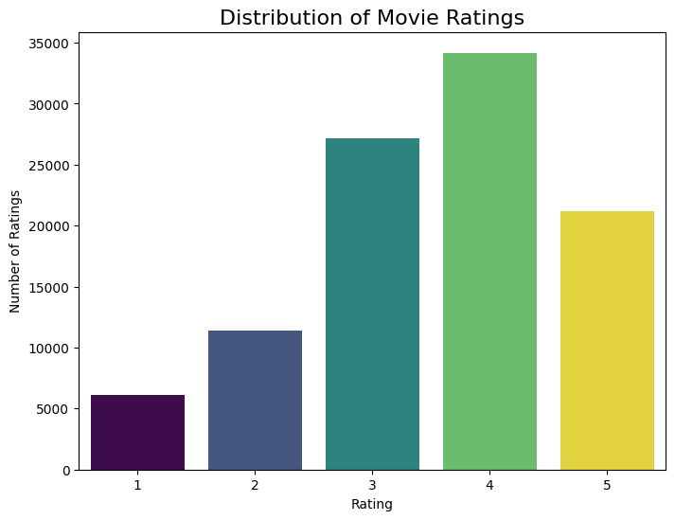

5. Top Users by Number of Ratings¶
In [39]:
if 'df' in locals() and 'user_id' in df.columns:
top_users = df['user_id'].value_counts().head(10)
print("Top 10 Users by Number of Ratings:")
display(top_users)
plt.figure(figsize=(10, 6))
sns.barplot(x=top_users.index, y=top_users.values, hue=top_users.index, palette='plasma', legend=False)
plt.title('Top 10 Users by Number of Ratings', fontsize=16)
plt.xlabel('User ID')
plt.ylabel('Number of Ratings')
plt.xticks(rotation=45)
plt.show()
plt.close()
else:
print("DataFrame 'df' or 'user_id' column not found. Cannot analyze top users.")
Top 10 Users by Number of Ratings:
 | count
user_id
405 | 737
655 | 685
13 | 636
450 | 540
276 | 518
416 | 493
537 | 490
303 | 484
234 | 480
393 | 448
dtype: int64
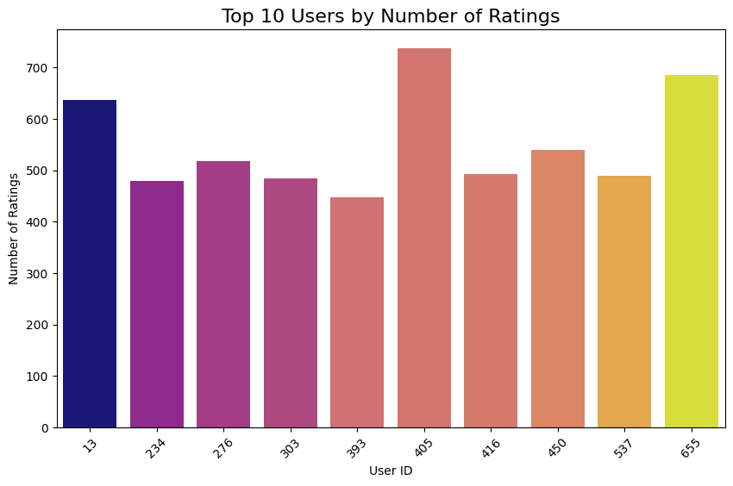

6. Top Items (Movies) by Number of Ratings¶
In [40]:
if 'df' in locals() and 'item_id' in df.columns:
top_items = df['item_id'].value_counts().head(10)
print("Top 10 Items by Number of Ratings:")
display(top_items)
plt.figure(figsize=(10, 6))
sns.barplot(x=top_items.index, y=top_items.values, hue=top_items.index, palette='magma', legend=False)
plt.title('Top 10 Items by Number of Ratings', fontsize=16)
plt.xlabel('Item ID')
plt.ylabel('Number of Ratings')
plt.xticks(rotation=45)
plt.show()
plt.close()
else:
print("DataFrame 'df' or 'item_id' column not found. Cannot analyze top items.")
Top 10 Items by Number of Ratings:
 | count
item_id
50 | 583
258 | 509
100 | 508
181 | 507
294 | 485
286 | 481
288 | 478
1 | 452
300 | 431
121 | 429
dtype: int64
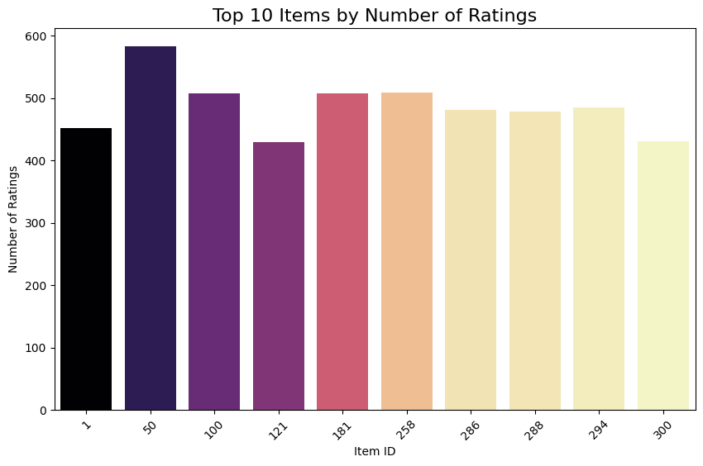

7. Average Rating per User and Item¶
In [41]:
if 'df' in locals() and 'user_id' in df.columns and 'item_id' in df.columns and 'rating' in df.columns:
avg_ratings_user = df.groupby('user_id')['rating'].mean()
print("Distribution of Average Ratings per User:")
plt.figure(figsize=(10, 6))
sns.histplot(avg_ratings_user, bins=20, kde=True, color='lightcoral')
plt.title('Distribution of Average Ratings per User', fontsize=16)
plt.xlabel('Average Rating')
plt.ylabel('Number of Users')
plt.show()
plt.close()
avg_ratings_item = df.groupby('item_id')['rating'].mean()
print("\nDistribution of Average Ratings per Item:")
plt.figure(figsize=(10, 6))
sns.histplot(avg_ratings_item, bins=20, kde=True, color='lightseagreen')
plt.title('Distribution of Average Ratings per Item', fontsize=16)
plt.xlabel('Average Rating')
plt.ylabel('Number of Items')
plt.show()
plt.close()
else:
print("DataFrame 'df' or required columns not found. Cannot analyze average ratings.")
Distribution of Average Ratings per User:
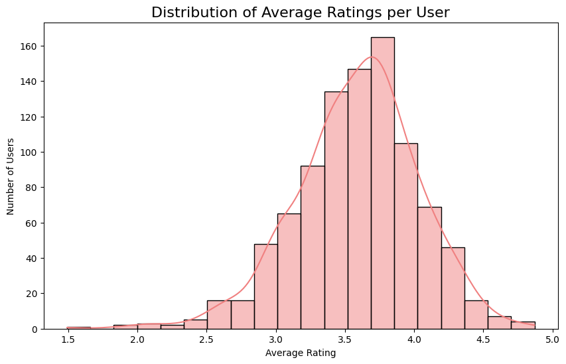
Distribution of Average Ratings per Item:
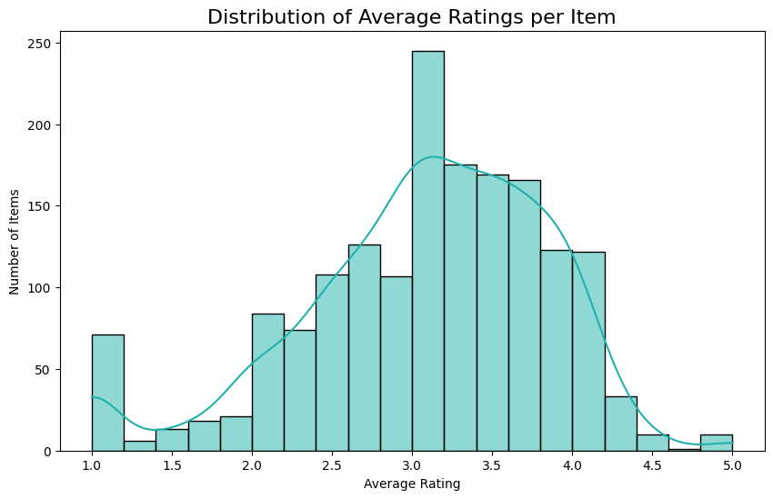

8. Ratings over Time¶
In [42]:
if 'df' in locals() and 'timestamp_dt' in df.columns:
ratings_over_time = df.set_index('timestamp_dt').resample('ME')['rating'].count()
print("Number of Ratings Over Time (Monthly):")
plt.figure(figsize=(12, 6))
ratings_over_time.plot(kind='line', color='darkblue')
plt.title('Number of Ratings Over Time (Monthly)', fontsize=16)
plt.xlabel('Date')
plt.ylabel('Number of Ratings')
plt.grid(True)
plt.tight_layout()
plt.show()
plt.close()
else:
print("DataFrame 'df' or 'timestamp_dt' column not found. Cannot analyze ratings over time.")
Number of Ratings Over Time (Monthly):
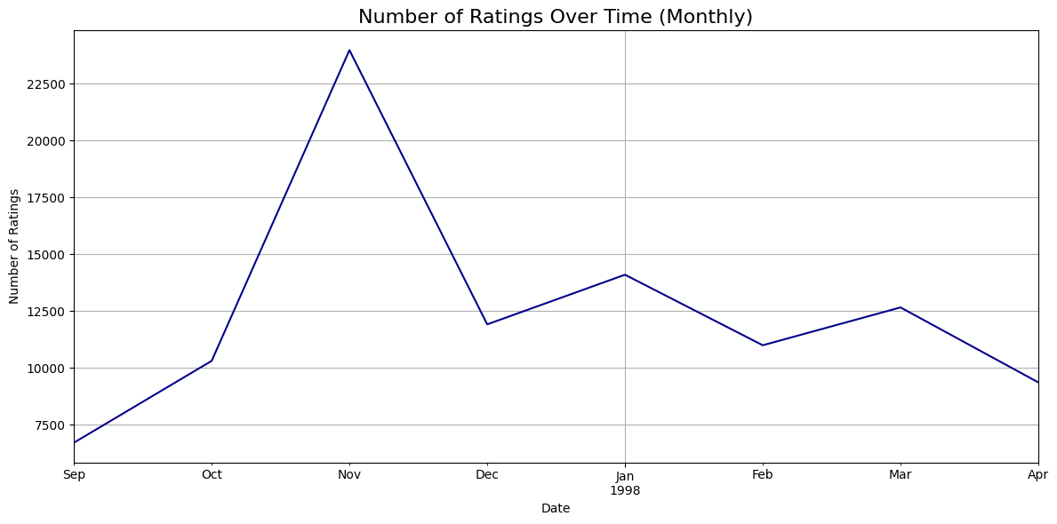

9. Save Main Figures into a PDF Report for MovieLens¶
In [43]:
if 'df' in locals():
pdf_filename_movielens = "MovieLens_EDA_Report.pdf"
with PdfPages(pdf_filename_movielens) as pdf:
if 'rating' in df.columns:
fig_rating_dist = plt.figure(figsize=(8, 6))
sns.countplot(x='rating', data=df, hue='rating', palette='viridis', legend=False)
plt.title('Distribution of Movie Ratings', fontsize=16)
plt.xlabel('Rating')
plt.ylabel('Number of Ratings')
pdf.savefig(fig_rating_dist)
plt.close(fig_rating_dist)
if 'user_id' in df.columns:
top_users = df['user_id'].value_counts().head(10)
fig_top_users = plt.figure(figsize=(10, 6))
sns.barplot(x=top_users.index, y=top_users.values, hue=top_users.index, palette='plasma', legend=False)
plt.title('Top 10 Users by Number of Ratings', fontsize=16)
plt.xlabel('User ID')
plt.ylabel('Number of Ratings')
plt.xticks(rotation=45)
plt.tight_layout()
pdf.savefig(fig_top_users)
plt.close(fig_top_users)
if 'item_id' in df.columns:
top_items = df['item_id'].value_counts().head(10)
fig_top_items = plt.figure(figsize=(10, 6))
sns.barplot(x=top_items.index, y=top_items.values, hue=top_items.index, palette='magma', legend=False)
plt.title('Top 10 Items by Number of Ratings', fontsize=16)
plt.xlabel('Item ID')
plt.ylabel('Number of Ratings')
plt.xticks(rotation=45)
plt.tight_layout()
pdf.savefig(fig_top_items)
plt.close(fig_top_items)
if 'user_id' in df.columns and 'rating' in df.columns:
avg_ratings_user = df.groupby('user_id')['rating'].mean()
fig_avg_user_rating = plt.figure(figsize=(10, 6))
sns.histplot(avg_ratings_user, bins=20, kde=True, color='lightcoral')
plt.title('Distribution of Average Ratings per User', fontsize=16)
plt.xlabel('Average Rating')
plt.ylabel('Number of Users')
plt.tight_layout()
pdf.savefig(fig_avg_user_rating)
plt.close(fig_avg_user_rating)
if 'item_id' in df.columns and 'rating' in df.columns:
avg_ratings_item = df.groupby('item_id')['rating'].mean()
fig_avg_item_rating = plt.figure(figsize=(10, 6))
sns.histplot(avg_ratings_item, bins=20, kde=True, color='lightseagreen')
plt.title('Distribution of Average Ratings per Item', fontsize=16)
plt.xlabel('Average Rating')
plt.ylabel('Number of Items')
plt.tight_layout()
pdf.savefig(fig_avg_item_rating)
plt.close(fig_avg_item_rating)
if 'timestamp_dt' in df.columns:
ratings_over_time = df.set_index('timestamp_dt').resample('ME')['rating'].count()
fig_ratings_time = plt.figure(figsize=(12, 6))
ratings_over_time.plot(kind='line', color='darkblue')
plt.title('Number of Ratings Over Time (Monthly)', fontsize=16)
plt.xlabel('Date')
plt.ylabel('Number of Ratings')
plt.grid(True)
plt.tight_layout()
pdf.savefig(fig_ratings_time)
plt.close(fig_ratings_time)
print(f"All main figures saved to '{pdf_filename_movielens}'")
else:
print("DataFrame 'df' not found. Cannot generate PDF report.")
All main figures saved to 'MovieLens_EDA_Report.pdf'

