SMART COMPLAINT DSA TRACKER
A Project Report Submitted in the partial fulfillment of the requirements for the award of the degree of
BACHELOR OF TECHNOLOGY
in
DEPARTMENT OF COMPUTER SCIENCE ENGINEERING
by
SRIRAM – 2520030218
CHANDRIKA – 2520030047
VEDADITHYA – 2520030481
Under the Guidance of
Dr. V. Sireesha
Professor
Department of Computer Science and Engineering
2026–27

DEPARTMENT OF COMPUTER SCIENCE ENGINEERING
DECLARATION
The Project Report entitled “Smart Complaint DSA Tracker” is a record of bonafide work of SRIRAM – 2520030218, CHANDRIKA – 2520030047 and VEDADITHYA – 2520030481, submitted in partial fulfillment for the award of B. Tech in Computer Science and Engineering. The work presented in this report describes the design and implementation of a file-based enterprise complaint management system built in pure Java 21 with custom data structures and algorithms, no external libraries and no database. The results embodied in this report have not been copied from any other department, university or institute.
SRIRAM – 2520030218
CHANDRIKA – 2520030047
VEDADITHYA – 2520030481

DEPARTMENT OF COMPUTER SCIENCE ENGINEERING
CERTIFICATE
This is to certify that the project report entitled “Smart Complaint DSA Tracker” is a bonafide work done and submitted by SRIRAM – 2520030218, CHANDRIKA – 2520030047 and VEDADITHYA – 2520030481 in partial fulfillment of the requirements for the award of the degree of BACHELOR OF TECHNOLOGY in Computer Science and Engineering during the academic year 2026–27.
Signature of the Guide Signature of the HOD
(Dr. V. Sireesha)

ACKNOWLEDGEMENT
We express our sincere gratitude to our guide, Dr. V. Sireesha, Professor, Department of Computer Science and Engineering, for her valuable guidance, suggestions, and continuous support throughout the development of the Smart Complaint DSA Tracker project.
We also express our sincere thanks to Dr. P. Venkateswara Rao, Associate Professor and HOD, Department of Computer Science and Engineering, for providing the necessary academic support and facilities for completing this project.
We are grateful to the Department of Computer Science and Engineering for providing an environment that enabled us to apply Data Structures and Algorithms to a practical complaint-management problem.
Finally, we thank all the team members for their cooperation and contribution in algorithm implementation, custom data structure development, Java Swing interface design, testing, documentation, and presentation.
SRIRAM – 2520030218
CHANDRIKA – 2520030047
VEDADITHYA – 2520030481

ABSTRACT
The Smart Complaint DSA Tracker is a Java-based Data Structures and Algorithms application developed to receive, prioritise, assign, track and analyse service complaints. It is a file-based enterprise complaint management system written in pure Java 21 with zero external libraries and zero database; all information is stored in ten human-readable flat files under project/data/.
The system integrates seven algorithm engines: Aho-Corasick, KMP and Rabin-Karp string matching for real-time hazard detection; binary max-heap and min-heap structures for priority triage and SLA monitoring; Hopcroft-Karp matching and Min-Cost Max-Flow for staff dispatch; Wagner-Fischer Levenshtein distance for duplicate detection; a suffix array with Kasai’s LCP array for root-cause clustering; Graham’s LPT, Held-Karp bitmask dynamic programming and metric TSP approximation for scheduling and routing; and Fork/Join tree reduction with the Blelloch prefix-sum scan for parallel analytics.
All containers are handcrafted: nine custom data structures replace the java.util collections. A Java Swing and AWT interface with a custom dark design system provides a Main Portal Launcher, a Customer Portal for registration, login, complaint submission, timeline tracking, feedback and notifications, and an Organization Portal with role-based Admin and Staff login, KPI cards, queue tools, search and filters, and a table showing the DSA strategy applied to every ticket.
Writes are committed to temporary files and then atomically renamed, delimiter escaping preserves multiline text, and a BackupManager takes timestamped backups with one-click restore. The system passed 13 of 13 unit and integration tests with a 100% success rate across restart cycles, and it meets all six course outcomes (CO1–CO6) of the Advanced DSA curriculum.

TABLE OF CONTENTS
CHAPTER 1 - INTRODUCTION
1.1 Overview
1.2 Problem Statement
1.3 Scope of the Project
1.4 Objectives
CHAPTER 2 - SYSTEM REQUIREMENTS
2.1 Functional Requirements
2.2 Non-Functional Requirements
2.3 Software and Hardware Requirements
2.4 Data Storage Requirements
CHAPTER 3 - SYSTEM DESIGN
3.1 High-Level Architecture
3.2 Data and Component Description
3.3 Complaint Lifecycle Design
3.4 DSA and CO Mapping
3.5 Data File Design
CHAPTER 4 - IMPLEMENTATION
4.1 Module-Wise Implementation
4.2 Pseudocode
4.3 Java Swing Interface
4.4 Project Structure and Development Environment
CHAPTER 5 - RESULTS
5.1 Testing Strategy
5.2 Functional Results
5.3 GUI Results
5.4 Complexity Analysis
CHAPTER 6 - CHALLENGES & LIMITATIONS
6.1 Issues Faced During Development
6.2 Solutions Applied
6.3 Limitations
CHAPTER 7 - CONCLUSION & FUTURE WORK
7.1 Conclusion
7.2 Future Work
7.3 Skills Learned
REFERENCES

LIST OF FIGURES
Fig. 1.1 Overview of the Smart Complaint DSA Tracker System
Fig. 3.1 High-Level Architecture of the Smart Complaint DSA Tracker
Fig. 3.2 Complaint Lifecycle Flowchart
Fig. 4.1 Project Workspace in VS Code
Fig. 4.2 Project Folder Structure and Source Files
Fig. 5.1 Main Portal Launcher
Fig. 5.2 Customer Portal — Login and New Registration
Fig. 5.3 Organization Portal — Administrator Dashboard and Complaint Table

CHAPTER 1 - INTRODUCTION

1.1 Overview
Smart Complaint DSA Tracker is a Data Structures and Algorithms project that applies different algorithmic techniques to the problem of receiving, prioritising, assigning, tracking and analysing complaints. The project combines string matching, binary heaps, graph matching and network flow, dynamic programming, suffix arrays, approximation algorithms, and parallel processing within a single application. It is described on its launcher screen as a “File-Based Enterprise Complaint Management System” that runs offline in pure Java with zero database, flat-file storage, and an advanced DSA engine.
The application is written in Java 21 with zero external libraries and zero database. All of its data lives in human-readable text files under project/data/. When the program starts, the records are loaded and organised into custom data structures so that searching, ranking and assignment operations can work on structured information instead of repeatedly processing raw text files.
Each complaint ticket stores important information such as:
• tracking ID, customer, title and description;
• category and department;
• priority, status and escalation level;
• assigned staff member and SLA deadline;
• history, responses, feedback and notifications.
One of the important features of the system is real-time hazard detection. An Aho-Corasick automaton scans complaint text while it is typed. When keywords such as “fire”, “spark”, “gas leak” or “explosion” are detected, the system automatically tags the category and escalates the priority, so a life-threatening hazard does not wait in an ordinary queue.
Complaints are kept in order of urgency by two binary heaps. A max-heap ranks tickets by an urgency score, and a min-heap implements earliest-deadline-first ordering of SLA breach timers. Unassigned tickets are matched to technicians using Hopcroft-Karp matching and Min-Cost Max-Flow, which respect department skill and per-technician capacity.
The application also supports duplicate and pattern analysis. When two users describe the same problem in different words, Wagner-Fischer Levenshtein distance measures how similar the texts are and flags them so an administrator can merge them. A suffix array with Kasai’s LCP array looks across all ticket text for recurring phrases, so that many separate tickets can be traced to one root cause.
For planning, the project offers Graham’s LPT scheduling, exact Held-Karp inspection routes for small sets of tasks, and a metric TSP 2-approximation for large areas. Dashboards use a Fork/Join parallel tree reduction and the Blelloch prefix-sum scan to compute analytics across several CPU cores.
The user-facing part of the application is provided through a Java Swing and AWT graphical interface with a custom dark design system. The Main Portal Launcher opens either a Customer Portal or an Organization Portal, so customers and administrators can use the DSA functionality without interacting directly with the individual algorithm implementations.
The overall system demonstrates how several individual Data Structures and Algorithms can be integrated into a practical application. Rather than using one algorithm for every operation, the project uses a different technique according to the nature of each problem.
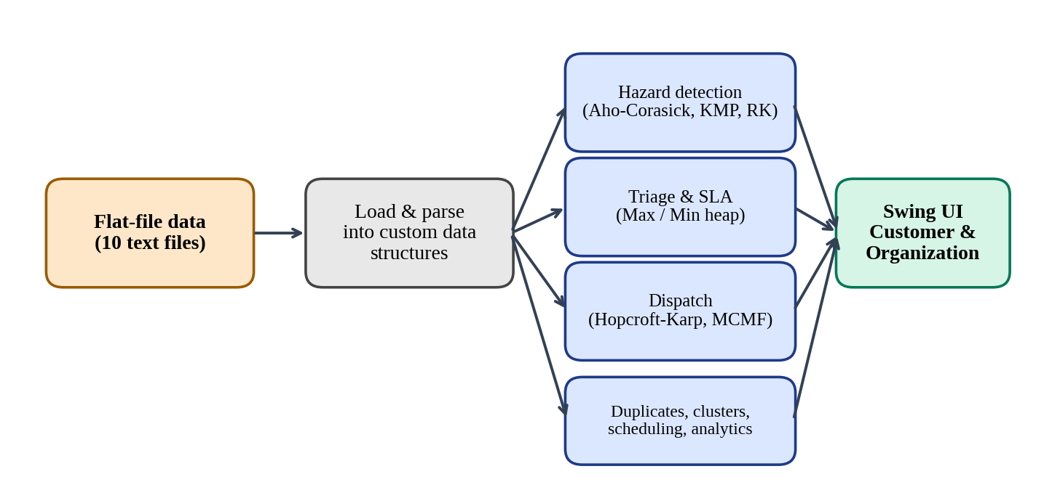
Fig. 1.1 Overview of the Smart Complaint DSA Tracker System
The system begins with the flat data files, followed by loading and parsing into custom data structures. The prepared data is then used by the hazard-detection, triage, dispatch, duplicate-detection, clustering, scheduling and analytics components. The results are presented to the user through the Java Swing interface.

1.2 Problem Statement
Traditional enterprise ticketing systems lean on heavy third-party dependencies and black-box relational databases. When a large number of complaints arrive, a simple first-come-first-served queue is not enough. A customer may report the same fault that another customer has already reported, so near-identical tickets pile up. A complaint that describes a fire or a gas leak must be handled immediately, but a plain queue cannot recognise the danger in the text.
Another challenge is fair assignment. Technicians have different skills and different capacity, and assigning tickets arbitrarily overloads some people while others are idle. Service deadlines add to the pressure, because the ticket closest to its SLA breach must be visible first.
Finally, a single complaint rarely reveals a systemic fault. For example, twenty separate tickets may all describe the same transformer failure, but each one looks like an isolated incident unless the text of all tickets is analysed together.
Therefore, the project addresses the problem of developing a complaint-management application that combines multiple Data Structures and Algorithms to filter duplicates, detect threats in real time, dispatch work fairly, and uncover root causes, using only fundamental computer science concepts. The major requirements addressed by the project include:
• spam and duplicate filtering;
• real-time hazard detection and escalation;
• priority triage and SLA monitoring;
• fair, skill-based workload dispatch;
• root-cause clustering;
• maintenance scheduling and inspection routing;
• parallel analytics;
• reliable file-based storage without a database.
The project also aims to provide a graphical interface through Java Swing so that the implemented algorithms can be used through a simple, role-based desktop application.

1.3 Scope of the Project
The scope of the Smart Complaint DSA Tracker covers the development of a Java-based complaint-management application using multiple Data Structures and Algorithms.
The project includes a Customer Portal with login and registration, multi-field ticket submission, a real-time hazard detector, a step-by-step graphical timeline, 1–5 star feedback and an in-app notification center. It also includes an Organization Portal with role-based Admin and Staff login, an operations dashboard with KPI cards, queue tools, search and filtering, duplicate detection and merging, and a systemic pattern cluster analyzer.
The scope includes seven algorithm engines: hazard detection (Aho-Corasick, KMP, Rabin-Karp and the Z-algorithm), priority and SLA monitoring (binary heaps), staff dispatch (Hopcroft-Karp and Min-Cost Max-Flow), the duplicate blocker (Wagner-Fischer Levenshtein distance), root-cause clustering (suffix array and Kasai LCP), scheduling and routing (Graham LPT, Held-Karp and metric TSP), and parallel analytics (Fork/Join and Blelloch scan).
The scope further includes nine handcrafted data structures, and zero-database flat-file persistence with ten data files, atomic writes, delimiter escaping and automated backups. Testing is also included within the scope: 13 unit and integration tests verify the engines and the persistence across restart cycles. The scope therefore covers the complete flow from data loading and algorithmic processing to user interaction and result presentation.

1.4 Objectives
The main objectives of the Smart Complaint DSA Tracker project are as follows:
1. To develop a Java-based complaint-management application that handles the whole complaint lifecycle from submission to feedback.
2. To prevent duplicate tickets from overwhelming departments by detecting near-identical complaints with Levenshtein distance and allowing administrators to merge them.
3. To implement Aho-Corasick, KMP and Rabin-Karp string matching and use them to detect hazard keywords as a complaint is typed.
4. To keep every dashboard sorted by urgency using a binary max-heap and to track SLA breach deadlines using a binary min-heap.
5. To assign complaints to technicians fairly by department skill and capacity using Hopcroft-Karp matching and Min-Cost Max-Flow.
6. To discover recurring phrase patterns across many tickets using a suffix array and Kasai’s LCP array, so that a root cause can be identified.
7. To plan maintenance work using Graham’s LPT, Held-Karp bitmask dynamic programming, and a metric TSP 2-approximation.
8. To compute dashboard analytics in parallel using Fork/Join tree reduction and the Blelloch prefix-sum scan.
9. To build nine data structures from scratch without java.util collections.
10. To store all data in flat files with atomic writes, delimiter escaping and automated backups, without any database.
11. To provide a Java Swing graphical interface with separate Customer and Organization portals.
12. To analyse the complexity of the implemented algorithms and understand their computational requirements.
13. To integrate different DSA techniques into one application, demonstrating how algorithms are selected according to different computational requirements.
14. To test the major functionality using unit and integration tests and verify the results across restart cycles.

CHAPTER 2 - SYSTEM REQUIREMENTS

2.1 Functional Requirements
Functional requirements describe the operations and services that the Smart Complaint DSA Tracker is expected to provide. The system combines data loading, hazard detection, triage, dispatch, duplicate detection, clustering, planning, analytics and graphical interaction. The following functional requirements define the expected behaviour of the application.

2.1.1 Data Loading
The system shall load its records from the ten flat files under project/data/: complaints, customers, staff, departments, history, responses, assignments, feedback, notifications and users. The data shall be read during start-up and made available to every engine, so the files are not repeatedly read for every operation.

2.1.2 Customer Registration and Login
The system shall allow a new customer to register and an existing customer to log in with a username or account ID and a password. After a successful login the customer shall be taken to the customer dashboard.

2.1.3 Role-Based Organization Login
The system shall provide a separate login for the Organization Portal with the roles Admin and Staff. The portal shall display the logged-in user and role and shall provide a logout option.

2.1.4 Multi-Field Complaint Submission
The system shall let a customer submit a complaint with several fields such as title, description and category. Each ticket shall receive a tracking ID and shall be stored in the complaint file.

2.1.5 Real-Time Hazard Detection
The system shall scan the complaint text as it is typed using the Aho-Corasick automaton. If a hazard keyword such as “fire”, “spark”, “gas leak” or “explosion” is found, the system shall tag the category and raise the priority automatically.

2.1.6 Pattern Matching Support
The system shall implement KMP, the Z-algorithm and Rabin-Karp as additional exact-matching techniques. KMP and Z shall search complaint descriptions in linear time without backtracking, and Rabin-Karp shall use a rolling hash to scan long text logs.

2.1.7 Priority Triage
The system shall rank complaints live using a binary max-heap with the urgency score Score = (Priority × 25) + (Affected × 0.8) + Overdue Boost, so that the highest-urgency complaint is always available first.

2.1.8 SLA Monitoring
The system shall track SLA deadlines with a binary min-heap using earliest-deadline-first ordering, so that the ticket closest to its SLA breach is shown at the top of the technician dashboard.

2.1.9 Staff Dispatch
The system shall match unassigned complaints with eligible technicians by department skill and shall respect each technician’s workload capacity. Hopcroft-Karp matching and Min-Cost Max-Flow shall be used.

2.1.10 Duplicate Detection and Merging
The system shall compute Levenshtein edit distance between complaint texts, flag near-identical complaints for admin review, and allow an administrator to merge duplicates into a single record with combined history.

2.1.11 Search Suggestions
The system shall use the edit-distance engine to offer “Did you mean?” suggestions and shall provide search and filtering of tickets by text, status, priority and category.

2.1.12 Root-Cause Clustering
The system shall index all complaint text in a suffix array, compute the LCP array with Kasai’s algorithm, and report recurring phrases that appear across many tickets as systemic pattern clusters.

2.1.13 Maintenance Scheduling and Routing
The system shall schedule maintenance tasks across technicians with Graham’s LPT, compute exact inspection routes for up to 12 critical tasks with Held-Karp bitmask dynamic programming, and use a metric TSP 2-approximation for larger areas.

2.1.14 Parallel Analytics
The system shall compute dashboard analytics on multiple cores using ForkJoinPool. A parallel tree reduction shall produce average, minimum and maximum resolution time, and the Blelloch prefix-sum scan shall produce cumulative daily ticket trends.

2.1.15 Status Timeline, Feedback and Notifications
The system shall show each customer a step-by-step graphical timeline of the complaint, accept a 1–5 star rating and feedback, and deliver in-app notifications when the status of a complaint changes.

2.1.16 Escalation and Archiving
The system shall record the escalation level of each ticket (for example Level 0 and Level 1) and shall archive resolved tickets using the parallel merge-sort strategy shown in the DSA Strategy column of the dashboard.

2.1.17 Persistence and Backup
The system shall store all changes in the flat files using atomic writes, shall escape delimiters so multiline text is preserved, and shall take timestamped backups that can be restored with one click.

2.1.18 Java Swing Graphical Interface
The system shall provide a Java Swing and AWT graphical user interface with a Main Portal Launcher, a Customer Portal and an Organization Portal. The interface shall act as the interaction layer while the core DSA operations remain in the engine classes.

2.2 Non-Functional Requirements
Non-functional requirements describe the quality characteristics and operational expectations of the Smart Complaint DSA Tracker. These requirements focus on usability, performance, scalability, reliability, maintainability, portability and independence from external libraries.

2.2.1 Usability
The application should provide a simple, role-based interface that can be used without understanding the internal algorithms. The dark design system in AppTheme.java keeps colours, fonts and component styles consistent. The dashboard should show KPI cards, a filterable table, and clear messages so that users know what action is required.

2.2.2 Performance
Hazard detection should respond while the customer is typing; a hazardous complaint is tagged critical in under one millisecond. Priority and SLA operations should use heaps so that insertion and extraction take logarithmic time. Records are loaded once at start-up and reused by every engine.

2.2.3 Scalability
The structure of the system should remain the same as the number of tickets grows. Parallel analytics use ForkJoinPool with O(N) work and O(log N) span, and the algorithms were chosen for good asymptotic bounds, such as O(E√V) for Hopcroft-Karp and O(N log N) for Graham’s LPT.

2.2.4 Reliability
Every write must be committed to a temporary file and atomically renamed so that a sudden termination does not corrupt the data. Results should stay consistent across restart cycles, and invalid or empty input should be handled without unexpected termination.

2.2.5 Maintainability
The algorithm engines, data structures, persistence classes and Swing interface should be organised as separate parts of the code, with a shared theme class. The nine custom data structures are reusable and can be tested independently.

2.2.6 Portability
The project uses only standard Java 21 and Java Swing, and it runs on any system with Java 17 or 21. It is started with java -cp bin Main or run.bat, and no installation of libraries, build tools or a database server is needed.

2.2.7 Data Consistency
Records must keep a consistent structure so that the loader can associate each field with the right ticket. Delimiter escaping converts tabs and newlines inside text, so multiline complaints cannot break record boundaries.

2.2.8 Independence
The project uses zero external libraries, zero database and zero java.util collections in its custom containers. This keeps every operation understandable and demonstrates the algorithms from first principles.

2.2.9 Extensibility
Because the engines and the interface are kept separate, new features such as additional notification channels or new analytics can be introduced without redesigning the entire application.

2.3 Software and Hardware Requirements
The project requires a Java Development Kit (Java 17 or Java 21; the project is written in Java 21). No external libraries, build tools or database server are needed. The program is compiled with the provided build.bat into a bin folder and started with java -cp bin Main in PowerShell or run.bat in Command Prompt. VS Code was used as the development environment.
The application is a desktop program, so any computer that can run a Java Swing interface is sufficient. The parallel analytics use all available CPU cores through ForkJoinPool.

2.4 Data Storage Requirements
All data lives in human-readable text files under project/data/. There are ten flat files, listed below. Tabs and newlines inside text fields are escaped (\t becomes \\t and \n becomes \\n) so that multiline complaint text does not break record boundaries.
Flat file | Purpose
complaints | Ticket records: ID, title, category, priority, status, deadline
customers | Registered customer accounts
staff | Technicians, their department skill and capacity
departments | Departments handling each complaint category
history | Chronological record of every ticket event
responses | Replies given on tickets
assignments | Ticket-to-technician assignments
feedback | 1–5 star ratings and comments
notifications | In-app notifications for customers
users | Login accounts and roles

A BackupManager takes timestamped point-in-time backups of these files that can be restored with one click.

CHAPTER 3 - SYSTEM DESIGN

3.1 High-Level Architecture
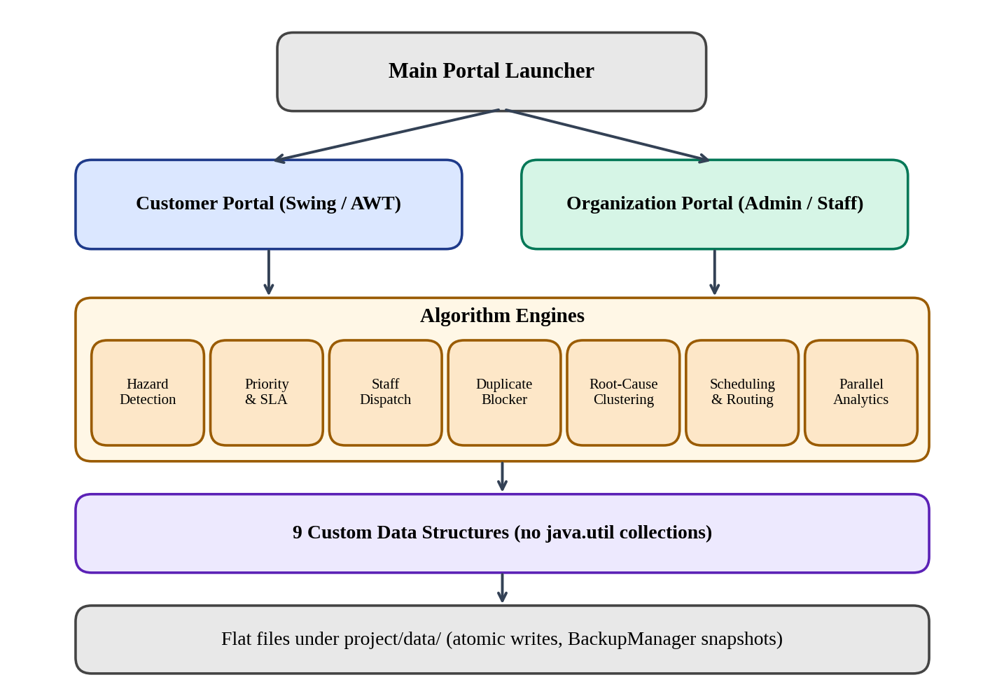
Fig. 3.1 High-Level Architecture of the Smart Complaint DSA Tracker
The high-level architecture describes the major components of the application and the flow of information between the flat files, custom data structures, algorithm engines and Java Swing interface. The architecture is designed to separate data storage, algorithm execution and user interaction so that each component has a clear responsibility.
The system begins with the ten flat data files under project/data/. During start-up the records are loaded and parsed, and the information is stored in the custom data structures so that it can be accessed by the different operations of the application without repeatedly reading the files.
The central layer of the architecture is the set of seven algorithm engines. The hazard-detection engine uses Aho-Corasick, KMP and Rabin-Karp. The priority and SLA engine uses a binary max-heap and min-heap. The dispatch engine uses Hopcroft-Karp matching and Min-Cost Max-Flow. The duplicate blocker uses Wagner-Fischer Levenshtein distance. The clustering engine uses a suffix array and Kasai’s LCP array. The scheduling and routing engine uses Graham’s LPT, Held-Karp and metric TSP. The analytics engine uses Fork/Join and the Blelloch scan.
Below the engines are the nine handcrafted data structures, which provide the containers used throughout the program, and below them the flat-file persistence layer with atomic writes and backups.
The Java Swing and AWT interface forms the user-facing layer. A Main Portal Launcher opens either the Customer Portal or the Organization Portal. Both portals call the same engines and read and write the same files, so a complaint submitted by a customer is immediately available to the organization, and the organization’s updates reach the customer’s timeline and notification center. The interface does not duplicate the algorithm implementations; it calls the engines and displays the results.

3.2 Data and Component Description

3.2.1 Algorithm Engines
The algorithm engines contain the DSA logic of the project:
• hazard detection (Aho-Corasick, KMP, Z-algorithm, Rabin-Karp)
• priority triage and SLA monitoring (max-heap and min-heap)
• staff dispatch (Hopcroft-Karp and Min-Cost Max-Flow with SPFA)
• duplicate blocker (Wagner-Fischer Levenshtein)
• root-cause clustering (suffix array and Kasai LCP)
• scheduling and routing (Graham LPT, Held-Karp, metric TSP)
• parallel analytics (Fork/Join tree reduction and Blelloch scan)
Table 3.1 Mapping of Features to Algorithm Engines
Section | Feature | Algorithms | Complexity
A | Hazard detection and search | Aho-Corasick, KMP / Z-function, Rabin-Karp | O(N+M+Z) Aho-Corasick; O(N+M) KMP / Z; O(N+M) average Rabin-Karp
B | Priority triage and SLA monitoring | Binary max-heap, binary min-heap (EDF) | O(log N) per operation
C | Staff dispatch and workload balance | Hopcroft-Karp matching, Min-Cost Max-Flow (SSP with SPFA) | O(E√V) matching; O(F·V·E) worst case for MCMF
D | Duplicate blocker and suggestions | Wagner-Fischer Levenshtein distance | O(N × M)
E | Root-cause clustering | Suffix array with Kasai LCP | O(N log²N) build, O(N) Kasai LCP and query
F | Scheduling and maintenance planning | Graham's LPT, Held-Karp bitmask DP, metric TSP (MST doubling) | O(N log N), 4/3-approx.; O(2ᴺN²) exact; 2-approx.
- | Parallel analytics | Fork/Join tree reduction, Blelloch prefix sum | Work O(N), span O(log N)

3.2.2 Custom Data Structures
Nine data structures are built from scratch: CustomArrayList, CustomLinkedList, CustomStack, CustomQueue, CustomPriorityQueue, CustomHashTable, CustomTrie, CustomGraph and CustomDisjointSetUnion. Their roles are described in Chapter 4.

3.2.3 Swing Interface Classes
The interface contains the Main Portal Launcher, the Customer Portal window with its Customer Login and New Registration tabs, and the Organization Portal window with the KPI cards, queue buttons, search and filter controls and the complaint table. AppTheme.java defines the shared dark design system used by all windows.

3.2.4 Persistence Classes
The persistence layer reads and writes the ten flat files, performs atomic writes through temporary files, escapes delimiters, and includes the BackupManager for timestamped backups and one-click restore.

3.3 Complaint Lifecycle Design
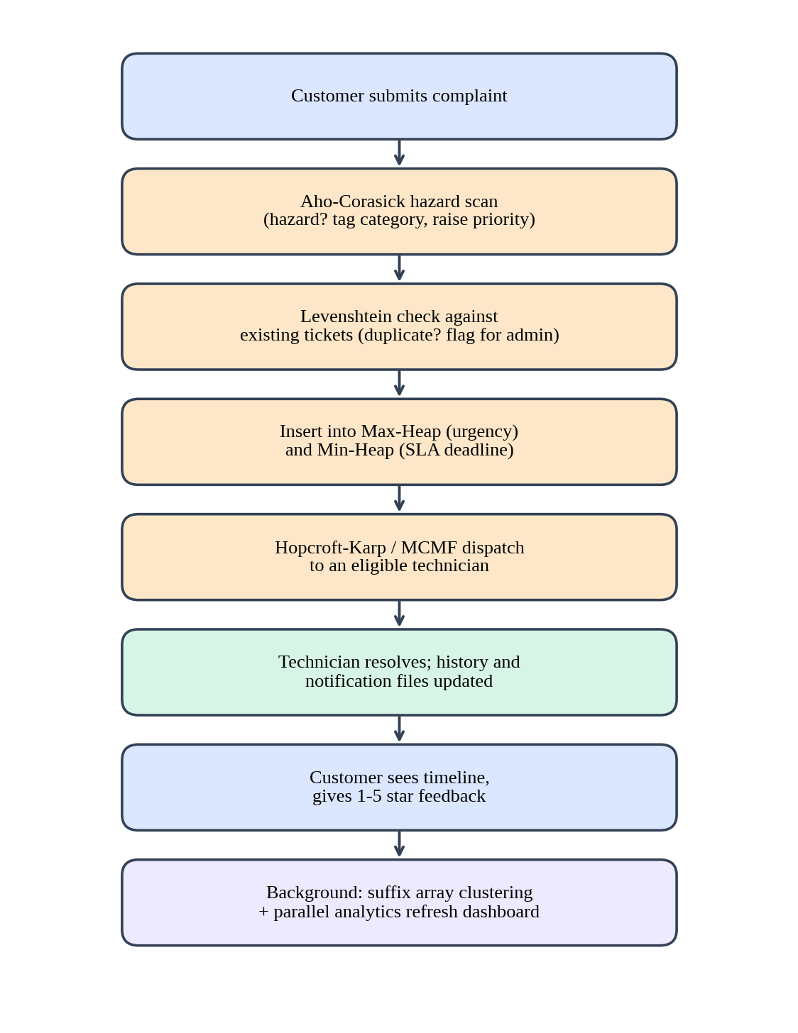
Fig. 3.2 Complaint Lifecycle Flowchart
A customer submits a complaint through the Customer Portal. While the text is being typed, the Aho-Corasick automaton scans it and, if a hazard keyword is found, tags the category and raises the priority. The complaint is then checked against existing tickets by Levenshtein distance, and likely duplicates are flagged for admin review.
The ticket is placed into the max-heap triage queue and the min-heap SLA queue. The dispatch engine matches it with an eligible technician, and the history and notification files record each step so that the customer sees the progress on the graphical timeline. After resolution the customer gives a 1–5 star rating.
In the background, the suffix-array engine looks for recurring phrases across all tickets, and the parallel analytics engine refreshes the dashboard numbers. Every write goes to a temporary file first and is then atomically renamed.

3.4 DSA and CO Mapping
The following table maps each course outcome to the techniques implemented in the project.
CO | Implementation in the project
CO1 | Problem strategy classification: choosing heaps, hash tables, graphs and tries according to the problem; complexity analysis
CO2 | String algorithms: Aho-Corasick, KMP, Z-algorithm, Rabin-Karp, suffix array with Kasai LCP
CO3 | Dynamic programming: Wagner-Fischer Levenshtein distance, Held-Karp bitmask DP
CO4 | Network flow: Hopcroft-Karp matching, Min-Cost Max-Flow (SPFA)
CO5 | Approximation and NP theory: Graham LPT (4/3), metric TSP by MST doubling (2)
CO6 | Randomised and parallel computing: Fork/Join tree reduction, Blelloch prefix sum

3.5 Data File Design
Each flat file stores one record per line, with fields separated by a tab character. Tabs and newlines inside field text are escaped so that a multiline complaint remains a single record. The complaints file holds the ticket data, while the history, responses, assignments, feedback and notifications files link to tickets through the tracking ID. This design lets the system keep related information in separate, human-readable files without any database.

CHAPTER 4 - IMPLEMENTATION

4.1 Module-Wise Implementation
Module 1 — Hazard Detection (Aho-Corasick)
An Aho-Corasick automaton, a multi-keyword dictionary trie with failure links, scans complaint text in a single pass. Keywords such as “fire”, “spark”, “gas leak” and “explosion” are loaded into the automaton. When one is detected the category is auto-tagged and the priority is escalated. For example, “Smoke and a burning smell near the transformer, possible fire risk” is tagged CRITICAL in under one millisecond.
Complexity: O(N + M + Z)
Module 2 — KMP and Z-Algorithm
Linear-time exact search across complaint descriptions with no backtracking. KMP uses the longest prefix-suffix array, and the Z-algorithm uses the Z-array of the concatenated pattern and text.
Complexity: O(N + M)
Module 3 — Rabin-Karp Rolling Hash
Polynomial rolling-hash arithmetic scans long text logs (patterns longer than 15 characters). Hash matches are verified by character comparison.
Complexity: O(N + M) average
Module 4 — Priority Triage (Binary Max-Heap)
A binary max-heap ranks complaints live using the urgency score Score = (Priority × 25) + (Affected × 0.8) + Overdue Boost. The highest urgency always surfaces first.
Complexity: O(log N) per operation
Module 5 — SLA Monitoring (Binary Min-Heap, EDF)
A binary min-heap implements Earliest Deadline First dispatch. It continuously tracks SLA breach timers and pushes the ticket closest to breach to the top of the technician dashboard.
Complexity: O(log N) per operation
Module 6 — Staff Dispatch (Hopcroft-Karp)
Tickets and technicians form a bipartite graph. Maximum bipartite matching pairs unassigned complaints with eligible technicians by department skill and enforces per-technician workload capacity.
Complexity: O(E√V)
Module 7 — Min-Cost Max-Flow (SPFA)
Successive shortest paths using SPFA minimise resolution cost and travel distance while maximising the total number of resolved complaints, turning dispatch into a network-flow optimisation rather than a first-come-first-served queue.
Complexity: Depends on flow value and graph size
Module 8 — Duplicate Blocker (Wagner-Fischer Levenshtein)
A dynamic-programming edit-distance matrix is evaluated for pairs of complaints. For example, “Water leakage near main gate 2” and “Leak of water close to gate no.2” are an 87% match and are flagged for admin review. One click merges them into a single record with combined history. The same engine powers “Did you mean?” suggestions.
Complexity: O(N × M)
Module 9 — Root-Cause Clustering (Suffix Array + Kasai LCP)
All complaint text is indexed in a suffix array and the LCP array is computed with Kasai’s algorithm. Long common prefixes reveal recurring phrases. For example, “transformer exploded near block B” appearing in 20 separate tickets is reduced to one root cause.
Complexity: Build O(N log²N); query O(N)
Module 10 — Graham’s LPT Scheduling
Solves the NP-hard makespan problem by ordering maintenance tasks by length and assigning them greedily to available technicians. The result is a 4/3-approximation (ρ ≤ 4/3).
Complexity: O(N log N)
Module 11 — Held-Karp Bitmask DP
Computes the exact optimal sequential inspection route for small sets of critical tasks (N ≤ 12), where the search space is still tractable.
Complexity: O(2ᴺ · N²)
Module 12 — Metric TSP 2-Approximation
Builds a Minimum Spanning Tree, doubles its edges and shortcuts under the triangle inequality for technician field-inspection routing across large areas. Kruskal’s algorithm uses the custom disjoint-set union.
Complexity: 2-approximation
Module 13 — Parallel Analytics
ForkJoinPool computes dashboard analytics on multiple cores. A parallel tree reduction yields the average, minimum and maximum resolution time, and the Blelloch two-pass prefix-sum scan yields cumulative daily ticket trends.
Complexity: Work O(N), span O(log N)
Custom Data Structures
Nine data structures are built from scratch, with no java.util collections:
No. | Data structure | Description and use
1 | CustomArrayList<T> | Dynamic array, amortised O(1) append, 1.5× growth
2 | CustomLinkedList<T> | Doubly linked list, O(1) head/tail, used for chronological history
3 | CustomStack<T> | LIFO stack for audit trails and action rollbacks
4 | CustomQueue<T> | FIFO queue for ticket triage and BFS traversal
5 | CustomPriorityQueue<T> | Binary heap supporting Min mode (EDF) and Max mode (triage)
6 | CustomHashTable<K,V> | Separate chaining with resizing, O(1) ticket lookups
7 | CustomTrie | Prefix tree for live keyword autocompletion
8 | CustomGraph<V> | Adjacency list supporting BFS, DFS, Dijkstra and clustering
9 | CustomDisjointSetUnion<T> | Path compression and union-by-rank, used for Kruskal’s MST

Flat-File Persistence
Every write is committed to a *.txt.tmp file and then atomically renamed, so the data files are never left half-written if the program stops suddenly. Delimiter escaping preserves multiline text. The BackupManager takes timestamped point-in-time backups and supports one-click restore.

4.2 Pseudocode
Hazard Detection
DETECT_HAZARD(text)
state <- root of automaton
FOR each character c in text
WHILE state has no child c AND state != root
state <- failure(state)
IF state has child c THEN state <- child
IF output(state) is not empty THEN
tag category; raise priority to CRITICAL
RETURN tags

Priority Triage and SLA
TRIAGE(ticket)
score <- priority*25 + affected*0.8 + overdueBoost
maxHeap.insert(ticket, score)
minHeap.insert(ticket, slaDeadline)
NEXT_URGENT(): RETURN maxHeap.extractMax()
NEXT_BREACH(): RETURN minHeap.peek()

Staff Dispatch (Hopcroft-Karp)
DISPATCH(tickets, staff)
build bipartite graph: edge(t, s) if skill(s) = department(t) and load(s) < capacity(s)
WHILE BFS finds free-vertex layers
FOR each free ticket t
DFS along layered graph to find augmenting path
flip matched / unmatched edges
RETURN matching

Duplicate Detection
SIMILARITY(a, b)
d <- LEVENSHTEIN(a, b) // Wagner-Fischer DP table
RETURN (1 - d / max(len(a), len(b))) * 100
FOR each new ticket t
FOR each open ticket u
IF SIMILARITY(t, u) is high THEN flag (t, u) for admin review

Root-Cause Clustering
CLUSTER(tickets)
text <- concatenate all complaint text with separators
SA <- suffixArray(text)
LCP <- kasai(text, SA)
FOR each run of LCP values above threshold
phrase <- common prefix; count distinct tickets
IF count is large THEN report phrase as root-cause cluster

Scheduling and Routing
SCHEDULE(tasks, technicians) // Graham LPT
sort tasks by length descending
FOR each task: assign to technician with least load
ROUTE(points):
IF n <= 12 THEN RETURN HELD_KARP(points)
ELSE T <- MST(points); walk T twice; shortcut repeated nodes; RETURN tour

Parallel Analytics
REDUCE(range)
IF range is small THEN compute sequentially
ELSE fork REDUCE(left half) and REDUCE(right half); join and combine
PREFIX_SUM(array) // Blelloch
up-sweep to build partial sums; down-sweep to distribute prefixes

Atomic Write
SAVE(file, records)
write escaped records to file.txt.tmp
rename file.txt.tmp over file.txt // atomic

4.3 Java Swing Interface
The Smart Complaint DSA Tracker provides a Java Swing and AWT graphical user interface with a custom dark design system defined in AppTheme.java. The interface is organised as a Main Portal Launcher and two separate portals.
The Main Portal Launcher shows the title “Smart Complaint Tracker”, the subtitle “File-Based Enterprise Complaint Management System”, and two large buttons, Launch Customer Portal and Launch Organization Portal. A footer line states the key properties of the system: Offline Pure Java, Zero Database, Flat File Storage, Advanced DSA Engine.
The Customer Portal (“Submit & Track Your Service Complaints”) opens with two tabs, Customer Login and New Registration. The login tab contains the Username / Account ID and Password fields and the button Login to Customer Dashboard. After login, customers submit multi-field tickets with the real-time hazard detector, follow the step-by-step graphical timeline, give 1–5 star feedback and read notifications.
The Organization Portal shows the logged-in user (for example System Administrator with the Organization Admin role badge) and a Logout button. The top of the dashboard contains seven KPI cards: Total, New, Assigned, In Progress, Resolved, Overdue and Escalated. Below them are the action buttons:
• Auto-Assign Queue
• Prioritize Queue
• Category & Pattern Segregator
• Work Schedule
• Departments
• Staff
• Network Graph
A search box with All Statuses, All Priorities and All Categories filters and a Reset button sits above the complaint table. The table has the columns Tracking ID, Customer, Title, Category, Department, Staff, Priority, Status, Escalation, Deadline and DSA Strategy. The DSA Strategy column shows which algorithm is managing each ticket, for example EDF Min-Heap SLA, Max-Heap Triage or Parallel MergeSort Archive.
The graphical interface only calls the engines and displays results. This separation between the user interface and the DSA implementation keeps the project organised and allows either part to be changed independently. The screenshots of the running interface are presented in Section 5.3.

4.4 Project Structure and Development Environment
The project was developed in VS Code. The workspace contains a class codes folder with practice programs, and the project folder with the following parts: backup (timestamped backups), bin (compiled classes), data (the ten flat files), deploy, docs, and src (the Java source). The root also contains build.bat to compile the project, run.bat to start it, a README.md, the project presentation, and the project abstract document.
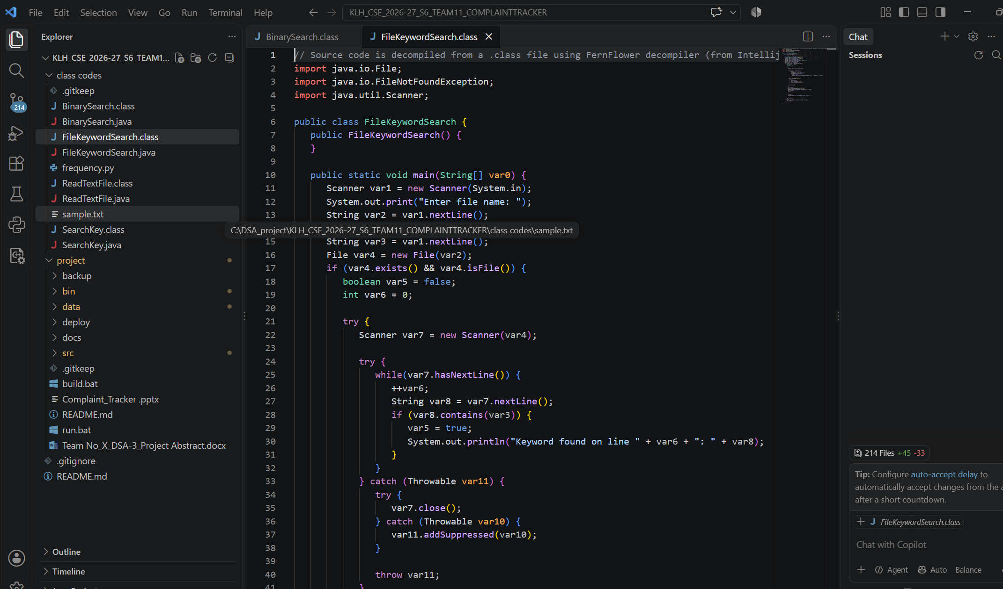
Fig. 4.1 Project Workspace in VS Code
Figure 4.1 shows the workspace in VS Code with the project folder and its sub-folders (backup, bin, data, deploy, docs and src) together with build.bat, run.bat and README.md.
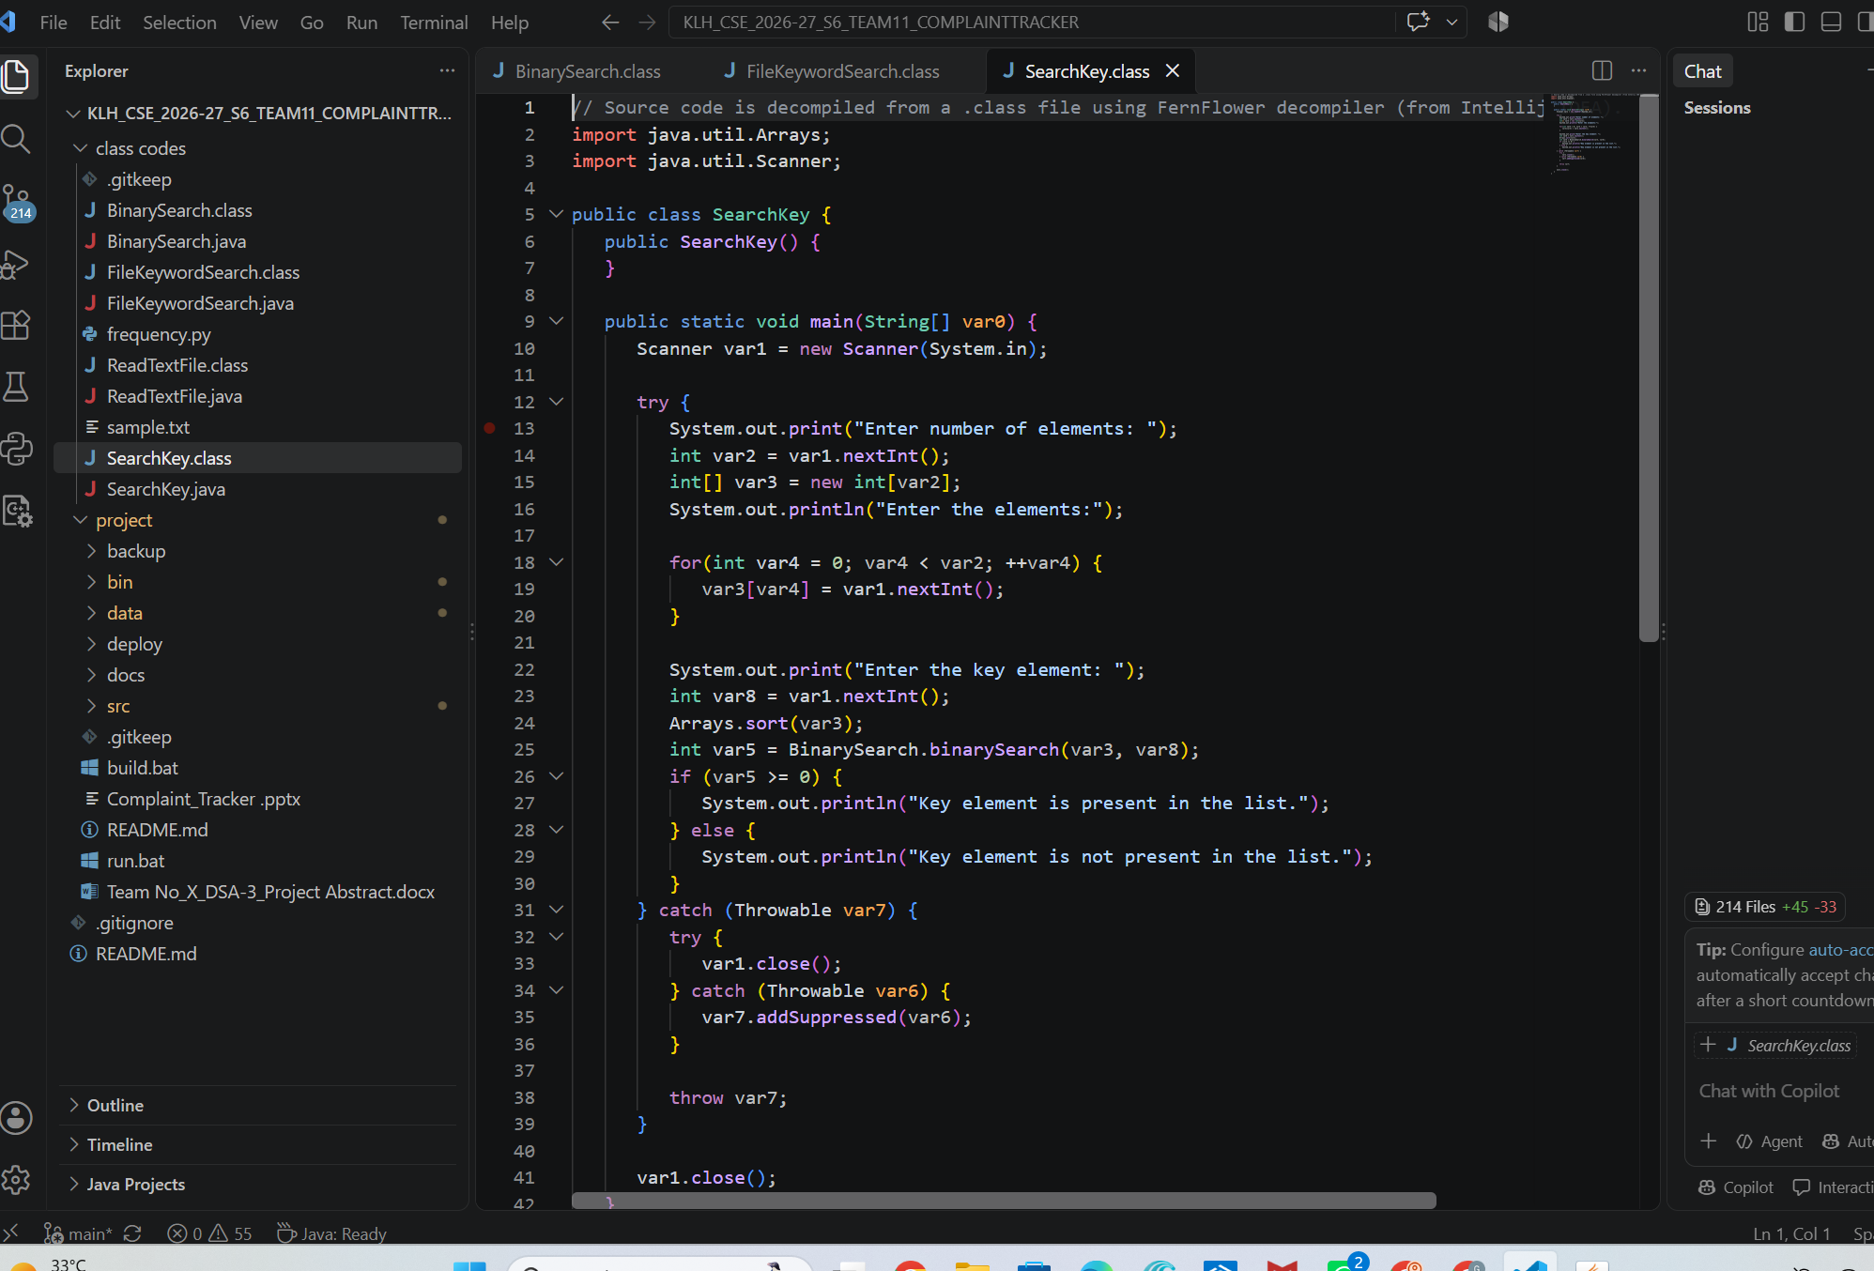
Fig. 4.2 Project Folder Structure and Source Files
Figure 4.2 shows the same project structure in the explorer, with the project folder, the build and run scripts and the project documents visible beside the code editor.

CHAPTER 5 - RESULTS

5.1 Testing Strategy
The system was tested with an automated suite of 13 unit and integration tests together with manual use of the two desktop portals. The tests exercise the algorithm engines and the flat-file persistence, and they were repeated across restart cycles to confirm that data written to the flat files is read back correctly. The application is self-contained, and it runs with Java 17 or 21 using java -cp bin Main in PowerShell or run.bat in Command Prompt. No external library or database was installed for any test.

5.2 Functional Results
The automated suite of 13 unit and integration tests passed in full (13 of 13), a 100% success rate that also held across restart cycles. The system uses zero external libraries or databases, and it meets all six course outcomes (CO1–CO6) of the Advanced DSA curriculum.

5.2.1 Hazard Detection
The text “Smoke and a burning smell near the transformer, possible fire risk” is auto-tagged CRITICAL in under 1 ms by the Aho-Corasick automaton.

5.2.2 Priority Triage and SLA
Tickets are ordered by urgency score through the max-heap, and the min-heap places the ticket closest to its SLA breach first. For example, tickets with 4 minutes, 22 minutes and 1 hour 05 minutes remaining are ordered in that sequence.

5.2.3 Staff Dispatch
Complaints are matched to technicians by department skill within each technician’s workload capacity. In the administrator dashboard, tickets show an assigned staff member or Unassigned, and the Auto-Assign Queue button applies the dispatch.

5.2.4 Duplicate Blocker
“Water leakage near main gate 2” and “Leak of water close to gate no.2” are detected as an 87% match and can be merged with one click into a record with combined history.

5.2.5 Root-Cause Clustering
Twenty separate tickets mentioning “transformer exploded near block B” are reduced to one identified root cause by the suffix array and LCP engine.

5.2.6 Scheduling and Routing
Graham’s LPT, Held-Karp (for up to 12 critical tasks) and the metric TSP 2-approximation produce maintenance schedules and inspection routes.

5.2.7 Parallel Analytics
The dashboard analytics run on several cores through ForkJoinPool, and the Blelloch scan produces cumulative daily ticket trends.

5.2.8 Persistence and Backup
Atomic writes, delimiter escaping and timestamped backups preserve data integrity, and the data is read back correctly after the application is restarted.

5.3 GUI Results
This section presents screenshots of the running application.

5.3.1 Main Portal Launcher
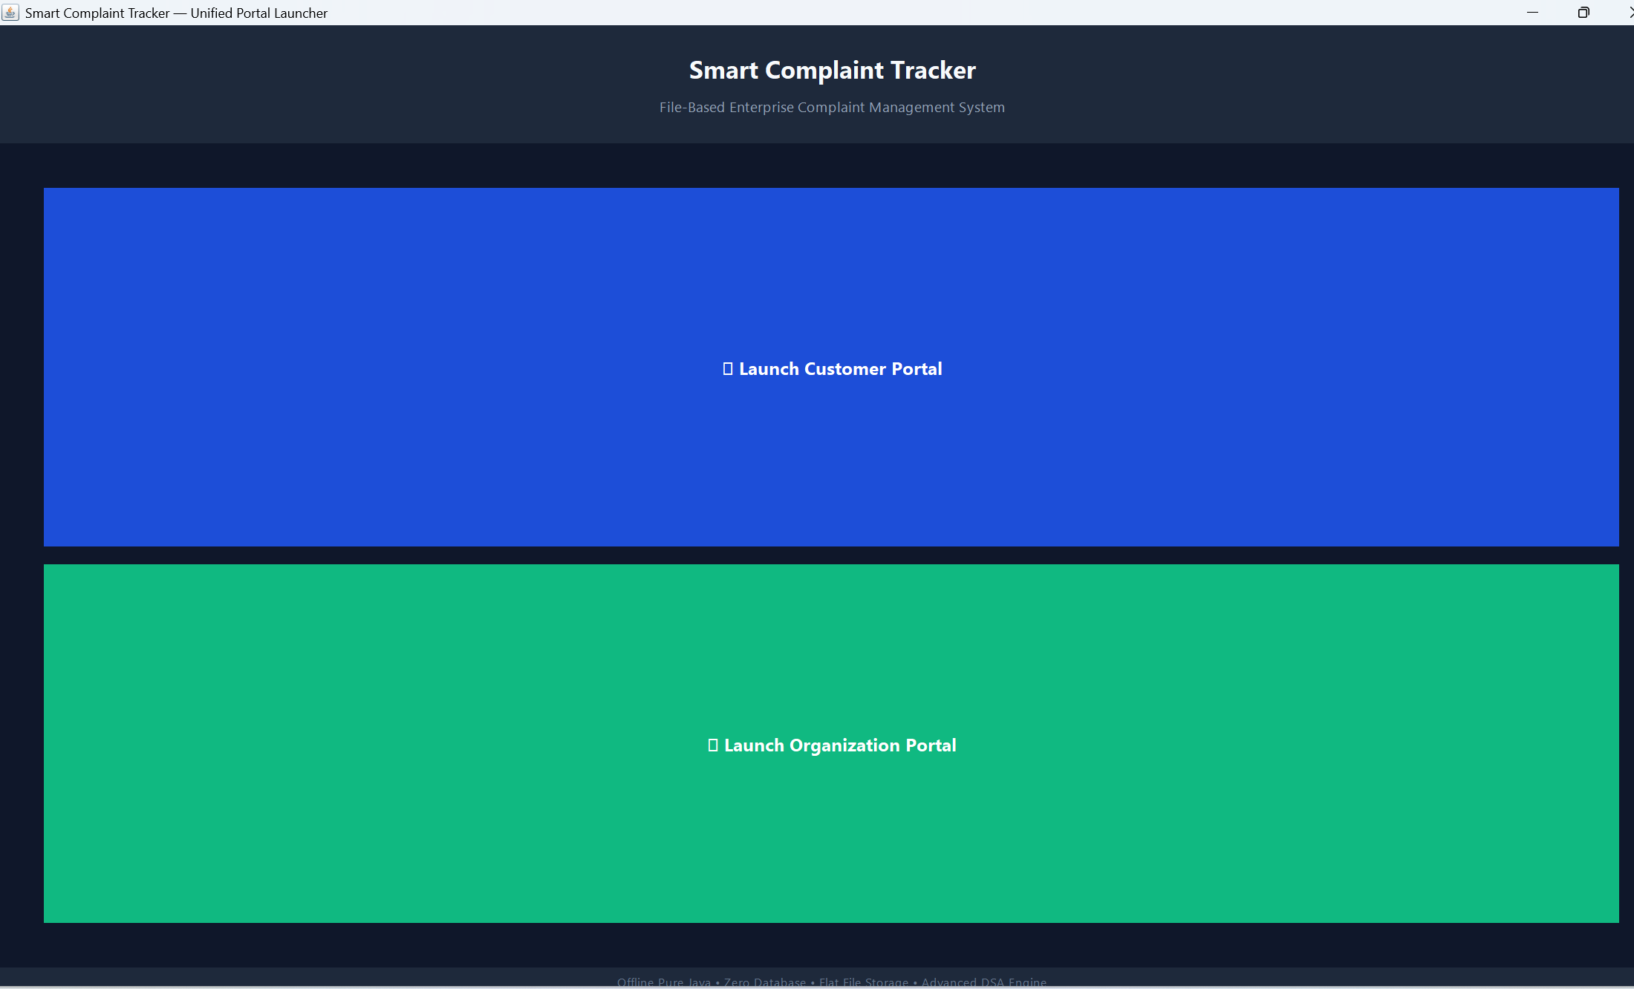
Fig. 5.1 Main Portal Launcher
The launcher window is titled “Smart Complaint Tracker — Unified Portal Launcher”. It presents the title, the subtitle “File-Based Enterprise Complaint Management System”, and two large buttons, Launch Customer Portal (blue) and Launch Organization Portal (green). The footer states: Offline Pure Java • Zero Database • Flat File Storage • Advanced DSA Engine.

5.3.2 Customer Portal
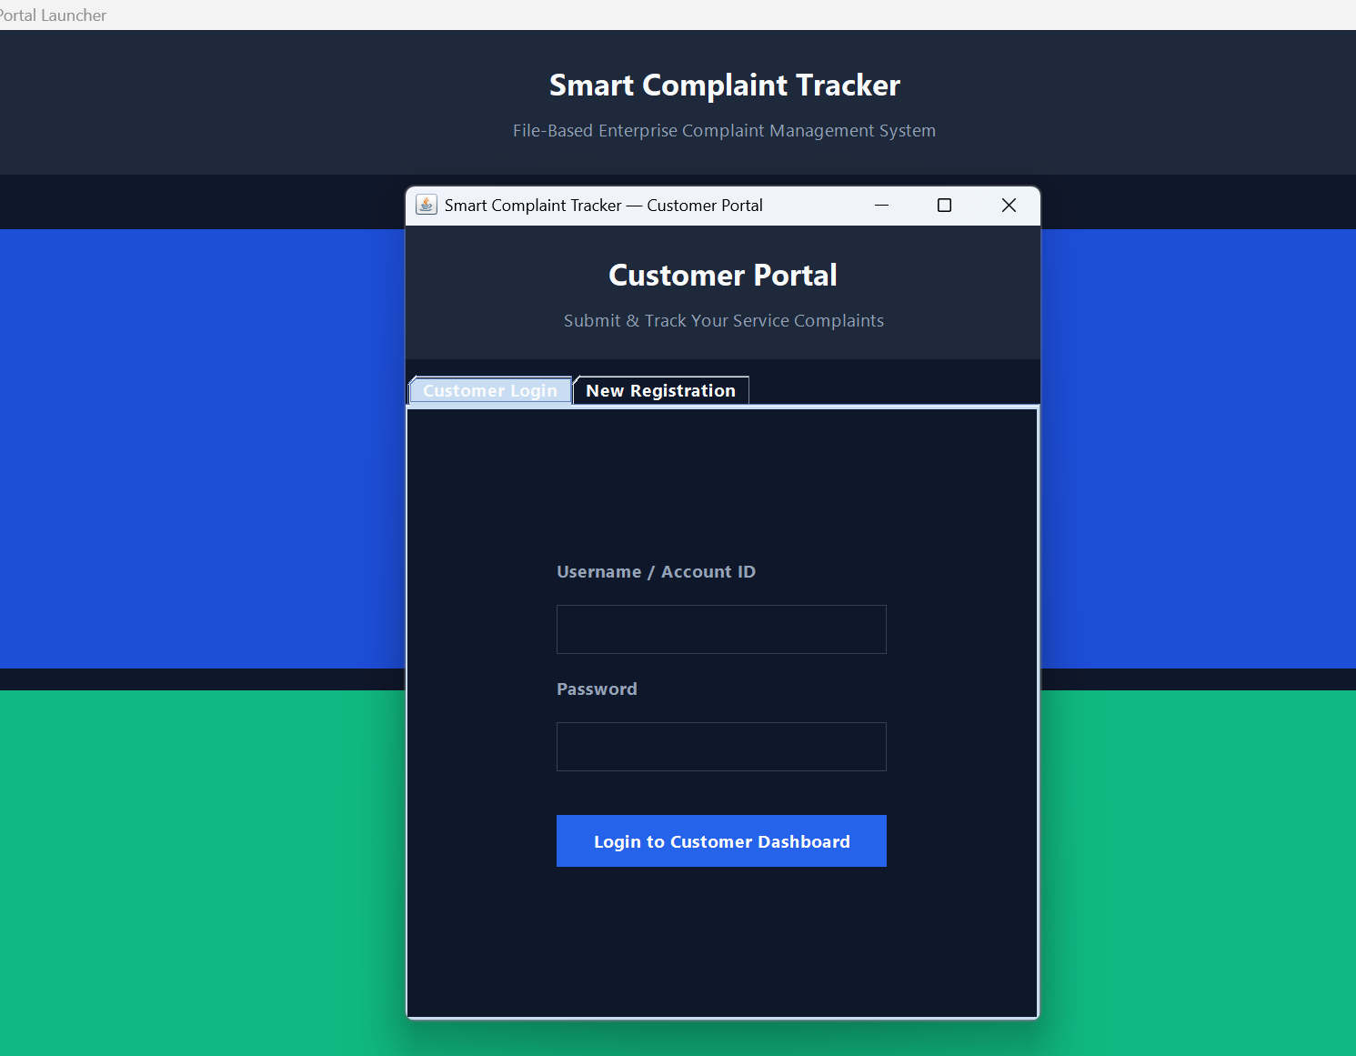
Fig. 5.2 Customer Portal — Login and New Registration
The Customer Portal opens above the launcher with the heading “Submit & Track Your Service Complaints”. It has the tabs Customer Login and New Registration. The login tab asks for the Username / Account ID and Password and has the button Login to Customer Dashboard.

5.3.3 Organization Portal
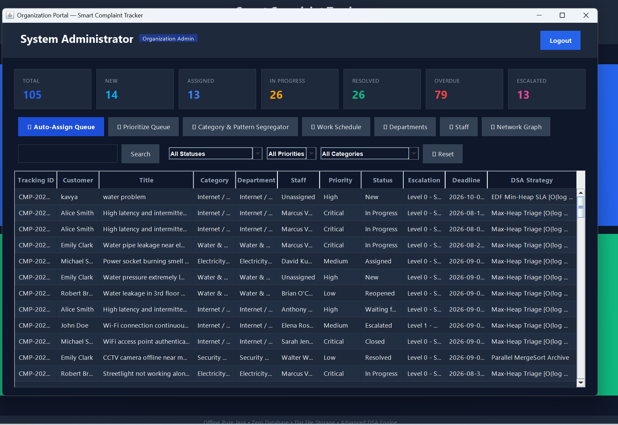
Fig. 5.3 Organization Portal — Administrator Dashboard and Complaint Table
The Organization Portal shows a System Administrator logged in with the Organization Admin role. The KPI cards report 105 total complaints, of which 14 are New, 13 Assigned, 26 In Progress, 26 Resolved, 79 Overdue and 13 Escalated. The queue buttons (Auto-Assign Queue, Prioritize Queue, Category & Pattern Segregator, Work Schedule, Departments, Staff and Network Graph) give access to the engines.
The complaint table lists the Tracking ID, Customer, Title, Category, Department, Staff, Priority, Status, Escalation, Deadline and DSA Strategy for each ticket. The data includes tickets such as “High latency and intermittent connectivity”, “Water pipe leakage near electrical panel” and “Power socket burning smell”. Statuses visible include New, Assigned, In Progress, Waiting, Reopened, Escalated, Closed and Resolved, and priorities range from Low to Critical. The DSA Strategy column shows how each ticket is managed: Max-Heap Triage for active tickets, EDF Min-Heap SLA for tickets tracked against deadlines, and Parallel MergeSort Archive for resolved tickets.

5.4 Complexity Analysis
Algorithm / structure | Complexity
Aho-Corasick | O(N + M + Z)
KMP and Z-algorithm | O(N + M)
Rabin-Karp | O(N + M) average; O(N × M) worst case
Binary max-heap / min-heap | O(log N) insert and extract
Hopcroft-Karp matching | O(E√V)
Min-Cost Max-Flow (SPFA) | Depends on flow value and graph size
Wagner-Fischer Levenshtein | O(N × M)
Suffix array + Kasai LCP | Build O(N log²N); query O(N)
Graham’s LPT | O(N log N), 4/3-approximation
Held-Karp bitmask DP | O(2ᴺ · N²), used for N ≤ 12
Metric TSP (MST doubling) | 2-approximation
Fork/Join tree reduction | Work O(N), span O(log N)
Blelloch prefix sum | Work O(N), span O(log N)
CustomHashTable lookup | O(1) average
CustomArrayList append | Amortised O(1)

Where N is the text or input size, M is the pattern or second string length, Z is the number of matches, E is the number of edges and V is the number of vertices.

CHAPTER 6 - CHALLENGES & LIMITATIONS

6.1 Issues Faced During Development
During the development of the Smart Complaint DSA Tracker, several technical and implementation-related challenges were encountered. The project combines many Data Structures and Algorithms and deliberately avoids external libraries, a database and the java.util collections. The main challenges were related to building every container from scratch, designing safe file storage, choosing algorithms for NP-hard problems, keeping the interface responsive, and connecting the engines to a two-portal Swing interface.

6.1.1 Building Data Structures from Scratch
The project does not use java.util collections for its containers. Lists, queues, stacks, heaps, hash tables, tries, graphs and disjoint-set unions all had to be implemented, tested and made reusable. Each structure has different growth, resizing and memory behaviour that must be handled correctly, for example the 1.5× growth of the dynamic array and the resizing of the hash table with separate chaining.

6.1.2 Integrating Several String Algorithms
Hazard detection uses Aho-Corasick, KMP, the Z-algorithm and Rabin-Karp. Each follows a different approach and has different preprocessing requirements: failure links for Aho-Corasick, the LPS array for KMP, and hash arithmetic for Rabin-Karp. These had to coexist without conflicts and be tested independently.

6.1.3 Storing Data Without a Database
With no database, records are stored in text files. Multiline complaint text could break a record boundary, and a sudden termination during a save could leave a file half-written. Related data such as history, responses and feedback also had to be linked to tickets across ten separate files.

6.1.4 Dispatch as a Graph Problem
Assigning tickets to technicians is not a simple queue operation. It required modelling tickets and technicians as a bipartite graph, enforcing per-technician capacity, and then optimising cost, distance and throughput using network flow.

6.1.5 Duplicate Detection
Different users describe the same problem in different words. Edit-distance comparison requires character-level calculation, so comparing many tickets can be expensive, and a similarity level had to be chosen that flags real duplicates without flagging unrelated tickets.

6.1.6 Scheduling and Routing
Makespan scheduling and tour planning are NP-hard. An exact method is possible only for small inputs, so the project had to combine exact Held-Karp for small sets with approximation methods for larger ones.

6.1.7 Parallel Analytics
Computing dashboard statistics across cores requires splitting the work, combining the partial results correctly, and avoiding the overhead of too many small tasks. The Blelloch scan also needs a correct two-pass design.

6.1.8 GUI Integration
The Swing interface has two portals and many controls. The GUI had to use the existing engines rather than duplicate them, remain responsive, and present large tables, KPI cards and status information consistently using a shared design system.

6.2 Solutions Applied
The following solutions were applied to address the challenges described above.

6.2.1 Solution for Custom Data Structures
Nine reusable structures were implemented and verified by the test suite. The array list uses 1.5× growth for amortised O(1) append, the hash table uses separate chaining with resizing, and the priority queue supports both Min and Max modes, so a single heap implementation serves both triage and EDF scheduling.

6.2.2 Solution for String Algorithms
The algorithms were organised as separate engines. Aho-Corasick performs the hazard scan in a single pass, while KMP, the Z-algorithm and Rabin-Karp were kept as separate linear-time searchers that can be tested individually.

6.2.3 Solution for File Storage
Delimiter escaping converts tabs and newlines in text, so each record stays on one line. Writes go to a *.txt.tmp file that is then atomically renamed, which prevents corruption. The BackupManager adds timestamped snapshots with one-click restore.

6.2.4 Solution for Dispatch
Hopcroft-Karp provides maximum matching by department skill and capacity, and Min-Cost Max-Flow with successive shortest paths (SPFA) minimises cost and distance while maximising the number of resolved complaints.

6.2.5 Solution for Duplicate Detection
Wagner-Fischer Levenshtein distance is converted into a similarity percentage, and likely duplicates are only flagged for admin review. The administrator confirms the merge with one click, which avoids merging unrelated tickets automatically.

6.2.6 Solution for Scheduling and Routing
Graham’s LPT provides a 4/3-approximation of the makespan in O(N log N). Held-Karp is used only for N ≤ 12, and metric TSP with MST doubling provides a 2-approximation for large areas.

6.2.7 Solution for Parallel Analytics
ForkJoinPool performs a parallel tree reduction with O(N) work and O(log N) span, and the Blelloch two-pass scan generates cumulative trends.

6.2.8 Solution for Swing Integration
The interface calls the engines and displays results, and the shared design system in AppTheme.java keeps all windows consistent. A Main Portal Launcher separates the Customer Portal from the Organization Portal.

6.2.9 Overall Effect of the Solutions
After these solutions were applied, all 13 unit and integration tests passed, and the results remained correct across restart cycles.

6.3 Limitations

6.3.1 Flat-File Storage
The project uses flat text files rather than a production database, so it is intended for academic and local execution rather than a large multi-user deployment.

6.3.2 Desktop Application Platform
The system is a desktop Swing application and does not offer a web or mobile interface. Notifications are available only inside the application.

6.3.3 Approximation and Exact-Method Limits
Held-Karp is exact only for small sets of critical tasks (N ≤ 12). Graham’s LPT and metric TSP give approximate results, within factors of 4/3 and 2 respectively, rather than optimal ones.

6.3.4 Duplicate Detection Based on Edit Distance
Edit-distance similarity compares characters, so two complaints that describe the same problem using very different words may not be flagged as duplicates.

6.3.5 Test Coverage
The system has been verified by its 13 unit and integration tests and by manual use of the portals. It has not been evaluated with very large volumes of real-world complaints.

6.3.6 Summary of Limitations
The system is a complete academic demonstration of how DSA techniques can run a complaint-management workflow. It is limited by its storage format, its desktop-only interface, and the approximation nature of some algorithms.

CHAPTER 7 - CONCLUSION & FUTURE WORK

7.1 Conclusion
The Smart Complaint DSA Tracker demonstrates the practical application of Data Structures and Algorithms to the problem of receiving, prioritising, dispatching and analysing complaints. The system was developed in pure Java 21 with zero external libraries and zero database, and it stores its data in ten human-readable flat files.
The project combines several algorithmic techniques rather than depending on a single method. Aho-Corasick, KMP, the Z-algorithm and Rabin-Karp support string matching and real-time hazard detection. Binary heaps provide dynamic priority triage and earliest-deadline-first SLA monitoring. Hopcroft-Karp matching and Min-Cost Max-Flow dispatch work to technicians by skill and capacity.
Dynamic programming is applied to duplicate detection through Wagner-Fischer Levenshtein distance and to inspection routing through Held-Karp. A suffix array with Kasai’s LCP array uncovers root causes behind many separate tickets. Graham’s LPT and metric TSP provide approximation algorithms for NP-hard planning problems, and Fork/Join with the Blelloch scan provides parallel analytics.
The system provides several user-oriented operations, including:
• complaint submission with real-time hazard detection;
• urgency-based triage and SLA tracking;
• skill-based staff dispatch;
• duplicate detection and merging;
• root-cause pattern analysis;
• maintenance scheduling and route planning;
• parallel dashboard analytics;
• feedback, notifications and backup and restore.
The Java Swing interface provides an accessible interaction layer through the Main Portal Launcher, the Customer Portal and the Organization Portal, as shown in Chapter 5. Nine handcrafted data structures, atomic flat-file persistence, and the BackupManager make the system self-contained and dependable.
All 13 automated tests passed with a 100% success rate across restart cycles, and all six course outcomes (CO1–CO6) of the Advanced DSA curriculum are met. Overall, the project provided practical experience in designing, implementing, testing and integrating multiple Data Structures and Algorithms in Java, and the completed system serves as an integrated demonstration of how different algorithmic approaches can be selected and combined according to the needs of a real-world style application.

7.2 Future Work
The current system provides the required complaint-handling, dispatch, analysis and interface functionality. Several additional features can be considered for future development.

7.2.1 Production Database
Flat-file storage can be replaced or complemented by a production database to support many simultaneous users.

7.2.2 Web and Mobile Interface
A web or mobile front end, together with email or SMS notifications, would let customers raise and follow complaints without a desktop program.

7.2.3 Stronger Authentication
Authentication can be strengthened, and finer permissions can be added for Admin and Staff roles.

7.2.4 Richer Analytics
Historical trend reports and richer administrator analytics can be added on top of the parallel analytics engine.

7.2.5 Semantic Duplicate Detection
Edit-distance similarity can be combined with semantic similarity so that complaints worded very differently can still be recognised as duplicates.

7.2.6 Automated Performance Benchmarking
Automated benchmarks and a larger regression test suite can be added for every engine.

7.2.7 Networked Deployment
The system can be deployed as a networked service for real organisations.

7.3 Skills Learned

7.3.1 Problem Analysis
Analysing a real operational problem and identifying which algorithmic technique suits each part of it.

7.3.2 String Matching
Implementing Aho-Corasick, KMP, the Z-algorithm and Rabin-Karp, and understanding their trade-offs.

7.3.3 Data Structure Implementation
Building lists, stacks, queues, heaps, hash tables, tries, graphs and disjoint-set unions without library collections.

7.3.4 Heaps and Scheduling
Applying binary heaps to priority triage and earliest-deadline-first scheduling.

7.3.5 Graph Matching and Network Flow
Modelling dispatch as bipartite matching and min-cost max-flow.

7.3.6 Dynamic Programming
Implementing Wagner-Fischer edit distance and Held-Karp bitmask dynamic programming.

7.3.7 Suffix Arrays
Building suffix arrays and LCP arrays and using them to find recurring phrases.

7.3.8 Approximation Algorithms
Applying Graham’s LPT and metric TSP to NP-hard problems.

7.3.9 Parallel Programming
Using ForkJoinPool, tree reduction and the Blelloch prefix-sum scan.

7.3.10 Java Swing
Designing a two-portal desktop interface with a custom dark design system.

7.3.11 File Handling and Reliability
Designing flat-file persistence with atomic writes, delimiter escaping and backups.

7.3.12 Testing
Writing unit and integration tests and verifying behaviour across restart cycles.

7.3.13 Technical Documentation
Documenting the design, implementation and results of a multi-module project.

REFERENCES
[1] D. E. Knuth, J. H. Morris Jr., and V. R. Pratt, “Fast Pattern Matching in Strings,” SIAM Journal on Computing, vol. 6, no. 2, pp. 323–350, 1977.
[2] R. M. Karp and M. O. Rabin, “Efficient Randomized Pattern-Matching Algorithms,” IBM Journal of Research and Development, vol. 31, no. 2, pp. 249–260, 1987.
[3] A. V. Aho and M. J. Corasick, “Efficient String Matching: An Aid to Bibliographic Search,” Communications of the ACM, vol. 18, no. 6, pp. 333–340, 1975.
[4] R. A. Wagner and M. J. Fischer, “The String-to-String Correction Problem,” Journal of the ACM, vol. 21, no. 1, pp. 168–173, 1974.
[5] V. I. Levenshtein, “Binary Codes Capable of Correcting Deletions, Insertions, and Reversals,” Soviet Physics Doklady, vol. 10, pp. 707–710, 1966.
[6] T. Kasai, G. Lee, H. Arimura, S. Arikawa and K. Park, “Linear-Time Longest-Common-Prefix Computation in Suffix Arrays and Its Applications,” CPM 2001, Lecture Notes in Computer Science, vol. 2089, pp. 181–192, 2001.
[7] J. E. Hopcroft and R. M. Karp, “An n^(5/2) Algorithm for Maximum Matchings in Bipartite Graphs,” SIAM Journal on Computing, vol. 2, no. 4, pp. 225–231, 1973.
[8] M. Held and R. M. Karp, “A Dynamic Programming Approach to Sequencing Problems,” Journal of the Society for Industrial and Applied Mathematics, vol. 10, no. 1, pp. 196–210, 1962.
[9] R. L. Graham, “Bounds on Multiprocessing Timing Anomalies,” SIAM Journal on Applied Mathematics, vol. 17, no. 2, pp. 416–429, 1969.
[10] G. E. Blelloch, “Prefix Sums and Their Applications,” Technical Report CMU-CS-90-190, Carnegie Mellon University, 1990.
[11] T. H. Cormen, C. E. Leiserson, R. L. Rivest and C. Stein, Introduction to Algorithms, 4th ed., MIT Press, 2022.
[12] R. K. Ahuja, T. L. Magnanti and J. B. Orlin, Network Flows: Theory, Algorithms, and Applications, Prentice Hall, 1993.
[13] Oracle Java Documentation, Java Swing, AWT and java.util.concurrent (ForkJoinPool) used for the implementation.
[14] Smart Complaint DSA Tracker project source code and data: src/, bin/, data/ and the project presentation.

