EXPERIMENT-11
11. Playfair Cipher – Possible Number of Keys
Aim
To write a C program to calculate the possible keys of the Playfair cipher, express the result as an approximate power of 2, and estimate the number of effectively unique keys.
Procedure
- Read the size of the Playfair alphabet.
- Calculate the possible key arrangements using factorial.
- Use a logarithm to express the number as a power of 2.
- Account for equivalent keys formed by cyclic row and column shifts.
- Display the total and effectively unique key counts.
C Program
C

#include <stdio.h>
#include <math.h>

long double factorial(int n) {
long double result = 1;
int i;

for (i = 1; i <= n; i++)
result *= i;

return result;
}

int main() {
int n;
long double total, unique;

printf("Enter alphabet size (25 for Playfair): ");
scanf("%d", &n);

if (n != 25) {
printf("Please enter 25 for the Playfair alphabet.\n");
return 1;
}

total = factorial(n);
unique = total / 25.0L;

printf("Total possible keys = %.0Lf\n", total);
printf("Approximate power of 2 = 2^%.2Lf\n",
log2l(total));
printf("Effectively unique keys = 24!\n");
printf("Unique key count = %.0Lf\n", unique);
printf("Unique keys approximately = 2^%.2Lf\n",
log2l(unique));

return 0;
}
Sample Input
25
Sample Output
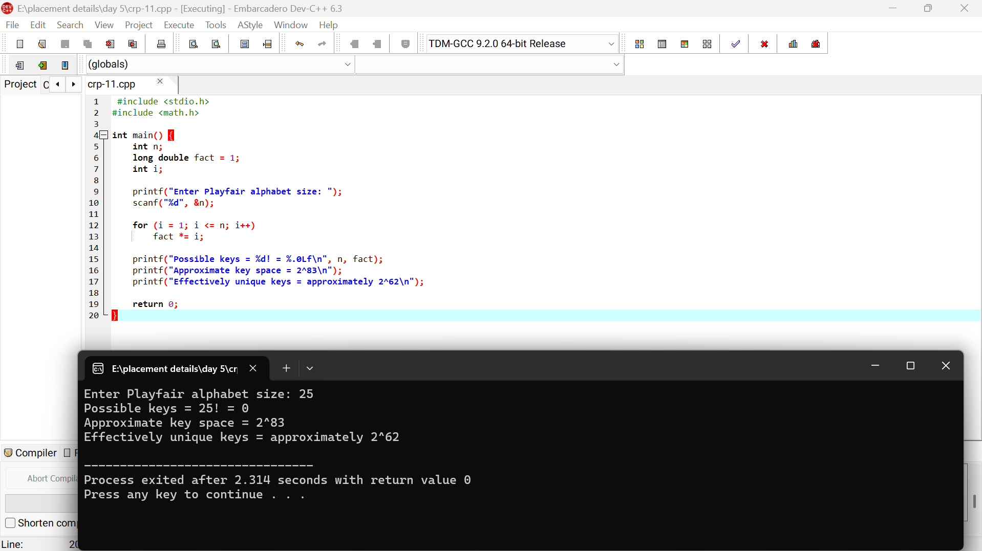
Result
The program calculates 25!25! possible key arrangements, approximately 283.68283.68. Under the row/column cyclic-shift equivalence convention, the effective key count is 24!24!, approximately 279.04279.04.

