EXPERIMENT-12
12. Hill Cipher – Encryption and Decryption

Aim
To write a C program to encrypt and decrypt a message using the Hill cipher with the key matrix
K=[9457]K=[95​47​]
Procedure
- Read the plaintext message.
- Convert letters to numbers using A = 0, B = 1, ..., Z = 25.
- Remove spaces and punctuation, and add X if the number of letters is odd.
- Encrypt each pair using C=KP mod 26C=KPmod26.
- Decrypt the ciphertext using the inverse key matrix modulo 26.
C Program
CODE:

#include <stdio.h>
#include <string.h>
#include <ctype.h>

int main() {
char input[500], plain[500], cipher[500], recovered[500];
int i, n = 0, a, b, c1, c2;
int inv[2][2] = {{5, 12}, {15, 25}};

printf("Enter plaintext: ");
fgets(input, sizeof(input), stdin);

for (i = 0; input[i] != '\0'; i++) {
if (isalpha((unsigned char)input[i]))
plain[n++] = toupper((unsigned char)input[i]);
}

if (n % 2 != 0)
plain[n++] = 'X';

plain[n] = '\0';

for (i = 0; i < n; i += 2) {
a = plain[i] - 'A';
b = plain[i + 1] - 'A';

cipher[i] = (9 * a + 4 * b) % 26 + 'A';
cipher[i + 1] = (5 * a + 7 * b) % 26 + 'A';
}

cipher[n] = '\0';

for (i = 0; i < n; i += 2) {
a = cipher[i] - 'A';
b = cipher[i + 1] - 'A';

c1 = (inv[0][0] * a + inv[0][1] * b) % 26;
c2 = (inv[1][0] * a + inv[1][1] * b) % 26;

recovered[i] = c1 + 'A';
recovered[i + 1] = c2 + 'A';
}

recovered[n] = '\0';

printf("Prepared plaintext: %s\n", plain);
printf("Encrypted ciphertext: %s\n", cipher);
printf("Decrypted plaintext: %s\n", recovered);

return 0;
}
Sample Input:
meet me at the usual place at ten rather than eight oclock
Sample Output:
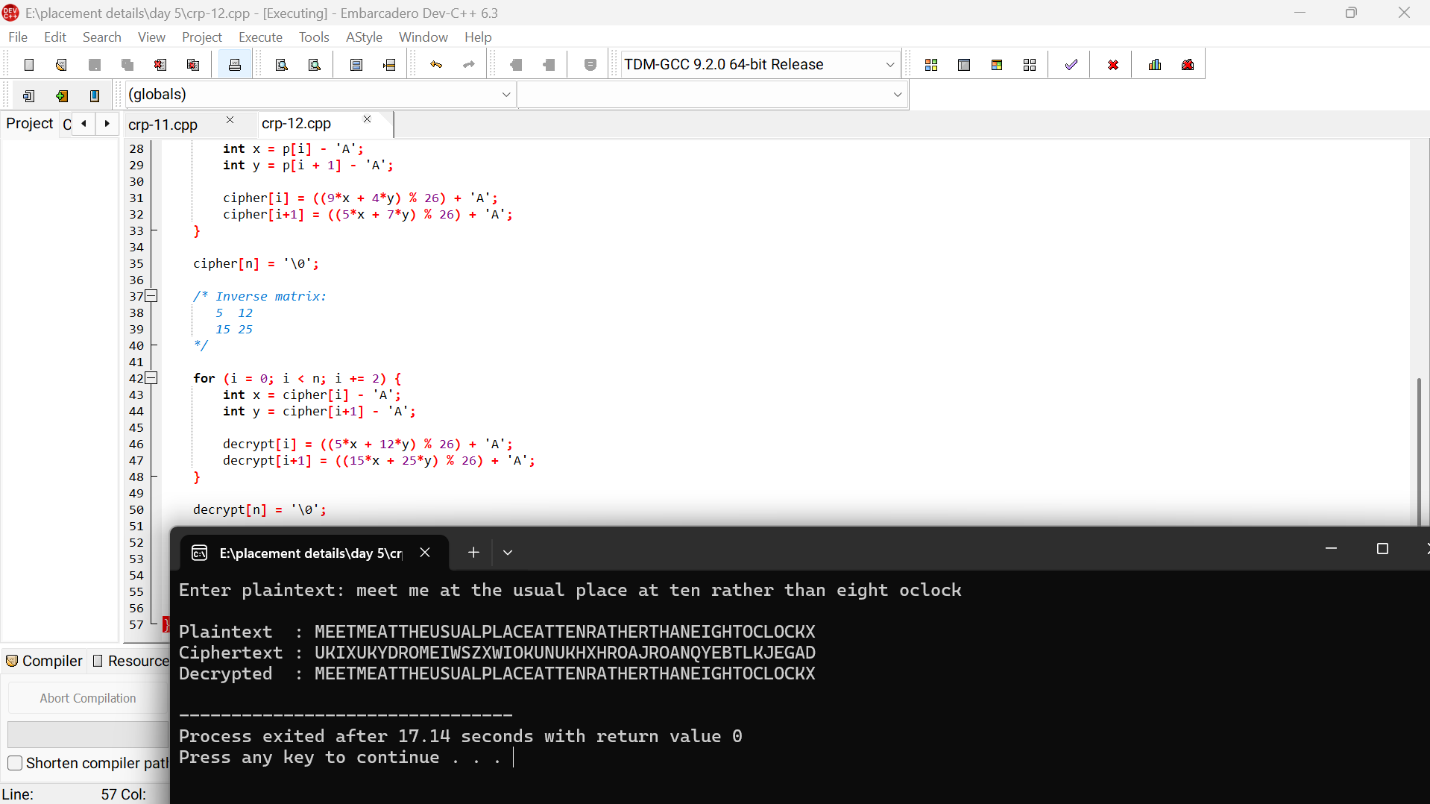
Result:
The program successfully encrypts and decrypts the given plaintext using the Hill cipher.

