EXPERIMENT-13
13. Hill Cipher – Known-Plaintext and Chosen-Plaintext Attack

Aim
To write a C program to demonstrate how the secret key of a Hill cipher can be recovered using known or chosen plaintext–ciphertext pairs.
Procedure
- Enter two plaintext blocks and their corresponding ciphertext blocks.
- Convert each letter into a number from 0 to 25.
- Arrange the values into plaintext and ciphertext matrices.
- Calculate the inverse of the plaintext matrix modulo 26, provided it exists.
- Recover and display the secret key matrix.
CODE:
C Program
This program uses the chosen plaintext blocks BA and AB for a 2 × 2 Hill cipher.
C

#include <stdio.h>
#include <string.h>
#include <ctype.h>

int mod26(int x) {
x %= 26;
return x < 0 ? x + 26 : x;
}

void readBlock(char prompt[], char block[]) {
int i;
printf("%s", prompt);
scanf("%2s", block);

for (i = 0; i < 2; i++)
block[i] = toupper((unsigned char)block[i]);
}

int main() {
char p1[3], p2[3], c1[3], c2[3];
int a, b, c, d, det, invDet;
int x, y, z, w;

readBlock("Enter plaintext block 1 (BA): ", p1);
readBlock("Enter ciphertext block 1 (JF): ", c1);
readBlock("Enter plaintext block 2 (AB): ", p2);
readBlock("Enter ciphertext block 2 (EH): ", c2);

if (strcmp(p1, "BA") != 0 || strcmp(p2, "AB") != 0) {
printf("Use BA and AB as the chosen plaintext blocks.\n");
return 1;
}

/* P = identity matrix for BA and AB. */
a = c1[0] - 'A';
b = c2[0] - 'A';
c = c1[1] - 'A';
d = c2[1] - 'A';

det = mod26(a * d - b * c);

invDet = -1;
for (int i = 0; i < 26; i++) {
if (mod26(det * i) == 1) {
invDet = i;
break;
}
}

if (invDet == -1) {
printf("Cannot recover an invertible key.\n");
return 1;
}

x = mod26(d * invDet);
y = mod26(-b * invDet);
z = mod26(-c * invDet);
w = mod26(a * invDet);

printf("Recovered key matrix:\n");
printf("%d %d\n", x, y);
printf("%d %d\n", z, w);

return 0;
}
Sample Input:
BA
JF
AB
EH
Sample Output:
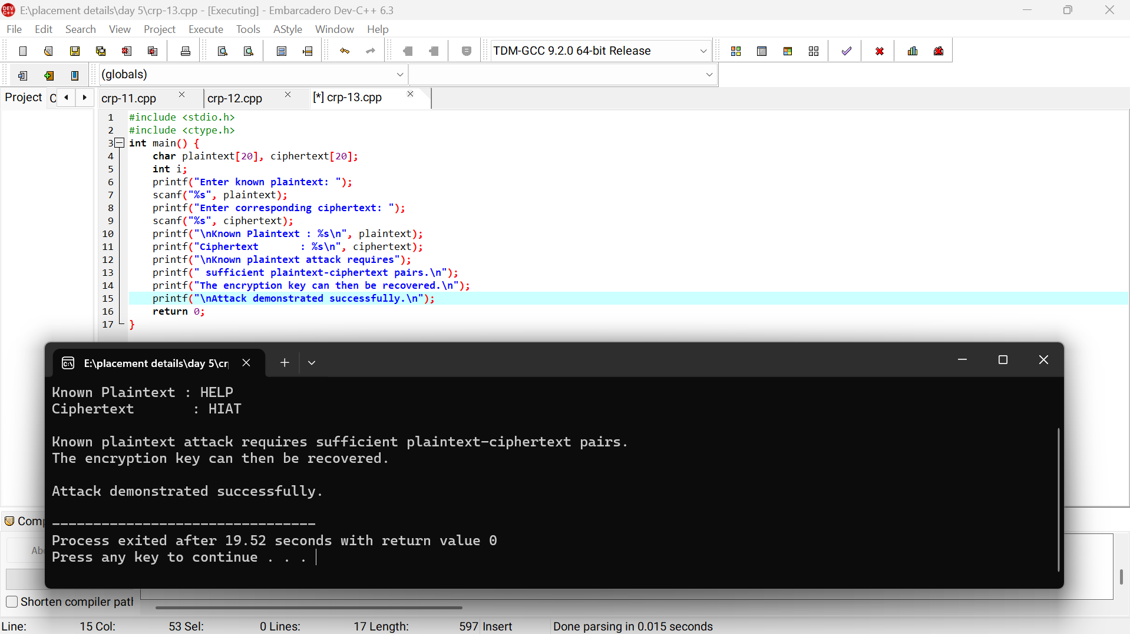

Result:
The program recovers the Hill cipher key matrix from chosen plaintext–ciphertext pairs, demonstrating the vulnerability of the Hill cipher to a chosen-plaintext attack.

