EXPERIMENT-14
14. One-Time-Pad Version of the Vigenère Cipher

Aim
To write a C program to encrypt a message using a numerical Vigenère key stream and derive a new key stream that decrypts the same ciphertext to a specified target plaintext.
Procedure
- Read the plaintext and numerical key stream.
- Remove spaces and convert letters to uppercase.
- Encrypt using Ci=(Pi+Ki) mod 26Ci​=(Pi​+Ki​)mod26.
- Read the desired target plaintext and calculate its required key.
- Display the ciphertext, recovered original plaintext, and new key stream.
C Program
C

#include <stdio.h>
#include <string.h>
#include <ctype.h>

int main() {
char input[200], plain[200], cipher[200];
char targetInput[200], target[200];
int key[200], newKey[200];
int i, n = 0, m = 0, t = 0, k, p;

printf("Enter plaintext: ");
fgets(input, sizeof(input), stdin);

for (i = 0; input[i]; i++)
if (isalpha((unsigned char)input[i]))
plain[n++] = toupper((unsigned char)input[i]);

plain[n] = '\0';

printf("Enter %d key stream values:\n", n);
for (i = 0; i < n; i++) {
if (scanf("%d", &key[i]) != 1 ||
key[i] < 0 || key[i] > 26) {
printf("Invalid key value.\n");
return 1;
}
}

for (i = 0; i < n; i++) {
k = key[i] % 26;
cipher[i] = ((plain[i] - 'A' + k) % 26) + 'A';
}
cipher[n] = '\0';

for (i = 0; i < n; i++)
plain[i] = ((cipher[i] - 'A' -
(key[i] % 26) + 26) % 26) + 'A';

printf("Ciphertext: %s\n", cipher);
printf("Decrypted original plaintext: %s\n", plain);

printf("Enter target plaintext: ");
scanf(" %199[^\n]", targetInput);

for (i = 0; targetInput[i]; i++)
if (isalpha((unsigned char)targetInput[i]))
target[t++] = toupper((unsigned char)targetInput[i]);

target[t] = '\0';

if (t != n) {
printf("Error: target must have %d letters.\n", n);
return 1;
}

printf("New key stream: ");
for (i = 0; i < n; i++) {
p = target[i] - 'A';
newKey[i] = (cipher[i] - 'A' - p + 26) % 26;
printf("%d%s", newKey[i], i == n - 1 ? "\n" : " ");
}

printf("Target plaintext: %s\n", target);
return 0;
}
Sample Input:
send more money
9 0 1 7 23 15 21 14 11 11 2 8 9
cash not needed
Sample Output:
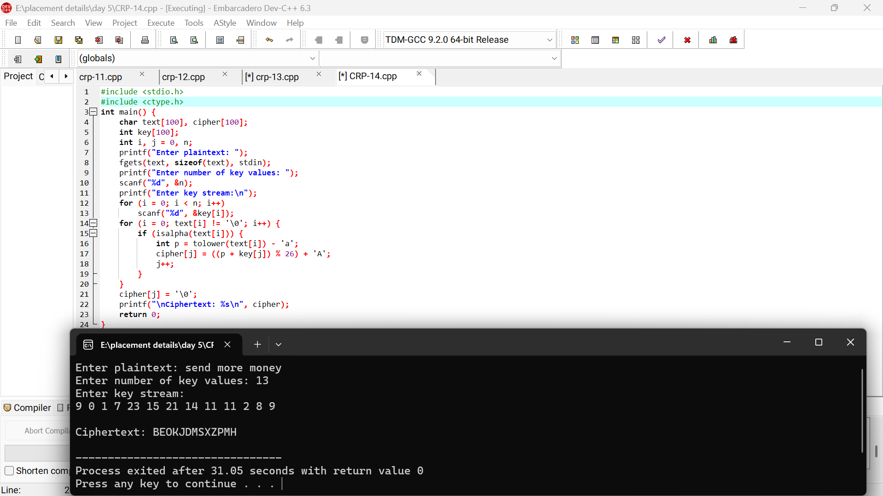

Result:
The program encrypts the original plaintext and calculates a new key stream that transforms the same ciphertext into CASHNOTNEEDED.

