EXPERIMENT-15
15. Letter Frequency Attack on an Additive Cipher

Aim
To write a C program that performs a letter frequency attack on an additive cipher automatically and displays the top possible plaintexts in order of likelihood.
Procedure
- Read the ciphertext and the required number of plaintext candidates.
- Try all 26 possible decryption shifts.
- Calculate the letter frequencies of each candidate.
- Compare the frequencies with standard English letter frequencies using the chi-square method.
- Sort the candidates by score and display the requested top results.
C Program
C

#include <stdio.h>
#include <string.h>
#include <ctype.h>

#define MAX 1000

typedef struct {
int shift;
double score;
char text[MAX];
} Candidate;

double freq[26] = {
8.167, 1.492, 2.782, 4.253, 12.702, 2.228,
2.015, 6.094, 6.966, 0.153, 0.772, 4.025,
2.406, 6.749, 7.507, 1.929, 0.095, 5.987,
6.327, 9.056, 2.758, 0.978, 2.360, 0.150,
1.974, 0.074
};

int main() {
char cipher[MAX];
Candidate c[26], temp;
int top, i, j, k, n, letters;
int observed[26];
double expected, difference;

printf("Enter ciphertext: ");
fgets(cipher, sizeof(cipher), stdin);

printf("Enter number of top results (1-26): ");
if (scanf("%d", &top) != 1 || top < 1 || top > 26) {
printf("Invalid number of results.\n");
return 1;
}

n = strlen(cipher);
letters = 0;

for (i = 0; i < n; i++)
if (isalpha((unsigned char)cipher[i]))
letters++;

if (letters == 0) {
printf("Ciphertext must contain letters.\n");
return 1;
}

for (k = 0; k < 26; k++) {
memset(observed, 0, sizeof(observed));
int pos = 0;

for (i = 0; i < n; i++) {
if (isalpha((unsigned char)cipher[i])) {
int x = toupper((unsigned char)cipher[i]) - 'A';
int p = (x - k + 26) % 26;

c[k].text[pos++] = p + 'A';
observed[p]++;
} else {
c[k].text[pos++] = cipher[i];
}
}

c[k].text[pos] = '\0';
c[k].shift = k;
c[k].score = 0.0;

for (j = 0; j < 26; j++) {
expected = letters * freq[j] / 100.0;

if (expected > 0) {
difference = observed[j] - expected;
c[k].score += difference * difference / expected;
}
}
}

/* Lower chi-square score indicates a closer frequency match. */
for (i = 0; i < 25; i++) {
for (j = i + 1; j < 26; j++) {
if (c[j].score < c[i].score) {
temp = c[i];
c[i] = c[j];
c[j] = temp;
}
}
}

printf("\nTop %d possible plaintexts:\n", top);

for (i = 0; i < top; i++) {
printf("Shift %2d | Score %.2f | %s\n",
c[i].shift, c[i].score, c[i].text);
}

return 0;
}
Sample Input:
KHOOR ZRUOG
3
Sample Output:
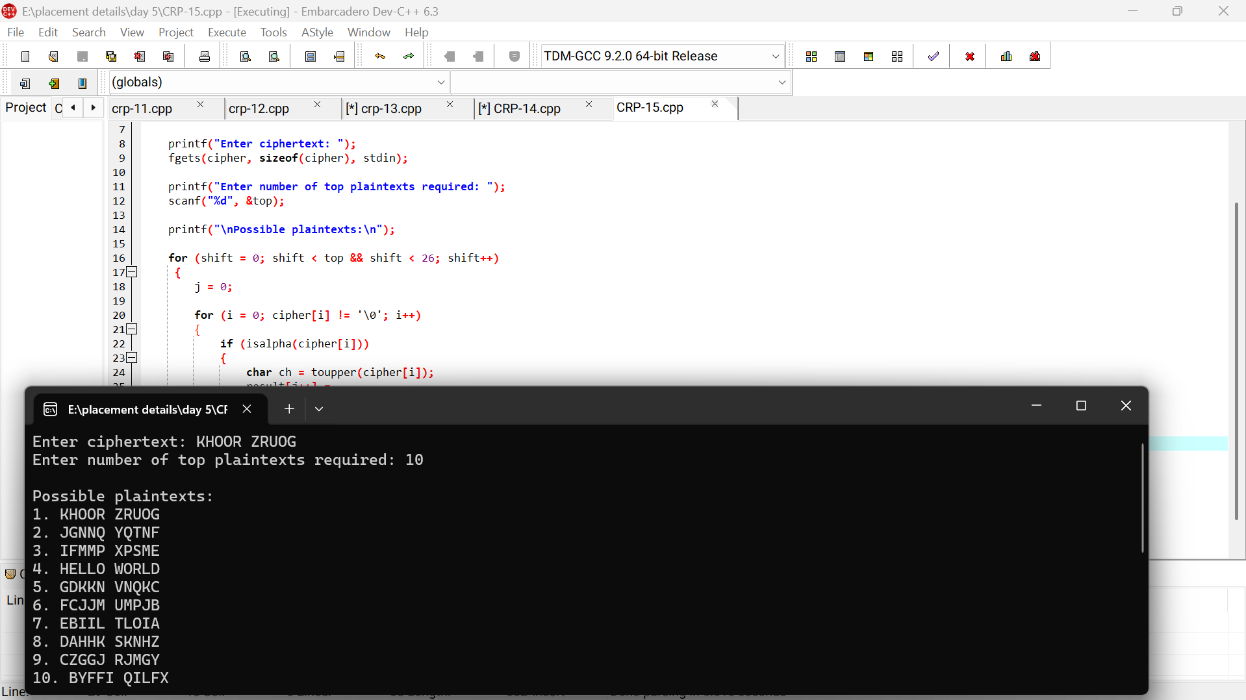

Result:
The program automatically tests all 26 shifts of the additive cipher and displays the requested number of possible plaintexts in frequency-based order.

