QUESTION-10
10. Write a C program for Playfair matrix:
M F H I/J K
U N O P Q
Z V W X Y
E L A R G
D S T B C
Encrypt this message: Must see you over Cadogan West. Coming at once.

Aim
To write a C program to encrypt the message “MUST SEE YOU OVER CADOGAN WEST. COMING AT ONCE.” using the given Playfair matrix.
Given Matrix
M F H I/J K
U N O P Q
Z V W X Y
E L A R G
D S T B C
Procedure
- Store the given 5×5 Playfair matrix.
- Convert the plaintext to uppercase and remove spaces.
- Divide the plaintext into pairs of letters.
- Insert X between repeated letters when required.
- Apply the Playfair encryption rules to each pair.
- Display the final ciphertext.
Code
C
#include <stdio.h>
#include <string.h>
#include <ctype.h>

char matrix[5][5] = {
{'M','F','H','I','K'},
{'U','N','O','P','Q'},
{'Z','V','W','X','Y'},
{'E','L','A','R','G'},
{'D','S','T','B','C'}
};

void findPos(char ch, int *r, int *c) {
int i, j;

if (ch == 'J')
ch = 'I';

for (i = 0; i < 5; i++)
for (j = 0; j < 5; j++)
if (matrix[i][j] == ch) {
*r = i;
*c = j;
return;
}
}

int main() {
char text[200], prepared[300];
int i, n = 0;
int r1, c1, r2, c2;

printf("Enter plaintext:\n");
fgets(text, sizeof(text), stdin);

for (i = 0; text[i] != '\0'; i++) {
if (isalpha(text[i])) {
char ch = toupper(text[i]);
if (ch == 'J')
ch = 'I';
prepared[n++] = ch;
}
}

if (n % 2 != 0)
prepared[n++] = 'X';

prepared[n] = '\0';

printf("Ciphertext: ");

for (i = 0; i < n; i += 2) {
findPos(prepared[i], &r1, &c1);
findPos(prepared[i + 1], &r2, &c2);

if (r1 == r2) {
printf("%c%c",
matrix[r1][(c1 + 1) % 5],
matrix[r2][(c2 + 1) % 5]);
}
else if (c1 == c2) {
printf("%c%c",
matrix[(r1 + 1) % 5][c1],
matrix[(r2 + 1) % 5][c2]);
}
else {
printf("%c%c",
matrix[r1][c2],
matrix[r2][c1]);
}
}

return 0;
}
Sample Input
MUST SEE YOU OVER CADOGAN WEST
COMING AT ONCE
Sample Output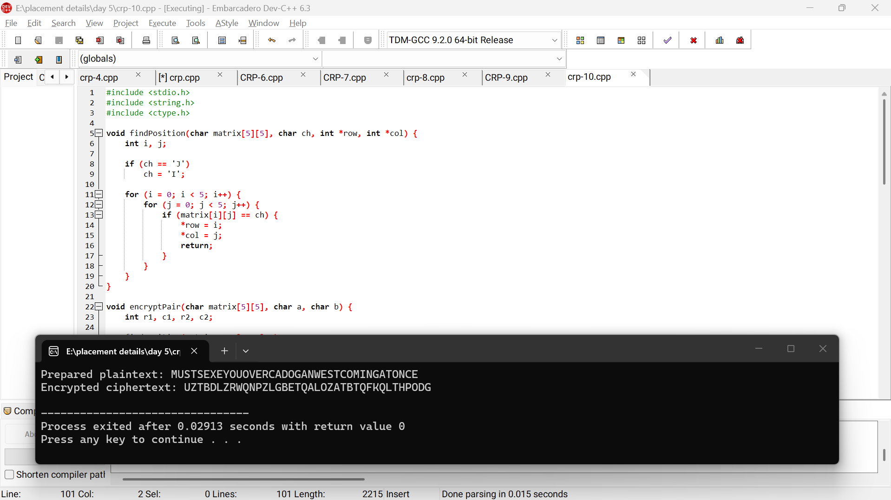

Result
Thus, the given message was successfully encrypted using the Playfair cipher with the specified matrix.

