QUESTION-4
4. Write a C program for polyalphabetic substitution cipher uses a separate monoalphabetic substitution cipher for each successive letter of plaintext, depending on a key.
Aim
To write a C program to implement a polyalphabetic substitution cipher using a given key.
Procedure
- Read the plaintext and key.
- Convert the letters to uppercase.
- Repeat the key until it matches the plaintext length.
- Convert letters into values from 0 to 25.
- Add plaintext and key values modulo 26.
- Convert the result back to letters and display the ciphertext.
Code
C
#include <stdio.h>
#include <string.h>
#include <ctype.h>
int main() {
char text[100], key[100], cipher[100];
int i, j = 0, p, k;
printf("Enter plaintext: ");
fgets(text, sizeof(text), stdin);
printf("Enter key: ");
fgets(key, sizeof(key), stdin);
for (i = 0; text[i] != '\0'; i++) {
if (isalpha(text[i])) {
p = toupper(text[i]) - 'A';
k = toupper(key[j % (strlen(key) - 1)]) - 'A';
cipher[i] = (p + k) % 26 + 'A';
j++;
} else {
cipher[i] = text[i];
}
}
cipher[i] = '\0';
printf("Ciphertext: %s", cipher);
return 0;
}
Sample Input
Enter plaintext: ATTACKATDAWN
Enter key: LEMON
Sample Output
Ciphertext: LXFOPVEFRNHR
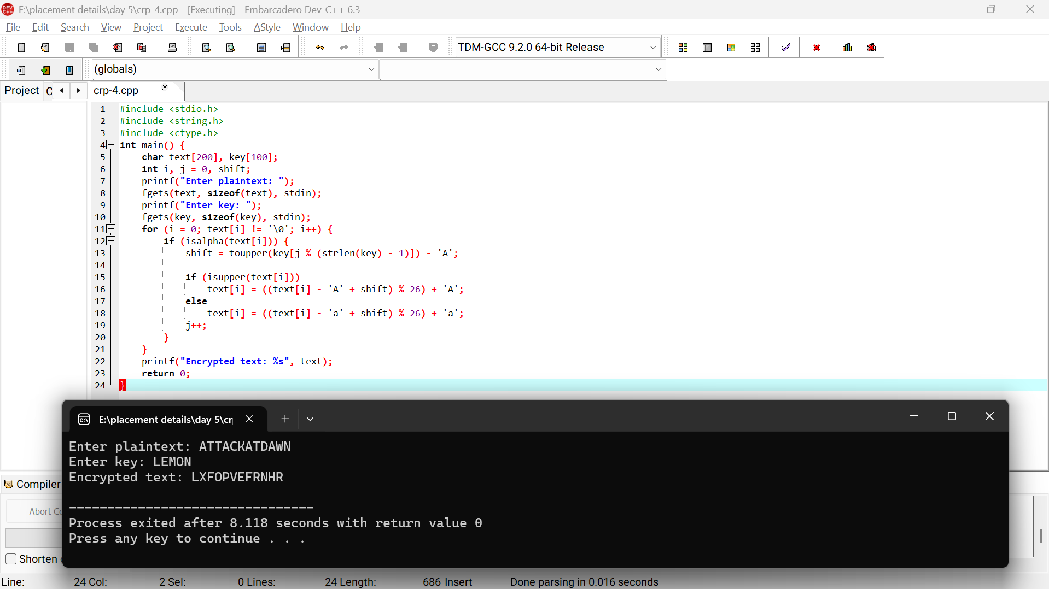
Result
Thus, the plaintext was successfully encrypted using the polyalphabetic substitution cipher.

